Step1

* Visit <https://veoci.com/>
* Click Log in on top right.

Step 2

* Hit “forgot password”.

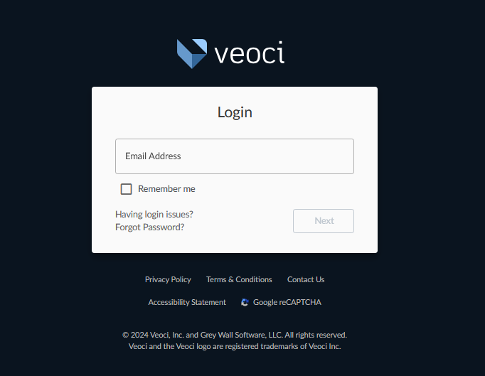

Step 3

* Enter the email address you provided to SAP during your registration. SAP refers to this as your “personal email”. It does not have to be your personal email, but it is the email address you provided during registration.
* Contact the SAP team (SAP@caloes.ca.gov) or your organization liaison to obtain your “personal email”.
* Note that your “personal email” or email address will be used as your Veoci username. (This email address can be changed in the future).
* Click “reset”.

Step 4

* Check your inbox or spam folder for the below email.
* Click the link provided and reset your password.

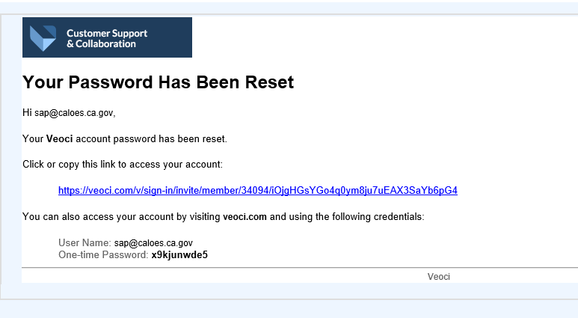

Step 5

* Once you reset your password, you should be prompted back to the Veoci log in page.
* Use your previous username (email) and new password to log into Veoci.
* Veoci will Multi-Factor Authentication. Click the email option.
* Check your email for the following email 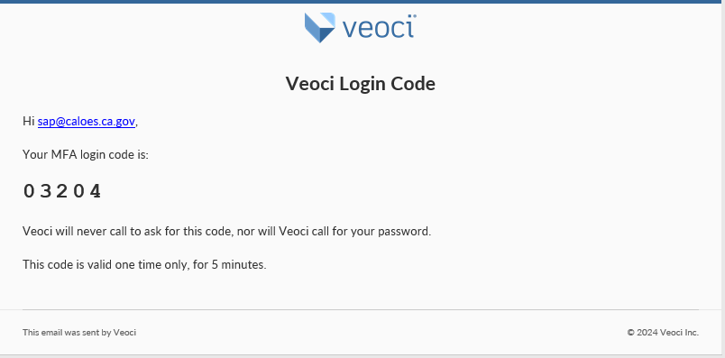
* Enter the password and you should be able to log in.

Step 6

* You will land in your Veoci homepage. This is the first iteration of the Veoci page, and we expect the page to be more user friendly in the coming months.
* Click “SAP Member Portal”.
* If you do not see the option, click “My apps” in the side bar. (side might be hidden, click the light blue box with an arrow to open the sidebar).
* If you miss click and get lost, follow the Main Menu drop down on the top left next to “Home”. Click “My Dashboard”. And click “My Apps”.

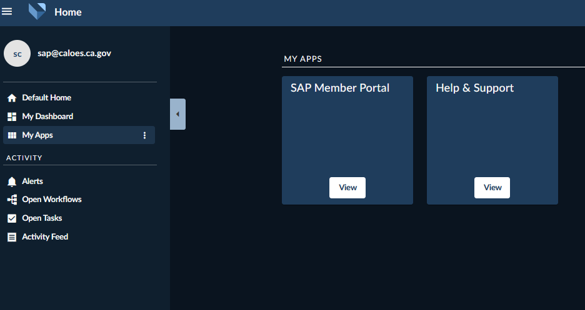

Step 7

* Click “View” in the “SAP Member Portal” app.
* You may select “Update Profile” on the right-hand side to update any information that does **not** need SAP approval. (This is SAP approval items effect your SAP ID and/or Veoci log ins. We want to make sure the changes you make are accurate).

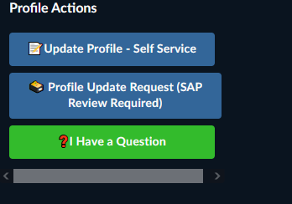

Veoci Headshot Import

* To upload a new photo ID for your SAP ID, follow these steps:
* Visit your member profile page (the page that appears after you log in).
* Locate two blue text boxes on the right-hand side, next to your "current user profile".
* Click the blue box labeled "Profile Update Request".
* Once clicked, a list of option appears, select the items you wish to modify.
* Click the pencil icon next to the "member profile" title.
* Most photo types can be attached or dragged into the grey box. (PDF are not allowed to be uploaded).
* Once the image is uploaded, click "submit" at the bottom right of your screen.
* The SAP team will review your image and approve your changes. (changes will be approved in 2-3 days)



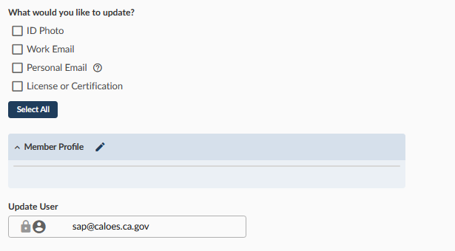

Notes

* This is an iterative process; some items will change in the coming weeks.
* Feel free to download, print and laminate your SAP ID and keep a card size cut out in your wallet.
* We expect to have an apple wallet/ Google pay type card that you can store on your cellphone by 2025.
* There is a Veoci App that can be helpful for you to access your card, but it will be optimized sometime in 2025 as well.
* All SAP members are expected to update and add missing information to your SAP profile.
* These profiles and digital cards will be the standard in future SAP deployments. We ask that all SAP members discard their plastic SAP ID by the end of 2024.
* Training videos on Veoci and new online data collection tools will be available sometime October 2024 on the SAP website.