Subapplicant – User Guide

Hazard Mitigation Assistance
Cal OES Community Portal



Table of Contents
First Steps 3
Registration/Sign-Up 3
Password Email 5
Homepage 5
Subapplication 6
Cal OES Community Portal 6
Preferred Browser 6
Cal OES Community Portal Homepage 7
Subapplication – Submission Detail Pages 7
Request For Information (RFI) 9
List of Questions, Inputs, Information 9
User Roles 10
Consultant User Roles 11
Subapplication Help 11
Subapplication Submission Best Practices: 11
Appendix A: General Subapplication Questions 12
Appendix B: Subapplication and Project Types by Program 21
Appendix C: Questions Specific to Planning Subapplication 25
Appendix D: Environmental Historic Preservation (EHP) Questions 26

First Steps
This Subapplication User Guide is intended to provide information on how to complete and submit a Subapplication after a Notice of Interest (NOI) is approved through the Cal OES Community Portal. When an NOI is approved, an email notification will be sent to the Subapplicant Primary Contact and Responsible Representative. The Primary Contact is the individual who submitted the NOI. The Responsible Representative is the individual identified in the NOI as having authority to apply for, accept, and manage Federal grant funding. The Responsible Representative will be required to log into the Cal OES Community Portal to assign user roles for the individuals who will develop the Subapplication.

Registration/Sign-Up
To submit a subapplication you must register for an account, if you don’t already have one. Select “Sign Up” on the Sign Up Page https://caloes.force.com/s/login/.

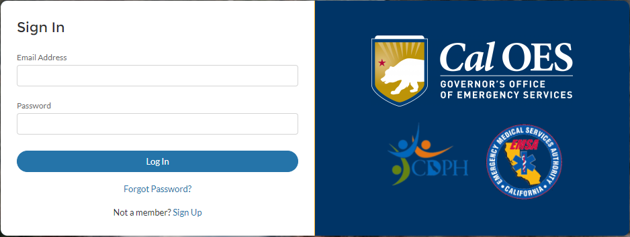

Entity Type

Enter your First Name, Last Name, Email, Phone and select your Entity Type. The entity types are County, State Agency, Non-governmental Entity, City, Tribal, and Special District. For Non-governmental entities you must also enter your Non-Governmental Entity name and Federal Tax ID #.

Entity Name

Once you select the Entity Type a drop down with a list of entity names will appear. Individuals working for departments within Cities or Counties will select the City or County name. For example, City of Sacramento Fire Department would register as Sacramento, City of. If your entity name is not specifically listed in the drop down list you will need to contact Salesforce.Support@caloes.ca.gov and submit a request to have your entity name added.

When making your request to add an unlisted entity name, provide the following information:

Your Name:

Your Phone number:

Your email Address:

Entity Name:

Entity Federal Tax ID #:

Entity Street Address:

Entity City:

Entity County:

Entity State:

Entity Zip:

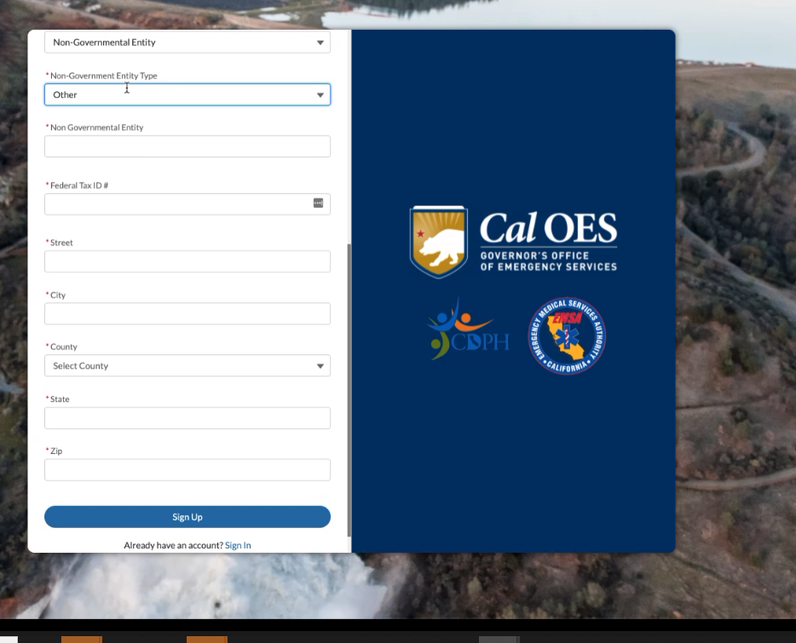

Password Email
Once you sign up, you will receive an email to verify your registration. This is a system generated email so please check your spam folder. Click the link within to set your password. Once your password is set you will be able to log in to the portal and land on the home page.

Subapplication
A Subapplication is a detailed proposal outlining the activities to be funded by the Hazard Mitigation Grant Program (HMGP). The following steps are a general overview of the Subapplication process:
- Subapplicant will complete and submit the Subapplication. All Subapplications will include a Scope of Work, Cost Estimate, Work Schedule, and uploaded supporting documents as required. Development of the Subapplication is achieved by answering a series of dynamic questions based on a specific Subapplication Type and Project Type. Answers, information, or responses will be provided using drop down menus, yes or no responses, narratives with specified character limits, and document uploads.
- Cal OES staff will review the Subapplication and may issue a Request for Information (RFI) to clarify any questions or obtain any missing information. Following the completed review, one of the following actions will occur:
  - The Subapplication will considered for submission to FEMA if eligible, feasible, cost-effective and meets the State’s funding priorities.
  - The Subapplication will be withdrawn from consideration if a determination is made that the proposed activity is not eligible, not costs effective, or does not meet the State’s funding priorities.
  - The Subapplication will be placed on a waiting list for consideration if additional funding becomes available.

Cal OES Community Portal
The Cal OES Community Portal is the access point for Subapplication submission. Sign In Page https://caloes.force.com/s/login/.

Preferred Browser
The CalOES Portal does not support Microsoft Internet Explorer. The preferred browser is Google Chrome. Microsoft Edge will also work.

Cal OES Community Portal Homepage

Once logged in to the portal, several options will be available. Select Hazard Mitigation Assistance (HMA).

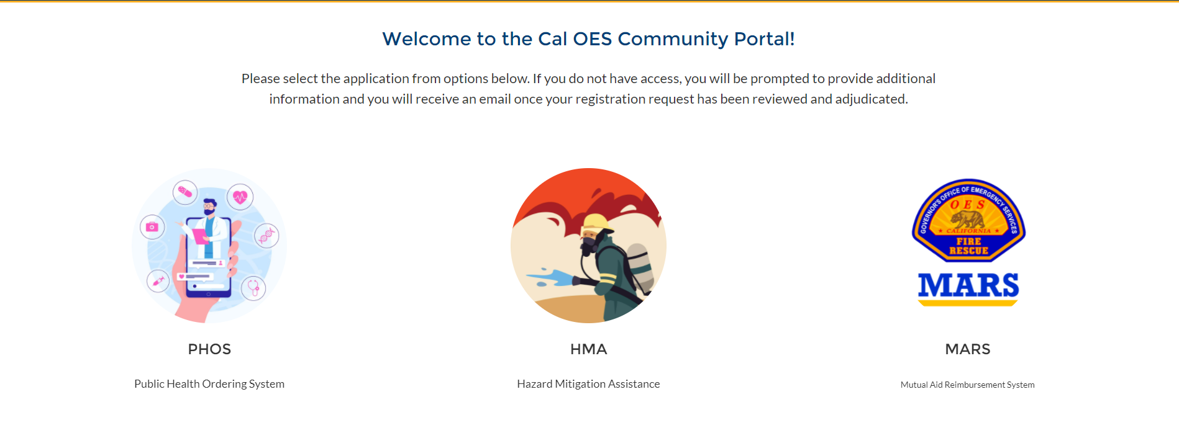

Subapplication – Submission Detail Pages

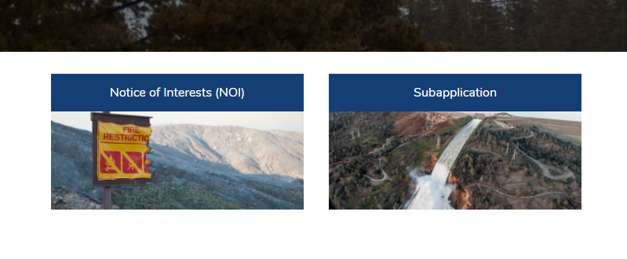
Select Subapplication after accessing Hazard Mitigation Assistance

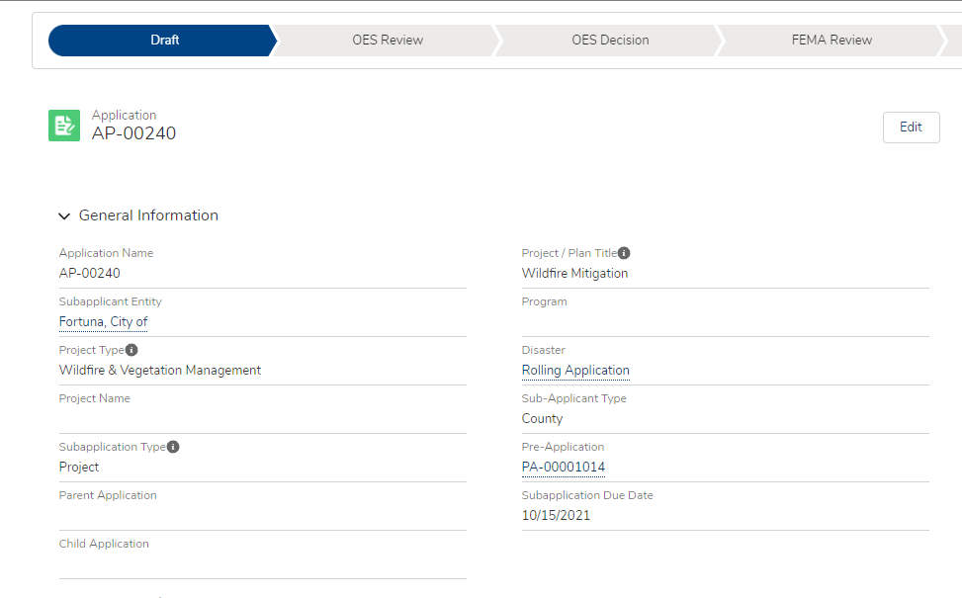
The initial Subapplication development page will automatically populate details submitted in the NOI. Selecting Edit will allow the User to begin the process of developing the Subapplication.

The status bar located in the header of the page provides the User a Subapplication status. When the Subapplication is submitted to OES the status in the header will move from Draft to OES Review. The User can return to the initial Subapplication development page by selecting Subapplication in the header.

Request For Information (RFI)

Once the Subapplication is submitted the Edit button will not allow access to the subapplication for revisions. Cal OES and/or FEMA may request additional details or clarification regarding information in the Subapplication. These requests are referred to as a Requests For Information (RFI). If an RFI is requested the Subapplicant will receive an email with time-sensitive instructions to log into the system to review and respond to the request.

The Edit button on the initial Subapplication page will be active once an RFI is requested. Click the Edit button and scroll down to the bottom of the page to view the RFI. Users can respond in writing to the RFI as well as upload documents. Multiple RFIs may be requested for a single Subapplication with a response required for each request.

List of Questions, Inputs, Information
Refer to Appendix A for a list of common questions to be answered. Refer to Appendix B for a list of Subapplication Types and Project types. The Subapplication is created using dynamic questions dependent on multiple variables such as Subapplication Type, Hazard Type, and Project Type. Creating a list of ALL possible questions is not feasible given the many variants of questions required for different combinations of Subapplication Type, Project Type and Hazard Type.

Progress made in the Subapplication will be saved as you go, but it’s recommended that you save your work often by selecting the Save button at the bottom of each page. You must complete all fields on a “page” in order for any of the information on that page to be saved when you leave the page. Because of this, we recommend that you compose and save your narrative responses outside of the web-based subapplication.

User Roles
The Primary Contact who submitted the approved NOI was required to identify the Responsible Representative. The Responsible Representative will need to log in to assign other users to contribute to completing the Subapplication. At minimum two contacts must be assigned user roles with one contact assigned as the Responsible Representative. Roles should be assigned base in the highest level of permission needed. While it is not necessary to do so, an individual user can be assigned multiple user roles. Responsible Representative is the only user that can submit the Subapplication.

Role Name | Description
Responsible Representative (Subapplicant employee authorized to apply for, accept, and manage Federal grant funding) | Manage user roles, view Subapplication, edit Subapplication, send Maintenance and Match Commitment letters, manage Requests for Information (RFI), Submit the Subapplication.
Primary Contact (Subapplicant employee) | View Subapplication, edit Subapplication, send Maintenance and Match Commitment letters, and manage Requests for Information (RFI).
Contributor (may be consultant) | View Subapplication, and edit Subapplication
Viewer | View the Subapplication

New contacts will receive an email with directions to log into the portal to verify registration. This is a system generated email sent from noreply@caloes.ca.gov. If you do not receive this email, check your spam folder. If no email is received, contact your IT department to check your spam filters. Sometimes an entity’s IT system flags these types of relayed messages as spam, and they are blocked before landing in a user’s inbox.

Click on the link in the registration email to set your password. Once your password is set you will be able to immediately log in to the portal.

Consultant User Roles
Consultants can be registered as a Contributor or Viewer to view and edit the Subapplication. Consultants shall not be registered as the Responsible Representative or a Primary Contact.

Subapplication Help
For questions related to Hazard Mitigation Assistance programmatic issues contact HMA@caloes.ca.gov. For troubleshooting login or technical issues with the Cal OES Community Portal system email salesforce.support@caloes.ca.gov and copy HMA@caloes.ca.gov. When sending send an email please provide Subapplicant entity name, AP number, and a detailed description of the issue.

Subapplication Submission Best Practices:

Subapplication Access: The Subapplication cannot be edited or viewed after submission. It’s recommended that you compose and save narrative responses for the Subapplication outside of the OES Community Portal.

Refresh Button: The Refresh Button  may help if there is a scenario when information is not populating appropriately, screens are not updating, or the system is stuck.

Project Site Locations: Multiple project site locations should be entered separately in the Subapplication. There is the option to include multiple, site-specific cost estimates for each project site locate. Site-specific cost estimates will roll up with the non-site specific cost estimate to result in the total project cost.

Work Schedule: Activities entered in the work schedule do not realign based on the months entered. As a best practice, activities should be entered in chronological order.

Maintenance Letter: The Total Maintenance Cost is calculated by multiplying the Project Useful Life (years) by the annual maintenance costs (dollars). The total costs should be calculated and entered into the Maintenance Commitment Letter (Useful Life in years x Annual Maintenance Cost (dollars) = Total Maintenance Cost).

Hit a Snag: Users may “Hit a Snag” while answering questions in the Subapplication. A “Hit a Snag” message should be followed by instructions for troubleshooting the issue. If a “Hit a Snag” message is not followed by instructions, then the User should close the window and refresh the browser. If the issue persists, the User will need to log out of the Cal OES Community Portal and repeat the previous process. If the problem persists, send an email to salesforce.support@caloes.ca.gov detailing the issue.

Appendix A: General Subapplication Questions
Each Subapplicant will answer general questions about the proposed project. Dynamic questions (not listed here), based on the Subapplication Type and Project Type, will populate as Subapplicants progress through the Subapplication. It is recommended that supplicants draft and save narrative responses outside the system before inputting them into the Subapplication. The completed Subapplication cannot be viewed once the Subapplication is submitted to Cal OES.

The following is a list of general questions that are included in the Subapplication. Questions answered during the Notice of Interest (NOI) will automatically populate in the Subapplication. Questions that require a narrative response display the character count limit to plan the length of the response.

General Information
- Subapplicant Name (Entity)
- Project / Plan Title (Avoid use of abbreviations in the title) –
  - The project/plan title should include:
    - Subapplicant name or location descriptor
    - Subapplication type or project type
Examples: Benicia Advance Assistance Defensible Space Program, City of Yucaipa Local Hazard Mitigation Plan Update, Marin County Exhibit Hall Seismic Retrofit Project, Lake County Special District Replacement of Redwood Water Tanks
- Program (HMGP, BRIC, FMA)
- Project Type –Hazard Type
- Subapplication Type

Location Information
- County
- State
- Region
- Funding Opportunity (Assigned by Cal OES)
- Project Number (Assigned by Cal OES)
- FIPS
  - **If you do not know your FIPS #, you can request it by emailing HMA@caloes.ca.gov **
- DUNS #
  - **If you do not know your DUNS #, call Dun & Bradstreet (D&B) 1-866-705-5711 for the information**
- Is this a phased project?
- EIN (For Private Non-Profits)
  - **The EIN is a federal 9-digit tax number**
- Applicant US Congressional District
- Applicant Assembly District
- Applicant Senate District Activity
- Was this project funded previously under a Federal program?
- Does another Federal entity have primary funding authority over the project site?
  - **FEMA will not provide assistance for activities for which it determines the more specific authority lies with another Federal agency or program. Other programs and authorities should be examined before applying for HMA funding. For example, is this activity eligible for funding from another federal program such as the NRCS Emergency Watershed Protection Act, FEMA Public Assistance Program, and the US Department of Agriculture/Department of the Interior Healthy Forest Restoration Act of 2002? Reference: 2015 HMA Guidance, Part III D.4**

Project/Plan Information
- Brief Summary - Describe how the proposed project is eligible for FEMA HMGP funding as defined by the eligible activities contained in the FEMA Hazard Mitigation Assistance Guidance document. (700 characters maximum)
- Has any physical work started or been completed? Please describe in detail. Physical work includes ground-breaking, demolition, construction, and/or geotechnical work that involves ground disturbance including soil boring?
- Project Alternatives, if no action is taken? (2,500)
- Project Alternatives, proposed action. (2,500)
- Project Alternatives, second action alternative. (2,500)
  - **describe why action not selected**
- Provide a detailed narrative of the hazards to be mitigated against and the impact the hazards present to the community and/or property. (2,500)
  - **Reference: 2015 HMA Guidance, Part IV H.**
- Provide a detailed description of the area and population that will be impacted by this project. (2,500)
  - ** Include a description of the natural and built environments proposed project is intended to protect. This discussion may be inclusive of the following: acreage, number of residences/structures/businesses and or facilities and should include size of population (traffic counts/estimates for road facilities if applicable) directly benefiting from the proposed project. This information should be consistent with information used in the BCA.**
- Has Subapplication been submitted to OES before? If yes, please provide project details.
- Is this project phased? If yes, provide mitigation activities for Phase 1 and Phase 2.
- What is the Project / Plan Duration? (Less than 33 months)

Problem Statement
- Describe the problem to be mitigated. (2,500)
  - **Include the cause of the problem, how long the problem has existed. The type of damages that occur, and any studies that have been performed**
- Describe the trigger event for a losses avoided analysis. (2,500)

Project Site(s)
- Have all specific sites where project work will be conducted been identified?
- Please complete the site inventory for all project sites, please ensure to add the required photos to each project site as uploaded files.
  - Site Name
  - Site Address
  - Action
- Activity Location Longitude
- **Provide latitude for at least one point at the activity location**
- Activity Location Latitude
- **Provide longitude for at least one point at the activity location**
Solution Description
- What is the percentage level of project design?
- What is the mitigation action? (2,500)
- How will this action provide protection from future natural hazards? (2,500)

Floodplain Related Questions
- Is the project located in a Special Flood Hazard Area (SFHA)?
  - **The SFHA is defined as the land in the floodplain within a community subject to a 1% or greater chance of flooding in any given year.**
- Has public notice of floodplain impact been completed?
- Does the Subrecipient participate in the National Flood Insurance Protection (NFIP) program?
- If the project is in a Special Flood Hazard area are NFIP requirements addressed?

Local Hazard Mitigation Plan
- What is the status of your entity’s Local Hazard Mitigation Plan Status?
- What type of LHMP, Local Single Jurisdictional or Multihazard?
- What is the expiration date of the Applicable Hazard Mitigation plan?
- Does the project comply with local hazard mitigation plan?
- How does the project comply with the State Hazard Mitigation Plan?
- Describe the scope of work for:
  - Planning process
  - Hazard Identification phase of the planning process
  - Risk Assessment phase of the planning process
  - Mitigation Strategy development phase of the planning process.
  - Plan preparation & drafting phases of the planning process.
  - Plan Approval & Plan Adoption phases of the planning process
  - Public outreach meeting and public hearing phase of the planning process.

Activity Costs
- Provide the total project costs.
- Project match commitment letter:
  - Entity name
  - Name of funding source
  - Funding Type
  - Non-Federal Share (Match) Availability Start Date?
  - Is there an expiration date of the Non-Federal Share (Match)?
- A detailed project cost estimate must include the following elements:
  - Cost Type
  - Item Name
  - Unit Quantity
  - Unit of Measure
  - Unit Cost
  - Cost Estimate Total
  - Is this a pre-award cost?
  - Cost Estimate Narrative
  - Action

Work Schedule
- Provide a realistic appraisal of the time and components required to complete the project
- Work Schedule should mirror the Scope of Work and Cost Estimate.
- A description of each major work element and milestones must include the following:
  - Task Name
  - Description
  - Start Month
  - Duration (months)
  - Action
- 3 Months (months 34 -36) must be set aside for project closeout

Benefit Cost Analysis (BCA)
- Upload a BCA
- Upload a BCA Methodology

Solution Description
- Brief Summary - Complete the response in the format provided. For example, this flood mitigation project will reduce or prevent localized flooding of 25 houses in a North Sacramento subdivision which floods when an average of one inch of rain falls for 5 consecutive days. Project will up-size five, 2-foot culverts to 4-foot culverts. (700)

This <insert project type> project will reduce or prevent <explain damage> resulting from <describe hazard> by <explain the mitigation action>

- What is the mitigation action? Describe in detail the proposed mitigation action and how it will mitigate the problem. The description should include the proposed approach and expected mitigation outcome(s). (2,500)
- Number of People Protected/Impacted by this Mitigation Action?
- How will action provide protection from future natural hazards?
  - Describe how the proposed action will reduce or eliminate damage or risk to life and property, include information on the level of protection the project will provide if designed to a specific standard (For example, 6.0 earthquake, 100-year flood, etc.)
Maintenance
- Provide the name of building(s), Facility(ies), area(s), structure(s), or infrastructure to which the maintenance applies. (2,500)
- What are the Past Maintenance Tasks Involved? (2,500)
- What is the annual maintenance cost?
- What are the future Maintenance Tasks Involved?
- Provide the future Maintenance Schedule.
- What are the future maintenance costs?

Grant Management Cost Application
- Subrecipient Management Costs are available at no more than 5% of the final project costs.
- Pre-Award: Subapplication development, community outreach, meetings related to Subapplication development.
- Staff Time - Salary or hourly employee time to manage technical monitoring, quarterly reporting, technical assistance, and the reimbursement and close-out process.
- Travel - Cost to attend professional development training course directly related to implementation of the Hazard Mitigation Grant.
- Equipment - Cost directly related to implementation of Hazard Mitigation Grant.
- Supplies - Supply cost directly related to implementation of the Hazard Mitigation Grant, such as printer materials and office supplies.
- Indirect Cost - Depreciation or use allowances on buildings and equipment, costs to operate and maintain facilities, general administration, and accounting administration.

Environmental and Historic Preservation (EHP)
- Is the project within or will it modify a floodplain?
  - **To download Flood Insurance Rate Map, go to the FEMA Flood Map Service Center https://msc.fema.gov/portal/search and click on the button for “Map Image – Download FIRM Panel”**
- Does the primary site alternative and/or its practicable alternative require a Section 10 of the Rivers and Harbors Act or a CWA Section 404 permit?
  - **For sites with wetlands, to download NWI Map, go to the USFWS wetlands map, https://www.fws.gov/wetlands/data/Mapper.html **
- Is the proposed project located in or adjacent to a residential or historic district?
  - **For sites located within a residential or historic district, a Visual Impact Assessment (VIA) should be performed by a qualified landscape architect. Information on VIA’s and guidance for developing them is provided on Department of Transportation’s site, http://www.dot.ca.gov/design/lap/landscape-design/via/**
- Identify and describe any existing, observed in the field, or known or expected to exist flora and fauna species at the project site and immediately surrounding the site. (2,500)
- Are any endangered/threatened species known to exist at the site or in the immediate vicinity?
  - **The USFWS Information for Planning ad Consultation web site (https://ecps.fws.gov/ipac/) can be used to search for Federally listed threatened and endangered species on the project site**
- Is the proposed project new construction or extension of an existing tower of 30’ in height or more?
- Will the project include construction?
- Will a project alternative convert or impact important farmland?
- Are there any listed, eligible or potentially eligible historic/archaeological resources (in) the (Area of Potential Effects)?
  - **Records searches are the primary means through which California Historical Resources Information System (CHRIS)is disseminated. A records search consists of a review of historical resources data on file at an Information Center (IC) regarding a specific geographic area. A records search may be conducted by filling out a CHRIS Data Request Form. The form can be obtained through California’s Department of Parks & Recreation’s website.**
- Provide a description of any hazardous, toxic substances found at the site. (2,500)
- Will the project include road construction and/or vehicular access?
- Provide status of U.S. Army Corps of Engineers permit receipt and attach a National Wetlands Inventory wetlands map.
- Provide a description of any hazardous, toxic substances found at the site
- Provide the completed FEMA Environmental Checklist.

Appendix B: Subapplication and Project Types by Program

Hazard Mitigation Grant Program (HMGP)

Subapplication Types
Subapplication Type | Examples
Planning | Activities include developing a new hazard mitigation plan or updating a current mitigation plan.
Planning Related | Activities include: Updating or enhancing sections of the current FEMA-approved mitigation plan, integrating information from mitigation plans with other planning efforts, building capacity through delivery of technical assistance and training, evaluating adoption and/or implementation of ordinances that reduce risk or increase resilience.
Project | Activities involve construction and/or physical work. Examples: acquisition demolition/relocation, debris basin, structural elevation, structural seismic retrofit, hazardous fuels reduction, defensible space, generator(s) (If benefit cost analysis (BCA) feasible).
Advance Assistance | Activities can be used to develop mitigation strategies and obtain data to prioritize, select, and develop mitigation projects and complete applications. Examples: evaluation of facilities or areas to determine mitigation actions, collect data for BCA and environmental historical preservation compliance, conduct engineering designs and feasibility studies, conduct hydrologic and hydraulic studies and cost estimation.
5% Initiative | Activities are defined as mitigation actions that meet all HMGP requirements but may be difficult to evaluate against traditional program cost-effectiveness criteria. Examples such as, early warning systems, post-disaster building code enforcement, public awareness and education for mitigation campaigns, hazard identification or mapping, new techniques/methods of mitigation and generator(s) (if protecting a critical facility and if there is insufficient data to evaluate a generator project using a standard HMA-approved Benefit-Cost Analysis (BCA) method).

Project Types
Project Type | Activities
Acquisition Demo-Relocation | Purchase of properties on a voluntary basis in order to remove structure(s) from natural hazards (flood/landslide/avalanche). Structures must be demolished or relocated outside hazard area.  **As referenced in the Hazard Mitigation Assistance Guidance: Property Acquisition and Structure Demolition Projects, Property Acquisition and Structure Relocation Projects
Drainage / Flood Control | Stormwater management projects, including the construction, installation, or improvement of culverts, drainpipes, pumping stations, floodgates, and detention or retention basins.  Flood protection measures for water and sanitary sewer systems or other utility systems. Slope stabilization or grading to direct flood waters away from homes, schools, businesses, utilities, or governmental facilities.  Flood protection and stabilization measures for roads and bridges construction, demolition, or rehabilitation of: Dams, Dikes, Levees, Floodwalls, Seawalls, Groins, Jetties, Breakwaters, Stabilized sand dunes, Large-scale channelization of a waterway  Vegetation management for shoreline stabilization (coastal, riverine, riparian, and other littoral zones) Soil stabilization and erosion control activities.  Drought mitigation activities.  **As referenced in the Hazard Mitigation Assistance Guidance: Localized Flood Risk Reduction Projects, Non-Localized Flood Risk Reduction Projects, Soil Stabilization, Infrastructure Retrofit, Green Infrastructure
Elevation-Floodproofing | Elevation: Construction to elevate structures above the base flood elevation.  Dry Floodproofing: Implementation of techniques to seal the structure from floodwaters.  **As referenced in the Hazard Mitigation Assistance Guidance: Elevation (Structure Elevation); Dry Floodproofing (Dry Floodproofing of Historical Residential Structures, Dry Floodproofing of Non-Residential Structures)
Seismic | Retrofitting homes or buildings structurally or non-structurally to reduce damages from earthquakes.  **As referenced in the Hazard Mitigation Assistance Guidance: Structural Retrofitting of Existing Buildings, Non-Structural Retrofitting of Existing Buildings and Facilities
Wildfire & Vegetation Management | Creation of defensible space around homes, structures, and critical facilities by reduction of flammable vegetation. Hazardous fuel reduction which is the removal of vegetative fuels proximate to at-risk structures. Implementation of ignition-resistant construction techniques utilizing non-combustible materials on new and existing structures.  **As referenced in the Hazard Mitigation Assistance Guidance: Wildfire Mitigation
Mitigation Reconstruction | Construction of an improved, elevated building on the same site where an existing building and/or foundation has been partially or completely demolished or destroyed.  **As referenced in the Hazard Mitigation Assistance Guidance: Mitigation Reconstruction
Generator(s) | Installation of generator(s) which provides a secondary source of power to a critical facility. Examples: police and fire station, hospitals, water and sewer treatment plant.  **As referenced in the Hazard Mitigation Assistance Guidance: Generators
Tsunami Vertical Evacuation | Construction of an evacuation tower which is utilized during a tsunami event to escape the tsunami and debris wave.
Safe Room | Construction of safe rooms to provide protection for people in public and private structures from tornado and severe wind events. This type of project includes retrofits of existing facilities or new safe room construction projects.  **As referenced in the Hazard Mitigation Assistance Guidance: Safe Room Construction

5% Initiative Types
5% Initiative | Examples
Generator(s) | Installation of generator(s) which provides a secondary source of power to a critical facility. Examples: police and fire station, hospitals, water and sewer treatment plant).
Post-Disaster Code Enforcement | Extraordinary post-disaster code enforcement projects to ensure disaster-resistant codes are implemented during disaster reconstruction after the normal costs of the building department are deducted. Example: Hiring staff to help process building permits to confirm post-disaster code is implemented, perform home construction plan review and field inspection of homes being built after a fire to ensure codes are followed.
Public Awareness and Education | Public awareness or education campaigns about mitigation. Example: Development of materials related to the various hazards that can impact a community and deliver trainings in the community.
Early Warning Systems | Equipment and systems for the purpose of warning citizens of impending hazards. Example: Installation of a camera system to detect and notify residents of fire risk.
Hazard Identification or Mapping | Hazard identification or mapping and related equipment for the implementation of mitigation activities. Example: Development of maps and data to will assist in the identification of necessary erosion control measures, slope stabilization, structural protection, and flood and debris flow hazard and risk analyses.
GIS for Mitigation | Acquisition of GIS software, hardware, and data whose primary aim is mitigation.
New Techniques Methods | The use, evaluation, and application of new, unproven mitigation techniques, technologies, methods, procedures, or products

Appendix C: Questions Specific to Planning Subapplication
Scope of Work
- Describe the Scope of Work (SOW) for the:
  - Planning Process (2,500)
  - Hazard identification phase of the planning process (2,500)
  - Risk Assessment phase of the planning process (2,500)
  - Mitigation Strategy development phase of the planning process (2,500)
  - Plan Preparation & Drafting Phases of the planning process (2,500)
  - Public Outreach, Meeting, and Public Hearing Phase of the planning process (2,500)
  - Plan Approval & Plan Adoption phases of the planning process (2,500)
Jurisdictions
- What type will be developed? (new plan, plan update, MJHMP update, new MJHMP, planning related)
  - **The subapplicant will not be eligible to receive project grant funds unless FEMA approves thed plan to be in compliance with the Federal hazard mitigation planning standards identified in 44 CFR 201.6. The application must state that the objective is to create a plan that is compliant with these regulations. In addition, the timeline for the grant should include at least 45 days for FEMA to review and approve the plan. Reference: 44 CFR 201.6**
- List the communities that will be participating and provide the letter of intent for each. (255)
  - **Plan Adoption: The narrative describes the plan drafting process, including State and FEMA reviews (i.e., approval pending adoption), adoption by participating jurisdictions, and final approval by FEMA. Reference: 2015 HMA Guidance, Part IV H.3.1**
- Provide a description of the planning process including composition, roles, and responsibilities of the planning team. (255)
- Provide a description of the proposed public engagement process and indicate if there will be workshops, public surveys, focus groups, websites, or other forums. How many of each are being considered? (255)
  - **Reference: 44 CFR 201.6 (B) (1-2) & 2015 HMA Guidance, Part IV H.3.1**
- Indicate if a contractor will be used.
- Does this plan encompass multiple jurisdictions?

Appendix D: Environmental Historic Preservation (EHP) Questions

- Floodplains – Is the project within or will it modify a floodplain? If yes, upload Flood Insurance Rate Map (FIRM)
  - **To download Flood Insurance Rate Map, go to the FEMA Flood Map Service Center https://msc.fema.gov/portal/search and click on the button for “Map Image – Download FIRM Panel” **
- Wetlands – Does the primary site alternative and/or its practicable alternative require a Section 10 of the Rivers and Harbors Act or a CWA Section 404 permit? If yes, upload the NWI Map.
  - **For sites with wetlands, to download NWI Map, go to the USFWS wetlands mapper https://www.fws.gov/wetlands/data/Mapper.html, click on the wetlands mapper link, click on “Find Location” and search by address. Click “Print” to download the NWI map. **
- Viewshed – Is the proposed project located in or adjacent to a residential or historic district? If yes, upload Visual Impact Assessment (VIA).
  - **For sites located within a residential or historic district a VIA should be performed by a qualified landscape architect. Information on VIAs and guidance for developing them is provided on the California Department of Transportation (DOT)’s web site (http://www.dot.ca.gov/design/lap/landscape-design/via/). **
- Existing habitat – Identify and describe any existing, observed in the field, or known or expected to exist flora and fauna species at the project site and immediately surrounding the site. (2,500)
- Endangered/threatened species and/or critical habitat – Are any endangered/threatened species known to exist at the site or in the immediate vicinity? If yes, please upload a list of these of these species according to the Federally-listed threatened and endangered species list.
  - **The USFWS Information for Planning and consultation web site (https://ecos.fws.gov/ipac/) can be used to search for Federally-listed threatened and endangered species on the project site. **
- Migratory flyway or migration barrier – Is the proposed project new construction or extension of an existing tower of 30’ in height or more? If yes, please upload construction plans.
- Invasive Species – Will the project include construction? If yes, please upload construction plans.
- Minority (or) low-income populations – Will the proposed project impact minority and low-income populations as identified in Executive Order 12898?
  - **To determine if the project is located in a high percent minority population, use the Environmental Justice screening Tool. The tool will indicate if the project site is located in a high percent minority population area and will have possible detrimental environmental impacts. The U.S. Environmental Protection agency (USEPA) Technical Guidance for Assessing Environmental Justice in Regulatory Analysis should be used to perform an analysis of environmental justice. This Guidance is provided on the USEPA web site (https://www.epa.gov/environmentaljustice/technical-guidance-assessing-environmental-justice-regulatory-analysis). **
- Farmland – Will a project alterative convert or impact important farmland? If yes, upload Form AD 1006 that is submitted to Natural Resource Conservation Service (NRCS)
  - **If important farmland may be present on the site per item and where project activities may affect land use the NCRS Form AD 1006 should be downloaded and submitted to NRCS for review and rating. The form is available on the NRCS web site. **
- Historic and Cultural Characteristics – Are there any listed, eligible or potentially eligible historic/archaeological resources (in) the (Area of Potential Effects)? If yes, please upload a list local information from which California Historical Resources Information System (CHRIS).
  - **Records searches are the primary means through which CHRIS information is disseminated. A records search consists of a review of historical resources data on file at an Information Center (IC) regarding a specific geographic area. A records search may be conducted by filling out a CHRIS Data Request Form. The form can be obtained for the State of California Department of Parks and Recreation’s website. **
- Hazardous/Toxic Substances - Provide a description of any hazardous, toxic substances found at the site (2,500)
- Roadway and Access – Will the project include road construction and/or vehicular access? If yes, please upload a detailed map and specifications for the road construction and/or vehicular access.

