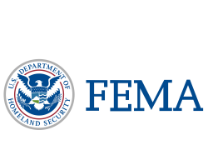
WF - 1

FEMA Mitigation Opportunities

Erosion Control and Watershed Protection

Overview
Post-fire mitigation funding opportunities are available to states, local and tribal governments, for the mitigation of wildfire or impacts of wildfire on publicly or privately owned forests or grasslands, which could lead to increased or new damage in the burned area. Funding of these programs are made available from the Federal Emergency Management Agency (FEMA) through the California Office of Emergency Services (CalOES).

Eligible Projects
• Surface erosion control actions necessary to reduce potential threats to structures or facilities (note: this might not be considered an emergency action if there is time to consult with necessary resource agencies prior to initiating the action, e.g. hydro seeding cannot happen until early spring.)
• Slope stabilization (Ground disturbance activities have higher environmental compliance)
• Actions to reduce risk of mass failures or risk to debris flows.
• Debris basins to hold debris flows due to fire (Ground disturbance activities have higher environmental compliance)
• Upgrades to existing culverts to reduce any threat of road failing due to plugged culvert
• Repairs or stabilization of roads or other facilities in danger of failure
• Installation of gabions, ecology blocks, K-railing and other erosion control measures used to protect at risk structures or facilities
• Installation of sediment traps or check dams at high risk areas when threat exists

Overall Complexity
Project | Application | Environmental | Legal
Erosion Control | Low | Low | Low
Slope Stabilization | Low | Medium | Medium
Debris Mitigation and Basins | Medium | Medium | Medium
Culvert Upgrades | Low | Medium | Medium
Infrastructure and Utility Protection | Low | Medium | Medium
Sediment Traps or Check Dams | Low | Medium | Medium

Fire Mitigation Examples

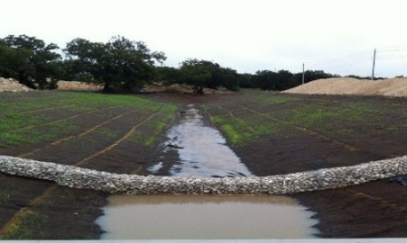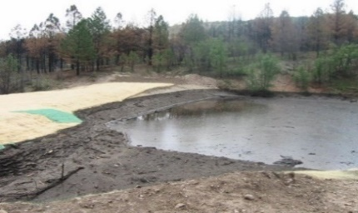

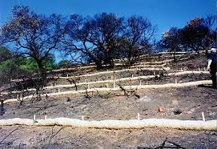

Application Requirements:
- Must be a local government, Tribe, or PNP
- Must have a FEMA approved Local Hazard Mitigation Plan
- Must fulfill appropriate state emergency management agency application requirements including, scope of work, budget, schedule, etc.
- Long-term benefits must outweigh costs (BCR > 1)
- Projects that cost less than or equal to $5,200 per acre of benefit are automatically cost effective. No benefit-cost analysis is required.
- Projects with costs greater than $5,200 per acre of benefit must submit a documented benefit-cost analysis
- 25% local match required
- Projects affecting private property must have property owner permission
- Funding limits set by the state emergency management agency
- No construction prior to FEMA/Cal OES approval

Environmental Requirements:
This depends on the action, the resources affected, and the applicable environmental and historic preservation (EHP) laws. Therefore, engagement with the FEMA EHP is required on a project specific basis. Compliance requirements and consultation timelines with resource agencies differ, however some timeframes associated with the review of an emergency action are truncated and EHP will conduct the compliance review process as expeditiously as possible. For example, under the Clean Water Act, the US Army Corps of Engineers (USACE) has emergency provisions which FEMA may be able to utilize to avoid duplicative compliance reviews. This can be achieved due to a Memorandum of Understanding and other programmatic agreements between FEMA and other resource agencies.
If emergency consultation is deemed necessary, FEMA EHP will contact the relevant resource agencies and provide them as much information as possible regarding the proposed action, design elements, mitigation measures, public risk, and other relevant information.

