
County Emergency Operations Plan (EOP)
Review Process
Fact Sheet

March 6, 2024
The California Governor’s Office of Emergency Services (Cal OES) reviews County Emergency Operations Plans (EOPs) and offers recommendations for improvement. This fact sheet outlines the Why, What, Who, When, and How of the review process for California counties. A summary of what has changed and what has not changed is highlighted.

Why
Recent legislation amended Government Code 8593.3.2, 8593.9, and 8610 to require that Cal OES review 10 county EOPs each year. The legislation also specifies items to be reviewed, requires that Cal OES provide technical assistance, and establishes a by-request Access and Functional Needs (AFN) Consultation.
What
Cal OES is required to review county EOPs. An Operational Area (OA) EOP is considered a county EOP if the OA EOP includes the county. A complete review submission includes all EOP annexes and appendices. Intersecting, stand-alone plans should also be submitted if the crosswalk elements are met by those documents. The EOP is reviewed against an EOP crosswalk (completed by the county). (Other jurisdictions, such as cities, special districts, or tribes, are welcome to use the crosswalk, but a Cal OES review is not required.)
Who
The Cal OES review will maintain existing relationships and enroll subject matter experts. The Region ESC remains the point of contact for the County and reviews the plan for compliance with Federal Emergency Management Agency Comprehensive Planning Guide (CPG) 101 and the California Standardized Emergency Management System (SEMS). The Community Planning Unit coordinates the reviews. A panel of subject matter experts evaluates specific areas of the plan. AFN Consultations (when requested) will be executed by the Cal OES Office of Access and Functional Needs.
When
Cal OES will select 10 existing plans each year for review. Counties will be notified in advance. Additionally, Cal OES will review plan updates. Plan updates should be submitted to Cal OES 90 days prior to approval/adoption to allow time for the review and incorporation of recommendations.

Changes
- There are new content and planning requirements for EOPs.
- The EOP Crosswalk has been expanded to include additional items.
- Counties are required to submit current plans and updated plans to Cal OES.
- Cal OES is required to review 10+ plans/year.
- Cal OES reviews existing plans (as well as updated plans).
- Plan reviews enroll Subject Matter Experts (in addition to the Region ESC).
- Cal OES offers an optional AFN Consultation and/or Cultural Competence Consultation.
No Changes
- The Region ESC remains the County’s primary point of contact.
- EOPs will still be reviewed for SEMS and CPG 101 compliance.

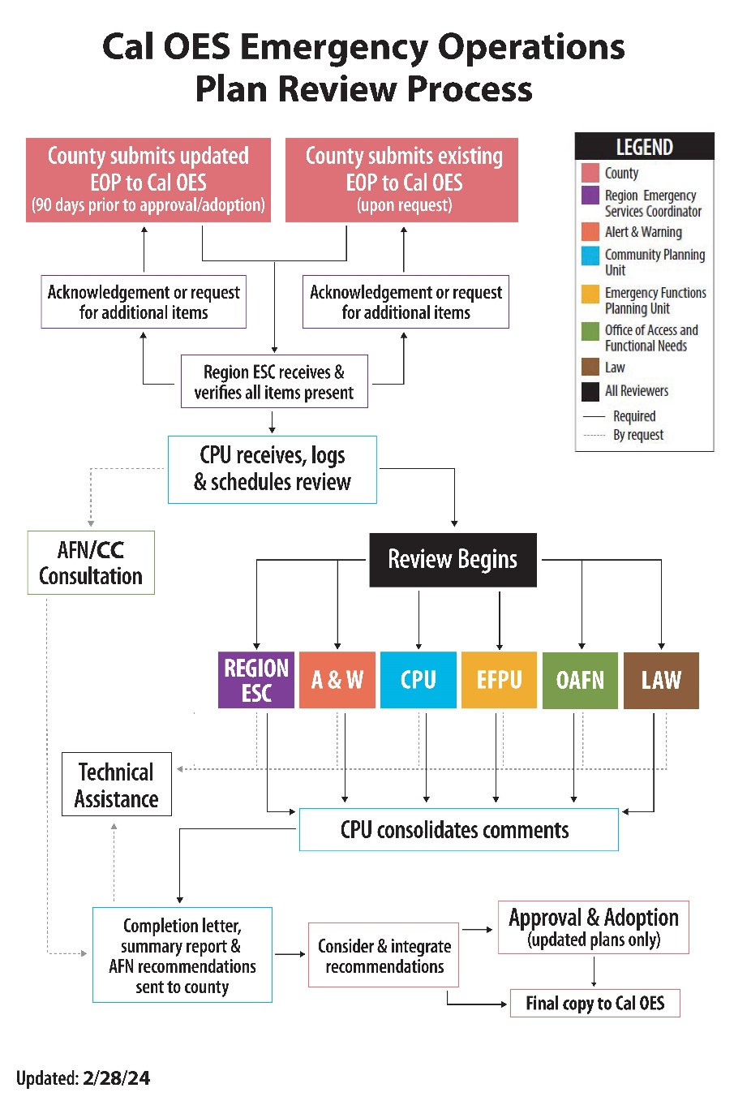
How
Counties should expect to follow this process for EOP reviews:
- Submission prompted.
  - Updated plans should be submitted to Cal OES for review 90 days prior to desired adoption and approval.
  - Existing plans should be submitted to Cal OES for review upon request.
Cal OES will determine a yearly EOP review schedule and communicate that schedule to the affected counties.
- Crosswalk completed. Counties will complete the EOP Crosswalk to demonstrate how each element is met by the plan, intersecting plans, or the planning process. Counties will indicate their desire for an AFN Consultation on the crosswalk.
- Plan submitted. Counties will submit a digital version of the plan to the Cal OES Region ESC. The submission should include the plan; pertinent annexes and appendices; intersecting, stand-alone plans; and the completed EOP Crosswalk.
- Technical assistance begins. During the review process, reviewers (Regional ESC, Alert & Warning, Community Planning Unit, Emergency Functions Planning Unit, Office of Access and Functional Needs, Law Enforcement) will reach out to the county contact to ask questions, gain clarification, and offer minor recommendations.
- Feedback received. Counties will receive the review feedback in a Summary Report (and AFN Consultation letter, if requested) upon completion of the review.
- Feedback integrated. Counties integrate recommendations from the Summary Report into the EOP or EOP planning process as appropriate.
- Final plan submitted. Plans should be submitted to the Cal OES Region after approval and adoption (for plan updates) or revision (for existing plans).
For more information, please email communityplanning@caloes.ca.gov.

