PUBLIC COMMENT DRAFT

2026 California Adaptation Planning Guide

July 27, 2026

The Governor’s Office of Emergency Services (Cal OES) is pleased to announce that the California Adaptation Planning Guide (APG) is being updated in partnership with the California Natural Resources Agency (CNRA) and Governor’s Office of Land Use and Climate Innovation (LCI). As part of our commitment to Senate Bill 246 (SB 246), this guidebook is being revised to better support communities across the state. By sharing this updated guidance, we aim to foster collaboration, leverage collective expertise, and support effective local climate adaptation planning.
Primary Objective of the guidebook:
Provide local and regional governments and agencies with practical guidance, tools, and strategies to support climate adaptation planning, including coordination across jurisdictions, understanding climate impacts, conducting vulnerability assessments, engaging communities, improving public safety, and identifying actions to reduce climate-related risks.
Public comment period ends September 9, 2026.
Options for submitting written comments include:
Public Input form: Form
Email: apg@caloes.ca.gov
Mail: Governor’s Office of Emergency Services
10370 Peter A. McCuen Blvd. (Building E)
Mather, CA 95655
Questions or concerns about the content should be directed to apg@caloes.ca.gov.
TABLE OF CONTENTS
INTRODUCTION 7
What is the APG? 7
What’s New in the 2026 Adaptation Planning Guide 10
Who Is This Guide For? 10
Who Developed the APG and Why? 11
How To Use This Guide 12
Legal Requirements This Guide Supports 15
Pathways to Action 15
What Is Climate Adaptation Planning? 20
Climate Change Mitigation and Adaptation 22
How is Equity Integrated into Climate Adaptation 24
What is Plan Alignment? 27
Additional Resources 29
How is California Vulnerable to Climate Change? 30
PHASE 1: DEFINE, ASSESS, AND INITIATE 31
Step 1.1: Identify the Purpose and Scope of the Adaptation Plan 32
Step 1.1A: What Plan or Project Will This Process Produce 32
Step 1.1B: What Does Adaptation and Resilience Mean to the Community? 35
Step 1.1C: Define the Planning Area 38
Step 1.2: Assemble the Planning Team and Resources 40
Step 1.2A: Assessing Capacity 40
Step 1.2B: Establishing a Budget to Fund the Adaptation Planning Process 40
Step 1.2C: Assembling the Planning Team 41
Step 1.3: Prepare an Equitable Outreach and Engagement Approach 45
Step 1.3A: Identify Partners 47
Step 1.3B: Developing a Community Outreach and Engagement Plan 50
Step 1.3C: Developing Engagement and Outreach Activities 50
Phase 1 Wrap-Up 57
PHASE 2: ASSESS VULNERABILITY 58
Key Concepts in Phase 2 59
Step 2.1: Hazards and Exposure 60
Step 2.1A: Review Existing Documents 61
Step 2.1B: Determine Historical Hazards 64
Step 2.1C: Identify Exposure to Climate Hazards 68
Step 2.1D: Describe How Climate Hazards Are Expected to Change 71
Step 2.1E: Determine Secondary and Cascading Hazards 77
Step 2.1 Wrap-Up 81
Step 2.2: Vulnerability and Potential Impacts 81
Step 2.2A: Evaluate Social Vulnerability 82
Step 2.2B: Evaluate Built Assets 87
Step 2.2C: Natural, Historic, and Cultural Resource Assets 91
Step 2.2D: Outreach and Engagement 95
Step 2.3: Adaptive Capacity 98
Step 2.3A: Reviewing Documents for Adaptive Capacity Insights 100
Step 2.3B: Evaluating Adaptive Capacity Strategies 101
Step 2.3C: Outreach and Engagement 103
Step 2.4: Prioritize Climate Vulnerability 104
Step 2.4A: Summarize Vulnerability 104
Step 2.4B: Prioritization 106
Phase 2 Wrap-Up 113
PHASE 3: ADAPTATION FRAMEWORK AND STRATEGIES 114
Step 3.1: Summarize Vulnerability 117
Step 3.2: Review Vision and Goals 119
Step 3.2A: Review Vision 119
Step 3.2B: Draft Goals 119
Step 3.3: Prepare Adaptation Strategies 122
Step 3.3A: Identify Opportunities to Strengthen Existing Strategies 122
Step 3.3B: Draft Adaptation Strategies 123
Step 3.3C: Equity Considerations in Strategy 131
Step 3.3D: Outreach and Engagement 135
Step 3.4: Prioritize Adaptation Strategies 136
Step 3.4A: Cost/Benefit Assessment for Adaptation Strategies 138
Step 3.4B: Outreach to Develop Adaptation Strategies 139
Phase 3 Wrap-Up 142
PHASE 4: IMPLEMENT, MONITOR, EVALUATE, AND ADJUST 143
Outreach and Engagement in Phase 4 144
Step 4.1: Implement 144
Step 4.1A: Develop an Implementation Program 145
Step 4.1B: Implementation Funding 147
Step 4.1C: Implementation Outreach 159
Step 4.2: Monitoring and Evaluation 160
Step 4.2A: Metrics and Indicators 161
Step 4.2B: Monitoring and Evaluating Outreach 167
Step 4.3: Adjust 168
Step 4.3A: Adjustment Considerations 168
Step 4.3B: Adaptation Pathways 169
Step 4.3C: Adjustment and Outreach 171
Phase 4 Wrap-Up 174
APPENDIX A: OUTREACH & ENGAGEMENT METHODS 175
Racial Equity Framework 175
The Spectrum of Community Engagement to Ownership 175
Best Practices for Conducting Outreach and Engagement Activities 176
Partner Interviews 179
Vulnerability and Resilience Building 181
Outreach to Develop Adaptation Strategies 184
APPENDIX B: CLIMATE DATA TOOLS 186
Vulnerable Communities Platform (VCP) 186
Extreme Heat 194
LCI’s Climate Data Viewer 194
Wildfire 194
US Forest Service (USFS) Wildfire Risk to Communities 194
CAL FIRE Historical Fire Perimeters 195
Wildfire Smoke Map from Stanford University’s Environmental Hazard Adaptation Atlas 196
CAL FIRE Fire Hazard Severity Zones (FHSZs) 196
Flooding 196
California Department of Water Resources (DWR) Best Available Maps (BAMs) 196
LCI’s Climate Data Viewer 197
Sea Level Rise 197
California Our Coast Our Future (OCOF) Viewer 197
U.S. Geological Survey (USGS) Hazard Exposure Reporting and Analytics (HERA) Web Tool 198
National Oceanic and Atmospheric Administration (NOAA) Sea Level Rise (SLR) Viewer 199
Drought 200
DWR Water Shortage Vulnerability Tool 200
LCI’s Climate Data Viewer 200
APPENDIX C: WORKSHEETS 202
Partner Mapping 203
Review Existing Documents 204
Determine Historical Hazards 205
Identifying and Analyzing Primary Climate Hazards 206
Secondary and Cascading Hazards 207
Evaluate Community Assets Exposed to Hazards 208
Partner Interview Findings 209
Reviewing Documents for Adaptive Capacity Insights 213
Adaptive Capacity Strategies 214
Prioritize Climate Vulnerability 216
Draft Adaptation Strategies 217
GLOSSARY 218
ACRONYMS 225

INTRODUCTION
California is already living with the consequences of climate change. Six of the ten most destructive wildfires in the state's history have occurred in the last decade. Atmospheric rivers have become more frequent and more disruptive. Extreme heat is emerging as a major public health emergency, and rising sea levels continue to increase risks for communities. These are not future threats but present ones, and communities across the state are making decisions right now that will determine how resilient they are in the decades ahead.
The California Adaptation Planning Guide (APG) helps communities make those decisions well. It provides a structured four-phase process for local and regional governments and agencies, to assess their climate vulnerability and develop concrete adaptation strategies grounded in the best available science, shaped by their communities, and integrated with their existing plans.
This third edition, released in 2026, reflects the latest climate science and state policy, builds on the California Climate Adaptation Strategy (2024), and incorporates lessons from communities that have completed adaptation plans since the APG was last updated in 2020.
The APG connects to a broader ecosystem of California state resources that support local and regional adaptation planning. These resources include, but are not limited to:
- California General Plan Guidelines
- California State Hazard Mitigation Plan
- California's Fifth Climate Change Assessment
- State Adaptation Clearinghouse
- Vulnerable Communities Platform

What is the APG?
The APG provides guidance to local and regional governments and agencies to support adaptation and resiliency planning. The APG is designed to be flexible and to guide communities in adaptation planning that best suits their needs, whether taking a preliminary, broad look at adaptation issues or conducting a detailed, formal planning process. The APG also provides the most recent summaries of statewide information and guidance on where to find and how to use adaptation planning tools.
Since the state’s release of the first APG in 2012, it has been widely used by communities, government agencies, Tribes, nongovernmental organizations, institutions, and others throughout California to guide adaptation planning.
Table 1 describes when to use the APG and includes related resources.
Table 1. What is the California Adaptation Planning Guide?
USE THE APG AS | THIS DOCUMENT  IS NOT | RELATED RESOURCES
Guidance for Tribes and Local governments (e.g., city, county, and regional), to plan for and adapt to climate change. | Guidance for state agencies. However, the APG supports consistency between state, regional, and local adaptation planning efforts and may also inform state agency technical assistance and grant programs that align with local plans. | California Climate Adaptation Strategy: California’s overarching framework for building community, economic, and environmental resilience to climate impacts, such as fire, floods, heat, drought, and sea level rise. It reflects key pillars of sector or threat-specific efforts, showing how they fit together and drive us toward California’s six climate resilience priorities. These resilience priorities are California’s climate adaptation “north stars” – they guide the state’s collective efforts, connect the dots across sector-specific work, and reflect the intended outcomes. The Strategy was called for in AB 1482 (Gordon, 2015), which also requires it to be updated every three years.
A four-phase planning process for local governments to develop local climate adaptation and resilience policies, programs, and actions. | A clearinghouse of case studies, guidance, and resources for adaptation practitioners. | Adaptation Clearinghouse: Serves as California’s centralized hub for adaptation resources. Hosted by the Governor’s Office of Land Use and Climate Innovation (LCI) as part of the Integrated Climate Adaptation and Resiliency Program (ICARP).
A framework for local, solutions-oriented initiatives based on climate science. The APG references the most recent climate science and provides California-specific data and tools. | A collection of recognized climate science for referencing impacts and vulnerabilities. | California's Fifth Climate Change Assessment: Provides extensive, research-based information on climate impacts and vulnerabilities statewide.  California State Hazard Mitigation Plan: Incorporates climate change into statewide hazard mitigation strategies.  Vulnerable Communities Platform (VCP): Developed by LCI, provides a comprehensive overview of exposure and social vulnerability to major climate hazards (e.g., extreme heat, sea-level rise, flooding, drought). Local governments and Community Based Organizations (CBOs) can use the VCP to identify frontline communities most vulnerable to climate change impacts, thereby informing climate adaptation planning and outreach. The VCP includes other tools, climate data sources, connections to funding opportunities and planning guidance, and a help desk for one-on-one climate adaptation support.  Cal-Adapt: Provides access to raw climate data and data visualization tools.
A framework for creating a vulnerability assessment and adaptation framework that can be integrated into an array of local government climate adaptation policies and programs, including LHMPs/THMPs and general plans. | A comprehensive guide on how to systematically prepare Local/Tribal Hazard Mitigation Plans (LHMPs/THMPs) and General Plan elements, such as safety elements. | Local Mitigation Planning Handbook and Tribal Mitigation Planning Handbook: The Federal Emergency Management Agency’s (FEMA’s) supporting guidebooks on preparing a Local Hazard Mitigation Plan (LHMP) and Tribal Hazard Mitigation Plans (THMP).  California General Plan Guidelines: Guides incorporating climate considerations into general plans. Made by LCI, it provides guidance on the preparation of general plans, including safety elements, and associated LHMP incorporation guidance.

What’s New in the 2026 Adaptation Planning Guide
In 2026 the state updated the APG to reflect the latest best practices, incorporate recent changes to state plans, policies, programs, and regulations, and help communities use the best available climate science and data.
In this third edition, new resources and guidance help communities with different planning needs, goals, and capacities advance their adaptation planning efforts. Updates include:
- Expanded risk assessment guidance, including newer climate data resources, a dedicated data tools appendix (Appendix B), and worksheets that walk users through the risk assessment process.
- Expanded funding and implementation guidance to help communities move from planning to action.
- Expanded equity and community engagement content, including a dedicated outreach appendix.
- New case studies throughout the guide highlighting how diverse California communities are addressing climate adaptation through a variety of planning efforts.

Who Is This Guide For?
The state prepared the APG to guide local and regional governments and agencies in developing stand-alone climate action and/or adaptation plans, and in integrating climate adaptation into hazard mitigation plans and general plan updates, consistent with state statutes.
Consistent with SB 246, the primary audience for the APG is local and regional governments and agencies preparing and updating adaptation plans. However, the planning process it outlines and many of the resources it provides can also support Tribes, community-based organizations, and other nongovernmental and private-sector planning efforts.
How This Guide Uses Key Terms
Planning entity refers to the local, regional government, agency, Tribe, or other organization leading the adaptation planning effort.
Planning team refers to the individuals, departments, and representatives responsible for managing the planning process, developing the plan, coordinating input, and supporting decision making throughout the adaptation planning process
Community refers to the people, places, organizations, and groups affected by climate risks and adaptation decisions, including residents, businesses, and cultural communities.
Partners refers to agencies, Tribes, community-based organizations, nonprofits, academic institutions, private sector organizations, and other groups that contribute to, coordinate with, or support adaptation planning and implementation.

Who Developed the APG and Why?
Since its initial release in 2012, the APG has been updated periodically, with the second edition published in 2020 and this third edition released in 2026. In 2015, the governor signed SB 246 (Wieckowski, 2015), which required the California Governor’s Office of Emergency Services (Cal OES) to update the APG within one year of an update to the Safeguarding California Plan, which is now called the California Climate Adaptation Strategy. This third update, prepared by Cal OES in partnership with the Governor’s Office of Land Use and Climate Innovation (LCI), the California Natural Resources Agency (CNRA), and other statewide partners, reflects the latest best practices; integrates recent updates to state plans, policies, programs, and regulations; and ensures communities have guidance on using the best available science and information.
Since the APG was first published, California has enacted new requirements for local adaptation planning, which are summarized in the following section. This updated edition provides helpful resources for local governments to meet these requirements and offers recommendations and advice on community-level climate adaptation planning—such as preparing vulnerability assessments and adaptation strategies. Lastly, the APG provides guidance to help Planning Entities integrate these plans and processes into their broader planning and operational activities.
Since 2012, California state agencies and partner organizations, along with organizations across the nation have developed a wide range of policies, plans, frameworks, toolkits, and guidance to support climate adaptation planning at the local and regional levels. These resources recognize that effective climate adaptation and disaster risk reduction occurs primarily at the local level, where communities can implement strategies tailored to their unique hazards, vulnerabilities, and priorities.
This third APG builds off the California Climate Adaptation Strategy. The strategy considers risks identified in the state’s climate assessment and outlines six climate resilience priorities. Each priority includes goals, and actions that have timebound metrics, lists the state agencies involved, and provides further details. It reflects key pillars of sector or threat-specific efforts, showing how these efforts align and drive us toward progress on California’s six climate resilience priorities.

How To Use This Guide
Communities across California have different needs and capabilities. Instead of prescribing a single approach, this guide offers a structured four-phase process that communities can modify to suit their unique needs. The APG also supports compliance with state and federal requirements.
Planning entities can use the APG as a step-by-step guide for conducting adaptation planning processes, updating an existing adaptation plan, or integrating adaptation into another plan. It may also benefit local entities in developing projects and demonstrating a need for grant applications. Each of the APG’s four phases has a dedicated chapter and supporting resources detailing steps and considerations (see Table 2). At the end of the process, the outcome will result in a framework that identifies vulnerabilities in a community and provides strategies and actions to address them.
Table 2. The Four-phase Process
Phase | Description
Phase 1: Define, Assess, and Initiate | Set the scope, assemble the planning team, secure resources, and design a community outreach and engagement approach.
Phase 2: Assess Vulnerability | Identify climate hazards, assess who and what is exposed and vulnerable, evaluate adaptive capacity, and prioritize vulnerabilities.
Phase 3: Define Adaptation Framework and Strategies | Develop vision and goals, create and prioritize adaptation strategies, and refine them with community input.
Phase 4: Implement, Monitor, Evaluate, and Adjust | Put strategies into action, track progress, evaluate outcomes, and adjust as conditions and knowledge evolve.

Figure 2. Adaptation planning process
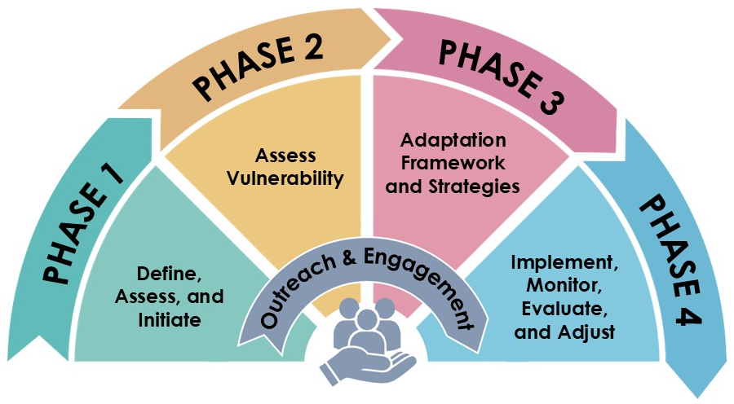

Community outreach and engagement should occur throughout all four phases (see Figure 2). While each phase includes a dedicated section on outreach and engagement, additional guidance is available in Appendix A.
How to Use the Appendices
Three appendices support the work throughout this guide. There are references to them in each phase.
Appendix A. Outreach and Engagement: Each phase includes an Outreach & Engagement step that redirects to this section for implementation guidance. Use section tags to navigate engagement strategies relevant to the current phase.
Appendix B. Climate Data Tools: Provides detailed instructions for applying data and mapping tools by hazard type or across hazards. Appendix C. Worksheets: Contains all worksheets referenced throughout Phases 1 – 4, each labeled by phase and step. To support your planning process, green “Put it Into Practice” boxes in the main text indicate where a corresponding worksheet is available for a specific step. Print desired pages to fill out while reading the APG or complete them digitally.

Legal Requirements This Guide Supports
General Plan Safety Element SB 379 (Jackson, 2015) and California Government Code §65302(g)(4) require local jurisdictions to review and update their General Plans’ Safety Elements to address climate adaptation and resiliency strategies applicable to their jurisdiction. The updates are required upon the next update of their local hazard mitigation plan (LHMP) on or after January 1, 2017. Local jurisdictions without an LHMP must update their safety elements by January 1, 2022.
Updated Safety Elements or LHMPs must include:
- A vulnerability assessment identifying the risks that climate change poses to the local jurisdiction
- A set of adaptation and resilience goals, policies, and objectives based on the information identified in the vulnerability assessment for the protection of the community
- A set of feasible measures designed to carry out the goals, policies, and objectives
California Government Code §65302(g)(4) provides flexibility for how jurisdictions may meet climate adaptation and resilience requirements. Local jurisdictions may satisfy Safety Element requirements through an adopted LHMP, stand-alone climate adaptation plan, or a similar document. To qualify, the similar document must “fulfill commensurate goals and objectives,” and include required components (e.g., Vulnerability Assessment, goals/policies, and implementation measures).
As further amended by SB 1035 (Jackson, 2018), after January 1, 2022, the Safety Element must be reviewed and updated upon each revision of the Housing Element or LHMP, and no less than once every eight years. Updates must continue to address climate adaptation and resilience, identify new information related to resilience, and identify new information related to flood and fire hazards.
The statute identifies relevant resources to support compliance, including the Adaptation Planning Guide, which provides guidance on conducting vulnerability assessments and developing adaptation strategies.

Pathways to Action
Communities in California have a range of possibilities for taking action to adapt to climate change, and intended outcomes extend beyond a plan itself to include investment decisions, implementation programs, project screening, funding strategies, and monitoring.
In meeting requirements for General Plan Safety Elements, communities may take advantage of a planned update of their jurisdiction’s general plan or Local Hazard Mitigation Plans (LHMP). Local jurisdictions may also choose to develop a stand-alone climate action or adaptation plan to elevate the importance of the issue and reflect community values. Standalone plans can also support strategic implementation and provide guidance for implementation across other plans, programs, and policies, or to provide more in-depth analysis than required in the general plan or LHMP.
Communities may also determine that a single plan, implementation mechanism, or outcome is insufficient to meet their vision and goals and opt to integrate adaptation across multiple plans.
A challenge in developing climate adaptation strategies is addressing the broad and varied impacts across community systems, including public safety, services, equity, energy reliability, public health, economic vitality, ecosystem health, and water supply. Fortunately, many existing local and regional plans, such as general plan safety elements and LHMPs, already address some of these impacts. As a result, communities often have a solid foundation for identifying effective strategies. In many cases, developing climate adaptation policy involves integrating and strengthening existing policies through regular plan updates, rather than starting from scratch.
The APG focuses on plans as the primary outcome. It focuses on three main types of plans:
- Updates to the safety element and/or other elements of the general plan
- Development of a stand-alone climate action or adaptation plan
- Preparation of a Local or Tribal Hazard Mitigation Plan (LHMP/THMP)
Table 3 outlines the relationship between these three plans and statutory requirements, as well as potential opportunities for integration and alignment.

Each of these plans may operate on different timeframes. The crosswalk identifies different triggers and timing considerations. While some plans have shorter time frames, like hazard mitigation plans, it is important to remember that projects will most likely exceed the lifetime of the plan itself, and it is important to consider long-term climate risks to ensure that communities are making wise investments. For example, for a General Plan adopted in 2015 that expires in 2040, a subdivision permitted in 2026 may still be in place in 2075, long after the general plan expires and possibly even longer after the standards, codes, guidelines, and policies governing its construction were written.

Table 3. Crosswalk of required local, regional, and Tribal plans: LHMP, Safety Element, and Climate Action/Adaptation Plans (CAPs)
Plan | Lead | Required? | Legislative and Statutory References | Triggers and Timing | Alignment Opportunities/  Interrelationships
Local Hazard Mitigation Plan (LHMP): Identifies natural hazard risks and vulnerabilities, as well as long-term strategies to protect people, property, and the environment.  May be multi-jurisdictional (e.g., county-wide) and must include jurisdiction-specific content. | Local governments, including special districts, and Tribes. | Required for FEMA Hazard Mitigation Assistance eligibility. | 44 CFR § 201.6,  Local Mitigation Planning Policy Guide,  California Gov’t Code §65302(g)(4),  AB 2140 (Hancock, 2006) | Must be updated every 5 years (they are generally valid for 5 years. It must be updated and reapproved to maintain eligibility. | Can be used to meet the Safety Element climate adaptation requirements (among other requirements).  When the LHMP is incorporated into Safety Element, cities and counties are eligible for increased cost sharing for FEMA Public Assistance (PA) under the California Disaster Assistance Act (CDAA) per California Assembly Bill (AB) 2140. For more information, see the Cal OES AB2140 Fact Sheet.  Provides hazard data, risk assessments, and mitigation actions that can be integrated into CAPs/CAAPs.
Tribal Hazard Mitigation Plan (THMP): Identifies the natural hazards that affect Tribes, identify actions to reduce losses from those hazards, and establish a coordinated process to implement the plan. | Typically, Tribal emergency services, fire, or planning/ community development department. | Required as a condition of receiving non-emergency Stafford Act assistance and FEMA mitigation grants including:  Public Assistance C-G (PA C-G)  Fire Management Assistance Grants (FMAG), Hazard Mitigation Grant Program (HMGP), Pre-Disaster Mitigation (PDM), Flood Mitigation Assistance (FMA).  The plan must be approved by FEMA before the grant award is made. | 44 CFR § 201.7,  Tribal Mitigation Plan Review Guide | Must be updated every 5 years (they are generally valid for 5 years). It must be updated and reapproved to maintain eligibility. | Provides hazard data, risk assessments, and mitigation actions that can be integrated with CAPs.  May be integrated into a multi-jurisdictional hazard mitigation plan (MJHMP) as an annex.
General Plan Safety Element: Reduces risk of death, injury, property damage, and economic/social disruption from hazards including fire, flood, drought, earthquakes, landslides, climate change, and other hazards. Guides zoning, land use, and development decisions. Must identify hazards and hazard abatement strategies. | City or County planning department. | Required | California Gov’t Code §65302(g)(4),  California General Plan Guidelines,  SB 379 (Jackson, 2015),  SB 1035 (Jackson, 2018),  AB 2140 (Hancock, 2006) | Upon the next LHMP update after 1/1/2017, or by 1/1/2022 if no LHMP adopted (SB 379).  Upon the next General Plan’s Housing Element update + review and update upon future housing element updates (SB 1035).  Updated with general Plan cycle (varies by jurisdiction). | LHMP and/or CAPs can be used to meet Safety Element climate adaptation requirements.  Information on development trends, goals and policies, land use plans, and other ordinances that support risk reduction can be integrated into LHMP.  When the LHMP is incorporated into Safety Element, cities and counties are eligible for increased cost sharing for FEMA Public Assistance (PA) under the California Disaster Assistance Act (CDAA) (AB 2140). For more information, see the Cal OES AB2140 Fact Sheet.
Climate Action/Adaptation Plan (CAP or CAAP): Evaluates and prioritizes actions to prepare for and respond to climate impacts (e.g., sea level rise, extreme heat, wildfire, drought). | Varies.  Typically planning department, sustainability office, regional government or Tribe. | No | SB 379(Jackson, 2015),  SB 1035 (Jackson, 2018) | No fixed schedule. Often aligned with general plan or funding cycles (typically 3–5 years). | Can be used to meet the Safety Element climate adaptation requirements by integrating into the general plan.  Detailed climate projections; descriptions of climate risks; existing climate-related goals and actions can be integrated into LHMPs.

What Is Climate Adaptation Planning?
In this guide, climate adaptation planning is a structured process for identifying threats and hazards that could affect a community under current and future climate conditions. It helps communities understand the risks these hazards pose and take steps to avoid or minimize climate-related impacts.
In practice, adaptation means planning for future conditions rather than past trends, reducing vulnerability before disasters occur, and making long-term decisions that protect lives, livelihoods, and community systems.
Climate adaptation planning allows communities to identify risks unique to their geography, populations, and built environments and to prepare for these conditions before they occur.
This planning process can be conducted as a stand-alone effort or integrated across plans, programs, departments, and sectors to support an effective, coordinated approach.

How is Climate Adaptation Related to Natural Hazard Mitigation?
A common framework used in emergency management is the emergency management cycle, which consists of four interconnected phases:
- Hazard Mitigation: Any sustainable action that reduces or eliminates long-term risk to people, property, and the environment from future disasters. Mitigation planning breaks the cycle of disaster damage, reconstruction, and repeated damage. Hazard mitigation can be one component of climate change adaptation (FEMA, 2025).
- Preparedness: Planning to ensure that activities, programs, and resources are in place to support immediate disaster response and long-term recovery
- Response: Measures implemented during or immediately after a disaster to minimize harm to people, focusing on short-term needs such as food, water, shelter, and medical care
- Recovery: Actions that occur after a disaster to restore the community to a normal state, ideally improving resilience. Reconstruction activities may occur in this phase

Figure 3. The emergency management cycle
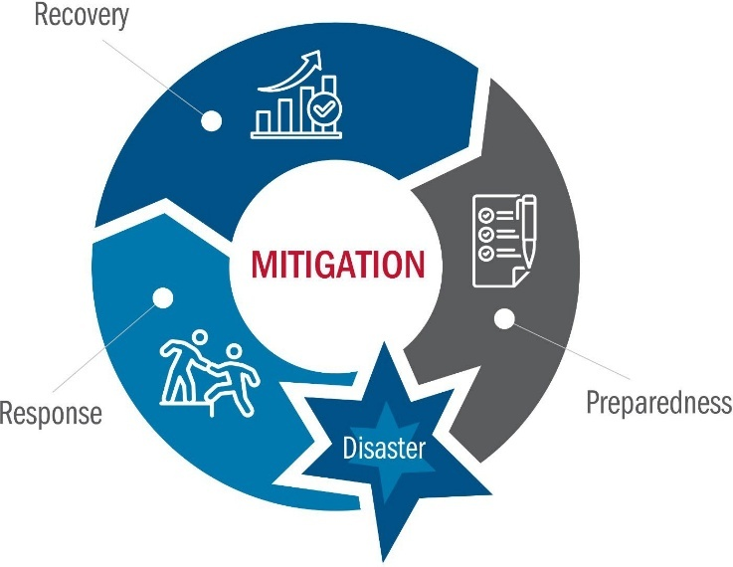
Source: Local Mitigation Planning Handbook (FEMA, 2025)
Various planning mechanisms support different phases of the emergency management cycle. Some examples include:
- Hazard Mitigation Plans primarily address the mitigation phase but may include some preparedness strategies
- Emergency Operations Plans guide response activities and sometimes address recovery
- Disaster Recovery Plans direct and coordinate recovery and reconstruction
Adaptation planning efforts can support all four phases of the emergency management cycle, depending on community needs and characteristics. For many communities, most strategies will focus on hazard mitigation. Adaptation planning and hazard mitigation planning share a common goal: reducing risk and increasing community resilience in the face of future hazards. Given their common goal, there are opportunities to integrate adaptation into hazard mitigation planning process or build on hazard mitigation for a stand-alone adaptation plan. While adaptation planners are not required to use the emergency management cycle as a framework, it can be a useful tool to consider the full range of strategies and topics that adaptation efforts can address.

Climate Change Mitigation and Adaptation
Addressing climate change requires a coordinated approach that includes climate mitigation and adaptation. These strategies are closely related but serve different purposes. Together, they support a comprehensive framework for reducing risk and building resilience.
- Climate change mitigation focuses on reducing greenhouse gas emissions to limit the severity of future climate impacts.
- Climate adaptation is an action or set of actions that reduces physical climate risk.
Figure 4 illustrates the relationship between these approaches. Communities should take advantage of strategies that support multiple goals. For example, homes that install solar panels and battery storage systems are better protected against climate-related disruptions to the electricity supply (an adaptation effort), but solar panels also generate electricity without any greenhouse gases (GHG) and allow homes to use less energy from GHG-emitting power plants (a climate change mitigation effort).
However, there is potential for conflict. Consider a program to install air conditioning systems in homes. While this will help protect residents against extreme heat (an adaptation effort), these systems will require more energy to run and could increase GHG emissions if the energy source is not carbon-free (working against climate change mitigation efforts).

Figure 4. Roles of GHG emissions reduction and climate adaptation in combating the sources and effects of climate change
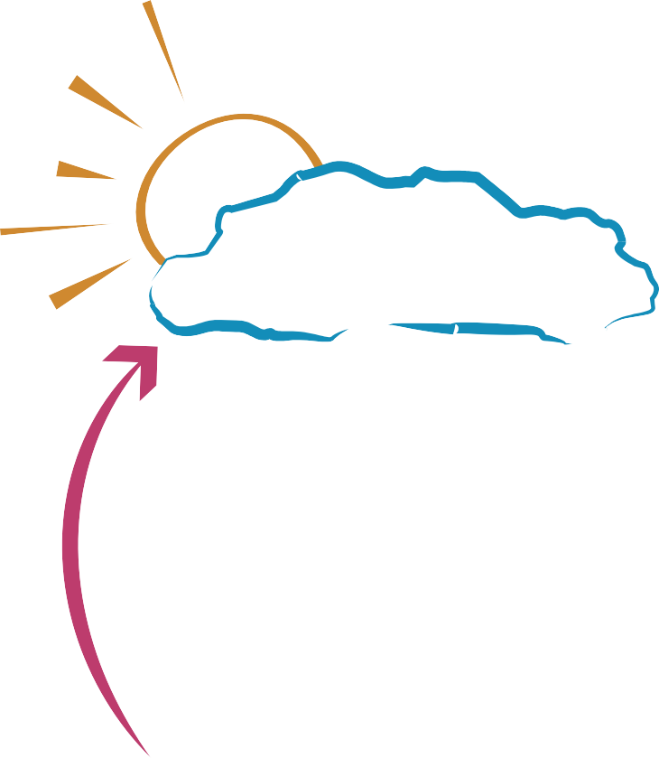


Climate adaptation is an action or set of actions that reduces physical climate risk.

Human activities, including energy use, land use changes, and industry, release GHGs that trap heat and contribute to global warming and climate change.
.
Climate change increases the frequency and severity of impacts such as extreme heat, drought, flooding, wildfire, changing precipitation patterns, and sea level rise.
Climate change mitigation focuses on reducing greenhouse gas emissions to limit the severity of future climate impacts.

State law requires communities to address GHG emissions (and climate change mitigation) in local planning and environmental review processes and climate adaptation in local long-range planning processes, such as general plans (or acceptable alternative). These requirements are established through SB 97 (Dutton, 2007), which directs consideration of greenhouse gas emissions in environmental review under the California Environmental Quality Act (CEQA), and SB 379 (Jackson, 2015), which requires cities and counties to address climate adaptation and resiliency through their general plan safety elements or an acceptable alternative.

Climate adaptation and mitigation planning should consider the needs of populations that may experience disproportionate impacts from climate-related hazards. Factors such as age, disability, language, income, housing, health, and other social or economic conditions can increase vulnerability to these events.
Communities should evaluate their specific needs and priorities when deciding how best to balance these strategies. Communities can prepare one stand-alone plan to address GHG reduction and climate adaptation, prepare separate stand-alone plans for each topic, or integrate the topics into other plans and planning processes.
While there are numerous synergies between climate adaptation and GHG reduction, there are also instances where there may be trade-offs. These trade-offs should be considered and balanced in the context of a broader planning framework that addresses community goals and needs. It is essential to reduce emissions and plan for impacts simultaneously because efforts to adapt will be overwhelmed by the harm done by climate change if emissions are not reduced.
Climate Change Mitigation, Adaptation, and Hazard Mitigation are all crucial resiliency measures that work together to minimize the impacts of hazards expected to become more frequent due to climate change. These approaches reinforce one another and are collectively necessary for a comprehensive climate resilience strategy. Local entities are encouraged to engage in all of these efforts.
An integrated approach to climate change involves adapting to future climate conditions and reducing GHG emissions. Climate adaptation activities can have several benefits, such as increased public health and safety, greater economic stability, reduced healthcare and infrastructure costs, increased housing resilience, improved air and water quality, and better stormwater management. Climate adaptation strategies can also lead to cost savings (California SHMP, 2023).

How is Equity Integrated into Climate Adaptation
Communities across California are increasingly prioritizing resilience as climate impacts become more frequent and severe. However, climate change does not affect all communities equally. Low-income Black, Brown, Indigenous, and other historically marginalized communities often face greater exposure to climate hazards while having fewer resources and opportunities to adapt. Historic disinvestment, inequitable land-use decisions, and other structural barriers have constrained adaptive capacity and increased vulnerability to climate-related risks. Resilience and adaptation efforts must be rooted in equitable processes and focus on delivering equitable outcomes for those most vulnerable to climate-driven hazards and impacts.
Climate adaptation planning provides a critical opportunity to address both historic and ongoing inequities while investing in climate mitigation, adaptation, and improved outcomes for underserved communities. Without intentional integration of equity, these plans risk worsening the very disparities they aim to address.
In this guide, equity means that all people are fairly included in society and that everyone is able to participate, prosper, and achieve their full potential. It recognizes that individuals and communities experience different advantages and challenges, and that planning processes must account for these differences to ensure fair outcomes (Adaptation Planning Guide, 2020)
Building equity into climate resilience planning and implementation means addressing and eliminating the disproportionate impacts affecting frontline communities and working to dismantle barriers that have prevented these communities from thriving. The goal is not only to help communities recover from climate-related hazards, but to create conditions where all communities can thrive before and after disasters. This is an opportunity to improve long-term community well-being and support more resilient communities for future generations.
This guide embeds equity throughout the planning process. In practice, this means:
- Procedural equity: Empowering vulnerable communities to influence planning and investment decisions (California Climate Adaptation Strategy, 2024).
- Distributional equity: Prioritizing vulnerable communities and individuals in adaptation actions to address past underinvestment (California Climate Adaptation Strategy, 2024).
- Structural equity: Implementing policies and programs that address historic underinvestment in communities (Georgetown Climate Center, 2020).
Procedural, distributional, and structural equity, reflect a commitment to ensuring that communities have a voice in decision-making and that adaptation planning and implementation are carried out through inclusive and representative engagement processes.
The APG provides tools and guidance for equitable climate adaptation across all four phases of the planning process, with each phase supporting a different part of planning and implementation.
Phase 1: Define, Assess, and Initiate
Phase 1 focuses on building inclusive and equitable engagement from the start. It provides tools, worksheets, and California case studies that help communities design participatory planning processes grounded in local knowledge and equitable decision making. Recognizing and building upon existing community strengths creates an asset-based approach, which uses knowledge, relationship and cultural practices that communities already possess.
Phase 2: Assess Vulnerability
Phase 2 focuses on understanding local climate hazards and conditions. It offers data, mapping, and screening tools that combine exposure with social, economic, environmental, and demographic information. These tools help identify communities most in need of support and prioritize adaptation actions. Qualitative input from workshops, surveys, and interviews should be used to support and provide context to these quantitative tools.
Phase 3: Define Adaptation Framework and Strategies
Phase 3 focuses on identifying, developing, and prioritizing equitable adaptation strategies and interventions.
Phase 4: Implement, Monitor, Evaluate, and Adjust
Phase 4 focuses on putting strategies into action. It includes financing and implementing tools with equity in mind and monitoring tools to track progress and maintain ongoing public engagement.
The APG recommends incorporating equity throughout the planning process from start to finish. Equitable climate adaptation planning presents the opportunity to holistically address both the cumulative burden of climate change and systemic socioeconomic disparities.

What is Plan Alignment?
Plan alignment is the process of leveraging connections, information, and resources to build shared language, data foundations, and processes across multiple planning efforts at any scale. Plan alignment presents an opportunity for a jurisdiction to create a single vision for itself through multiple aligned planning efforts. At its core, plan alignment is based on collaboration.
The results of plan alignment include a suite of plans with different scopes and purposes sharing common data, similar underlying assumptions, aligned visions, and complementary goals, strategies, and actions. It also creates a shared understanding, process, and structure that allows multiple entities within a community or region to continue collaborating and aligning efforts over the long term. For example, a county developing a Hazard Mitigation Plan may be able to use shared information and vulnerability data from its Community Wildfire Protection Plan (CWPP) to identify wildfire risks and coordinate investments. Aligning these plans can help prioritize actions, such as fuel reduction projects, emergency preparedness efforts, and infrastructure improvements in areas with the greatest need.
Other benefits include reduced duplication of effort, lower potential for policy conflicts, streamlined public outreach, and increased eligibility for implementation funding (ICARP). Aligning plans can also demonstrate grant competitiveness by demonstrating need, co-benefits, readiness, partnerships, and consistency with state priorities. Ultimately, plan alignment often helps different departments within the same jurisdiction coordinate efforts and programs at every phase of the planning process. Climate adaptation planning does not occur in isolation. It is closely linked with and can be advanced through existing local and regional planning efforts that may include:
- Local Coastal Programs (LCPs): Local governments in the coastal zone must prepare policies and standards for development in the coastal zone consistent with the Coastal Act and certified by the Coastal Commission. Local coastal programs contain the ground rules for future development and protection of coastal resources. Climate change issues, particularly sea-level rise and associated effects, should be addressed in the LCP for both the short and long term.
- Subregional Shoreline Adaptation Plans: Under SB 272 (Laird, 2023), local governments within the jurisdictions of the California Coastal Commission and the San Francisco Bay Conservation and Development Commission (BCDC) must meet additional sea level rise adaptation planning requirements by following their respective agency guidelines. For jurisdictions within BCDC, this includes preparing subregional shoreline adaptation plans consistent with the Regional Shoreline Adaptation Plan (RSAP) Guidelines. These plans provide an important framework for coordinating shoreline adaptation efforts and should be considered for alignment with local climate adaptation planning processes.
- Integrated Regional Water Management Plans (IRWMPs): IRWM groups (48 in the state) are collaborative efforts to address regional water resources. The regional approach supports local jurisdictions by providing coordination and information. The associated grant funding for these programs supports adaptation strategy development and implementation.
- Emergency Operations Plans (EOPs): Climate analyses could affect the scope of wildfire, flood, and extreme heat events. EOPs should consider how increased frequency and intensity of climate change hazards will affect emergency response and evacuations.
- Tribal Community Plans: Tribal plans, both sector specific and comprehensive, are appropriate plans for goals, objectives, and policies related to climate change adaptation and environmental justice. These plans ensure effective and efficient program administration and service delivery to communities and citizens.
- Community Health Assessments (CHAs) and Community Health Improvement Plans (CHIPs): Strategies addressing impacts on human health, public health systems, and medical services can be integrated into a CHIP, which is required as part of accreditation for local health departments.
- Historic or Cultural Preservation Plans: Strategies aimed at mitigating the vulnerabilities of historic and cultural resources of all communities can be included in the goals and objectives of preservation plans.
- Extreme Heat Action Plans: Strategic frameworks that guide local or regional jurisdictions in addressing the impacts of extreme heat on vulnerable populations and public infrastructure. These plans incorporate community engagement, public awareness, nature-based solutions, and a coordinated-whole-of-government approach to build resilience.
- Community Wildfire Protection Plans (CWPP): Strategic plans aimed at helping communities identify and reduce risks posed by wildfires.
How climate adaptation is integrated into other community planning processes varies by the needs of the community and how local adaptation and resilience fit within those needs. The APG’s guidance includes considerations for a variety of plans and, where applicable, the integration of climate adaptation into multiple plans and programs. Regardless of the choice of vehicle, the ultimate goal should be to integrate climate adaptation and resilience into all public entity and policy-making processes. Achieving this often means incorporating climate adaptation into the tools used to implement plans. This can include:
- Capital Improvement Plan/Program (CIP): For adaptation strategies that require capital expenditures (relocating a wastewater treatment plant, building a cooling center, etc.), the community CIP is an appropriate place to address priorities, funding, and scheduling of adaptation strategies. Examples of CIPs include flood infrastructure, conveyance, pump stations, stormwater systems, recharge basins, groundwater wells, telemetry, and evacuation routes.
- Zoning code and other land development codes, ordinances, and resolutions: Adjust zoning and land use regulations to reduce climate risks. This may include restricting development in flood-prone areas, promoting green infrastructure, supporting mixed-use development to reduce heat islands, or requiring setbacks and buffers to protect sensitive habitats. Zoning and land use tools can also help preserve floodplains, recharge areas, riparian corridors, and multi-benefit open space for long-term resilience.
- Administrative policy, procedures, and initiatives: These involve updating internal guidance, design standards, or maintenance practices to reflect future climate risk.

Additional Resources
To support communities across California in adapting to climate change, LCI’s Integrated Climate Adaptation and Resiliency Program (ICARP) launched the Climate Resilience Plan Alignment Toolkit in 2022. This toolkit is designed to support local and regional climate resilience planning efforts by promoting alignment across multiple planning frameworks and documents, rather than focusing on a single system or methodology.
Additional resources include tools and guidance available through ResilientCA, such as the Coastal Resilience Compass Plan Alignment Guide, Flood After Fire Resilience Plan Alignment Guide, and Wildfire Resilience Plan Alignment Guide. Users can also explore case studies and success stories of plan alignment in communities and regions across California.

Water Planning Resources
Adaptation planning can often build on existing water planning efforts. Depending on the region, planners may want to coordinate with Watershed Resilience Programs (WRPs), Sustainable Groundwater Management Plans, Regional Flood Management Plans, Agricultural Water Management Plans, Urban Water Management Plans, and county drought plans.

Watershed Resilience Program: The WRP builds on the Integrated Regional Water Management (IRWM) Program by supporting climate vulnerability assessments, adaptation planning, watershed-scale collaboration, and equitable community engagement. It also encourages coordination across water supply, groundwater, flood management, ecosystems, wildfire, and land use planning.

How is California Vulnerable to Climate Change?
Climate change is already impacting California and will continue to affect it for the foreseeable future. Current and projected climate impacts include increased temperatures, sea level rise, reduced winter snowpack, altered precipitation patterns, more severe wildfires, and more frequent storm events. According to the California Fifth Climate Change Assessment:
- California has warmed faster than the global average. The greatest warming has occurred in the foothills of the Sierra Nevada and east of Los Angeles, with slower, but still significant, increases along the coast.
- Through 2100, projections suggest a continued upward trend in heat, with mean temperatures ranging from 7.1° F to 11.6° F above the 1951-1980 mean.
- Climate data predicts that the average number of heat wave days is expected to increase to an average of five days by mid-century and over ten days by the end of the century.
- Research shows that the Sierra Nevada could lose a median of 45% of its snowpack by mid-century and up to 70% by the end of the century, compared to historical levels.
- California sea levels will likely rise on average 0.8 feet by 2050 and 3.1 feet by 2100, relative to a 2000 baseline.
Climate change brings intensifying risks to the state, as well as emerging and less predictable threats. These include cascading impacts that can compound disruptions and strain local resources. As a result, relying on past events to plan for future conditions is increasingly insufficient. This shifting hazard landscape requires planning entities and local governments to take new approaches to risk assessment and to strengthen community resilience.
- Local governments can look to California's Fifth Climate Change Assessment for the latest climate change projections and modeling for the state’s future climate. The Fifth Assessment includes original research that fills gaps in the state’s understanding of climate impacts as well as regional and topical reports uplifting community priorities throughout the state. With a focus on the needs of communities most vulnerable to climate change impacts, the Fifth Assessment is intended to support on-the-ground implementation and decision-making at local, regional, Tribal, and state levels.

PHASE 1: DEFINE, ASSESS, AND INITIATE
All adaptation planning begins with scoping.
Phase 1 establishes the purpose of the planning effort, the intended outcomes, who should be involved, and how the process will be resourced and managed.
Getting this foundation right helps prevent costly rework and ensures the plan reflects real community needs. It also supports alignment with existing and future planning efforts. Without a clear foundation, the process may fall short in addressing community priorities and effectively preparing for climate impacts.
It should follow central planning principles by being transparent, inclusive, and grounded in the best available science. The process should:
- Promote meaningful community and partner engagement
- Advance the health, safety, and welfare of all people
- Address existing and future inequities
- Remain consistent with applicable laws and adopted plans
Phase 1 has three steps (see Figure 5). The steps in this phase are numbered, although they do not always need to be completed in order. For example, conducting equitable outreach and engagement for residents and community partners (Step 1.3) can occur much earlier in the process to involve interested community members from the very beginning of the planning process. In some instances, it may be helpful to work on multiple steps at the same time.

Figure 5. Steps in Phase 1

How to Use the Appendices in This Phase
Appendix A: Outreach and Engagement: This phase relies heavily on outreach and engagement strategies and guidance. Refer to Appendix A throughout Phase 1 for detailed guidance on engagement methods and best practices.
Appendix C: Worksheets: One worksheet, Partner Mapping, supports this phase and is used in Step 1.3A. Look for the green Put It into Practice boxes to see when and how to use it.

Step 1.1: Identify the Purpose and Scope of the Adaptation Plan
Goal: Establish a clear understanding of why the adaptation planning effort is being undertaken, what it will produce, and the geographic area it will address.

Step 1.1A: What Plan or Project Will This Process Produce
The first step in adaptation planning is defining the purpose, intended outcomes, and scope of the effort. This includes identifying how the plan will be developed, adopted, implemented, and integrated into existing planning processes.
Adaptation planning can be advanced through several types of planning mechanisms, including comprehensive plans, focused plans, and implementation programs (see Figure 6).
- Comprehensive plans such as General Plans address a broad range of mandated and optional elements. Climate change affects many of these elements, creating opportunities to advance adaptation throughout the plan (see Figure 6).
- Focused plans such as Climate Adaptation/Action Plan (CAP/CAAP), Hazard Mitigation Plan (HMP), and other topic-specific plans (e.g., extreme heat, wildfire) provide more in-depth, targeted assessment.
- Implementation programs such as Capital Improvement Plans (CIP), carry out specific actions on an ongoing basis (see Figure 6 for examples).
The adaptation planning process outlined in Phases 1 through 4 of the APG may result in one or more of these plan types but focuses primarily on comprehensive and focused plans.
Coastal Hazard Resilience Planning in California: Crosswalks
Resilience planning in the Coastal Compass highlights the integration of various local planning initiatives discussed in this APG for coastal communities, while also offering guidance that can be useful for inland communities. The guide includes “crosswalks” to help planners identify when local hazard mitigation plans, adaptation plans, general plans, and local coastal programs can complement and support each other.

Figure 6. Types of plans and programs
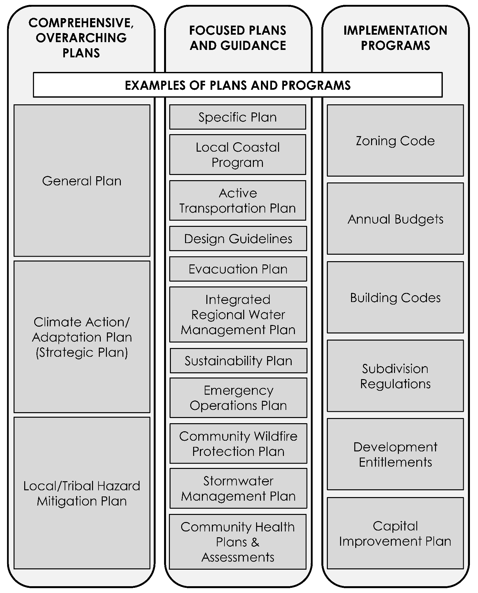

Under California Government Code §65302(g)(4), the State’s requirements may be met through any plan or document that contains the required information. However, in practice, the general plan, climate action/adaptation plan, or hazard mitigation plans are the most common mechanisms for seamlessly integrating climate adaptation strategies and considerations. The Introduction of this guide provides more information about these local planning efforts.

Step 1.1B: What Does Adaptation and Resilience Mean to the Community?
The goal of adaptation planning is to improve community resilience in the face of a changing climate. This step can also prompt communities to consider what level of risk (e.g., flood, water shortage) they are willing to accept. A resilient community is one that is prepared for current and future hazard conditions and experiences less harm than they would have when disasters happen. Resilient communities can also recover more quickly and thoroughly. They rebuild in a way that accounts for evolving climate conditions rather than rebuilding the same way as before. All adaptation planning processes should be responsive to new data, emerging science, and evolving community needs. Ongoing monitoring and evaluation allow strategies to be adjusted over time and are critical to building resilience.
Resilience describes a state of readiness to face climate risks, while adaptation refers to actions that reduce physical climate risk. Together, these concepts guide local and statewide efforts to prepare for current and future climate impacts (California Climate Adaptation Strategy, 2024).
- Resilience is not specific to any single hazard type and should ideally address multiple hazards at the same time, such as wildfires, droughts, floods, winter storms, and more. Resilience should include actions that address both immediate, pressing needs and decisions that protect long-term investments.
- As communities recover from recent disasters and face future risks, resilience must focus not only on surviving disasters but on revitalizing communities and the natural environment and diversifying regional economies to resist and adapt to external shocks.

Developing a Community-Wide Vision for Adaptation and Resilience
Resilience looks different across different communities and regions in the state. A community in the Sacramento Delta faces different threats and has different priorities than a community in the Inland Empire or North Coast. Before beginning the technical steps, ground the process in the community's specific cultural, ecological, and climate contexts:
- What do community members most value and want to protect?
- What climate hazards do residents already experience? What strengths already exist?
- What does recovery look like after a disaster occurs? Who recovers quickly and who does not?
A vision statement captures what community members most value about their community and what they want their community to become.
When drafting a vision statement, it is helpful to envision what the community will look like in the future (e.g., in 10, 20, or 50 years or more). How will the community function, what it will be known for, who will be served by the community and its services, what it will look like, what resources will be needed, and more.
Effective community vision statements typically address some combination of equity and community well-being; environmental sustainability; economic and social resilience; and long-term targets with clear timeframes:
- Equity and community well-being: making sure all residents benefit and vulnerabilities are addressed.
- Environmental sustainability: reducing emissions, protecting natural resources, and managing water and ecosystem resilience.
- Economic and social resilience: strengthening local economies and infrastructure to withstand climate impacts.
- Long-term resilience goals: clear timelines and ambitious targets (e.g., carbon neutrality by mid-century).
Vision statements work best when they are developed with broad community input, not written in a planning office. Visioning is often the first activity of a community engagement process. The process can include a variety of activities to engage partners. The outreach step in this phase (Step 1.3) is designed to support this.
Desert Planning Resource
For communities in the inland desert region, resources such as the Desert Climate Resilience Initiative’s Indigenous Resilience Interview Archive can provide additional insight into community-identified climate priorities, lived experiences, and resilience perspectives from Indigenous communities.
Ultimately, ideas and recommendations should be compiled into a single draft vision that is vetted through the adaptation planning process. The vision should be informed by both quantitative information and qualitative insights, this recognizes that community stories, lived experiences, and local knowledge is as important as data information.
Goals describe the desired outcomes from the adaptation planning process and are grounded in the community’s vision for resilience. Goals should reflect community needs, priorities, and values of the public and of the partners involved in the planning effort. Establishing goals early creates a common foundation for the planning effort and keeps participants on track throughout the planning process. Later in the process, after preparing the vulnerability assessment, participants prepare more specific goals as a framework for the adaptation policies. Phase 3 of the APG provides additional guidance for drafting goals.

Example Vision Statements with Broad Goals
Below are two case study examples of vision statements that articulate broad, ambitious goals informed by community input, and outline how local jurisdictions plan to implement them.
Case Study: Vision Statement from San Fernando’s 2026 CARP
In 2026, the City of San Fernando released its first Climate Action and Resilience Plan (CARP), through funding from LCI’s Adaptation Planning Grant Program. Below, the city’s vision statement clearly articulates the CARP’s goals and lays the groundwork for building community-wide resilience.
San Fernando’s vision is to create a safe, healthy, and climate-resilient city where all residents, regardless of income, age, language, or housing status, can thrive. This is guided by the City’s five Equity Guardrails, developed with the Community Advisory Group:
- Fair and Inclusive Access to Resources and Opportunities
- Sustainable City Revenue and a Vibrant Downtown
- Cultural Resilience in Community Sustainability
- Neighborhood Investment that Safeguards Housing Stability
- Safe, Healthy, and Connected Communities
The CARP envisions homes that stay safe during extreme heat, shaded walking and biking routes across the city, clean and reliable energy, abundant urban trees, resilient water systems, and neighborhoods equipped with the tools and resources needed to withstand future climate stresses. San Fernando will lead with integrity, transparency, and community partnership—advancing practical, achievable strategies while promoting equity at every stage of implementation.

Case Study: Resilience Vision From San Francisco
San Francisco’s 2025 Hazards and Climate Resilience Plan (HCR) was created to make the jurisdiction resilient to immediate and long-term threats of climate change and natural hazards through actions to mitigate risks, adapt built and natural assets, and build a more equitable and sustainable city. This includes ensuring systems are in place so that individuals, communities, institutions and businesses survive, adapt, and thrive no matter the kinds of chronic stresses and acute shocks they experience. The HCR also coordinates with and supports San Francisco’s Climate Action Plan 2026, which outlines urgent strategies needed to achieve net-zero greenhouse gas emissions by 2040 and minimize the severity of climate change and its associated impacts.

Step 1.1C: Define the Planning Area
The participating entities usually define the geographic area of the plan or project. For example, a city conducting an adaptation planning process will focus on building resiliency within its city limits or within the areas it serves or influences. Similarly, a county’s efforts usually support adaptation planning in unincorporated areas within its boundaries. Regional governments may also conduct adaptation work for all jurisdictions in their area, and multiple jurisdictions may collaborate on regional adaptation work, creating a geographic area that spans multiple jurisdictions. Tribes may identify planning areas that consist of land and waters where they manage, plan, or make policy decisions.
It can be helpful to develop a map of the planning area. Cities and counties may develop a map of their jurisdictional boundaries using Geographic Information System (GIS) software. California provides spatial data of jurisdictional boundaries through the California State Geoportal. Tribes may use Tribal lands data (reservation, trust land, traditional hunting and fishing areas, Treaty defined areas, etc.) or traditional territories (ITEP Tribal Climate Change Adaptation Plan Template; Climate Action Resilience Plan Framework from the Northern California Tribal Climate Collaborative (NCTCC). The Climate Action Resilience Plan Framework from NCTCC suggests visiting the NCTCC Climate Resource Library for key mapping layers and the NCA Interactive Atlas for mapping resources.
In some cases, planning for a natural resource, ecosystem, or bioregion — a watershed, for example — may need to cover a broad area that does not follow political boundaries. Even if the planning effort is limited to a specific area with defined boundaries (such as a state park), natural areas outside of these boundaries may need to be included to the extent possible to help ensure resilience. Additionally, non-jurisdictional planning geographies, such as watersheds are also relevant for water and flood related resilience planning.
Specific areas within a community, such as neighborhoods or defined frontline communities, may also be the focus of an adaptation planning effort.
Many coastal cities and counties (along the open coast and in the San Francisco Bay Area) have land use and natural resource management authority over sovereign state tidelands and submerged lands granted to them by the State Legislature. These lands can and should be included in planning efforts that address coastal lands and resources, such as Local Coastal Programs (LCPs), some Local Hazard Mitigation Plans (LHMPs), and the Safety Element of General Plans for coastal jurisdictions. Local governments can learn more about sovereign state tideland and submerged land grants here: Granted Public Trust Lands.

Case Studies: Planning Areas for Hazard Mitigation Plans (HMPs)
Multi-Jurisdictional Hazard Mitigation Plans (MJHMPs) allow multiple jurisdictions to collaboratively assess hazard risks and develop shared strategies to reduce risk, often by pooling resources and coordinating planning efforts. While MJHMPs are frequently led by counties, they may also be organized around natural features such as watersheds or include special districts, including fire, school, or utility districts. Examples of MJHMP configurations include:
- Scotts Valley Band of Pomo Indians Multi-Tribal Hazard Mitigation Plan was the first Multi-Tribal HMP in the United States to receive FEMA approval, which included five Tribes .
- Las Virgenes-Malibu Council of Governments MJHMP 2024 represents cities within a Joint Powers Authority.
- Imperial Irrigation District’s 2025 LHMP has a planning area spanning three counties, including Imperial County, parts of Riverside County, and portions of San Diego County.
- Tahoe Transportation District/Tahoe Resource Conservation District 2023 HMP was developed jointly by Tahoe Transportation District and Tahoe Resource Conservation District, covering a bi-state planning area in California and into Nevada.
- The 2025 LHMP Shasta-Tehama-Trinity Joint Community College District encompasses multiple community college campuses across three counties.
- The 2025 MJHMP for San Luis Obispo Office of Education comprises 10 school districts.

Step 1.2: Assemble the Planning Team and Resources
Goal: Establish the planning team, budget, timeline, and capacity needed to complete the adaptation plan.
Consider the available resources for the planning process, including financing, technical resources, knowledge, and time, and what can be accomplished with them. This helps set realistic expectations for the planning effort and identifies any critical gaps that need to be filled.

Step 1.2A: Assessing Capacity
It is important to begin this phase by determining if those conducting adaptation planning activities have the knowledge to work with technical resources and prepare a useful end-product. If not, look at expanding the participants to include members with the necessary expertise or consider training opportunities to fill in knowledge gaps. Relevant capacity areas to assess can include climate data literacy, community engagement, grant writing, and project delivery.
It can be helpful for communities to use a simple matrix to identify their capacity for adaptation planning. The Adaptation Capability Advancement Toolkit is one approach. It helps participants to assess their leadership and organizational culture, staffing and technical capability, partner engagement and partnerships, and operations and institutionalized processes. Capacity is measured on a four-point scale, from Initiation (the lowest level of capacity) to Optimization (the highest level). Matrices such as Adapt-CA can also help with goal setting for adaptation planning efforts. After communities identify their current capacity for adaptation planning, they can figure out their deficits and draft goals to help them approach or achieve optimal conditions.

Step 1.2B: Establishing a Budget to Fund the Adaptation Planning Process
When establishing a budget to support the development of a plan, it is essential to account for all APG phases. The budget should include labor costs to complete the work in addition to other costs, including equipment, meeting supplies, materials, production, transportation, training, facility rental, direct financial compensation to engagement participants, and food/beverages for meetings. If existing staff can do all the work, only minimal additional resources may be needed; however, additional expertise may be needed to conduct all or parts of the process. If existing staff lead a new adaptation planning process, it is important to ensure key staff have dedicated time in their workload to oversee the process. If a capacity assessment determines that existing staff resources are not available to lead an adaptation planning process, the budget may need to include hiring additional staff or external consultants, or developing partnerships with regional collaboratives, university partners, or other community-based or non-governmental organizations.
An inclusive and equitable adaptation planning process includes the participation of community members and partners, and the budget should encompass the financial needs of a robust outreach and engagement process that values community-based contributions. This could include providing direct financial compensation to community advisory group members, and other engagement participants via stipends or vouchers.
After estimating the budget, determine if existing general funds or other dedicated internal funds are available. If neither is available, identify options for external funding sources, such as grants, public-private partnerships, or philanthropic funding. Communities may also be able to receive low-cost or free assistance from experts working pro-bono or from a local university.

Step 1.2C: Assembling the Planning Team
One of the first tasks in the planning process is to identify and recruit the individuals and departments that will serve on the planning team. The planning team is the driving force behind the plan and is responsible for guiding its development from start to finish. It holds primary responsibility and decision-making authority throughout every stage of the process. The planning team provides institutional and technical knowledge and often supports partner outreach and engagement. To ensure a well-rounded planning process, the team should include individuals from a variety of agencies and organizations that bring together diverse skills and experience. If resources allow, the planning team may also be supported by an advisory group that includes representatives of partner agencies and community organizations that provide subject matter expertise and credibility to the process. If a consultant team is hired to support the process, it should be involved in the planning team as well.

Select a Planning Team Leader
The planning team should have a designated leader who is responsible for coordinating the planning process, engaging partners, facilitating meetings, overseeing public outreach, and keeping the project on schedule. The team leader should be empowered to make recommendations and/or have direct access to decision-makers. When selecting a team leader, consider who has the time, capacity, and organizational support to remain engaged throughout the entire planning process.

Identify Planning Team Members
A planning team often includes individuals from departments under the same organization. For example, if a city planning department leads the adaptation planning effort, consider including individuals from public works, parks and recreation, police, public health, and building departments as part of the planning team. If special districts within the project boundaries play important roles, such as a fire protection, school, or water district, consider including a representative from these districts on the planning team. Coordination across departments, particularly for larger jurisdictions, should occur when assessing vulnerabilities and developing, vetting, and prioritizing adaptation strategies. Such coordination will not only result in a more meaningful and comprehensive adaptation plan but can also help build staff capacity and buy-in for adaptation initiatives.
When feasible, planning teams are encouraged to include representatives from health care organizations, universities, community-based organizations, Tribes, nonprofit organizations, community-based organizations and other entities that serve vulnerable populations. Community-based organizations are often trusted messengers and can ensure outreach is conducted and communicated in culturally and linguistically appropriate ways, while also continuing to build trust with community members.
Keep in mind that not everyone involved in the process will be part of the core planning team. A broader group may contribute in other ways, such as participating in general or targeted community and partner engagement efforts, such as public meetings, or serving on advisory committees or focus groups. Outreach and engagement are discussed in Step 1.3 of this phase.
Questions to consider when identifying planning team members:
- Does this individual bring important information or skills, especially a person identified as a useful technical or knowledge resource?
- Does this individual represent a population group that will be included in the vulnerability assessment or an agency with some responsibility or control over any critical assets?
- Can this individual be involved over the length of the planning process?
- Is the individual empowered to make decisions in support of the process?
- Are community members, Tribes, and community-based organizations involved early enough to help shape planning priorities?

If possible, adaptation planning processes should not be conducted by a single person. Communities will benefit from adaptation plans that are developed by a diverse team of resilience experts that understand the community’s climate conditions and priorities.

When to Consider Hiring a Contractor
Many entities may lack the staff capacity, time or specialized expertise to complete plan development in-house. Contracting can help with tasks, particularly in technical areas such as vulnerability and risk assessments; it can also reduce administrative burdens and support technical analyses, coordination, facilitation, public engagement, GIS, and plan development.
- The level of contractor involvement should align with local capacity and project needs. Regardless of the role assigned, the lead entity should maintain oversight to ensure the process and final products reflect local priorities and community needs. A contractor's scope of work should also specify expectations for climate change data, scenarios, uncertainty treatment, QA/QC, and compatibility with state tools.
- Local governments are increasingly contracting directly with community-based organizations to lead equitable outreach and engagement; budgets for hiring a contractor should account for this option.
FEMA’s 2025 Local Mitigation Planning Handbook includes a Considering a Consultant to Support Local Mitigation Planning Starter Kit starting on page 154, which identifies tasks that may be delegated to contractors versus those that should remain the community’s responsibility. FEMA’s 2012 Choosing Contracting Help for Your Hazard Mitigation Plan provides additional guidance on selecting and working with contractors.
Policy Connection: Local Hazard Mitigation Plans
The Local Mitigation Planning Policy Guide requires plans to document opportunities for partner involvement in the planning process. This documentation must show how each of the following types of partners were presented with this opportunity:
- Local and regional agencies involved in hazard mitigation activities:
- Examples include public works, emergency management, local floodplain administration and GIS departments.
- Agencies that have the authority to regulate development:
- Examples include zoning, planning, community and economic development departments; building officials; planning commissions; or other elected officials.
- Neighboring communities:
- Examples include adjacent local governments, including special districts, such as those that are affected by similar hazard events or may share a mitigation action or project that crosses boundaries. Neighboring communities may be partners in hazard mitigation and response activities, or may be where critical assets, such as dams, are located.
- Representatives of businesses, academia, and other private organizations:
- Examples include private utilities or major employers that sustain community lifelines.
- Representatives of nonprofit organizations, including community-based organizations:
- Examples include housing, healthcare or social service agencies.

Community Advisory Groups
Community advisory groups are made up of local and regional partners with local knowledge about social, built, natural, economic, and cultural systems. Community advisory groups provide local expertise and can support outreach and engagement. Community advisory group members can be trusted messengers for the project and ensure that engagement includes a broad representation of interested community members in climate adaptation planning. Commonly, community advisory group members are provided with financial compensation for their participation.
Case Study: City of San Rafael Sea Level Rise Collaborative
The City of San Rafael developed a Sea Level Rise Planning Collaborative to plan and reduce flood risks in East San Rafael, one of the Bay Area’s most climate-vulnerable communities. The project brought together local agencies, community groups, and technical experts. Together, they assessed hazards and co-created an engagement process to explore adaptation strategies. The core partners included the University of California, Berkeley, the City of San Rafael, Canal Alliance, the Multicultural Center of Marin, and the County of Marin. These partners were supported by technical consultants who contributed engineering and planning expertise. Over time, new partners joined to contribute to events and research, including the Exploratorium, Canal Arts, Y-Plan, Greenbelt Alliance, and many others. This approach of network building and new partnership development was key to this project’s success. Formally, the project involved a Sea Level Rise Steering Committee of community experts and a Technical Advisory Committee of professional experts, which met regularly to review data, co-develop public materials, and ensure the project’s technical outputs reflected community priorities.

Step 1.3: Prepare an Equitable Outreach and Engagement Approach
Goal: Develop and implement an outreach and engagement plan that ensures an equitable, inclusive, and accessible process to inform the climate adaptation plan.
Inclusive, community-wide engagement is critical to creating effective, equitable and sustainable adaptation strategies. Engagement ensures that plans reflect local knowledge, priorities, and the diverse needs of community members.
This is particularly important in contexts where communities have historically been excluded from decision-making processes. For example, Tribes and disadvantaged communities have frequently been marginalized in public decisions throughout California’s history. Equitable public engagement is critical to building and strengthening relationships with communities, fostering trust, creating opportunities for open and inclusive dialogue, elevating community voices and lived experiences, and supporting shared decision-making power on actions that affect current and future generations.
Equitable engagement also means reducing barriers to participation. Outreach strategies should consider all the factors that may affect a person’s ability to participate; this could include language, disability, transportation or even childcare. Providing multiple opportunities and methods for engagement helps to integrate a broader range of community perspectives to the planning process.
Integrating community outreach and engagement throughout all phases of an adaptation plan can help foster trust between the core planning team and community partners to develop a plan that has collective support.

Outreach and Engagement Touchpoints
The APG recommends two touchpoints for partner engagement in Phase 2, one in Phase 3, and three in Phase 4:
Phase 2: Assess Vulnerability
- Step 2.2D: Outreach and Engagement
This step focuses on conducting interviews with community and programmatic or infrastructure experts to explore climate impacts that may not be captured in reports or data; how critical assets, services, and populations are affected by climate hazards; where vulnerabilities are most acute and why; and how future climate conditions may change the severity of impacts.
- Step 2.3C: Outreach and Engagement
Here engagement and outreach efforts focus on gathering feedback and insights to integrate into the assessment of climate vulnerability and adaptive capacity assessment developed in Phase 2. The goal of these engagements is to identify local knowledge of climate impacts, neighborhood strengths and assets, as well as community-defined priorities, concerns, and ideas for adaptation.
Phase 3: Adaptation Framework and Strategies
- Step 3.3D: Outreach and Engagement
This step focuses on conducting outreach and engagement to draft specific adaptation strategies in partnership with communities.
- Step 3.4B: Outreach to Develop Adaptation Strategies
This involves evaluating options based on costs, co-benefits, needs, equity, etc. to determine what should be pursued in implementation.
Phase 4: Implement, Monitor, Evaluate and Adjust
- Step 4.1C: Implementation Outreach
This step provides recommendations for including outreach and engagement during the implementation process and, in particular, at conclusion of preparing the plan and launching implementation.
- Step 4.2B: Monitoring and Evaluation
This step focuses on accountability and transparency, ensuring the planning team keeps the community informed throughout implementation. It includes tracking progress against milestones, identifying delays, and communicating key decision points.
- Step 4.3C: Adjustment and Outreach
This step focuses on ensuring outreach and engagement occurs throughout the implementation process, including informing the community of any changes or modifications to strategies identified in Phase 3.

Step 1.3A: Identify Partners
The engagement process should be inclusive and multidisciplinary. It should include people of varying levels of authority, including those empowered to make recommendations and decisions and representatives of governmental and non-governmental organizations. Partner mapping is the process of visualizing relationships and prioritizing engagement efforts through understanding perspectives and interests in the community. For each partner, the planning team should decide who should be involved; what their role will be in the process and the plan implementation; and how, when, and how often they should be engaged.
State law, as mandated by AB-52 and governors’ Executive Orders (Order B-10-11 & N-15-19), and SB 18 (Burton, 2004) requires local agencies to meaningfully consult with California Native American Tribes to aid in the protection of traditional Tribal cultural places through local planning processes. Beyond meeting this statutory requirement, early and meaningful Tribal consultation helps local jurisdictions better understand Tribal priorities, incorporate Indigenous knowledge and perspectives where appropriate, strengthen relationships with Tribes, and ultimately improve planning outcomes. Local agencies should follow the State of California Tribal Consultation Guidelines for any climate adaptation-related update to the General Plan or other planning documents as early as possible in the planning phase.
Best Practices for Tribal Consultation
CNRA's Tribal Consultation Policy and its accompanying Best Practices (Appendix 2) are useful references for local governments and other organizations engaging with Tribes. The appendix organizes consultation around three principles: early, often, and meaningful.
- Early means beginning “from the onset of a department action, when Tribal input may be effectively incorporated to inform department actions and decisions, and before any major or irreversible decisions have been made or finalized.”
- Often means building and maintaining relationships with Tribes on an ongoing basis, not only when consultation is required. Early and consistent communication helps establish trust and create opportunities for meaningful collaboration before decisions are made.
- Meaningful consultation requires that the department prioritize listening with the intent to fully hear, understand, respect, and consider Tribal feedback and comments. Accordingly, consultation must occur well in advance of any major decisions. Meaningful consultation should help prevent or mitigate potential conflicts by proactively addressing concerns and should actively seek to build trust between departments and Tribes. “Meaningful” should include a process of reciprocal communication and consideration but does not imply that both parties will reach consensus or agreement. However, a consensus-seeking approach should be pursued throughout the consultation process where feasible.
Additional practices from the Appendix worth adopting locally include:
- Provide outreach to Tribes using multiple mechanisms (e.g., email, phone calls, letters, etc.) and accommodate each Tribe’s preferred mode and location for meetings, including on-site visits where a Tribe is willing to host.
- Recognize that it is up to each Tribe to define its areas and resources of interest. Tribes and Tribal people possess “Traditional Knowledge” (sometimes referred to as “traditional ecological knowledge” or “Indigenous knowledge”). Each Tribe will have its own definition of Traditional Knowledge, but this expertise may generally be summarized as observations, practices, and beliefs unique to a particular group of people that are developed through millennia of interactions and experiences with a specific place or environment. Respect Traditional Knowledge and what Tribes share about how a project may affect their rights and resources. Avoid defining, interpreting, or characterizing these matters without direct input from the affected Tribes.
- Where funding allows, build resources into project budgets to compensate Tribes for their time and expertise, and incorporate this consideration into early budget forecasting rather than treating it as an afterthought.
- Maintaining the confidentiality of sensitive Tribal information must be a priority for all departments. To protect important cultural resources, Tribes often must share a certain amount of sensitive information about those resources (e.g., their locations). Be transparent with Tribes about the limitations the California Public Records Act places on an agency’s ability to maintain confidentiality. At the beginning of each consultation meeting, inform Tribes whether notes will be taken and offer to stop taking notes if they wish to discuss anything off the written record during the consultation.
- Recognize that Tribes and departments may have limited staff capacity, which can affect their ability to consult and build relationships. Tribes with limited staff and funding may not have the capacity to respond to every consultation invitation that interests or impacts them. Departments also have limited staff and resources. To address these capacity challenges, departments should make consultation periods as long as possible (the Appendix recommends up to 90 days per round) to provide Tribes with a more realistic opportunity to respond.
- Document relationships, past consultations, and commitments so that Tribal partnerships and lessons learned do not reset with each staff turnover.
Additional policy, resources, and best practices are available on the CNRA Tribal Consultation website.

Put It into Practice
See Appendix C – Partner Mapping
For each partner organization, record their interest in the plan, intended role, preferred engagement format, and frequency.
Partner Organization | Interest/ Connection to Plan | Role (Informant/ Reviewer/  Co-Developer) | Preferred Format | Frequency

Integrating Equity into Community Outreach and Engagement
The California Racial Equity Commission (REC) developed a Racial Equity Framework to support government entities to advance racial equity across the state. This framework provides resources and restorative practices to address harm, navigate healing, and strengthen relational trust across institutions, communities, and public systems. It emphasizes the importance of partnering with community-based organizations such as nonprofits, grassroots organizations, when engaging with communities, and describes mechanisms through which participation can be encouraged, like compensation. Collaborating with organizations that have established relationships with marginalized or underserved populations can significantly strengthen engagement efforts. When assembling the planning team for a climate adaptation plan, this approach should be reflected by intentionally including representatives from these trusted organizations to ensure community perspectives are embedded throughout the planning process.
The REC also highlights the Spectrum of Community Engagement to Ownership, a framework developed by Rosa Gonzalez of Facilitating Power. This tool supports local jurisdictions, community-based organizations, and community leaders in selecting engagement approaches that elevate community leadership and advance community-driven solutions. Engaging residents, businesses, students, and other community members is essential because they bring lived experience, local knowledge, cultural insight, and practical ideas that may not be visible to local governments. Those most affected by climate impacts are uniquely positioned to identify priorities, co-develop solutions, and help ensure strategies are both effective and equitable. Centering these voices not only strengthens the quality and relevance of planning outcomes, but also fosters trust, builds capacity, and creates a shared sense of ownership that supports long-term implementation success.
For further guidance on applying the Racial Equity Framework refer to Appendix A - The Spectrum of Community Engagement to Ownership.
Additionally, it is recommended that all core planning team members receive training in outreach and engagement practices prior to engaging partners. This may include topics such as cultural humility, structural, and systemic inequities. While these issues may not traditionally be addressed in the context of climate risk, understanding these dynamics is essential to conducting equitable engagement and working effectively with disproportionately vulnerable populations.

Outreach for Local and Tribal Hazard Mitigation Plans
Local Hazard Mitigation Plans (LHMPs) and Tribal Hazard Mitigation Plans (THMPs) must provide opportunities for public and partner participation throughout the planning process, including an opportunity to review and comment on the draft plan prior to formal adoption.
At minimum, the planning process must document how the public was given an opportunity to participate and how comments were considered and incorporated. For LHMPs, this includes outreach to community partners, neighboring jurisdictions, special districts, private sector partners, and representatives of community organizations. For THMPs, outreach should reflect Tribal governance structures and cultural protocols and include engagement with Tribal leadership, departments and programs, elders, youth, cultural resource representatives, and other community members, as appropriate.
For the most current LHMP and THMP requirements and detailed guidance on public outreach and participation, please refer to:
- Local Mitigation Planning Policy Guide
- Local Mitigation Planning Handbook
- Tribal Mitigation Plan Review Guide
- Tribal Mitigation Planning Handbook

Leveraging Public-Private Partnerships
Planning entities should consider leveraging public-private partnerships to support community adaptation planning efforts. Protecting a healthy local economy is a critical part of maintaining a community’s long-term resilience, and many businesses recognize the threat that climate change may pose to their activities and financial health. Businesses also can provide increased investments and other resources that may not always be available to local governments.
Opportunities for public-private partnerships include creating an economic working group or advisory body, establishing training and capacity-building opportunities such as resilience or continuity planning workshops, and setting adaptation standards for permitting new private developments. Utilities and private landowners are also important partners where they play an essential role in recharge, floodplain restoration, and infrastructure resilience. Communities can partner with local businesses as well as larger companies, and the State’s large Investor-Owned Utilities (IOU), including Pacific Gas and Electric Company, Southern California Edison, Southern California Gas Company, San Diego Gas & Electric Company. Under the California Public Utilities Commission’s (CPUC) guidance, IOUs conduct community engagement as part of their Climate Adaptation and Vulnerability Assessments (CAVAs), providing opportunities for local governments and Tribes to coordinate on shared climate risks, infrastructure needs, and adaptation strategies.
Case Study: Capital Regional Climate Readiness Collaborative
The Capital Regional Climate Readiness Collaborative is a membership network encompassing 6 counties in the Sacramento Area: El Dorado, Placer, Sacramento, Sutter, Yolo, and Yuba. It is exploring strategies to bring economic sectors such as agriculture, manufacturing, government, professional services, and technology into climate resilience planning efforts. Working with these businesses is essential to preserve economic vitality of the region in the face of water scarcity, heat waves, extreme weather, and other climate change hazards. The Capital Regional Climate Readiness Collaborative coordinates with local and regional businesses to plan and prepare for disasters, invest in climate-smart strategies, promote green jobs, and encourage diversity in supply chains to increase economic resilience.

Step 1.3B: Developing a Community Outreach and Engagement Plan
After the core planning team has been assembled and the partner mapping exercise is complete, a community outreach and engagement plan can be prepared. The plan can be simple, goal-oriented, and flexible to adapt over time. Ideally, as noted in the 2019 Regional Resilience Toolkit, an outreach and engagement plan should:
- Identify partners (partner mapping is one method).
- Determine culturally appropriate outreach needs and strategies.
- Align planning and outreach messages to community values, priorities, and lived experiences.
- Establish clear outreach goals for each partner organization and broader community.
- Define how best to engage individuals and groups, including specific objectives and roles.
- Identify the most effective engagement methods for each group, such as in-person meetings, digital communications, one-on-one conversations, or partnerships with trusted community-based organizations.
- Describe how outreach and engagement activities will be coordinated with other planning efforts.
- Assess the need for an advisory group, including its purpose, structure, and membership.
- Clarify the focus and intended outcomes of each event, or input opportunity.
- Provide a timeline or schedule outlining activities, objectives, and responsible parties.

Step 1.3C: Developing Engagement and Outreach Activities
Keeping partner mapping in mind is important for each outreach and engagement activity. Moreover, the core planning team should determine what they are trying to achieve and help set expectations for the public. For each engagement and outreach activity, ask the following questions:
- What is the goal of the engagement? The outreach and engagement touchpoints throughout the phases suggest activities for specific goals.
- How will input be used?
- What will come of it? Think beyond ‘updating a plan’ - articulate what this effort means to the community.
It is critical to ensure community members understand the nature of the process being undertaken and what will come of it. They need to understand how exactly their input will be recorded and used.
After considering the goals of an activity, local agencies and communities need to decide what level of engagement is appropriate. Core activities and characteristics necessary to build a robust public engagement process include:
- Providing educational opportunities so community members understand climate risks, data, and planning goals.
- Soliciting meaningful community input that influences analysis, priorities, and decisions.
- Maintaining a direct method of communication with the community specifically for the climate adaptation planning effort.
- Building trust in the engagement process includes a final step of responding to contributors and commenters on how their feedback was incorporated, combined with other feedback, or determined to be out of scope.
Outreach can include, but is not limited to, in-person and virtual meetings on specific topics or geographic areas, roundtables, listening sessions, forums, community festivals, workshops, or pop-up events.
Equity assessment for climate adaptation planning
Consider incorporating an equity assessment into your adaptation planning process to better understand how climate risks, adaptation benefits, and potential burdens are distributed across communities. An equity assessment can help identify disproportionately affected populations, inform equitable outreach and engagement, and ensure adaptation strategies advance resilience without exacerbating existing disparities.
The Regional Shoreline Adaptation Plan requires an Equity Assessment as part of its minimum standards and integrates equity throughout the planning process, including equitable outreach and engagement, existing conditions, vulnerability assessment, adaptation strategies, implementation, and project prioritization. Section 3.3.3 of the Minimum Standards provides a useful example that governments can adapt to their own planning efforts.

Case Study: Marin County Multi-Jurisdictional Hazard Mitigation Plan’s Equity and Whole Community Approach
During the development of Marin County Operational Area Multi-Jurisdictional Hazard Mitigation Plan 2023, the Marin County Office of Emergency Management (OEM) and the Steering Committee prioritized equity and engagement of the whole community. As a means to reach as many members of the community as possible, Marin County OEM required that services be universally designed and delivered from the beginning to allow for the greatest level of engagement and feedback possible. Elements of the equity approach included:
- The County provided multiple means for public engagement via hybrid meetings (in-person meetings with a virtual attendance and comment option).
- All presentations were accompanied by American Sign Language (ASL), Closed-Captioning, and Spanish Interpretation.
- Presentations were reviewed by accessibility professionals prior to broadcasting to ensure the documents were able to be read by screen-readers.
- All presentations were available online and recorded for people who may not have been able to attend the live presentations.

Case Study: City of Los Angeles Vulnerability Assessment
The City of Los Angeles’ Climate Vulnerability Assessment 2024 had a community engagement process in which the Community Partners Program played a key role in identifying needs and developing equitable climate adaptation strategies co-created with those most affected by climate impacts. The community partners include the Fernandeño Tataviam Band of Mission Indians, Pacoima Beautiful, Promesa Boyle Heights, Rising Communities, Strategic Concepts in Organizing and Policy Education, and Strength Based Community Change. These CBOs led outreach in their respective communities, leveraging local expertise and trusted relationships to engage vulnerable populations. Through this process, they gathered lived experiences from unhoused individuals, LGBTQIA+ residents, and outdoor farmworkers; reviewed climate data; identified gaps; and facilitated discussions to co-develop strategies grounded in community priorities.
It is helpful to think of outreach and engagement activities existing along a spectrum of participation, rather than as a single approach. The 2024 International Association for Public Participation (IAP2) Spectrum (Figure 7) is a widely used conceptual model that illustrates different levels of public participation, ranging from providing information to deferring decision-making authority to the public. It can help guide decisions on what level of engagement and participation is appropriate for the goals.

Figure 7. IAP2 Spectrum illustrating different levels of public participation
Increasing Impact on the Decision

 | Inform | Consult | Involve | Collaborate | Empower
Public Participation Goal | To provide the public with balanced and objective information to assist them in understanding the problem, alternatives, opportunities, and/or solutions. | To obtain public feedback on analysis, alternatives, and/or decisions. | To work directly with the public throughout the process to ensure that public concerns and aspirations are consistently understood and considered. | To partner with the public in each aspect of the decision, including the development of alternatives and the identification of the preferred solution. | To place final decision making in the hands of the public.
Promise to the Public | We will keep you informed. | We will keep you informed, listen to and acknowledge concerns and aspirations, and provide feedback on how public input influenced the decision. We will seek your feedback on drafts and proposals. | We will work with you to ensure that your concerns and aspirations are directly reflected in the alternatives developed and provide feedback on how public input influenced the decision. | We will work together with you to formulate solutions and incorporate your advice and recommendations into the decisions to the maximum extent possible. | We will implement what you decide.

Effective Strategies to Meet Communities Where They Are
Effective public engagement and outreach strategies will differ depending on the community, local culture, and geographic region. Strategies will also differ depending on the current and historic political climate and topic being addressed. To support a comprehensive climate adaptation planning process and foster long-term community resilience and trust, it is important to reach all members of the community.
Equity in adaptation planning requires actively removing barriers so that all community members can participate in, access, and benefit from the planning process. Equity challenges should be identified and addressed continuously, rather than treated as a one-time task. Above all, it is important to meet a community where it is at. Effective and equitable engagement requires intentional design. The following list includes best practices to ensure outreach efforts are accessible and inclusive.
Communication and Information Access
- Use clear, simple language and avoid technical jargon.
- Utilize trusted communication channels such as local radio, community newsletters, social media, and newspapers.
- Offer multilingual translation and interpretation for materials and meetings. These translations should reflect the languages most commonly spoken by the community the planning team is doing outreach in.
- Ensure meetings, materials and activities are accessible to people with disabilities by providing closed captioning, sign language interpretation, accessible documents, assistive listening devices, and above all, opportunities for individuals to request additional accommodation.

Practitioner resource — The Adaptation Roadmap
Centering People in Decision-Making
Effective adaptation planning is grounded in community values, lived experiences, and local knowledge. The Adaptation Roadmap provides practitioners with tools and guidance for designing collaborative and equitable planning processes, including strategies for meaningful engagement, effective communication, and incorporating diverse perspectives into adaptation decisions.
Learn more: Adaptation Roadmap: A Practitioner's Guide to Plan and Implement a Collaborative, Equitable, Integrative, and Flexible Approach to Sea Level Rise Adaptation
Partnerships and Community Trust
- Consider partnering with other local organizations to put on an event, including with local businesses, restaurants, and associations. Many agencies often contract engagement to community-based organizations that already have a strong presence in the community. Think about leveraging existing relationships in the community.
Meeting Format and Scheduling
- Offer meetings at varied times (daytime, evening, weekend) based on what would work best for the community. Again, try to meet community members where they are at. If people usually grocery shop in the evening after work, one option is to set up a booth outside the shop from 6-8 PM. Be aware of major employment patterns and how they affect availability. For example, in agricultural areas, Saturday meetings may not work during harvest season.
- Provide alternatives to in-person engagement when in-person gatherings are inaccessible or create barriers to engagement with vulnerable populations.
Location and Transportation Accessibility
- Host events in familiar, accessible locations (libraries, community centers, schools, churches, farmers’ markets).
- Ensure locations are accessible by multiple modes of transportation. Especially if car ownership is low, hold meetings within walking distance or on transit lines. When possible, arrange vans or provide travel stipends to support participation.
- When possible, build upon existing community events and gatherings instead of creating new opportunities for engagement. This approach can reduce participation barriers and reach more community members.
Family and Youth
- Recognize that childcare is critical for participation in communities with many young children. When planning events, consider offering childcare services, youth activities, or youth engagement opportunities.
Food and Beverages
- When possible, offer food and beverages to participants.
- If the event overlaps with a mealtime, provide that meal for the attendees.
- Provide food that the community likes; consider partnering with favorite local restaurants or the culinary department at a local college. If there is a booth where people just stop by, offer quick snacks.
Financial Compensation
- If possible, consider offering participants stipends for their participation in surveys, workshops, or focus groups that inform the plan. The Living Wage Calculator can be helpful for determining stipend amounts.
Refer to Appendix A - Best Practices for Conducting Outreach and Engagement Activities for a comprehensive list of suggested engagement activities that can be replicated to support the plan’s community engagement.
Case Study: Meeting Communities Where They Are
When developing their Eastern Coachella Valley (ECV) Shade Equity Master Plan, Kounkuey Design Initiative (KDI) partnered with the Oasis Leadership Committee (OLC), a local resident-led advocacy group, to guide their engagement process. Through this partnership, KDI compensated OLC members for their participation in the project and for participating in a graduate-level course on extreme heat taught at UCLA. KDI originally planned to host several in-person design workshops. However, after Immigration and Customs Enforcement (ICE) launched several deportation raids in the region, OLC members warned that local residents did not feel safe attending public meetings. In response, the OLC and KDI developed a decentralized, intimate engagement model. The KDI team created workshop toolkits for the OLC to facilitate "Dinner Table Dialogues," small, private design workshops hosted by individual families in their homes. This approach enabled the OLC to conduct 32 home workshops, eight in each of the four communities, reaching more than 140 residents and ensuring robust participation in a safe and trusted environment.

Phase 1 Wrap-Up
Phase 1 of the APG is an essential step for defining the purpose and scope of the plan and identifying key partners that should be involved in the adaptation planning process. This section also provides guidance on funding and financing an adaptation plan, including available tools and resources. Phase 1 also emphasizes the importance of preparing a community engagement and outreach plan to inform the adaptation planning process. Once all scoping activities in Phase 1 are complete, communities can prepare to assess vulnerability, which is discussed in Phase 2.

PHASE 2: ASSESS VULNERABILITY
Phase 1 developed the scope, goals, team, and engagement approach for building a community’s resilience to climate change. Phase 2 walks through conducting a vulnerability assessment (VA), which identifies and characterizes the climate hazards a community faces and the conditions that position a community to be vulnerable to those hazards.
This guidance uses the best available knowledge from state and federal resources for conducting vulnerability assessments. The approach is designed to ensure that the resulting vulnerability assessment meets Safety Element requirements in California Government Code § 65302(g)(4), as updated by SB 379 and SB 1035. This approach to a vulnerability assessment aligns closely with FEMA’s Hazard Mitigation Planning Risk Assessment Process, and the APG makes Tribal and Local Hazard Mitigation Planning policy connections when this is the case. Phase 2 presents four steps for completing the vulnerability assessment—exposure, vulnerability, potential impacts, adaptive capacity, and prioritization. This phase provides users with a process to identify: 1) a community’s major climate vulnerabilities and 2) which vulnerabilities to prioritize when developing adaptation strategies in Phase 3. Steps 2.1-2.4 in this phase should be followed sequentially (see Figure 8).
Figure 8. Steps in Phase 2

How to Use the Appendices in This Phase
Appendix A: Outreach and Engagement: Consult it at engagement touchpoints in 2.2 D and 2.3C, or any time the planning team wants to integrate community voice into the assessment.
Appendix B: Climate Data Tools: Various data and mapping tools are referenced throughout this phase. Consult Appendix B for detailed instructions on using these tools.
Appendix C: Worksheets: 10 worksheets support this phase. Look for the green Put It into Practice boxes for when to use each one

Key Concepts in Phase 2
Vulnerability Assessments typically evaluate three components: hazard, exposure, and vulnerability. If these terms are already familiar, feel free to skip ahead to Step 2.1.
A natural hazard is any potentially damaging physical event or trend, such as a flood, drought, or heatwave. Climate adaptation planning focuses on natural hazards that are affected by climate change, known as climate hazards. For example, heatwaves are a climate hazard. In California, heatwaves have already become more severe and frequent due to climate change.
Exposure refers to the presence of people; livelihoods; species or ecosystems; environmental functions, services, and resources; infrastructure; or economic, social, or cultural assets in places and settings that could be adversely affected. Planning entities should evaluate climate hazards that are relevant to their planning area based on historical occurrences, current conditions, and future projections. Examining how exposure differs across the planning area helps identify potential impacts.
Vulnerability describes the propensity or predisposition to be adversely affected. Vulnerability encompasses a variety of concepts and elements, including sensitivity or susceptibility to harm and a lack of adaptive capacity. For example, a home that has been elevated is less vulnerable to flooding than one that has not. Buried utility lines are less vulnerable to wildfire. Natural systems that are protected are less vulnerable to climate impacts than those that have been degraded.
Social vulnerability (also referred to as social sensitivity) refers to the conditions that people or communities experience that can make the impacts of climate change more severe or detrimental for them. This can be measured through the socio-economic conditions that exacerbate climate impacts or influence the ability of people or communities to prepare for, respond to, and recover from climate impacts, like age, language proficiency, transportation access, and income.
For example, during floods, older adults may struggle to evacuate, non-English speakers may miss emergency alerts, and households without cars may have difficulty reaching shelters. These vulnerabilities often overlap, as seen in California’s Central Valley, where farm workers face extreme heat alongside low incomes, limited cooling access, and language barriers, increasing their risk of heat-related illness.
Vulnerable communities experience heightened exposure and increased sensitivity to climate change and have less capacity and fewer resources to cope with, adapt to, or recover from climate impacts. These disproportionate effects are caused by physical (built and environmental), social, political, and/or economic factors, which are exacerbated by climate impacts. These factors include, but are not limited to, race, ethnicity, class, gender, sexual orientation, national origin, income inequality, and disability (ICARP, 2026).
Risk is the potential for adverse consequences of a hazard on lives, livelihoods, health and well-being, ecosystems and species, economic, social and cultural assets, services (including ecosystem services), and infrastructure. Reducing risk requires action to lessen the hazard, reduce exposure, or strengthen the ability to withstand and recover from impacts.
Figure 9. Venn diagram that shows the intersections that make up risk
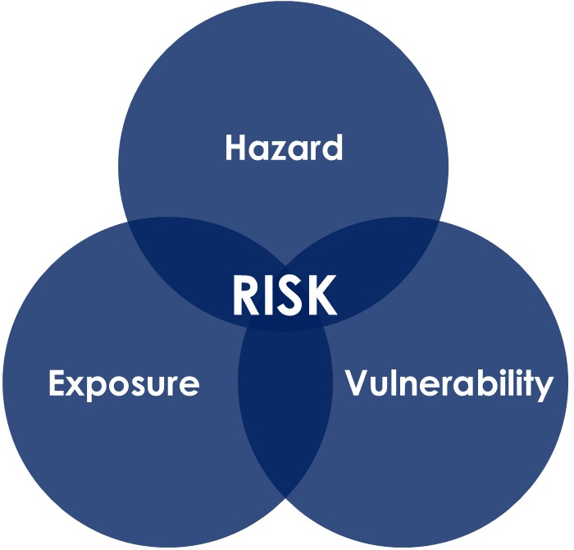

Step 2.1: Hazards and Exposure
Goal: Identify and describe the community’s exposure to current and projected climate hazards, including historical/observed events, regulatory-defined areas of exposure (e.g.,100-year flood zones), and future climate-change related hazard exposure.
Users will:
- Review existing documents relevant to climate hazards and vulnerability.
- Conduct an overview of major historical hazard events and the consequences to the community.
- Determine which hazards are of concern to a community and analyze the severity of each hazard.
- Describe how the priority hazards are projected to change over the period of analysis.
- Evaluate secondary and Cascading hazards.

Step 2.1A: Review Existing Documents
Before starting the assessment, gather and review existing reports that provide information on climate hazards, vulnerable assets and populations, and projected risks in the area. Incorporating these plans, studies, and data into the planning document ensures building on the most current research and evidence. It can also save time and resources by avoiding duplication of existing work.

Local Documents
There are several ways to find relevant local planning documents. A basic internet search using the planning area of focus along with the name of any of the plans listed in Table 4 is a great place to start. Table 4 identifies these plans and highlights key information to look for when reviewing them, including relevant policies, strategies, and other content that can be incorporated into the planning process.
Additional resources include the Adaptation Clearinghouse, which hosts case studies of adaptation planning, including vulnerability assessments, and the California Climate Action Plan Database, which can be used to identify climate action plans. Users may also search the internet for relevant studies and reports prepared by colleges and universities, reputable nonprofit organizations, and state or regional agencies. Local sources, including print and online news articles, can also provide valuable information on past climate events, such as locations of flooding, wildfire impacts, extreme heat events, and other community-specific impacts. In Step 2.3, these documents will be reviewed for adaptive capacity – policies and strategies to address existing and future climate impacts.

Table 4. Key elements to consider when reviewing common local plans
Planning Mechanism | What to Look For
Climate Action/Adaptation Plan (CAP) | - Information on climate hazards, vulnerable assets, and populations  - Local climate projections  - Identified climate risks and vulnerabilities  - Adaptation and climate mitigation goals and actions  - Implementation strategies
Climate Vulnerability Assessment | - Hazard information  - Detailed climate projections  - Identification of vulnerable populations, critical infrastructure, and natural resources  - Risk rankings  - Exposure data
Local Hazard Mitigation Plan (LHMP) | - Climate hazard identification (flood, wildfire, extreme heat, drought, sea level rise)  - Vulnerability and risk assessment  - Climate adaptation strategies aligned with broader hazard mitigation goals
General Plan – Safety or Environmental Justice Elements | - Hazard Information  - Development trends and infrastructure planning  - Goals and policies that support climate resilience and hazard reduction
Emergency Operations Plan (EOP) | - Data on hazards or events of concern and vulnerabilities
Economic Development Plans | - Existing partners  - Prioritized economic growth areas  - Data on demographics, local industries, infrastructure and growth  - Consideration of climate impacts on local industries, infrastructure, and growth  - Strategies for resilient and sustainable economic development
Land Use Ordinances | - Hazard-specific provisions and overall development rules
Community Wildfire Protection Plan (CWPP) | - Wildfire risk assessments  - Priority areas for fuel reduction  - Prevention and adaptation strategies  - Community preparedness measures
Threat and Hazard Identification and Risk Assessment (THIRA) | - Identification of climate-related and other hazards  - Exposure and vulnerability analyses  - Critical natural and built assets  - Existing capabilities, partners, and resource gaps  - Hazard mitigation and risk reduction strategies
Local Coastal Program (LCP) | - Coastal hazards and shoreline conditions  - Coastal resource protection policies  - Sea level rise adaptation policies and development standards  - Coastal access, habitat, and infrastructure considerations
Subregional Shoreline Adaptation Plan | - Assessment of shoreline and coastal hazard exposure for natural, built, and community assets, including vulnerable communities.  - Identification and prioritization of shoreline adaptation focus areas based on local values, community priorities, and regional objectives  - Detailed vulnerability assessments for priority areas  - Adaptation strategies, projects, and policy recommendations  - Regional coordination opportunities, implementation partners, and funding considerations
Recovery Plans | - Information on potential partners  - Risk reduction plans and strategies  - Recovery priorities and governance structures  - Strategies to reduce future risk while rebuilding  - Opportunities to integrate resilience into long-term recovery and redevelopment

Policy Connection: Local Hazard Mitigation Plans
Local Hazard Mitigation Plans must document how existing plans, studies, reports, and technical information were reviewed and incorporated, and how that review informed the plan’s findings and recommendations.
Hazard mitigation principles and actions should flow into the community’s other plans, including land use, capital improvements, transportation, housing, and more. At the same time, the goals, data, and strategies from those plans should inform the Hazard Mitigation Plan. When these connections are intentional and well-documented, the result is a more resilient community across every planning domain.
What it looks like in the community depends on the vulnerability of the built environment, the plans and programs already in place, and the people responsible for carrying them out. The most successful integration happens when a diverse set of partners, including planners, emergency managers, public works, developers, and community members, collaborate across disciplines rather than working in silos.
For more ideas on connecting hazard mitigation with the community’s other plans, review Plan Integration: Linking Local Efforts.

Put It into Practice
See Appendix C -
Review Existing Documents
Use the table below to organize and inventory the reports collected.
Report Name and Link | Key Findings and Notes

Step 2.1B: Determine Historical Hazards
To better understand the climate impacts that the community will face, it is important to look at the events which have occurred in the planning area. Documenting when events occurred, what impacts they caused, and which communities, systems, or assets were affected can help identify areas of exposure and vulnerability. Where available, collect information on the magnitude and consequences of each event, such as recovery costs, asset damages, service disruptions, displaced residents, injuries, and the duration of impacts. These data provide valuable context for understanding how future climate events may affect the community, estimating the benefits of adaptation investments, and identifying opportunities to reduce future losses. Past hazard events also serve as useful case studies for developing problem statements, prioritizing vulnerabilities, and informing adaptation strategies. There are a variety of sources with information on past hazard events. The documents reviewed in Step 2.1A (see Table 4) are likely to have information on past hazard events. Additionally, state and federal emergency websites document past hazard events.
Explore Past Disasters
State Emergency Websites:
- California State Disaster Proclamations List: Includes disaster proclamations by county since 1991
- Open State of Emergency (SOE) Proclamations: Only includes current disaster proclamations
- CAL FIRE Incident Page (specific to wildfire): Scroll down to “Incidents by Year” to view past incident reports which include perimeter/acres burned and assessment of property damages, injuries, and fatalities
- California Geological Survey (CGS) Landslide History: Includes past landslides and descriptions of damages
Federal Emergency Websites:
- FEMA Declared Disasters Data Sets: Downloadable files with all FEMA declared disasters by state
- National Oceanic and Atmospheric Association (NOAA) Storm Events Database: Includes records pertaining to a variety of disaster events including flood, debris flow, wildfire smoke, heatwave, flood, etc.
- Monitoring Trends in Burn Severity: Includes historical record for wildfire occurrence and burn severity.

Policy Connection: Local and Tribal Hazard Mitigation Plans
Local and Tribal Hazard Mitigation Plans are required to include a history of previous hazard events and occurrences, including relevant disaster declarations. This information may be presented in either a narrative format or a table, depending on how the jurisdiction chooses to organize and communicate the data, as long as it is clear and complete. The Tribal Mitigation Planning Handbook recommends documenting when and where hazards occurred, including events preserved through Tribal oral histories and storytelling traditions.
It can be helpful to compile previous hazard occurrences in a table, especially if the hazard has happened many times in the past. For each event identified, include the dates, locations, and impacts of the event. Include cost data where available since it is especially useful for quantifying the costs of future events and the benefits of adaptation. Narratives of significant events can also be particularly helpful, especially if some of the events are not formally documented but are part of the community’s shared history.

Case Studies: Two Options to Display Past Hazard Occurrence
Option 1: Narrative Description
“The Poe fire broke out on September 6, 2001. It was caused by a dry branch falling on a live PG&E power pole near the Yankee Hill community 14 miles north of Oroville. A local disaster was declared. The fire burned 8,333 acres. Several roads were closed. 49 homes, 120 outbuildings, 4 commercial structures and 55 vehicles destroyed. 3 homes damaged. The estimated loss of burned structures, outbuildings and contents were $6.2 million. There was also a loss of over 43 private wells. No human injuries or deaths were reported, but many cattle and horses were lost”(Butte County 2024 LHMP Update).
Figure 10. Option 2: Table

The 2024 Colusa County LHMP Update displayed past hazard history with a table.

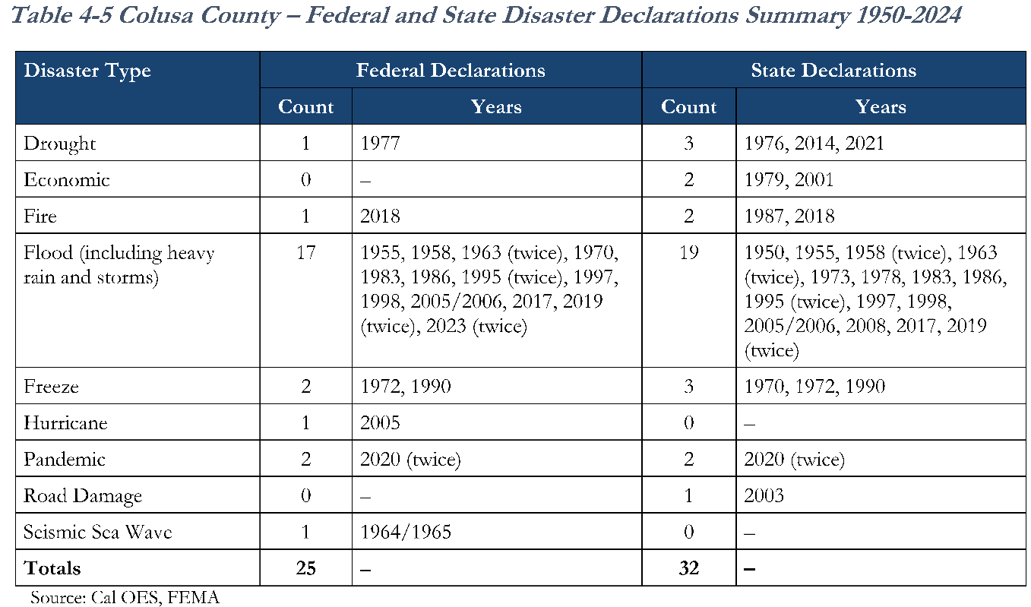

Put It into Practice
See Appendix C - Determine Historical Hazards
Record findings about historical hazard events in the table below.
Event Name and Date | Hazard Type | Neighborhoods or Regions Affected | Human Impacts | Infrastructure Impacts | Environmental Impacts

Step 2.1C: Identify Exposure to Climate Hazards
This step identifies the climate hazards the community is currently exposed to. Not every community will experience all climate hazards, so it is important to identify those that are relevant to the planning area. California's primary climate hazards include extreme heat, wildfire, sea level rise, drought, and flooding. Secondary and cascading hazards such as post-fire debris flows or saltwater intrusion from sea level rise should also be considered at a later point in the assessment (see Step 2.1E).
There are several resources available to learn about the hazards that the community is currently exposed to. This step uses the VCP’s Climate Vulnerability Map to get a high-level overview of the climate hazards in communities. It covers extreme heat, sea level rise, drought, flooding, and wildfire. Consult Appendix C for additional tools and step-by-step instructions. The VCP uses a color scheme shown in Figure 11. The purple gradient in the first box represents a combination of climate hazard data; orange represents social vulnerability data; the combined gradient shows overall climate vulnerability. The dark maroon in the top right indicated communities with both the highest hazard exposure and the highest social vulnerability.

Figure 11. The VCP’s bivariate color scheme, which uses the intersection of climate hazard and social vulnerability
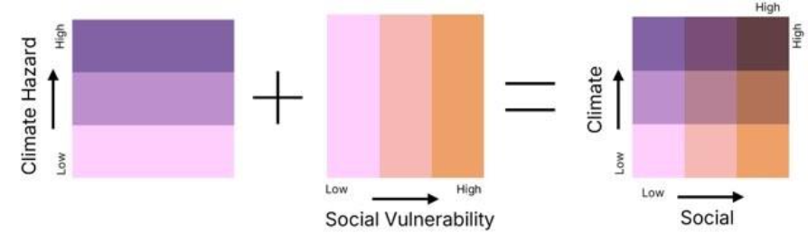
See Figure 12 of the City of Yreka; the VCP identifies that the neighborhood is exposed to extreme heat, flooding, and drought, with extreme heat being of the biggest concern in the current timeframe (shown in the darkest maroon color).
Figure 12. City of Yreka’s climate hazard assessment from the VCP
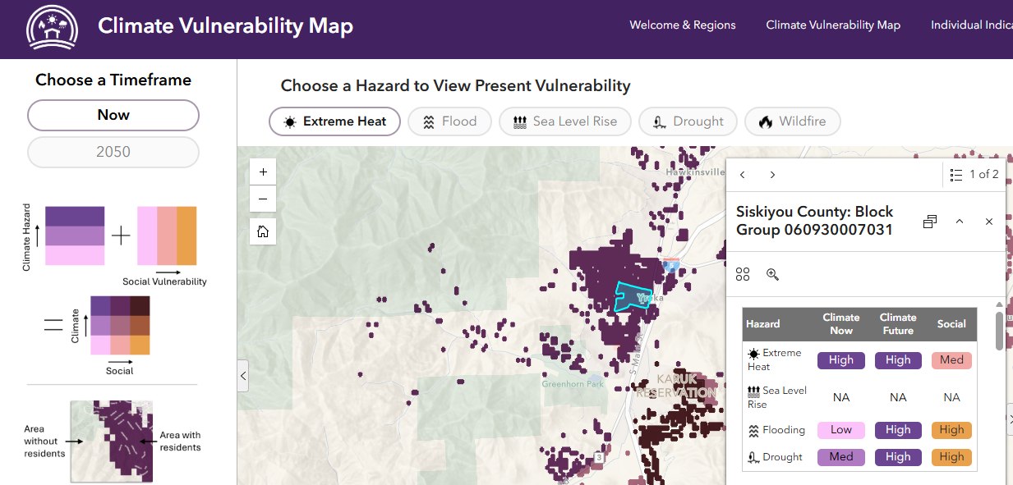

Pay attention to where hazards are most severe in the community, as exposure can vary significantly by neighborhood. See Figure 13 of the City of Sacramento; the VCP shows that the neighborhoods of Natomas north of the River currently have high exposure to flooding (shown in the darkest purple color), while exposure is lower in West Sacramento and Downtown.
Figure 13. City of Sacramento’s flood assessment from the VCP
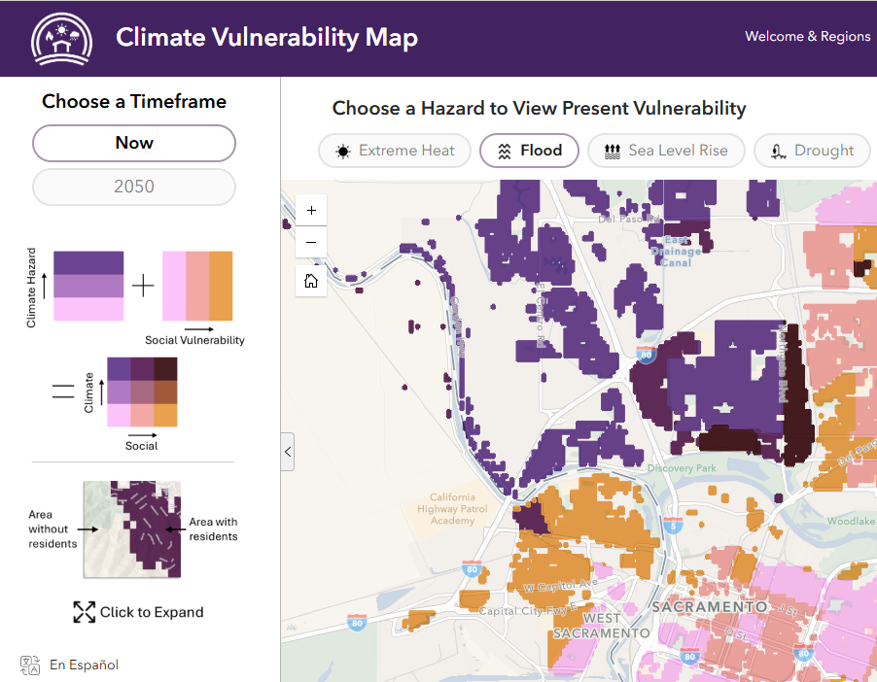

Put It Into Practice
See Appendix C –
Identifying and Analyzing Primary Climate Hazards
Use the table below document and organize the initial hazard assessment from the VCP for the community. In Step 2.1C, fill out row A, B, and C.
 | Extreme Heat | Flood | SLR | Drought | Wildfire
A. Is this climate hazard present in the area of interest (Yes/No) now or in 2050?
B. What specific neighborhoods are affected in the current timeframe?
C. How are they affected? (HIGH Climate & HIGH Social, MED Climate & HIGH Social, etc.)
D. How does vulnerability change between now and 2050?

Step 2.1D: Describe How Climate Hazards Are Expected to Change
After identifying which climate hazards are currently a concern, communities should also consider how climate change will affect their severity, likelihood, timing, and location. Planning efforts such as Local/Tribal Hazard Mitigation Plans (LHMPs/THMPs), General Plan Safety Elements, Climate Adaptation Plans (CAPs) all rely on comprehensive assessments of both current and future risks.
Incorporating climate projections helps communities evaluate whether existing approaches will remain effective under future conditions and a changing climate. Projections help ask and answer questions like:
- Will infrastructure that was originally designed for past flood levels remain adequate as precipitation patterns change?
- Could future development be exposed to increased wildfire or extreme heat risk?
- Will evacuation routes, shelters, and emergency response systems remain viable during more severe events?
California has strong resources for this. Start with the VCP, which aggregates local climate data and shows projected hazard severity into 2050. As an example, see Figure 14 depicting the City of San Fernando: by 2050, the east side of the city becomes more vulnerable to extreme heat (darkest maroon).
Figure 14. City of San Fernando (left panel: extreme heat in current timeframe, right panel: extreme heat in 2050 timeframe)
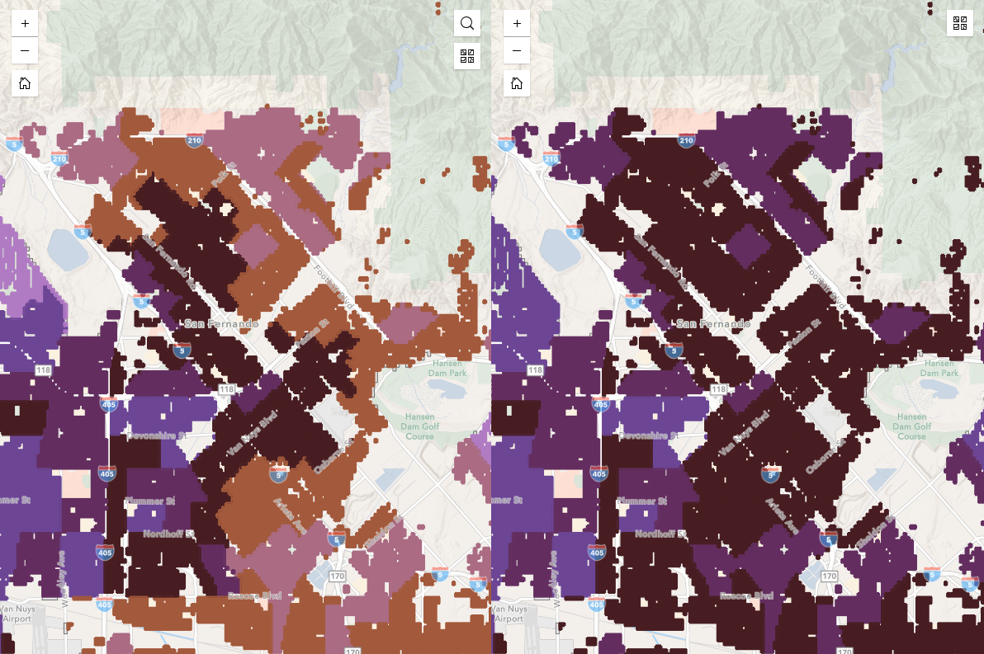
Current
2050

Put It into Practice
See Appendix C -
Identifying and Analyzing Primary Climate Hazards
Going back to the table in Appendix C, fill out row D for Step 2.1D.
 | Extreme Heat | Flood | SLR | Drought | Wildfire
D. How does vulnerability change between now and 2050?

For detailed projections, for example, specific numbers of extreme heat days, sea level rise maps, and more, use the tools below. The Plumas County case study below illustrates how projections available on the Cal-Adapt Enterprise were used in that county's plan.
Case Study: Plumas County’s Multi-Jurisdictional Hazard Mitigation Plan
The Plumas County MJHMP Update from 2026 included projections produced for California’s Fourth Climate Change Assessment available on the Cal-Adapt Enterprise.
Figure 15. Using Cal-Adapt in a Multi-Jurisdictional Hazard Mitigation Plan
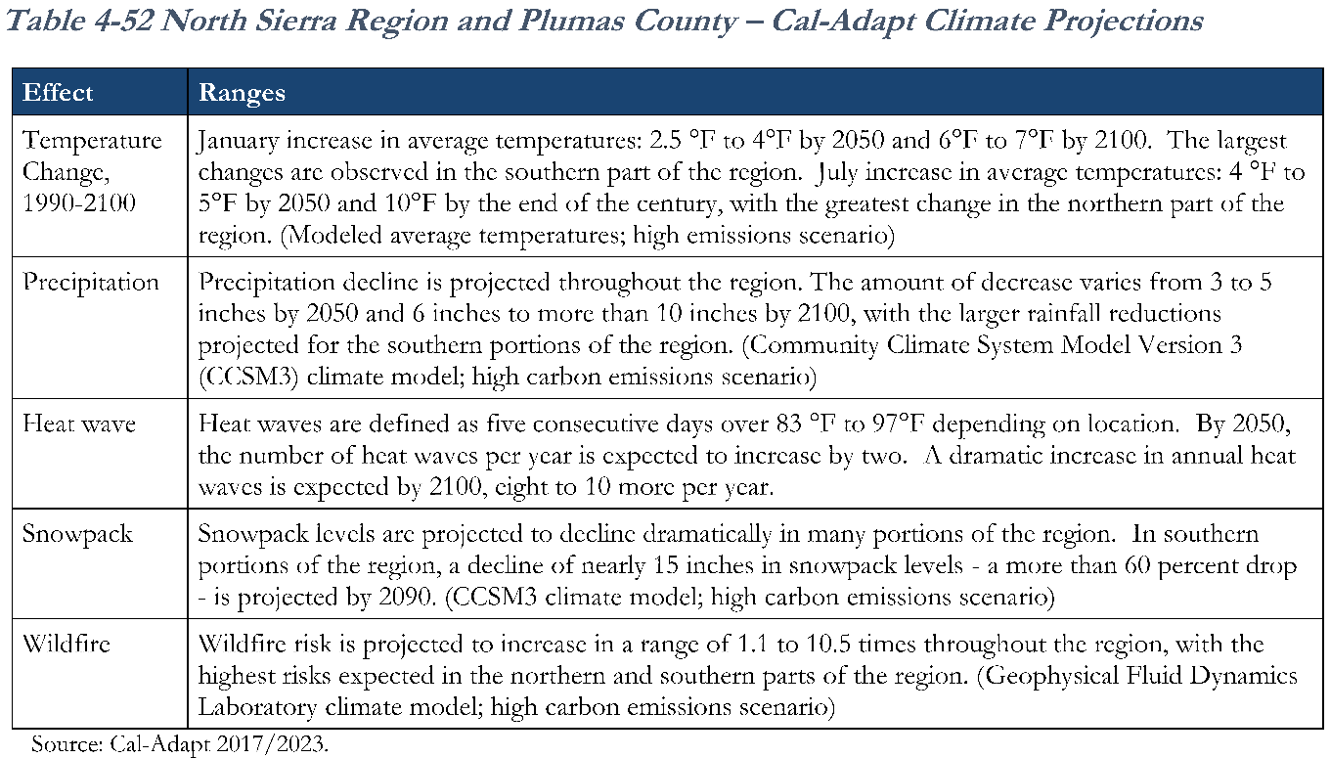

Each hazard section below highlights a few recommended tools; see Appendix B: Climate Data Tools for the complete list, direct links, and guidance on choosing among them. Use the recommended tools to obtain climate and environmental data for each hazard. Record your findings in the corresponding worksheets provided in Appendix C.
Extreme Heat
- LCI’s Climate Data Viewer. : The Climate Data Viewer displays metrics for extreme heat developed from Cal-Adapt: Analytics Engine projections, including the hottest day of the year, number of summer days over 90°F and 100°F, and hot summer nights.
Wildfire
- US Forest Service Wildfire Risk to Communities: The USFS has several wildfire maps including the annual probability of wildfire, expected wildfire intensity, exposure of communities, and the susceptibility of homes or communities to wildfire damage.
- Fire Hazard Severity Zones (FHSZ): The State’s wildfire hazard classification system that can support climate adaptation planning vulnerability assessments by identifying areas with elevated wildfire hazard conditions.
- CAL FIRE’s Historical Fire Perimeters: This map shows outlines of all past major fires in the state since 1878.
- Standford Wildfire Smoke Map: This map shows the annual average wildfire smoke PM2.5 concentrations by census tract.
Flooding
- California Department of Water Resources Best Available Maps: DWR, in coordination with FEMA and USACE, developed these statewide floodplain maps to provide a comprehensive view of existing flood exposure and vulnerability. These maps include 100-, 200-, and 500-year floodplain information and serve as a baseline resource for understanding current flood risks. While these maps do not represent climate projections, they provide valuable flood hazard information for communities with FEMA regulatory maps, DWR awareness maps, or USACE regional studies.
- Climate Data Viewer: Displays metrics for flood developed from Cal-Adapt: Analytics Engine projections, including annual precipitation, rainiest day of the year, days over 1” and 2” of rain, and percent precipitation on heavy rain days.
Sea Level Rise
- California Our Coast Our Future (OCOF) Viewer: This dashboard shows projections for different levels of sea level rise, different storm intensities, and other scenarios.
- National Oceanic and Atmospheric Administration (NOAA) SLR Viewer: This map is similar to the OCOF viewer, but it covers different scenarios, including marsh migration and high tide flooding.
- Adapting to Rising Tides Bay Shoreline Flood Explorer: BCDC developed this map to provide a regional-scale illustration of coastal flooding due to specific sea level rise and storm surge scenarios.
- Regional Shoreline Adaptation Atlas: This tool includes region wide data on coastal flood hazards, community vulnerability, existing conditions, Strategic Regional Priorities, and nature-based adaptation suitability.
- USGS Hazard Exposure Reporting and Analytics (HERA) web tool: This tool contains the same USGS CoSMoS hazard maps and scenarios as the OCOF viewer, but it provides exposure metrics for a variety of assets, summarized by community and county jurisdictions (Census Designated Place boundaries).
Drought
- DWR Water Shortage Vulnerability Tool: This dashboard displays metrics related to water infrastructure and reported shortages.
- LCI’s Climate Data Viewer: The Climate Data Viewer displays metrics for drought developed from Cal-Adapt: Analytics Engine projections, including dry spell length.
California’s Fifth Climate Change Assessment provides additional resources that allow users to interact with and analyze climate projections data. If the planning team has the technical capacity and would like to work directly with climate projections data, please reach out for assistance from the Climate Services team at LCI. For example, the Cal-Adapt: Analytics Engine facilitates access to climate and weather data for California and offers scientific guidance for application of these data.
Climate Projections in California
California’s climate change projections are available for an array of greenhouse gas (GHG) emissions scenarios, climate models, and timeframes. Often, tools using climate projections data will require users to select these parameters to obtain information on projected changes.
California’s Fifth Climate Change Assessment provides a helpful model for selecting these parameters. California’s Fifth Climate Change Assessment assumed a range between “intermediate”- to- “high” GHG emissions in the near term (SSP2-4.5 and SSP3-7.0, respectively) to most accurately assess the climate impacts California will face through the end of this century with a focus on SSP3-7.0. The Assessment used the “very high” GHG emission scenario (SSP5-8.5) as a worst-case scenario to guide the most aggressive adaptation planning.
Table 5. Three of the common greenhouse gas trajectory scenarios hosted on the Analytics Engine
EMISSIONS TRAJECTORY | DEFINITION | DESCRIPTION | OUTCOME
SSP2-4.5 | 4.5 watts per meter squared of radiative forcing in the year 2100 | Emissions continue at present levels to mid-century and then decline | 2.7°C warmer at end of century
SSP3-7.0 | 7.0 watts per meter squared of radiative forcing by the year 2100 | Emissions roughly double from current levels by 2100 | 3.6°C warmer at end of century
SSP5-8.5 | 8.5 watts per meter squared of radiative forcing by the year 2100 | Emissions roughly double from current levels by 2050 | 4.4°C warmer at end of century
California’s Fifth Climate Change Assessment used 30-year time frames for analyses of climate projections, as shown in Table 6Table 5. The Assessment focused on the mid-century time frame to determine near-term projections, and time series from the historical period through 2100 to illustrate variability and changes across the 21st Century. While mid-century projections are commonly used for adaptation planning, some communities may choose to evaluate late-century conditions (through 2100) depending on their planning goals, asset lifespans, and desired level of long-term resilience. It is important to note that the “mid-century” timeframe used in many tools extends through 2070 (or, in some cases, 2074), rather than representing only the year 2050. Communities should select timeframes that align with their adaptation goals and the lifespan of the systems or assets being considered.
Table 6. Timeframes used by California’s Fifth Climate Change Assessment
Descriptive Term | Time Range
Historical | 1981-2010
Mid-Century | 2041-2070
Late-Century | 2071-2100

The high-resolution climate projections data available for California were developed for a range of global climate models (GCMs). Multiple GCM projections should be considered in assessing climate changes and impacts. One helpful way to get started with analyzing downscaled climate projections is to use the California Fifth Climate Change Assessment’s General Use Projections. The General Use Projections are single ensemble members of SSP3-7.0 projections of five GCMs that were selected as an entry point into climate data utilization to reduce the barrier of working with the full suite of data.

Challenges and Limitations of Climate Projections
Climate projections are valuable tools for planning ahead, but they must be interpreted carefully. Because they rely on models with inherent uncertainties, their results can sometimes be misunderstood or misapplied. Keep the following in mind:
- Climate projections are not predictions. Climate projections depend on assumptions about future greenhouse gas emissions and policy decisions, rather than predicting exactly what will happen.
- Results differ across models. No single model is “best” for every situation. Looking at multiple projections helps provide a more complete understanding of possible future conditions.
- Uncertainty in climate projections shouldn’t prevent effective planning. Despite differences across models, there is strong agreement on overall trends, such as rising temperatures, increasing sea levels, and more frequent heavy precipitation. For many planning mechanisms, knowing general climate trends is sufficient for most planning risk assessments.
Policy Connection: Local Hazard Mitigation Plans
Local Hazard Mitigation Plans must include an assessment of the probability of future hazard events affecting the planning area. This assessment should also consider how changing future conditions may influence the type, location, frequency, and range of intensities associated with each hazard.

Step 2.1E: Determine Secondary and Cascading Hazards
Secondary hazards do not emerge directly from a climate event but from the cascading impacts that follow. A primary climate hazard, such as wildfire, extreme heat, flooding, sea level rise, or drought can trigger a chain of additional challenges that affect communities, infrastructure, and public systems. For example, after the 2018 Thomas Fire near Montecito, a post-fire rainfall triggered a debris flow event in the Santa Ynez mountains that killed 23 people and damaged over 400 homes.
Understanding cascading and secondary hazards helps decision-makers build a more accurate assessment of vulnerability and better anticipate what may happen after a major climate event, not just during it. Additional examples include:
- Landslides occurring on fire-damaged slopes after heavy rainfall, sometimes weeks or months after the initial fire, thus contaminating lakes, rivers, and coastal waters from wildfire ash and heavy metals
- Increased heart- and lung-related hospitalizations due to wildfire smoke during fire events

Case Study: City of Carson’s Local Hazard Mitigation Plan
Carson’s 2026 LHMP discusses secondary hazards in addition to primary ones.
Figure 16. Carson LHMP’s cascading hazards
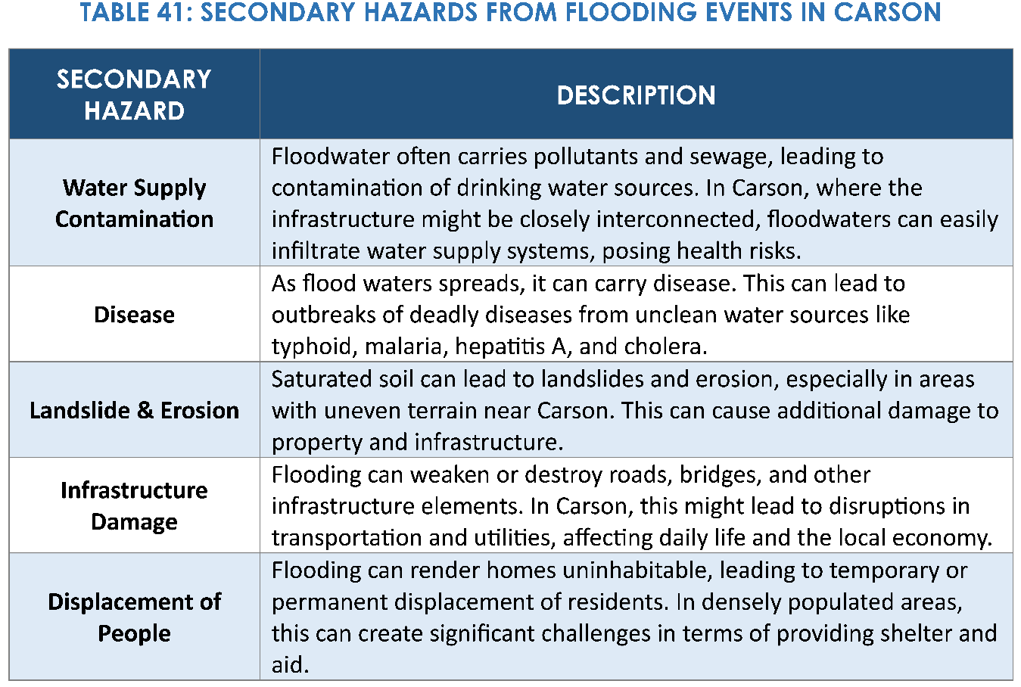

Local context determines the nature and severity of cascading and secondary hazards. For example, desert communities face compound climate vulnerabilities resulting from the intersection of extreme heat, drought, limited shade and green infrastructure, high social vulnerability, agricultural labor dependence, and degraded natural environments. These challenges can differ significantly from those experienced in coastal and inland urban areas. In particular, inland desert regions may experience compounding vulnerabilities associated with extreme heat exposure, agricultural labor conditions, limited shade infrastructure, water access challenges, invasive species impacts, and concentrations of disadvantaged populations. These factors should be documented as part of your vulnerability assessment.

Revisit the plans discussed in Step 2.1A: Review Existing Documents to identify cascading impacts and interconnected risks affecting your planning area. Document any relevant findings in the worksheet to support your vulnerability assessment.
Put It into Practice
See Appendix C - Identifying and Analyzing Primary Climate Hazards
Used in Steps 2.1C, 2.1D, 2.2A
Use the table below to document and organize an initial assessment of the community’s vulnerabilities. Fill in the observations and insights based on the VCP’s Climate Vulnerability Map. The key below describes where to look to find the information to fill in each row of the table.
#1. Look at the map for each hazard to assess if there is vulnerability present and where it is located.
#2. Look at the Pop-ups for a quick ‘report card’ of the clicked block group that includes its High/Med/Low designation for each hazard.
#3. Use the ‘Compare Tool’ – found in the top right corner of the page – to compare hazards across the Now timeframe and the 2050 timeframe.
#4. Use the ‘Individual Indicators’ tab – found in the top right of the page – to select specific individual indicators of vulnerability from the left side menu.
 | Extreme Heat | Flood | SLR | Drought | Wildfire
A. Is this climate hazard present in the area of interest (Yes/No) now or in 2050? (#1)
B. What specific neighborhoods are affected in the current timeframe? (#1,#2)
C. How are they affected? (HIGH Climate & HIGH Social, MED Climate & HIGH Social, etc.)? (#1,#2)
D. How does vulnerability change between now and 2050? (#3)
E. What specific social indicators are driving vulnerability in this area? (#2, #4)

Secondary and Cascading Hazards
Record findings about secondary and cascading hazards in the table below.
Secondary Hazard | Source | Effect (Where and Who)

Step 2.1 Wrap-Up
The final step in the exposure analysis is to synthesize all information gathered to identify the community’s primary hazards and highest areas of concern. Consider summarizing:
- What hazards are most pressing?
- Where do secondary hazards create compounding risk?
- Which neighborhoods face the highest exposure?
- What patterns do historic hazards reveal?
- Notable gaps or uncertainties
The next step evaluates sensitivity and potential impacts of identified hazards in the planning area.

Step 2.2: Vulnerability and Potential Impacts
Goal: Identify populations and assets vulnerable to climate hazards and summarize potential impacts.
Communities across California vary greatly in the climate hazards they face and their socio-economic makeup. Social vulnerability (also referred to as social sensitivity) refers to the conditions that people or communities experience that can make the impacts of climate change more severe or detrimental for them. Communities confronting institutionalized inequity, structural racism, and chronic underinvestment face not only greater immediate danger but also steeper barriers to long-term physical and economic recovery.
Assets describe any human-caused or natural feature that has value, including people, buildings, infrastructure, such as bridges, roads, sewers, and water systems, lifelines, such as electricity and communication resources; and environmental, cultural, or recreational features, such as parks, wetlands, and landmarks. All assets may be affected by climate hazards, but some are more vulnerable.
This step will:
- Identify concentrations of residents, employees, and businesses
- Identify concentrations of underserved communities and socially vulnerable populations, including residents of designated disadvantaged communities where applicable
- Consider areas of planned growth and projected population increases identified in local General Plans or regional forecasts and assess future vulnerability in those areas
- Identify facilities that provide critical health, social, and human services essential to disaster response and long-term recovery
- Identify visiting and transient populations and where they are likely to be located, such as students, seasonal agricultural workers, Tribal visitors, second homeowners, tourists, and attendees at major events
This will help us identify where residents may face greater barriers to preparing for, responding to, or recovering from climate-related hazards and disasters.

Step 2.2A: Evaluate Social Vulnerability
There are social conditions that can make dealing with any climate hazard more difficult. For example, having a physical disability can impact one’s ability to evacuate during a flood or fire, or move to a cooling center during a heatwave. Table 7 includes examples of indicators that capture general conditions that increase social vulnerability.
Table 7. Examples of indicators associated with increased social vulnerability included in the Vulnerable Communities Platform
Indicator Name | Indicator Description | Reason
Tribal Lands | Land held in trust for federally recognized Tribes (includes both off and on reservation trust lands). | Tribal lands have often been constrained to at-risk, low-value lands, suffer from continued disinvestment, and, as a result, populations often lack access to basic services, while economies are more susceptible to disruption from climate hazards.
Food Insecurity | Households lack consistent access to food. | Food insecurity can worsen health impacts and increase vulnerability during emergencies.
Housing Insecurity | Difficulty paying rent, mortgage, rent, or utility bills. | Housing instability can reduce access to safe shelter during emergencies and reduce the ability to implement adaptive measures (e.g., cooling or heating).
Lacks Reliable Transportation | Limited access to dependable transportation. | Transportation barriers can hinder evacuation, access to services, and recovery efforts.
Children | Population under age 5. | Young children are more vulnerable to climate hazards and depend on others for safety and care.
There are also conditions that only increase vulnerability to certain climate hazards. For example, having asthma may make a person more susceptible to wildfire smoke or extreme heat. Relying on domestic wells and state small water systems may also position a community to be more vulnerable to drought. Below, in Table 8, are examples of indicators associated with specific climate hazards. For the full list of indicators included in the VCP, please reference the 2026 Methodology Report.

Table 8. Examples of hazard-specific indicators associated with increased social vulnerability included in the Vulnerable Communities Platform
Indicator Name | Indicator Description | Applicable Climate Hazard | Reason
Asthma | Probability of having current asthma based on ever having it and/or still having it. | Extreme Heat & Wildfire Smoke | Leads to greater difficulty breathing and a higher risk of mortality.
Air Quality PM2.5 | A populated area that has pollution particles above safe levels on average. | Extreme Heat | Both heat and exposure to fine particulate matter (PM 2.5) cause adverse health impacts – often co-occurring and compounding the effects, including increased mortality risk.
Surface Urban Heat Island (SUHI) | Summertime SUHI intensities for daytime and nighttime. | Extreme Heat | Intensifies climate-driven heat risks, especially for marginalized communities lacking cooling infrastructure, shade, and green space.
Tenancy | Percent of the population living in housing units that are rented. | Flooding, SLR, & Wildfire | Higher climate risks due to limited control over their housing, greater exposure to hazard-prone areas, and fewer resources for mitigation or recovery.
Near Water Pollution Source | Areas within one mile of a facility of concern monitored by the State Water Resources Control Board. | Flooding & SLR | Climate hazards can alter and transport residual contaminants from toxic facilities, making them more toxic and bringing them into contact with humans.
Water System Risk | If a water system service area is failing, at-risk of failing, a high-risk aquifer, or outside a CA water system service area. | Drought | Drought reduces the availability and reliability of water sources, strains failing systems, and increases costs of safe water.

The indicators shown in Table 7 and Table 8 represent conditions that may increase vulnerability but are not a comprehensive list. Some conditions are difficult to represent spatially or are not well represented in state and national datasets. For example, unhoused individuals are a critical issue for many cities across California, but mapping unhoused populations across the state remains a challenge and is not included in the VCP. The fact that unhoused individuals are disproportionately exposed to climate events makes it important for planning entities to consider this population in their climate adaptation work.

Additionally, vulnerability assessment tools also often rely on census-based data, which may not fully capture local conditions depending on the size and characteristics of census geographies. These limitations can be especially relevant in rural areas, where populations are more dispersed and census areas may encompass diverse conditions. Planning entities can address these gaps by incorporating additional local data, community knowledge, and engagement to better understand place-specific vulnerabilities. Quantitative indicators from maps and tools should be used alongside qualitative information to develop a more complete understanding of social vulnerability.
See VCP methods report descriptions for the indicators that are relevant to each climate hazard in the area. Which of these indicators have particularly high value in the area according to the VCP? What does this say about the community living there?
Consider validating these findings with Tribes, community-based organizations, and other partners. Their perspectives can help explain why certain patterns exist.
Visit Appendix B - Vulnerable Communities Platform (VCP) for a full walkthrough of how to use the Climate Vulnerability Map for this purpose.
Put It into Practice
See Appendix C -

Referring to the table in Appendix C, add the relevant social vulnerability insights from the VCP to the Location column for Rows B and D under Step 2.2A.
 | Extreme Heat | Flood | SLR | Drought | Wildfire
B & D. What specific social indicators are driving Medium and High vulnerability in this area?

Tools to Evaluate Social Vulnerability
It may be necessary for the assessment to conduct a more detailed analysis of particular social indicators. This may be especially needed when the data seen on the platform doesn’t appear to reflect the full picture of vulnerabilities that the planning team knows of that exist in the community.
Below are other tools and resources to help identify social vulnerability in communities. The VCP’s Other Vulnerability Tools page allows you to compare key data layers from many of these tools side by side to see which ones best represent vulnerability in the community. The page also includes guidance on what each tool can do, what data and features it offers, etc.
- CalEnviroScreen5.0 can be used to identify California communities that are most affected by environmental pollution, and where people are often especially vulnerable to pollution’s effects.
- CA Statewide Parks Program Community FactFinder can be used to understand park and outdoor access.
- Cal OES’ Access and Functional Needs Viewer is designed to assist emergency managers in identifying, locating, and deploying access and functional needs (AFN) related assets and resources during all phases of emergencies. This tool can be used to understand and evaluate a project that has an emergency management component.
- California Healthy Places Index can be used to help understand community conditions that impact life expectancy.
- Caltrans’ Transportation Equity Index (EQI) can be used to identify transportation-based priority populations by integrating transportation and socioeconomic indicators.
- Climate & Health Vulnerability Indicators for California and the CCHVIz visualization platform includes 18 indicators on climate exposure, population sensitivity, and adaptive capacity for health impacts.
- California Building Resilience Against Climate Effects (Cal BRACE) project includes data, tools, and templates for assessing the health equity impacts of climate change (see the CalBRACE Toolkit ).
- For small water systems, see the tutorial Small Water Systems Vulnerability Explorer Tool.
- San Francisco Bay Conservation and Development Commission’s (BCDC's) Community Vulnerability Mapping Tool. The tool also includes also includes a Community Based Organization (CBO) Directory Map and information on engaging local community groups in the San Francisco Bay Area region.
In addition, some regions and counties in California have developed their own tools to visualize social vulnerability to climate change within their region. These might be useful to consider because vulnerability is usually measured relative to an area. This means that at different scales, the areas of greatest vulnerability may change. A given community may not be designated as disadvantaged when compared to the entire State (e.g., through a Statewide comparison like CalEnviroScreen), but when compared to other communities within the same county, it may be considered disadvantaged. Such communities still have populations and individuals who are disproportionately affected by climate change and face greater barriers to preparing for, responding to, and recovering from events. When selecting a tool for use in the assessment, consider:
- What is the intended use of the tool? Is it designed for siting a specific type of project? For a specific policy or grant?
- For what climate hazards does it provide data? Does it cover all the hazards present in the community (wildfire, extreme heat, flooding, etc.)?
- What data or features does it display? Does it produce an index that gives a percentile value? A Yes/No binary?
- At which geographic scale is the data organized? Is it by block group, census tract, city, zip code, or county?

Step 2.2B: Evaluate Built Assets
After considering climate hazards that may affect a community, it is important to understand how those hazards could impact the built environment and the assets that communities depend on. Identifying built assets and other essential services that support community functions is an important step in understanding vulnerability. Knowing where these assets are located and the risks they may face can help communities prioritize resilience strategies. Examples of built assets include:
- Hospitals and healthcare facilities
- Schools (K-12, universities, community colleges)
- Major roads, bridges, rail and bus lines
- Water and wastewater infrastructure
- Energy systems
- Levees and stormwater systems
- Community centers
- Shelters
- Emergency services (fire departments, police stations)
- Cultural assets (museums, libraries, churches, parks or recreational spaces)
Many built assets support one or more FEMA Community Lifelines, which include the essential services, infrastructure, and capabilities communities depend on to maintain daily operations, public health and safety, and economic security. Because these systems are connected, disruptions to one lifeline can affect other community functions. Evaluating Community Lifelines helps communities identify critical infrastructure, understand connections between assets and services, and prioritize actions to reduce risk and improve resilience.
In addition to infrastructure and essential services, other community assets may be priorities for protection or investment, including historic buildings, social or religious institutions, and unique community features such as monuments and parks.
The first step in identifying these assets is to review the reports identified in Step 2.1A: Review Existing Documents to determine whether any analyses have been conducted regarding potential risks to infrastructure. The second step should be to look through the past hazard events identified in Step 2.1B: Determine Historical Hazards. Infer what infrastructure may be most vulnerable based on impacts from previous heatwaves, floods, and fires. Consider: Do the stormwater systems get backed up after heavy rain? Are there recurring power outages in certain areas? Assets to include in the assessment are applicable to one or more of the following:
- They serve large portions of the population daily, and disruption would significantly affect community functioning
- They provide essential services such as water, electricity, transportation, and public safety
- They support employment and economic activity
- They hold cultural, historic, or symbolic value
- They play critical roles during emergencies, even if not typically viewed as essential (e.g., community centers serving as shelter)
When defining built asset categories, consider whether similar assets should be grouped together or evaluated separately. Particularly critical or highly disruptive assets may warrant individual evaluation. For example, communities can generally group roadways into one category, but it may make sense to evaluate each major roadway or highway individually. If a handful of similarly built assets face different potential impacts (for example, multiple hospitals or wastewater treatment plants in different parts of the community that are exposed to different climate hazards), it might also be helpful to evaluate them separately.
Policy Connection: Tribal Hazard Mitigation Plans
Tribal mitigation plans should provide an overall summary of vulnerability to identified hazards, including vulnerable populations, structures, systems, cultural resources, and other Tribal assets. Plans should also identify what the Tribe wants to protect and describe the planning area, including Tribal lands, jurisdictional boundaries, and culturally significant places. Cultural and sacred sites are often located in vulnerable areas and can be protected through appropriate mitigation measures. In these cases, the locations of these sites and information regarding their cultural significance can remain confidential while still supporting protection and planning efforts.
Using the VCP to Evaluate Assets
To evaluate risk to built assets, communities should conduct local-level analyses whenever possible using GIS data, asset inventories, and local knowledge to identify infrastructure and facilities exposed to climate hazards. For high-consequence infrastructure, technical experts and additional assessment methods should be used to better evaluate risks and identify appropriate adaptation strategies.
The VCP’s Infrastructure Map can support local analysis by examining built assets within the planning area. This map combines public data layers on common infrastructure such as schools, libraries, healthcare facilities, and roads with the VCP’s Climate Vulnerability Map layers for each hazard. To use the tool, zoom into the area of interest, turn on the desired VCP Vulnerability layer, and review each infrastructure layer to see what infrastructure is exposed. However, it is important to note that this map is not a comprehensive or authoritative source; many community assets are not covered. Local data sources (or even Google Maps) can be used to find locations of other assets important to the community.
Be aware that this is a very high-level diagnosis—hazards outside the community can also have an impact (e.g., damage to transmission lines miles away from the community can cause a power outage). It may also be useful to distinguish between the physical asset and the service it provides. The two may experience different vulnerabilities and require different adaptation strategies. For example, a drought can significantly affect water deliveries in the community, even if it causes no physical damage to the water infrastructure. A hospital might survive a severe storm event with no damage or loss of capacity, but an emergency medical response service can be harmed by blocked or damaged roadways.
Evaluation
When evaluating built assets, consider not only their exposure to climate hazards, but also their vulnerability. Vulnerability can vary based on age, condition, construction type, materials, and use. Built assets include not just buildings but also the full range of infrastructure that communities depend on such as roads and highways, bridges and culverts, water and wastewater systems, electric utilities and telecommunications infrastructure, stormwater systems, and other public facilities. When evaluating existing built assets, consider:
- Buildings: Types (residential, commercial, industrial, etc.), age, construction type, whether any are critical facilities, and compliance with disaster-resistant building codes
- Transportation infrastructure: Road and highway classifications and materials, bridge age, structural type, culvert capacity, and condition in areas subject to flooding or debris flows
- Utilities: Age and material of water and wastewater pipelines; location of above-ground versus buried electric infrastructure; vulnerability of substations, transmission lines, and telecommunications facilities to high winds, wildfire or flooding
- Stormwater and flood control infrastructure: Capacity of storm drains and detention basins relative to projected precipitation intensity, condition of levees and flood control channels
When evaluating assets, consider the broader consequences of potential disruptions, including impacts on essential services, public health and safety, economic activity, and community well-being. Where possible, quantify vulnerabilities (for example, the number of affected buildings, miles of infrastructure, or estimated asset value) to make risk statements more concrete and urgent. However, recognize that economic valuation alone may not fully capture community priorities, particularly for critical infrastructure and assets that support vulnerable populations.

Put It into Practice
See Appendix C - Evaluate Community Assets Exposed to Hazards
Use this table to document community assets. List each specific asset (each school, senior center, library, etc.) by name.
Exposed Asset | Potential Hazard | Impact (Where and Who)

Case Study: Morro Bay Annex of San Luis Obispo County Multi-Jurisdictional Hazard Mitigation Plan
The City of Morro Bay was a planning participant in the San Luis Obispo County MJHMP 2025-2030. The City describes its future development and how that may affect its vulnerability to natural hazards in Annex D.
“Morro Bay is mostly built-out and geographically constrained by the Pacific Ocean to the west, steep topography to the east, and protected agricultural land and open space to the north and south. The city approves approximately 20 to 30 new residential units each year. This includes new single-family homes, accessory dwelling units, and multi-family units. These are mostly infill units located on existing lots throughout the city, some of which (particularly in North Morro Bay and Morro Bay Heights) are located on moderate to steep (10 - 30 percent) slopes.
“The city permits approximately 1 to 5 new commercial development/redevelopment projects each year. These most commonly consist of hotel and retail projects. Some of these projects are located on the Embarcadero on City tidelands lease sites. These areas are potentially vulnerable to coastal hazards, flooding, and tsunami inundation. The city is in the process of updating its Waterfront Master Plan to include a sea level rise vulnerability assessment and adaptation plan. The Local Planning Team noted that in the Waterfront Master Plan, they have identified a safety risk of traffic congestion and one-way access to certain areas that can limit or impede evacuation access and egress. Specifically, the traffic congestion on Embarcadero is being caused by larger vehicles having difficulty turning around in central Embarcadero and excessive length of dead-end roads creating congestion and safety hazards.”

Step 2.2C: Natural, Historic, and Cultural Resource Assets
California’s natural landscapes, including its forests, wetlands, rivers, farmlands, coastline, urban forests, and open spaces, are community assets that deserve the same attention in a vulnerability assessment as roads, buildings, and utilities. These resources support local economies, protect public health, and in many cases directly reduce hazard risk for nearby residents. When they are damaged or degraded by wildfire, drought, flooding, or other hazards, the impacts can ripple across the whole community.
What these resources entail and mean locally varies widely across California’s diverse regions. These resources support local economies through agriculture, tourism, outdoor recreation, and ecosystems services, and thus, conserving restoring, stewarding them can help communities reduce hazard risk, protect habitats and biodiversity, and build long-term resilience. The natural environment can also directly shield residents from hazard impacts. Wetlands and riparian areas absorb floodwaters. Healthy soils and vegetation manage stormwater, control erosion, and reduce runoff. Vegetation and urban tree canopy provide shade that protects people from extreme heat. Dunes and coastal wetlands buffer shoreline communities from storm surge and high tides.
Natural Resources
Natural resources include, but are not limited to, forests, wetlands, rivers, and lakes, beaches, farmlands, rangelands, groundwater basins, wildlife habitat, and the plant and animal species that depend on them. Natural resources support working lands, including farms, ranches, orchards, vineyards, cannabis, and timber lands. In the Central Valley, irrigated farmland and water delivery infrastructure encompass one of the most productive agricultural economies in the world and support entire rural communities.
In California, these assets are managed across a complex patchwork of jurisdictions, including federal agencies, (such as the USFS and Bureau of Land Management), state agencies, special districts (such as resource conservation districts and water districts), county agricultural commissions, private landowners, and California Native American Tribes. Each of these entities brings different knowledge, authority, and capacity to a vulnerability assessment, which is why partnerships and coordination matter.
Communities should identify natural resource assets within and around their planning area, evaluate the hazards they face, and consider how the loss or degradation of these assets would affect residents. Resources that provide direct hazard protection, such as wetlands that reduce flood risk or urban forests that reduce extreme heat, are especially important to identify because their degradation can increase community vulnerability in ways that are not always immediately visible. Communities should also evaluate the health of these resources, if they are degraded or in an unhealthy state, they may need to be restored or enhanced to convey hazard mitigation benefits. For example, this may include restoring hydrological functioning of wetlands and rivers, reducing the density of unhealthy forest stands, or building the soil health of a landscape where soils are highly degraded.
Climate change creates both challenges and opportunities for natural resource management. Drought and heat can expand invasive species and stress ecosystems already under pressure, while drier late-season conditions may open new windows for prescribed burning, and longer shoulder seasons may support more trail work and habitat restoration.
Historic Resources
Historic resources offer meaningful social and economic benefits, including heritage tourism, neighborhood character, and community identity. In California, these include adobes, Gold Rush-era buildings, and agricultural landscapes tied to farmworker history. Communities should identify these resources in their asset inventory and evaluate their exposure to hazards.
Cultural Resources
Cultural resources reflect what a community values, practices, and holds in common. They include museums, libraries, cultural centers, parks, stadiums, and geological or natural sites of special significance, as well as the living traditions, seasonal events, and community practices that are significant to the community and cannot be replaced.
Tribal Cultural Resources
In California, Tribal cultural resources deserve particular attention. For California Tribes, cultural resources can encompass landscapes, waterways, plant communities, and places of spiritual and traditional significance. The Karuk Tribe’s 2019 Karuk Climate Adaptation Plan, for example, identifies species of cultural importance that serve as indicators of ecosystem health and are central to Tribal ceremonies and relationships with the land.

Figure 17. Excerpt from the 2019 Karuk Climate Adaptation Plan

Pacific Giant Salamander / Púfpuuf / Dicamptodon tenebrosus
Importance as Cultural Indicator
In Karuk beliefs, púfpuuf is a spiritual being who transformed into a salamander to monitor spring and creek water quality and quantity. The healthy presence of púfpuuf is indicative of a healthy riparian and aquatic fresh water ecosystem. Púfpuuf is central in Karuk culture - they’re not a Karuk food source, but they are a keeper of water that is critical to our life. Púfpuuf has its own prayer in ceremonies related to how humans - as the only species capable of lighting a fire and making sure it doesn’t get out of hand - can maintain balance in riparian systems. As a cultural indicator pacific giant salamander is connected to the transitional riparian habitat between the in-stream and the up-slope environments.
Activities that are Meaningful to the Community
Beyond physical sites, communities should consider the activities and traditions that define them. Many California communities depend on seasonal industries such as agriculture, fishing, ski tourism, coastal recreation, and harvest festivals that operate within narrow windows where weather, water availability, and environmental conditions must align. A late frost in the Central Valley, a wildfire smoke event during peak summer tourism in the Sierra Nevada, or a harmful algal bloom closing shellfish harvesting on the North Coast can devastate a local economy in ways that go well beyond a single season. Identifying these dependencies as part of a vulnerability assessment helps communities understand the full stakes of natural resource protection.
Climate change can also intensify pressure on recreational amenities that communities value. The 2024 Nevada County Recreation and Resiliency Master Plan highlights how rising temperatures are expected to increase demand for access to rivers, lakes, and other cooling destinations:
“Access to bodies of water is a critical feature of recreation in Nevada County. The county contains an extensive network of both year-round and seasonal creeks, streams, and rivers, as well as reservoirs and high-mountain lakes (…) Crowding or lack of parking at rivers was often noted by survey respondents as a barrier to recreation. This amplified use is projected to continue as the number of heat waves increases and summer temperatures rise. Residents from both within the county and from surrounding communities will seek cooler temperatures in the Sierra mountains and from Nevada County’s rivers and lakes.”
This example demonstrates that climate vulnerability may emerge not only through environmental degradation, but also through increased demand and overuse of important community spaces that serve as climate refuges.
Assessing Vulnerability of Natural, Historic, and Cultural Resource Assets
Assessing the vulnerability of these assets follows the same basic framework used in this guide. This requires input from a range of partners, including biologists, ecologists, historians, archaeologists, recreation managers, preservation specialists, land managers, and Tribes. No single entity holds all of this knowledge, so coordination through existing partnerships and regional networks is often important.
Data on natural and cultural resources can be limited, and baseline conditions are not always well documented. For example, Desert ecosystems present distinct vulnerability assessment challenges, with recovery timelines measured in decades to centuries rather than years. The Prioritization, Adaptation, and Resilience for Climate Toolkit (PARC Toolkit), and the Coachella Valley Conservation Commission's natural community accounts and monitoring protocols could be cited as accessible resources for planners working in inland Southern California desert regions. In these cases, qualitative assessments informed by local expertise, land manager knowledge, and Tribal input can provide valuable insight. Communities should also document data gaps as findings to address in future planning efforts.
The impacts themselves may differ from those affecting built assets. A damaged road may have a repair cost and timeline, but the loss of a wetland, salmon run, historic landmark, or valued recreation area may be difficult or impossible to replace. Impacts are often gradual and cumulative rather than tied to a single event. Forests stressed by prolonged drought become more vulnerable to severe wildfires, beaches erode incrementally as seas rise, and repeated wildfire-smoke seasons can steadily degrade recreational opportunities and public health. Vulnerability assessments should therefore consider both acute disaster impacts and long-term environmental change.
Adaptation Strategies and Approaches
The Northern Institute of Applied Science has developed Adaptation Strategy “menus” for a range of natural resource topics to support climate adaptation planning and use with the Adaptation Workbook. These menus help communities translate broad adaptation ideas into specific actions and identify the purpose behind different management approaches.
Topics include forests, agriculture, recreation, wetlands, wildlife, urban forests, and fire-adapted ecosystems. Strategies can be combined and adapted to fit local ecosystems, community priorities, and project goals.

Step 2.2D: Outreach and Engagement
Data and maps provide a critical foundation for understanding climate vulnerability, but they are not the full picture. Ground-truthing brings local context, lived experience, and operational insight into the assessment process. By engaging directly with partners, communities can confirm, refine, and expand their understanding of climate impacts and the assets, services, and populations most affected. Community members bring valuable expertise about local conditions, historical context and cultural resources and resilience efforts that technical assessments alone may not capture.
This step focuses on partner interviews to validate assumptions, surface unaccounted impacts, and explore how climate risks may evolve over time. This is relevant to information collected in Step 2.1 and Step 2.2. Partner interviews are used to explore:
- Past and current climate impacts that may not be captured in formal reports
- How critical assets, services, and populations are affected by climate hazards
- Where vulnerabilities are most acute and why
- How future climate conditions may change the severity of impacts
These conversations help move from generalized vulnerability indicators to place-specific, experience-based insights that strengthen planning and decision-making. The most valuable insights often come from people who work closest to critical assets and services or who are deeply embedded in the community. Priority partners may include:
- Asset managers and operators (e.g., transportation, utilities, water, and wastewater)
- Emergency services and public safety leaders (fire, police, emergency management)
- Public health professionals and healthcare facility managers
- Community service providers and nonprofit leaders
- Leaders of environmental or climate partner organizations
- Directors of youth programs, schools, or colleges
- Long-standing residents and community leaders with institutional memory
- Representatives from federally and non-federally recognized Tribes, where applicable.
- Disability organizations and Access and Functional Needs (AFN) advocates
Asset and service managers often have a detailed understanding of asset sensitivity, system interdependencies, and adaptive capacity, as well as impacts that were never formally documented. Community members and organizations outside of local government bring essential perspectives on experience, equity, and informal adaptation strategies.
While a preliminary approach may focus on staff within local government, it is essential to also engage partners outside of government. These voices help create a more complete understanding of climate impacts and build early momentum for adaptation. External partners may include:
- Community-based organizations serving individuals with limited English Proficiency, older adults, historically underserved neighborhoods, youth individuals, and other organizations serving frontline communities.
- Critical services not owned or operated by local government
- Faith-based organizations
- Cultural organizations
- Informal community networks like mutual aid organizations or tenant unions

Discussions about climate impacts may involve personal loss, displacement, or other traumatic experiences. The interviews should be approached with empathy to create opportunities for participants to share experiences voluntarily. Empathy and respect strengthen trust between government and communities.
Engaging a broad mix of perspectives strengthens credibility, improves accuracy, and supports more inclusive planning outcomes. See Appendix A - Partner Interviews for guidance on conducting partner interviews.

Put It into Practice
See Appendix C - Partner Interview Findings
Use the tables below to document insights gathered from interviews.
Impact Area | Key Insights
Services impacted (e.g., utilities)
Facilities or physical assets impacted
Populations impacted (demographic, health, occupations, etc.)
Downstream or cascading disruptions
Economic impacts
Existing community assets, such as partnerships, local knowledge, local resilience strategies
Ecological or cultural resource impacts

Topic | Key Insights
How may impacts change with future climate conditions?
Assets or services expected to face increased risk
Populations expected to be more affected in the future
Emerging or previously undocumented risks
Other predicted future climate impacts

Question | Key Insights
How have impacts varied across the community?
Which populations have been most affected to date?
Which populations may be most vulnerable in the future?
Where do partner insights align or conflict with mapped data?
How have impacts varied across the community?
Are there communities you believe are underrepresented?

Case Study: Community Mapping in the City of Berkeley
The City of Berkeley conducted mapping activities with community members to support their update to their Safety and Environmental Justice Element. The objectives of the mapping activity were to serve as both a trust-building exercise and to help the planning team understand and document the lived experience of community members within the City. The City partnered with the Ecology Center for this engagement, who used a variety of personalized techniques to collect information for the maps, including a combination of survey, interview, conversation, and facilitated process of “walking through” areas in Berkeley based on location, landmarks, hazards and personal experience. These community maps were used to supplement the socioeconomic datasets and maps that already exist, and led to a more localized and personalized set of Environmental Justice maps for Berkeley.

Step 2.3: Adaptive Capacity
Goal: Characterize the community's ability to respond to climate hazards.
Understanding exposure and vulnerability to climate hazards is only part of effective adaptation planning. Communities also need to understand their adaptive capacity: the policies, programs, plans, and systems already in place that help manage climate impacts today and in the future.
This step identifies and reviews existing documents and strategies to assess how well the community is currently positioned to respond to climate hazards, where gaps exist, and where opportunities to strengthen or build upon existing efforts exist.
Adaptive capacity refers to adjusting to climate change (including climate variability and extremes) by coping with consequences, minimizing damages, or taking advantage of opportunities. Evaluating adaptive capacity helps answer key questions such as:
- What strategies already exist to manage climate impacts?
- How effective are they today?
- Will they remain effective as climate conditions change?
- Who benefits from these strategies and who may be left out?
It can include:
- Infrastructure, like a seawall that has extra height to accommodate future sea level rise
- Natural assets like street trees or a park
- Policies and programs like an incentive program for people to retrofit their homes to be more wildfire resistant
- Technical expertise like a well-funded and staffed planning, sustainability, or emergency response department at a local government
- Social systems like support and volunteers in the community for nonprofits such as Meals on Wheels that can deliver food, water, and perform wellness checks on seniors during heatwaves
- Coordination across sectors like a city heat response plan where public health identifies at-risk populations, emergency management issues alerts, parks and recreation opens cooling centers, and transportation provides free rides to those centers
Case Study: Hazard Mitigation, Capability Assessments, and Adaptive Capacity
Local and Tribal HMPs are required to conduct a capability assessment of the planning area to determine what programs, plans, staff, and funding are in place to support mitigation efforts. In the APG, it is called adaptive capacity, but the resources identified in one can be the same, or nearly so, for the other.
For example, the 2026 Madera County MJHMP Update evaluated their existing plans and regulations to determine how each could support mitigation work and what might be lacking in their plans and regulations.
Figure 18. Capabilities from Madera County MJHMP
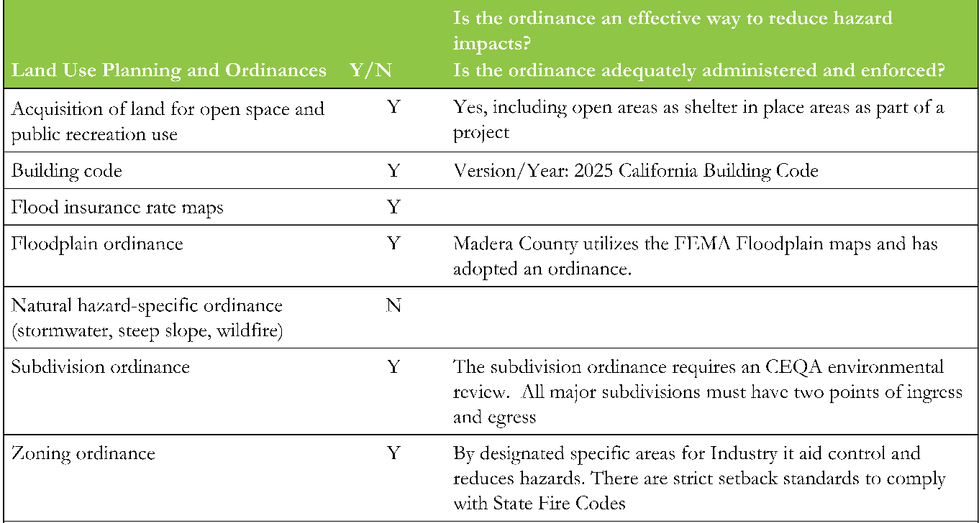

Step 2.3A: Reviewing Documents for Adaptive Capacity Insights
This step focuses on identifying and reviewing documents that describe existing or planned policies, plans, and programs related to climate resilience, hazard management, and community wellbeing. Relevant information may come from local, regional, State, Tribal, or federal sources, and from both governmental and non-governmental entities.
Use the documents collected in Step 2.1A Review Existing Documents. Focus on documents most relevant to the community’s priority hazards and local context summarized in Step 2.1 Wrap Up. Review these documents for insights into local adaptive capacity, including existing capabilities, resources, governance structures and opportunities for improvement. The table below identifies additional local documents that can inform the assessment of adaptive capacity.
Table 9. Local Documents to Review for Adaptive Capacity
Local Standards, Ordinances, and Programs | Sector-Specific Plans:
- Capital Improvement Programs  - Zoning Codes  - Building Codes  - Fire Codes  - Tree Ordinances  - Urban Heat Island Ordinances  - Floodplain Ordinances  - Stormwater Management Programs | - Urban Water Management Plans  - Integrated Regional Water Management Plans (IRWMPs)  - Transit and Regional Transportation Plans  - Public Health and Safety Plans (e.g., Community Health Assessments)  - Emergency Services Plans  - Fire Management Plans  - Floodplain Management Plans  - Open Space and Land Management Plans  - Sustainable Communities Plans (SB 375)  - Downtown or Corridor Plans
In addition to formal plans and assessments, local news sources and technical studies can provide helpful insight into adaptive capacity. News reports documenting past hazard events, such as flood locations, wildfire impacts, or other climate-related disruptions, can help identify recurring challenges, community impacts, and response efforts.
Studies prepared by colleges and universities, reputable nonprofit organizations, and State or regional agencies can also provide additional data, analysis, and perspectives to inform the assessment of existing strengths, gaps, and opportunities for building climate resilience.
Put It into Practice
See Appendix C - Reviewing Documents for Adaptive Capacity Insights
Use the table below to inventory the reviewed adaptive capacity related documents.
Document Name | Link | Scale (local, regional, State) | Sector (e.g., water, land use, public health) | Reason for Inclusion

Step 2.3B: Evaluating Adaptive Capacity Strategies
As documents are reviewed, focus on specific policies, programs, or strategies that help manage climate impacts. These may include incentives or rebate programs for resilience building, evacuation protocols, land-use regulations, infrastructure standards, water conservation policies, or public health interventions. For each strategy, consider the following:
- Which climate hazards are addressed?
- Is it designed to manage current climate impacts, future impacts, or both?
- Is the strategy already implemented, currently in progress, or planned?
- Are existing or planned projects climate-sensitive? What is their expected useful life?
- Do existing or planned projects reduce or increase vulnerability?
- Are there alternatives or design modifications that could improve climate resilience?
- Does it explicitly consider social vulnerability or equity?
- Does it explicitly consider vulnerable or historically underserved populations?
- How well are strategies working in practice today?
- What partnerships are recommended in the strategy?
- Where do implementation challenges exist?
- Are strategies expected to remain effective under future climate conditions?
- How well do strategies account for compounding or cascading impacts?
Integrating insights from the interviews will help distinguish between strategies that exist on paper and those that are meaningfully reducing risk in the community.
Additionally, where possible, integrate insights from partner interviews conducted in Step 2.2D. During that step, the planning team likely engaged with interviewees who can help them gain more insight into the community’s adaptive capacity.

Put It into Practice
See Appendix C –
Adaptive Capacity Strategies
Use the table below to pull out specific policies, programs, or strategies related to adaptive capacity that can, will, or have helped to manage the climate vulnerabilities in the community. Note: Some documents outline “goals” that are recommended but lack implementation plans. These can be noted, but it is recommended to indicate that the strategy does not have an implementation plan in the “Status” column.
Source (e.g., General Plan) and Plan Adoption Date | Relevant Policy or Strategy | Climate Impacts Addressed | Timeframe | Status (Implemented, In Progress) | Opportunities to Strengthen Strategy | Addresses Social Vulnerability?

Policy Connection: Tribal Hazard Mitigation Plans
Tribal hazard mitigation plans should describe the Tribe’s existing capabilities to reduce hazard risks, including both pre-disaster and post-disaster policies and programs. These may include land use and environmental protection regulations, floodplain management and building codes, participation in the National Flood Insurance Program (NFIP), as well as recovery planning, grants management capacity, and long-term recovery procedures.
The Tribal Mitigation Planning Handbook notes that each Tribe has unique capabilities that should be reviewed to identify existing resources, gaps, and priorities for reducing losses. These include planning, regulatory, and program tools such as ordinances, policies, land use and natural resource plans, economic development strategies, emergency management systems, culturally grounded practices, and communication methods that support preparedness and mitigation.

Step 2.3C: Outreach and Engagement
Climate adaptation planning is most effective when it is shaped with communities, not just for them. Developing an equitable outreach and engagement approach ensures that adaptation priorities reflect local knowledge, lived experience, and community-defined needs, particularly those of populations most affected by climate impacts. To ground-truth the analysis on adaptive capacity, climate impacts, and social sensitivity with lived experience, engage community members to identify:
- Local knowledge of climate impacts
- Neighborhood strengths and assets
- Community-defined priorities, concerns, and ideas for adaptation.
- Innovative local practices or community-led solutions that could be expanded or replicated elsewhere.
Step 1.3A created a community outreach plan. Review the events and activities outlined in the plan and look at where to make modifications to ensure that the planning team collects information that can add to the assessment of climate vulnerabilities. Consider if other changes to the community outreach and engagement plan are needed based on the vulnerability assessment, for example, to reach populations and neighborhoods identified as particularly vulnerable in the assessment. Refer to Appendix A - Best Practices for Conducting Outreach and Engagement Activities for more information on the types of events and activities that can be conducted.

Step 2.4: Prioritize Climate Vulnerability
Goal: Identify priority climate vulnerabilities based on the information collected in previous steps.
This step prepares a table summarizing vulnerabilities. It then walks through the process of vulnerability scoring, which is one strategy that can be used to prioritize major climate vulnerabilities to address in Phase 3. This step also provides examples of California entities who have used vulnerability scoring for prioritization of climate vulnerabilities.

Step 2.4A: Summarize Vulnerability
For each of the climate hazards of concern to the community, produce a table that summarizes vulnerability by describing the following. There is no new work being done in this step; simply gather information from the tables created in Step 2. An example is included below.
- Exposure: the projected severity of climate hazards in the community (see Step 2.1)
- Population and community assets: the populations and assets associated with the potential climate hazard and its location(s) (see Step 2.2)
- Vulnerability and potential impact: how the population and community assets might be affected by a climate hazard given the characteristics of the community (e.g., social vulnerability). Additionally, consider the implications for the community from the potential impacts of the climate hazard, including consequences for public safety, human health, ecosystem services, continuity of public services, costs to the local government or borne by the public, and other impacts identified in Step 2.2.
- Adaptive capacity: existing ability to manage the potential impacts of the climate hazard (see Step 2.3)
Table 11. Example of extreme heat climate hazard in Sacramento, CA
Exposure, Sensitivity, and Adaptive Capacity | Results
Is this climate hazard present in the area of interest (Yes/No) now or in 2050? | Yes
What specific neighborhoods are affected in the current timeframe? | ALL
How are they affected? (HIGH Climate & HIGH Social, MED Climate & HIGH Social, etc.) | Most of area has high heat hazard. The Lemon Hill, North Highlands, Diamond Springs, and Arden Arcade neighborhoods also have high social vulnerability to heat and therefore have the high-high vulnerability designation,
How does vulnerability change between now and 2050? | Remains overall high, the few remaining medium areas are converted to high.
Detailed Climate Projections | - Average Max Temp (°F): increases from 74.1 in baseline to 79.3 in mid-century  - Extreme Heat Days frequency (#days): Increases from 4 days in baseline to 22 days in mid-century  - Extreme Heat Days duration (#days); Increases from 2 days in baseline to 7 days in mid-century
Secondary and Cascading Hazards | - Power outages; high demand for air conditioning and possible damage to electric infrastructure from heatwaves  - Poor air quality; increased heat and stagnant air can trap pollution and elevate ground-level ozone.
What specific social factors are driving vulnerability in this area? | Many limited English-speaking households in the Lemon Hill, Parkway, Florin, and Old North Sacramento neighborhoods (10-15%). Extreme heat health index is high in those neighborhoods as well as the Arden Arcade, Carmichael, Rancho Cordova, and North Highlands (60-80th percentile). Percent of outdoor workers is also high in those areas (30-40%).
Exposed Assets and Impacts | - Public Schools: Mark Twain elementary school, west campus high school, pacific elementary school  - Libraries: Colonial Heights library, Southgate library, Arcade library  - Community Clinics: Sacramento Community Clinic, Refugee Health Clinic, One Community Health
Adaptive Capacity Insights from Interviews | - Interviewee emphasized the need for shade at bus stops for low-income residents who are dependent on public transit.  - Interviewee mentions many people are unable to make it to cooling centers at libraries because they are inconveniently located and instead go to cafes or movie theaters to cool down on hot days.
Adaptive Capacity Insights from Document Review | Sacramento Climate Action and Adaptation Plan  - Cool Libraries. The City shall work with the Sacramento Public Library (SPL) to facilitate the incorporation of cooling techniques into neighborhood library facilities.  - Tree Canopy Expansion. The City should strive to achieve a 25 percent urban tree canopy cover by 2030 and 35 percent by 2045.  - Bus Shelter Design – The City shall encourage Sacramento Regional Transit District (SacRT) to study the feasibility of designing and installing bus shelters that are designed to offer protection and relief from heat, including the incorporation of shade trees.

Step 2.4B: Prioritization
One strategy that can be used to prioritize climate vulnerabilities is vulnerability scoring. Vulnerability scores are based on the combination of potential impact and adaptive capacity and help identify the major climate vulnerabilities to address.
Although this step discusses a quantitative scoring process, it is possible to use qualitative approaches for prioritization. For example, some organizations may find it beneficial to instead convene partner groups and identify key priorities through facilitated discussion. This approach may be appropriate for situations where partner input is particularly emphasized, where assessments need to be completed quickly, or where the information available is simply not conducive to a more systematic scoring approach.
While quantitative data and mapping tools provide valuable insights, they should not be viewed as neutral or fully representative of community experiences. Combining quantitative analysis with qualitative information can provide a more complete understanding of community needs.
Step 2.4A produced tables for each climate hazard and the related populations and assets at risk. Step 2.4B uses potential impact and adaptive capacity to produce vulnerability scores. It is ultimately up to what the planning team decides to focus on – they might evaluate and score each population or asset depending on the goals of the assessment. This scoring can help clarify which climate impacts pose the greatest threats and should be prioritized in adaptation planning.
To score potential impact and adaptive capacity, use the rubric in Table 12 as a guide, but adjust the scoring system to the circumstances. For example, if using three scoring levels is not enough, the system can expand to four, five, or more levels. Criteria can be customized to reflect the community's specific goals, including quantifiable metrics related to safety, costs, or other factors. Different inputs can help with the scoring process, depending on the planning team’s capacity and partner engagement. The scoring process is based on the team’s judgment, so it is a good idea to seek a broad range of inputs, including those of community members and any scientific studies that assess climate change impacts.

Table 12. Potential impact and adaptive capacity scoring rubric
Score | Potential | Adaptive Capacity
Low | Impact is unlikely based on projected exposure; would result in minor consequences to public health, safety, and/or other metrics of concern. | The population or asset lacks capacity to manage climate impact; major changes would be required.
Medium | Impact is somewhat likely based on projected exposure; would result in some consequences to public health, safety, and/or other metrics of concern. | The population or asset has some capacity to manage climate impact; some changes would be required.
High | Impact is highly likely based on projected exposure; would result in substantial consequences to public health, safety, and/or other metrics of concern. | The population or asset has high capacity to manage climate impact; minimal to no changes are required.
After scoring the potential impact and adaptive capacity for each population and asset for the relevant climate hazards, use the matrix in Table 13.
Table 13. Vulnerability score matrix example
 | High Adaptive Capacity | Medium Adaptive Capacity | Low Adaptive Capacity
High Potential Impacts | 3 | 4 | 5
Medium Potential Impacts | 2 | 3 | 4
Low Potential Impacts | 1 | 2 | 3
Record a description of each population and asset and the associated potential impact, adaptive capacity, and vulnerability scores in a table such as the one below.
Table 14. Vulnerability scoring worksheet example
Vulnerability Description | Potential Impact Score | Adaptive Capacity Score | Overall Vulnerability Score
Flooding preventing entry to emergency operations center | Medium | Medium | 3
Wildfire inhibiting provision of key public services | High | Low | 5
These scores will be used to determine which vulnerabilities are most pressing and should be prioritized for designing adaptation strategies in Phase 3.
Put It into Practice
See Appendix C – Prioritize Climate Vulnerability
Use the table below to describe vulnerabilities, assign them a Potential Impact Score and Adaptive Capacity Score, and then combine those scores to create an Overall Vulnerability Score.
Vulnerability Description | Potential Impact Score | Adaptive Capacity Score | Overall Vulnerability Score

Here are two case studies highlighting prioritization efforts by regional and county governments in California.
Case Study: Western Riverside Council of Governments (WRCOG)
The Southern California Association of Governments (SCAG) created the Southern California Climate Adaptation Planning Guide in October 2020. The Western Riverside Council of Governments (WRCOG) utilized SCAG’s Vulnerability Scoring process to create impact and adaptive capacity scoring tables (Table 15 and Table 16, respectively) in their 2025 Western Riverside Adaptation and Resiliency Strategy: Part 1, Vulnerability Assessment.
First, WRCOG developed their own impact scoring table, building on the framework below.

Table 15. Impact (IM) scoring table developed by WRCOG
IM Score | Summary (Buildings and Infrastructure, Economic Assets, Community Services) | Summary (Populations and Biological Resources)
IM0 | Impacts are minimal. There are no service disruptions that community members are aware of. | All impacts are minimal. Community members may not notice effects.
IM1 | Performance or services may be somewhat degraded on occasion. | Community members notice minor impacts. There may be mild disruptions to some behaviors or actions.
IM2 | The asset is likely to experience chronic stress, limiting the ability to reliably function. Effectiveness may be entirely disrupted on occasion. | There is a marked decline in overall quality of life. Reductions to health, public safety, and/or community viability are likely.
IM3 | The asset may only function in a limited way. It may frequently or always be unable to meet community needs | There is a substantial drop in the well-being of communities. Current lifestyles/habitat may no longer be viable.
IM4 | The ability of the asset to provide beneficial service is destroyed. | There is a severe risk of injury or death in human populations and of major habitat shifts or degradation for biological communities.
Next, WRCOG developed their own adaptive capacity scoring table, building on the framework below.

Table 16. Adaptive capacity (AC) scoring table developed by WRCOG
AC Score | Summary
AC4 | Assets and populations can adapt with little or no effort. Overall quality of life may improve as a result.
AC3 | Adaptive solutions are feasible for most or all sensitivities. Some sensitivities may face limited challenges.
AC2 | Threats can be reduced or mitigated, but solutions are only feasible for some assets. Many assets are likely to face substantive difficulties in adapting.
AC1 | Adaptive solutions are expensive and/or technologically difficult, but feasible. Approach may require politically unpopular actions or widespread lifestyle changes.
AC0 | No method of adapting is currently feasible, although solutions may be possible in the future.

Finally, WRCOG applied their scoring tables to climate hazards for key populations. The vulnerability score is determined from the impact and adaptive capacity scores; high impact and low adaptive capacity equate to a high vulnerability score. For example, they evaluated the vulnerability of unhoused persons to extreme heat using their rubric and produced the vulnerability scoring below, where impact (IM4) and adaptive capacity (AC1) equated to a vulnerability score of V5.
Table 17. Example of vulnerability scores applied to climate hazards for key populations in WRCOG
Vulnerability Score | V5
Sensitivity | Unhoused Persons
Sensitivity Type | Population
Impact | Unhoused persons lack permanent, and often temporary, shelter, which leaves them more exposed to extreme heat. Dehydration is common among persons experiencing homelessness, which can complicate existing medical conditions. Unhoused persons are more likely to suffer from respiratory and other illnesses, which can be exacerbated during periods of extreme heat. Unhoused persons often lack access to water, sunscreen, or protective clothing such as hats, further increasing their exposure to extreme heat events.
Impact Score | IM4
Adaptive Capacity | Persons experiencing homelessness do not have regular access to cool indoor location. Riverside has various unhoused shelter locations that can provide shelter from extreme heat conditions. However, unhoused persons may not have adequate communication to know about them or may be unable to travel to these locations.
Adaptive Capacity Score | AC1

Case Study: San Diego County’s Vulnerability Assessment and Adaptation Report
The 2021 County of San Diego Vulnerability Assessment and Adaptation Report used vulnerability scoring. See an example of one of their vulnerability score tables below focused on population impacts.
Table 18. Example of vulnerability score table focused on population impacts in San Diego County
Vulnerability Description | Potential Impact | Adaptive Capacity | Vulnerability
Increased human health risk (i.e., poor air quality, infectious diseases, mental health concerns, limited access to potable water, heat-related illnesses) | High | Medium | 4
Reduced available water supply from extended drought periods | High | High | 3
Increased exposure to flood risk from extreme precipitation and sea level rise | Medium | High | 2
Increased exposure of people to landslides | Medium | High | 2
Increased exposure of people to wildfires | High | Medium | 4
Lack of electricity during Public Safety Power Shutoffs implemented during times of high wildfire risk | High | Medium | 4
Limited ability to prepare for climate events and to respond and evacuate | Medium | High | 2
The County elected to prioritize climate vulnerabilities that received an overall score of four or higher. These are climate vulnerabilities where impacts to populations and assets would be severe and where few or insufficient existing policies and programs are in place to address the vulnerabilities. By focusing on the highest scoring climate vulnerabilities, the County can better prioritize where adaptation efforts should be made. The highest scoring climate vulnerabilities identified were:
- Increased human health risk (i.e., poor air quality, infectious diseases, mental health concerns, limited access to potable water, heat-related illnesses)
- Increased exposure of people to wildfires
- Lack of electricity during Public Safety Power Shutoffs (PSPS) events implemented during times of high wildfire risk
- Increased demand for electricity generation during extreme heat events
- Reduction in available water supply
- Loss of vegetation and habitat
- Increased exposure of emergency responders to heat-related sickness, smoke inhalation, and infectious disease

Phase 2 Wrap-Up
The vulnerability assessment is the process that provides participants with details of how a community may be impacted by climate change. Through this analysis, communities can identify the most vulnerable populations and assets, and which climate hazards may be most impactful. This can be the most technical and data intensive phase of adaptation planning, but with resources like the Vulnerable Communities Platform, the process can be streamlined and made more accessible. Community engagement during this phase can help refine the analysis and make sure it more accurately reflects conditions of communities. Using the results from the vulnerability assessment, communities can develop an adaptation framework and strategies, following the process discussed in Phase 3.

PHASE 3: ADAPTATION FRAMEWORK AND STRATEGIES
The goal of Phase 3 is to develop the adaptation framework, a structure for identifying, organizing, and prioritizing projects, plans or actions that can be implemented to reduce climate vulnerabilities and increase community resilience. Through Phases 1 and 2, the planning team identified the community’s vision, desired outcomes for the adaptation planning process, and assessed vulnerability to climate change. Phase 3 uses those findings to inform the preparation of the adaptation framework and strategies, consistent with the vision, goals, and desired outcomes of the community.
An adaptation framework provides the overall approach for moving from vulnerability assessment to implementation. It connects the community’s climate risks, goals, and priorities with the actions needed to build resilience. Within this framework:
- Goals define the desired long-term outcomes the community seeks to achieve through adaptation.
- Adaptation strategies are the specific policies, programs, projects, measures, or actions that advance these goals by reducing climate vulnerabilities and increasing resilience.

This chapter describes the steps for developing and prioritizing strategies (see Figure 19). The primary steps are: 1) summarize vulnerability findings, 2) review vision and goals, 3) develop adaptation strategies, 4) prioritize adaptation strategies, and 5) conduct outreach and engagement.
Figure 19. Steps in Phase 3

STEP 3.3D
OUTREACH & ENGAGEMENT
STEP 3.4
PRIORITIZE STRATEGIES
STEP 3.2
REVIEW VISION & GOALS
STEP 3.3
PREPARE STRATEGIES
STEP 3.1
SUMMARIZE VULNERABILITY

How to Use the Appendices in This Phase
Appendix A: Outreach and Engagement: Consult Appendix A at Engagement Touchpoint, Step 3.3D for additional guidance on engagement.
Appendix C: Worksheets: The Draft Adaptation Strategies worksheet supports this phase. Look for the green Put It into Practice boxes for when to use it.

Policy Connection: General Plan Safety Elements and Climate Adaptation
As noted earlier in the APG, California Government Code § 65302(g)(4) requires local jurisdictions to review and update their safety elements upon the next revision of an LHMP on or after January 1, 2017, or if a local jurisdiction has not adopted an LHMP, beginning on or before January 1, 2022, as necessary to address climate adaptation and resiliency strategies. The review and update should include preparation of the following:
- A vulnerability assessment
- A set of adaptation and resilience goals, policies, and objectives based on the information identified in the vulnerability assessment for the protection of the community
- A set of feasible implementation measures designed to carry out the goals, policies, and objectives including, but not limited to, all of the following:
  - Feasible methods to avoid or minimize climate change impacts associated with new uses of land
  - The location, when feasible, of new essential public facilities outside of at-risk areas, including, but not limited to, hospitals and health care facilities, emergency shelters, emergency command centers, and emergency communications facilities, or identifying construction methods or other methods to minimize damage if these facilities are located in at-risk areas
  - The designation of adequate and feasible infrastructure located in an at-risk area
  - Guidelines for working cooperatively with relevant local, regional, state, and federal agencies
  - The identification of natural infrastructure that may be used in adaptation projects, where feasible. Where feasible, the plan shall use existing natural features and ecosystem processes, or the restoration of natural features and ecosystem processes, when developing alternatives for consideration. Natural infrastructure means the preservation or restoration of ecological systems, or utilization of engineered systems that use ecological processes, to increase resiliency to climate change, manage other environmental hazards, or both. This may include, but is not limited to, flood plain and wetlands restoration or preservation, combining levees with restored natural systems to reduce flood risk, and urban tree planting to mitigate high heat days.

Step 3.1: Summarize Vulnerability
Goal: Summarize vulnerabilities from previous phase in a concise problem statement for the planning team.
A helpful first step in developing the adaptation framework is to review the priority climate vulnerabilities identified in Step 2.4 from the vulnerability assessment. For example, the planning team may have identified that unhoused populations are particularly vulnerable to extreme heat in the community (see Step 2.4 example from Western Riverside Council of Governments). Now, the planning team should summarize all the information from Step 2.4 so that the community can clearly see its biggest vulnerabilities.
One helpful way to summarize vulnerabilities is by writing problem statements. The purpose of the problem statements is to provide concise descriptions of climate vulnerabilities and their causes. For example, problem statements might highlight which critical community infrastructure is at risk to specific climate hazards and the impact on the community if the infrastructure is disrupted. Problem statements can also address how well the community is prepared to deal with the problem and identify opportunities for new policy and strategies. Ultimately, problem statements help to provide a shared understanding between partners, decision-makers, and members of the planning team. If needed, these problem statements should be translated into whatever primary language(s) the community speaks.
A problem statement may also summarize known or suspected causes or contributing factors, often informing policy discussions and decisions. These causes are not always straightforward and identifying them can inform fundamental policy debates and action. For example, severe wildfires in California have become more frequent, but the relative influences and factors such as climate change, increased development in the wildland-urban interface, and forest management practices vary by community. These differences drive policy choices, for example, whether to focus on land use and development or on controlled burns and forest thinning. Several adaptation planning resources recommend summarizing the vulnerability assessment in these short statements to explain vulnerabilities and their consequences, including the Local Mitigation Planning Handbook, the 2019 Regional Resilience Toolkit, and BCDC’s Adapting to Rising Tides Guide.

Case Study: Ramona-Barona Climate Adaptation and Resilience Plan
In 2026, the Ramona Municipal Water District and the Barona Band of Mission Indians co-developed the Ramona-Barona Climate Adaptation and Resilience Plan (CARP) that provides a strategic roadmap for enhancing resilience in their rural region of unincorporated San Diego County.
Problem Statement: “Wildfire poses one of the most urgent and escalating threats to both Ramona and Barona. As climate change drives hotter, drier conditions, wildfires are becoming more frequent, intense, and unpredictable. These threats are placing lives, homes, infrastructure, and ecosystems at increasing risk. The region’s emergency response capabilities are further strained by limited and vulnerable evacuation routes. Key corridors such as SR 78, SR 67, and Wildcat Canyon Road have historically proven inadequate during wildfire and flood events, creating dangerous bottlenecks and delaying critical response times. Public Safety Power Shutoff (PSPS) events, triggered to reduce wildfire risk, further exacerbate these challenges. These conditions illustrate the area’s high exposure to wildfire, the sensitivity of critical transportation routes, and limited capacity to adapt or respond during emergencies, underscoring the need for proactive planning, infrastructure investment, and community preparedness to protect residents and build long-term resilience.”
Drafting problem statements helps reveal relationships and patterns of vulnerability and consider the types of adaptation strategies needed. Ultimately, this organization of vulnerabilities will help craft effective strategies to increase resilience. Doing so provides the following benefits:
- Communicate critical planning issues, for example, which critical assets are particularly vulnerable, what areas currently have repetitive losses, or how many high-hazard areas are currently zoned for future development.
- Assist the community and partners in prioritizing and focusing on the areas that have the greatest need for adaptation based on the vulnerability assessment and climate change impacts.
- Create a clear and cogent “story” to help support decision-making by elected officials and other partners.
- Provide a foundation for seeking funds to reduce the potential for harm and increase community resilience.

Step 3.2: Review Vision and Goals
Goal: Refine plan vision and goals.

Step 3.2A: Review Vision
The objective of this step is to review the community’s vision for adaptation and resilience. Phase 1 included preparing a vision or definition of what adaptation and resilience mean to the community. In Phase 3, reviewing or refining the vision helps frame how to address the issues in the vulnerability assessment. If the community did not prepare a vision statement during Phase 1, now is a good time to do so.

Step 3.2B: Draft Goals
While the vision statement describes what the community wants to achieve as a desired future state, goals provide concrete direction for achieving that vision. Clear, shared goals established with input from the planning team, partners, decision makers and the public guide development of implementable strategies.
The 2017 General Plan Guidelines define a goal as a “general direction-setter.” It is an ideal future end related to public health, safety, or general welfare. A goal is a general expression of community values and may be abstract in nature. It may not be quantified or time-dependent. Refer to the examples below to get started and inspire the goals:
- Physical areas (e.g., new development along the shoreline, natural resource areas, or assets)
- Asset classes (e.g., infrastructure, natural resources)
- Social values (e.g., protecting parks because beauty and recreation are highly held values)
- Economic values (e.g., protecting major economic drivers like large businesses)
- Character, history, sense of place (e.g., protecting historic structures or neighborhoods)
- Existing functions/activities (e.g., emergency services)
- Specific communities (e.g., vulnerable populations)
Below are some suggestions and tips to guide in drafting goals:
- Plan Updates: If the plan is being updated, the planning team should review the previous goals and confirm or revise them to reflect current conditions and priorities.
- Risk assessment findings: Group the problem statements from Step 3.1 by themes, such as climate change effects, populations and types of assets. Several problem statements or groups may lead to a single adaptation goal.
- Outreach findings: Consider themes that emerged during planning team meetings, partner meetings, and public engagement. For example, a recurring theme might be improving education and raising awareness of climate risks.
- Community goals: Review existing goals in the community’s planning documents, such as general plans and transportation plans.
- It can be helpful to review goals from state-level planning documents, as they can give ideas or guidance for the community’s goals. For local or Tribal hazard mitigation plans, consider looking at Part 4 of the State Hazard Mitigation Plan. When developing a Climate Adaptation Plan, review the state’s 2024 California Climate Adaptation Strategy priorities and goals.
Overall, the goals should directly respond to the risks to the community identified in the vulnerability assessment by increasing adaptive capacity, protecting assets, and reducing impacts from hazards and other climate change effects. Goals should be clear and accessible to partners and the public. The goals will be supported by strategies developed in Step 3.3.
Case Study: Lake County Climate Adaptation Plan
The Lake County Climate Adaptation Plan from 2026 provides a comprehensive, collaborative framework for addressing Lake County’s most pressing climate hazards and their impacts on social well-being, natural resources, and the economy. Organized around the County’s Pillars of Landscape Resilience, the countywide adaptation goals, strategies, and actions emphasize feasible, cost-effective solutions that protect vulnerable populations, safeguard natural and cultural resources, diversify the economy, and strengthen essential services. Each of the ten overarching goals has multiple strategies with implementation actions that address existing policies and programs and identify gaps and vulnerabilities.
Lake County Climate Adaptation Goals:
  - Air Quality: Advance community resilience to smoke and poor air quality events.
  - Biodiversity Conservation: The county’s network of native species and ecological communities is healthy, abundant, and distributed across the landscape to support and sustain their full ecological and cultural roles, furthering countywide climate resilience.
  - Carbon Sequestration: Enhanced carbon sequestration capacity across forests, agricultural and working lands, and wetlands to support climate resilience and provide other ecological and community benefits.
  - Economic Diversity: A sustainable and resilient natural resource-based economy.
  - Fire-adapted Communities: Fire-prepared and resilient communities with the capacity to manage desired fire and suppress unwanted fire while protecting lives, housing, and critical infrastructure.
  - Fire Dynamics: Fire burns in an ecologically beneficial and socially acceptable way that perpetuates landscape heterogeneity and rarely threatens human safety or infrastructure.
  - Forest Resilience: Resilient forest ecosystems that provide essential ecosystem services, support cultural heritage, and sustain economic opportunities.
  - Social and Cultural Well-being: A community connected with nature to recreate, maintain, and improve overall health and contribute to environmental stewardship as a critical component of their identity.
  - Water Security: Reliable, safe, and equitable access to clean, potable water for all Lake County communities.
  - Wetland Integrity: Protected and restored wetland and riparian ecosystems provide essential ecosystem services, provide natural climate resilience benefits, and are key linkages between upland and aquatic systems in forested landscapes.
When designing goals, it is essential to consider how they will be monitored and tracked for effectiveness. Some communities may prepare one or more “objective” statements for each goal. These objective statements are meant to be specifically measurable in some way that shows progress toward the goal. For example, a goal to reduce community vulnerability to wildfires might include objectives for the percentage of homes that meet defensible-space best practices. Whether specific objective statements are prepared or not, the goal and strategy development process should proceed with consideration of how to develop specific, monitorable indicators of progress.

Step 3.3: Prepare Adaptation Strategies
Goal: Develop adaptation strategies informed by the vulnerability assessment, community priorities, and community and partner engagement.
With the community’s vulnerabilities, problem statements, and adaptation goals established, the planning team can begin developing adaptation strategies. Use the Vulnerability Assessment prepared in Phase 2 to identify priority areas for action and the problem statements developed in Step 3.1 to explore how those vulnerabilities could be addressed.
Adaptation strategies should reflect the community’s priorities, values, assets, and local context. Depending on the planning mechanism, strategies may take the form of policies, programs, projects, measures, or other actions that increase resilience. Because planning requirements vary, strategies should be developed in accordance with applicable laws, regulations and guidance. For example, strategies developed for a General Plan Safety Element should comply with the specifications in California Government Code § 65302(g)(4), while those prepared for a Hazard Mitigation Plans should be consistent with Local Mitigation Planning Policy Guide, or Tribal Hazard Mitigation Policy Guide. The following steps provide a framework for developing adaptation strategies that build on the outcomes identified in Phases 1 and 2, and can be integrated across multiple planning mechanisms.
Policy Connection: Local and Tribal Hazard Mitigation Plans
Local and Tribal Hazard Mitigation Plans are required to include mitigation goals, actions, and an implementation strategy to guide efforts to reduce harm from hazard impacts. It is suggested that vulnerability assessments, community outreach, and community or State-wide goals be used to inform mitigation measures.

Step 3.3A: Identify Opportunities to Strengthen Existing Strategies
Strategy development should identify existing projects that need climate-related adjustment. Refer to the strategies pulled from existing plans in Step 2.3B to assess adaptive capacity and identify opportunities to build on them. These opportunities might include:
- Expanding a strategy to address additional or secondary climate impacts
- Strengthening equity considerations or targeting underserved populations including individuals experiencing homelessness
- Improving coordination across departments or agencies
- Updating standards or thresholds to reflect future climate projections
- Aligning funding or capital improvement plans with climate risk priorities
- Identify strategies that have been planned but not implemented
Consider also where there are gaps in addressing climate impacts, and consider what strategies could respond to these gaps.
If a plan is being updated, a similar set of questions can help determine how to update strategies. Considering how strategies have performed, have they achieved the desired outcomes and reached the target population? If not, what barriers have impeded implementation or success?
Homelessness and Equity resources
Consider referring to and using the Homeless Emergency and Active Readiness Toolkit (HEART), to ensure plans address the needs of people experiencing homelessness, particularly people experiencing unsheltered homelessness. For additional guidance, including webinars, best practices, case studies, and other resources, visit the California Interagency Council on Homelessness.

Step 3.3B: Draft Adaptation Strategies
Each goal drafted in Step 3.2 should have a set of strategies to support its achievement. Strategies should respond to the problem statements prepared in Step 3.1. As part of strategy development, the planning team should answer these questions:
- Who will be responsible for the strategy?
- How will it be achieved?
- How will it be assessed?
- What is needed to accomplish it?

Strategy development should be an iterative, inclusive, and transparent process with the community. The initial phase may focus on brainstorming and generating a range of potential strategies that can be refined later in response to additional partner and community input, feasibility considerations, and the structure and requirements of the planning mechanism. As strategies are further developed, additional implementation details can be added, including responsible parties, resources, timelines, and performance measures. Engaging partners and the public throughout this process helps identify opportunities to integrate adaptation planning into multiple community programs and plans.
The examples below from the Local Mitigation Planning Handbook illustrate how problem statements can be used to identify a range of strategies.
Problem Statement: In wildland-urban interface (WUI) areas, two critical facilities (school and county maintenance shop), 200 low-income residents, and $500 million in property value are at risk from wildfires. Development pressure is also increasing.
- Potential Strategies:
  - Local Planning Regulations: Adopt a wildfire mitigation ordinance to limit the use and development of wildfire hazard areas to mitigate risk to life and property.
  - Structure and Infrastructure Projects: Retrofit the school and the county maintenance shop with fire-resistant construction materials and create a defensible space around the buildings.
  - Natural Systems Protection and Nature-based Solutions (NBS): Identify large tracts of vacant land in high-hazard areas. The Department of Parks can acquire the land to develop trails and preserve open space.
Case Study: Ramona-Barona Climate Adaptation and Resilience Plan
The Ramona Municipal Water District and the Barona Band of Mission Indians co-developed the Ramona-Barona Climate Adaptation and Resilience Plan (CARP) in 2026 that provides a strategic roadmap for enhancing resilience in their rural region of unincorporated San Diego County. Step 3.1 includes an example problem statement from their plan related to wildfire, their proposed strategies to address concerns with more frequent wildfires and inadequate evacuation routes are:
- “Implement vegetation management and home-hardening programs,
- Expand defensible space and fuel-break maintenance,
- Upgrade and add signs to evacuation routes, and
- Coordinate interagency response planning through the Ramona Fire Safe Council and countywide wildfire mitigation efforts.”

Types of Adaptation Strategies
It is important to identify and analyze a range of strategies to address the impacts identified in the Vulnerability Assessment. Even when resources, funding, or support are not immediately available, identifying a broad set of potential strategies allows the community to pursue future funding and implementation opportunities.
It is common to categorize strategies in response to different implementation options. The 2019 Regional Resilience Toolkit provides examples of strategy categories or types:
- Programmatic: Strategies to expand or create new programs, activities, and initiatives
- Plans, regulations, and policy development: Strategies to develop or revise policies, plans, regulations, and guidelines
- Capital improvement/infrastructure projects: Strategies designed to address physical and functional deficiencies and needs in the built and natural environment
- Education/outreach/coordination: Strategies related to initiating or expanding partnerships and relationships, communicating and sharing information, and expanding awareness
- Evaluation: Strategies to improve feedback, input, and data and information or conduct further or new analyses

Multi-Benefit Strategies and Co-Benefits
Multi-benefit strategies are intentionally designed to achieve multiple outcomes at once. In addition to reducing vulnerability to climate hazards, they can advance equity, public health, ecosystem health, carbon reduction, and overall community well-being.
A co-benefit is an additional benefit that increases resilience. When evaluating adaptation strategies, the planning team should consider other benefits they may provide, as well as potential tradeoffs. Potential co-benefits and multi-benefits may include, but are not limited to:
- Cost savings
- Air quality improvement
- Water quality protection
- Stormwater management
- Increased public safety
- Recreation, open space, and tourism
- Greenhouse gas emissions reduction
- Public health improvement
- Enhanced or restored natural systems
- Economic continuity
Ideally, all strategies will have one or more co-benefits. In some cases, the co-benefit may be more compelling than the primary adaptation benefit. For example, identifying land for preservation as open space to serve as a wildfire buffer can also provide valuable co-benefits, such as creating recreational areas and enhancing overall community well-being.
Case Study: City of West Sacramento Climate Action and Adaptation Plan
In June 2025, the City of West Sacramento Climate Action and Adaptation Plan: Roadmap to Reduce Greenhouse Gas Emission & Strengthen Climate Adaptation and Resiliency was published. They displayed their 26 CAAP actions in a matrix to show how each supports up to 7 co-benefits. Their first 10 actions are captured in Figure 20.
Figure 20. West Sacramento’s CAAP displays actions vs co-benefits
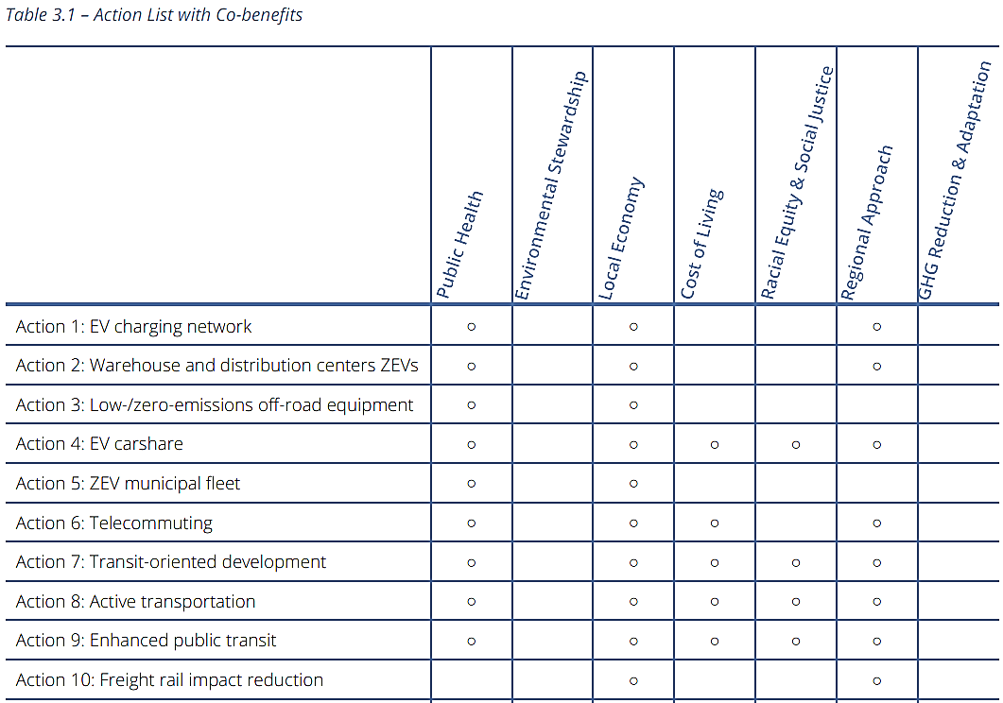

Clearly showing co-benefits of strategies is effective for communicating to the public and decision-makers the value of investing in climate adaptation planning. Co-benefits can advance broader community planning goals, reinforcing the principle of integrating climate adaptation across all plans and policies while delivering multiple, complementary outcomes for the community.

Nature-Based Solutions (NBS)
Nature-based solutions that deliver on California’s climate change goals are land management practices that increase the health and resilience of natural systems, which supports their ability to buffer climate impacts and serve as a durable carbon sink (lands that absorb more carbon than they release) (California Climate Adaptation Strategy, 2024).
One of the strategy’s North Star priorities, “Accelerate Nature-Based Climate Solutions and Strengthen Climate Resilience of Natural Systems,” encourages adaptation measures that protect natural and managed ecosystems, reduce community exposure to hazards, durably store carbon, and enhance equity and public health.
Case Study: Wildlife Connectivity as a Nature-Based Solution in the Coachella Valley
In desert and semi-arid landscapes, wildlife connectivity is a critical nature-based climate adaptation strategy. Maintaining connected habitat and movement corridors enables species to shift their ranges in response to changing climate conditions, including movement northward and upslope to track suitable habitat. As climate change alters species distributions, conserving and restoring landscape connectivity increases ecosystem resilience by facilitating dispersal, maintaining genetic exchange, and improving long-term species persistence. Species distribution modeling and climate refugia analyses can be used to identify and prioritize corridor investments where they will provide the greatest adaptation benefits.
Recent scientific analyses further demonstrate the need for this strategy. Biodiversity modeling conducted for the Desert Conservation and Resilience Initiative projects that approximately 90 percent of desert indicator plant species will shift their distributions northward within the Coachella Valley under future climate conditions.
Complementary genetic studies of the Palm Springs pocket mouse and Coachella Valley round-tailed ground squirrel are evaluating whether existing corridors are effectively supporting these climate-driven movements.
The Coachella region has embedded this approach within the region’s multi-agency conservation framework and is being implemented through several coordinated initiatives:
- Land protection efforts, including the acquisition of nearly 160 acres within the Upper Mission Creek/Big Morongo Canyon Conservation Area to complete the Morongo Wash wildlife corridor.
- The SR-62 Wildlife Crossing Project, led by Coachella Valley Mountain Conservancy in partnership with the Mojave Desert Land Trust and the Wildlife Conservation Board, will improve connectivity across an important elevational gradient linking the low desert to surrounding mountain ecosystems.
- The 2025 Coachella Valley Multiple Species Habitat Conservation Plan Wildlife Connectivity Assessment identified priority crossing locations along Interstate 10 in the Banning Pass, where design work is now underway to improve wildlife movement through Stubbe Wash and the Whitewater River corridor.
Determining the Appropriate Level of Detail for Adaptation Strategies
Some strategies look like general statements of policy preference or desired direction, and others are highly detailed and contain specific implementation direction.
Case Study: Safety Element Strategies
The following strategies are from the Town of Mammoth Lakes Safety Element, updated in 2019.
General Statements:
- Establish public outreach and education programs to inform residents, businesses, and visitors of air quality alerts.
- Support sustainable and feasible forest thinning by product economies and markets to create a revenue stream for mechanical treatments required to meet wildfire mitigation and protection needs.
- Increase the groundwater recharge potential within the Town boundaries and surrounding areas.
- Encourage a drought tolerant and fire-resistant landscaping demonstration garden to encourage public participation in water conservation and fire preparedness efforts.
Detailed Implementation Direction:
- Expand the Mammoth Lakes Mosquito Abatement District to include all areas within the Town boundary.
- Encourage Mammoth Community Water District to add water wells to increase water supply reliability during drought years.
- Improve wildfire management coordination between the Town, the Great Basin Unified Air Pollution Control District, Cal FIRE, and U.S. Forest Service (USFS), to mitigate economic impacts of prescribed or managed fires.
- Work with Mammoth Lakes Fire Protection District to create a Land Inventory using GIS to identify fuel reduction status and points of contact.
Where possible, strategies should provide details about who is responsible for the strategy and how it will be achieved and measured. Considering how strategies are measured and assessed is important in this phase of the planning process (more information on strategy assessment is in Phase 4.3). Providing these details supports implementation. When not included, additional engagement, assessments, or studies may be necessary to progress strategies.
Put It into Practice
See Appendix C – Draft Adaptation Strategies
Use the table below to help develop strategy details.
Problem Statement: This is the problem statement that the strategy is responding to. This should come out of the risk assessment and reflect community goals.
Strategy Statement
Strategy Result or Objective: A short description of what the strategy is designed to achieve
Hazards Addressed
Lead Agency: Which agency has the authority, capacity, and knowledge to implement.
Partners: Those who have some decision-making authority, political influence, policy or regulation authority, or who can assist with implementation
Implementation Timeframe (e.g., Ongoing, Short-Term, Mid-Term, Long-Term, # of years/months, etc.)
Co-Benefits
Monitoring Metrics
Cost Estimate / Potential Funding Sources

Example Adaptation Strategies
Adaptation strategies from other communities can be a helpful starting point as the planning team drafts adaptation strategies tailored to the community’s circumstances. Additionally, the 2019 Regional Resilience Toolkit, Tribal Resilience Action Database, Local Mitigation Planning Handbook and Tribal Mitigation Planning Handbook have worksheets and tools to support strategy development. These worksheets provide sources for and examples of strategies that address common hazards and assets.
Strategies will require adjustment or greater specificity for application in a community. Communities should expect to go beyond these strategies to address all their high-priority adaptation needs. This may include bolstering programs that are already locally effective or developing innovative strategies based on characteristics.

Additional Resources for Adaptation Strategy Development
- California Climate Adaptation Clearinghouse
- State General Plan Guidelines, Appendix A: Example Model Goals, Objectives, and Policies and Programs
- DWR Climate Change Program's Resources for Water Managers
- U.S. Climate Resilience Toolkit
- Climate Adaptation Knowledge Exchange (CAKEx)
- Georgetown University’s Adaptation Clearinghouse
- Urban Sustainability Directors Network’s Guide to Equitable, Community-Driven Climate Preparedness Planning
- NAACP’s Our Communities Our Power: Advancing Resistance and Resilience in Climate Change Adaptation Action Toolkit
- Local and Regional Government Alliance on Race & Equity’s Racial Equity: Getting To Results
- The Greenlining Institute’s Making Equity Real in Climate Adaptation and Community Policies and Programs: A Guidebook
- BCDC’s Regional Shoreline Adaptation Plan
- Shoreline Adaptation and the Public Trust: Protecting California’s Public Trust Resources from Sea Level Rise
- California Natural Resources Agency’s (CNRA’s) Strategies for Climate Action page for state climate-action resources.
- Climate Adaptation Strategies for Transportation Infrastructure
- DWR Climate Action Plan and GHG Emission Reduction Plan

Step 3.3C: Equity Considerations in Strategy
Vulnerability has underlying historical roots that should be considered when developing strategies. The Movement Strategy Center, an organization that supports visions and relationships necessary to move from incremental change to transformation, describes vulnerability as a consequence and not a condition. This approach encourages adaptation strategies that address the root causes of climate risk and not only responding to its immediate impacts. For example, a community that has been underserved by health care may be more vulnerable to health impacts from extreme heat events.
Consider setting large-scale goals for the entire community, but targeted strategies are needed to meet those goals for underserved and socially vulnerable populations. For example, a plan could set a goal of making sure that all residents, workers, and visitors can access safe, cool spaces during a heat wave. While the wealthiest residents most likely have access to private homes with air conditioning, lower-income residents may lack such resources. Cooling centers are a common strategy to deal with the immediate impacts of heat, but this may not meet the needs. These spaces also need to be accessible to those who need them. Consider accessibility to people with disabilities, public transit availability and proximity. Also consider ways to provide travel vouchers, availability of wi-fi and charging stations (including power cords), access to potable water and facilities, and staff cultural or language competencies. Prioritizing vulnerable communities and individuals in adaptation strategies is distributional equity. Equitable adaptation strategies should also create an opportunity for the communities most affected by climate impacts to help shape the future of adaptation planning processes.
Strategies aimed at improving overall public health, the root cause of vulnerability in this case, should also be considered. Structural equity and transformative adaptation aim at addressing social inequities that contribute to climate impacts. Figure 21 shows an example approach to developing adaptation strategies and achieving equity.

Figure 21. An example of community adaptation solutions and transformative actions
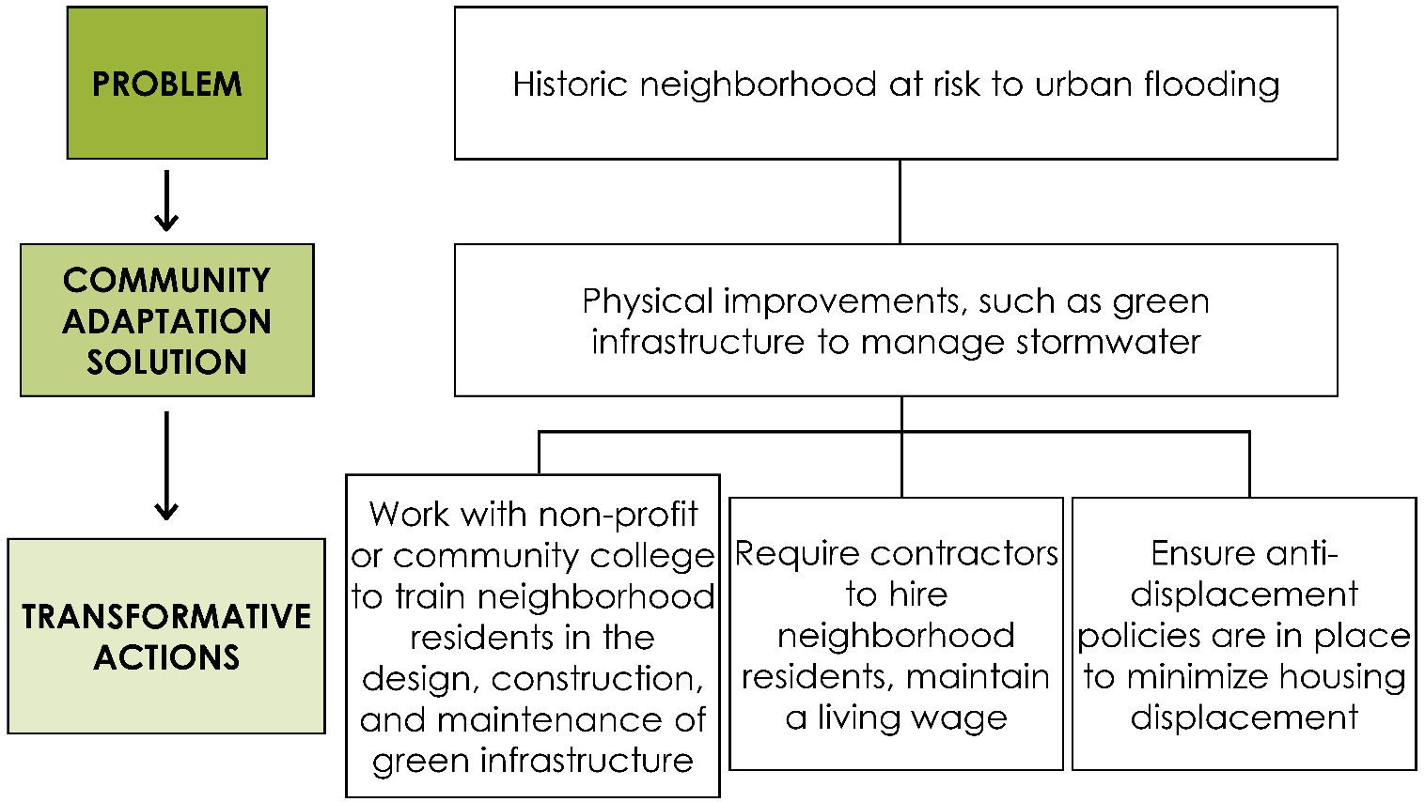
Source:Guide to Equitable Community-Driven Climate Preparedness Planning Guide to Equitable Community-Driven Climate Preparedness Planning (2017)
It is also important to think about the potential unintended consequences of the strategies being considered, as they can sometimes create new vulnerabilities or exacerbate existing inequities. This is known as maladaptation, when adaptation measures result in harmful outcomes, shift risks to other communities, or reduce the ability of vulnerable populations to adapt over time.
For example, while resilience investments can improve neighborhood conditions and increase property values, they may also contribute to gentrification. Gentrification can displace low-income residents, erode community networks, and diminish the resilience of populations already facing disproportionate risks. Where possible, consider complementary actions that help existing residents remain in and benefit from their communities as adaptation investments are made.
By proactively evaluating potential unintended consequences, identifying co-benefits and multi-benefit strategies, and centering equity throughout the planning process, teams can avoid maladaptive outcomes and ensure that climate investments reduce vulnerability, advance community priorities, and deliver lasting resilience benefits for those most impacted by climate change.

Case Study: Bay Area Rapid Transit (BART)’s Sustainability Action Plan
In January 2026, BART published its 2026-2035 Sustainability Action Plan to continue supporting climate resilience, public well-being, and responsible environmental practices through its operations and services.
The plan is structured around seven key categories that each outline a broad goal (APG Steps 1.1, 3.2), supported by specific actions and measurable targets (APG Step 3.3). All categories additionally focus on equity and vulnerable populations, as seen in Why It Matters at the end of this case study.
One category is Resilience & Adaptation (RA):
- Broad Goal: Adapt BART assets and operation services to be more resilient to the impacts of climate change
  - RA Action 1: Continue evaluating local hazards to update the LHMP every five years. The 2027 update will include consideration of social vulnerability and communities that may have the hardest time adapting or recovering after disruptions and disasters
    - Timed Target: Complete update by Quarter 4 2027
  - RA Action 2: Create Climate Resilience Roadmap
    - Timed Target: Complete by Quarter 4 2028
  - RA Action 3: Pilot local passengers’ resilience hub at BART stations
    - Timed Target: Annual reporting on partnerships and activities starting in 2026
- Why It Matters: A climate-resilient BART system doesn’t just keep trains running; it protects daily mobility and ensures the Bay Area stays connected, clean, and prepared for the future. Disruptions could disproportionately affect low-income and transit-dependent communities, further deepening existing inequities.
Table 19 shows a set of questions adapted from the Greenlining Institute’s guidebook, Making Equity Real in Climate Adaptation and Community Resilience Policies and Programs. The questions are partly based on the “Resiliency Guidebook: Equity Checklist” developed by the California Governor’s Office of Land Use and Climate Innovation. For consistency with the APG, Table 19 uses the term “strategy” instead of “program or policy,” as used in Greenlining’s original table.

Table 19. Questions to ensure equity in adaptation process
Topic | Questions
Identifying vulnerable populations | Which vulnerable populations may be impacted by or could benefit from the strategy?  How has the community identified these populations?
Targeted Funding | Does the strategy have dedicated set-asides for vulnerable communities?
Accessibility | Are the benefits of the proposed strategy broadly accessible to households throughout the community, particularly communities of color, low-income populations, housing-insecure households, people with disabilities, people experiencing homelessness, Tribal and indigenous communities, and immigrant communities?
Engagement | Is the process designed to collaborate with vulnerable populations that engages and empowers them in a meaningful, authentic and culturally appropriate manner?  Which best practices for community engagement are being implemented?
Assured Benefits | What mechanisms will be used to assure particular benefits to vulnerable populations (e.g. provide technical assistance or capacity building, provide jobs, provide extra financial resources or investments)?
Disproportionate Impacts | Does the strategy generate burdens (including displacement and increased costs), either directly or indirectly, on vulnerable populations?  If yes, how will they be addressed and mitigated?
Capacity Building | How will the strategy provide for local capacity building (e.g. through funding, expanded knowledge base or other resources)?
Relationship Building | Does the strategy help foster the building of effective, long-term relationships and trust between diverse communities and government?  Does the strategy align with and support existing community priorities, creating an opportunity to leverage resources and build collaborative partnerships?
Shared and Multiple Benefits | How may the strategy decrease inequality in income or wealth?  How does the strategy increase adaptive capacity and/or reduce exposure to climate change effects in frontline communities?  Can the benefits of the strategy be targeted in progressive ways to reduce historical or current disparities?  How may the strategy ensure safety and improve health outcomes for vulnerable populations?
Economic Opportunity | Does the proposed strategy support vulnerable communities through workforce development, affordable housing, or contracting opportunities?
Accountability | How will the equity impact of the strategy be evaluated?  Does the proposed strategy have appropriate accountability mechanisms to ensure that vulnerable communities will equitably benefit and not be disproportionately harmed?
Adaptive Management | If data shows that folks are not on track to meet the equity outcomes, is there a plan to adjust and correct course?
Communication | How will progress be communicated to partners?

Step 3.3D: Outreach and Engagement
To brainstorm, detail, and refine adaptation strategies, community members should be engaged to identify specific adaptation strategies that would be most effective in the community.
There are several outreach and engagement methods that are particularly well suited to facilitate the co-development of specific adaptation strategies:
- Design charrette:
A charrette, unlike a simple workshop or presentation to the public, is a multiple-day iterative process that fosters diverse and community-sourced design ideas for a given study area among any array of partners. Residents, partners, decision-makers, staff and technical consultants work together in meetings, workshops and site walks over a concentrated period to forge collaborative visions.
- Focus Groups:
These groups usually involve guided discussion for a group of 6-15 people to allow for detailed feedback and discussion regarding adaptation strategies and options. Focus groups can also provide a safe setting for discussions with individuals who may feel left out in larger public meetings. This allows planners to better understand specific community needs and barriers.
Refer to Appendix A - Best Practices for Conducting Outreach and Engagement Activities for the full list of potential methods to engage the community.

Step 3.4: Prioritize Adaptation Strategies
Goal: Prioritize adaptation strategies for implementation.
In Step 3.3 the planning team and community developed adaptation strategies based on the vulnerability assessment and community engagement (see Step 3.3D: Outreach and Engagement). In this step the planning team should prioritize those adaptation strategies. This will aid in making decisions about complex issues, and it will make the strategy development process transparent and easier to communicate to community staff and residents. Prioritization of strategies should consider several factors:
- Vulnerability and Risk Reduction: Using the Vulnerability Score from Step 2.4B, which strategies will be effective at addressing assets or systems with the highest vulnerability?
- Life and Safety: What impact will the strategy have on protecting lives, residences, businesses, and critical facilities in the planning area? Does it reduce exposure, sensitivity, or consequences of hazard events?
- Administrative and Technical Capacity: Who will implement the strategy and does the responsible entity have sufficient staff and organizational capacity? Is technical or administrative assistance needed? Is staff training required?
- Project Cost: How much will the strategy cost to implement? Does the community have sufficient funding for the project, including any required local match?
- Funding: What resources are available to pay for implementation, such as grants, bond funding (e.g., LA County’s Measure W that funded the Safe, Clean Water Program, California Prop 68, California Prop 4 ), tax programs (e.g., Bay Area’s Measure AA, tax-increment financing), public-private partnerships, and others, as summarized in Phase 4. Additional information on available state grant opportunities can be found through the California State Grants Portal.
- Efficiency and Cost Effectiveness: How do the costs compare to the effectiveness/benefit? (What is the benefit-cost ratio?) What are direct and additional indirect benefits of the strategy? What future losses might be avoided?
- Co-benefits and Multiple Benefits: Does the strategy deliver co-benefits or multiple benefits?
- Reducing Environmental Impacts and Scaling Nature-based Solutions: What are the potential environmental impacts or considerations of implementing the strategy? Does the strategy support nature-based solutions, natural systems, ecosystem services, or multiple environmental benefits?
- Equity and Community Benefit: Who bears the cost, and who receives the benefits (including co-benefits)? Does the strategy prioritize or meaningfully benefit frontline and underserved populations and address existing inequities?
- Maladaptation: Could this strategy unintentionally create new risks, increase vulnerability, or worsen existing inequities? Who benefits from this strategy, and who could experience unintended negative impacts? Could this strategy shift climate risks or burdens from one community, sector, location, or population to another?
- Local Authority and Political Support: Does the community have the legal authority to implement the strategy? Is there political and institutional support to carry it forward? Is the strategy consistent with applicable laws?
- Responsiveness and Appropriateness: How responsive or appropriate is the strategy to the needs and conditions of everyone in the community, especially those on the frontline?
- Timing and Useful Life: When will implementation begin, how long will the strategy take to complete, and what is the expected useful life or lifespan of the investment? For large infrastructure projects, consider how the asset’s lifespan aligns with future climate conditions, maintenance needs, and long-term resilience goals.
- Monitoring and Reporting: How will the strategy be tracked and monitored for effectiveness over time? Are there clear performance indicators to track progress and outcomes?
Case Study: Yurok Tribe and Climate Change
The Yurok Tribe in northern California prepared the Yurok Tribe Climate Change Adaptation Plan for Water & Aquatic Resources 2014-2018 using a similar multiphase adaptation planning process. Step 3 of the process was “Identify and Prioritize Solutions.” A particular focus was the importance of traditional knowledge derived primarily from interviews with elders and the adoption of holistic thinking in all phases of the process. From these was derived a set of four criteria for evaluating potential strategies (Section 8.2):
- Address important areas of concern [identified in the vulnerability assessment].
- Are in line with the Yurok holistic world view on the inter-connectedness of all things.
- Provide benefits across multiple habitats and species.
- The degree of benefit provided and whether they might cause harm in some way.
One strategy that came from this approach was: “Continue to reinvigorate traditional Yurok values and practices.” The plan states: “Traditional Yurok values and practices are a form of resilience that have helped Yurok survive and thrive amidst the numerous challenges they have experienced (Ch. 1). ‘[These values] have carried Yurok throughout time,’ notes Joe Hostler, with the Yurok Tribe Environmental Program, and will help Yurok in a future with climate change as well” (Section 8.2). The strategy then details specific actions to implement the strategy and address climate change.

Step 3.4A: Cost/Benefit Assessment for Adaptation Strategies
As part of the prioritization process, the planning team should consider whether the anticipated benefits of the identified strategies reasonably outweigh their costs.
Benefits may include avoided losses, such as reduced damage to buildings and infrastructure, protection of human life, and fewer injuries during climate-related events. Information from past hazard events, including documented damages, recovery costs, and avoided losses, can provide valuable context when evaluating the potential costs and benefits of adaptation strategies.
Communities should also consider other benefits that are more difficult to quantify, including improved health, quality of life, ecosystem function, and other social and environmental outcomes. A variety of cost-benefit evaluation frameworks can be used to compare adaptation strategies and identify the most effective and implementable options.
Cost-benefit analysis has important limitations in the context of adaptation planning. Many resilience strategies produce benefits - including direct revenue, economic activity, and environmental and social improvements – which may accrue years after project completion. In addition, environmental, social, and public health benefits are often difficult to quantify or assign monetary value. Traditional, cost-benefit methods may also favor projects that protect high-dollar value assets, potentially undervaluing investments in lower-resourced communities, and may have a lower cost-benefit ratio than those in well-resourced communities (Ready-to-Fund Resilience Toolkit - Adaptation Professionals). For these reasons, cost-benefit analysis should be considered along with other factors, such as equity, feasibility, community priorities, and long-term resilience.
Case Study: Santa Clara County’s Multi-Benefit Assessment
The Santa Clara County Climate Collaborative created a Multi-benefit Assessment that assesses the impact of a resilience project or strategy by analyzing it through multi-benefit criteria:
- Equity: Reduces environmental injustices and systemic disparities experienced by marginalized communities and ensures equitable distribution of project benefits and burdens
- Long-Term Value: Prioritizes solutions that deliver multiple long-term benefits and value in line with the costs of design, implementation, and maintenance
- Ecosystem Benefit: Supports thriving ecosystems and biodiversity, balancing the needs of wildlife, landscapes, and natural resources without creating harm to the community
- Community Benefit: Creates community benefits that improve human health and well-being, community resilience, quality of life, and supports a prosperous and just economy
- Cross-Jurisdictional Alignment: Bridges and strengthens connections between organizations, jurisdictions, etc. to work towards scaled solutions
The Multi-benefit Assessment provides a Multi-benefit Criteria Worksheet to help city staff and project partners evaluate and prioritize resilience projects or strategies. To use the worksheet, each criteria area has its own set of questions to answer. For each question, the project can receive a score of +, 0, - depending on if it will have a positive, neutral, or negative impact. Neutral or positive scores are accepted but not negative scores. If the project or strategy yields a negative score, it must be redesigned to give a neutral or positive score.

Step 3.4B: Outreach to Develop Adaptation Strategies
Adapting Rising Tides (ART)
The ART Program offers an online ART Portfolio, which includes reports, resources, examples, how to guides, and supplies to support climate adaptation planning. ART Supplies includes a helpful How-To Guide: “Developing Evaluation Criteria” from 2016, which provides more information and guidance to support preparation of an evaluation worksheet.
In prioritizing strategies, it is helpful to get feedback from a variety of partners outside the core planning team, especially those representing frontline communities because they will most likely evaluate the strategies differently. Community members with lived experience may identify barriers and challenges that are not apparent through technical analysis alone.
To develop an effective implementation plan it is essential to get input on who could assist and what could possibly hinder the implementation of a strategy.
Once partners have brainstormed possible adaptation strategies, the planning team should categorize and prioritize strategies before seeking additional feedback from the community. One way to help with this would be to summarize and visually illustrate aspects of each strategy, which could include:
- A cost or feasibility estimate
- A list of co-benefits, including equity implications
- Potential impacts on historically underserved communities
- Downsides to adopting the strategy
- Potential barriers or challenges
- Implementation needs
- Case study or example
- Other important information from Step 3.4
Figure 22 illustrates how the City of Long Beach presented its adaptation strategies in its 2020 CAAP: Climate Action + Adaptation Plan. Incorporating clear, compelling, eye-catching graphics can help translate complex information into formats that are easier to understand and more engaging for the public. This approach supports accessibility across multiple engagement settings, including online surveys, in-person workshops, and other community outreach formats. Public facing materials should be accessible by using plain language, sufficient color contrast, and translations when appropriate. It is important to also make the formats compatible with assistive technologies.

Figure 22. Adaptation action flyer from Long Beach’s 2020 CAAP outreach
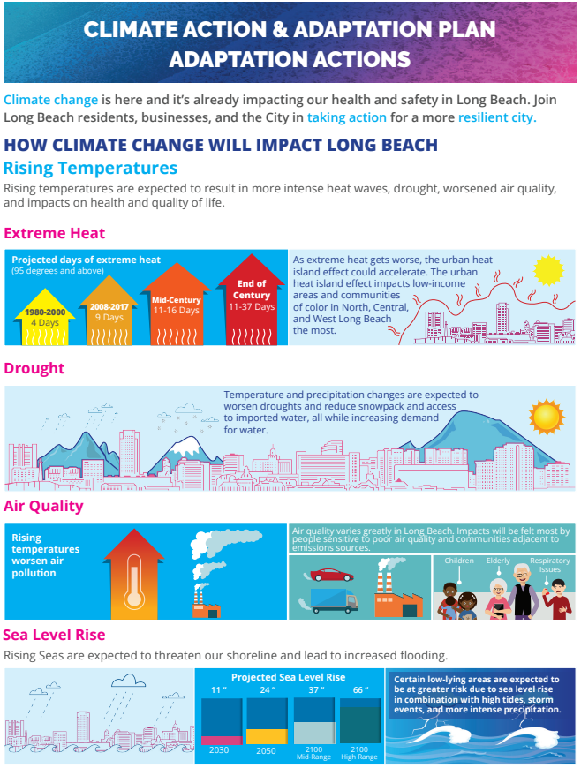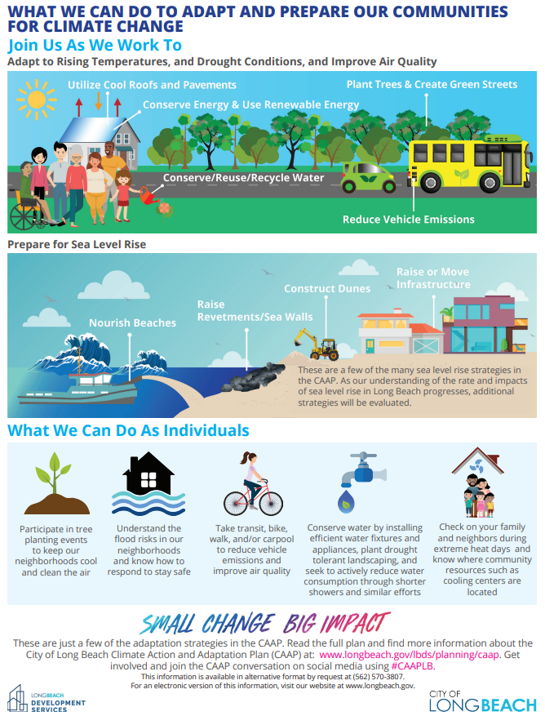
To further support strategy review and prioritization, some government agencies have developed interactive games to engage residents in sustainability planning and decision-making. For example, the City of Santa Cruz hosted a Community Climate Game Day at the Santa Cruz Downtown Library. The City’s advertisement for the free event is shown in Figure 23, illustrating how interactive and participatory formats can be used to make climate planning more engaging and accessible to community members.

Figure 23. Santa Cruz’s Community Climate Game Day ad
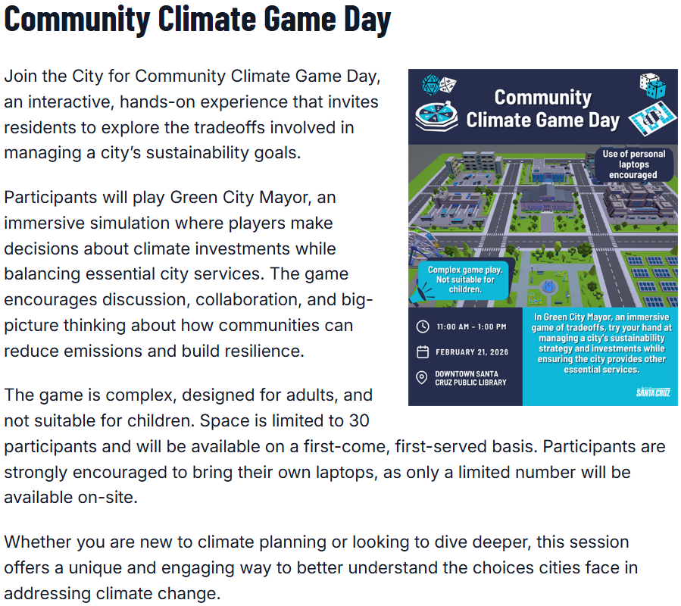

Phase 3 Wrap-Up
Communities have a wide range of potential strategies to improve resilience to a changing climate. These strategies can take the form of new programs or initiatives, policies, regulations, physical construction projects, and evaluation efforts, among others. Strategies should be feasible and appropriate for the community with its available resources. They should be responsive to the issues identified in the vulnerability assessment, address overarching issues such as equity, and provide co-benefits to the community. Once the planning team has identified and prioritized the adaptation strategies, it can move into the fourth phase of adaptation planning: Implement, Monitor, Evaluate, and Adjust.

PHASE 4: IMPLEMENT, MONITOR, EVALUATE, AND ADJUST
In Phase 3, the planning team built an adaptation framework of the community’s vision, goals, and priority adaptation strategies. These activities should be done with an eye to Phase 4 – implementing, monitoring, and adjusting the adaptation plan.
This section summarizes the most important step of adaptation planning: implementation. To ensure implementation of each strategy is effective and continues to be effective, communities should monitor and modify strategies as needed.
This section divides Phase 4 into three steps, shown in Figure 24 below.
- Prepare an implementation program to put adaptation strategies into action.
- Create a monitoring program to track implementation and evaluate the ongoing effectiveness and relevance of adaptation strategies and ensure monitoring and evaluation programs can be adjusted as needed.
- Adjust adaptation strategies as monitoring and evaluation input is received.
Figure 24. Steps in Phase 4

How to Use the Appendices in This Phase
Appendix A: Outreach and Engagement: This phase relies heavily on outreach and engagement. Refer to Appendix A throughout this phase for detailed guidance on engagement methods and best practices. Specific guidance for engagement touchpoint Step 4.1C is included in the Appendix.

Outreach and Engagement in Phase 4
Long-term implementation cannot be effective without close collaboration with the community. Outreach and engagement should be conducted through all phases of adaptation planning and should continue through implementation.
Phase 4 emphasizes that implementation, monitoring, and adjustment should actively and meaningfully involve community members. This is particularly important in frontline communities who are disproportionately vulnerable to climate change, including Tribal communities. This ensures that community members are partners if the results of monitoring and evaluation require a change in adaptation strategies. Involving the same representatives from community advisory groups formed during the previous phases can help with this objective.
In all the phases, equity is a critical consideration. This means including opportunities for meaningful involvement from members of frontline communities and vulnerable populations who are disproportionately impacted by climate change and often underrepresented in community decision-making processes. Distributional and structural equity should be a key consideration in the prioritization and implementation of strategies. This means implementing strategies that seek to more fairly distribute benefits of programs and investments and seek to remedy historic underinvestment in communities.
When community members understand and feel the benefits of climate change adaptation strategies, they become advocates for implementation and support adjusting approaches to adaptation over time. Each step of Phase 4 incorporates outreach and provides a list of sample actions. These outreach actions are primarily taken from the Guide to Equitable Community-Driven Climate Preparedness Planning (2017) by the Urban Sustainability Directors Network.

Step 4.1: Implement
Goal: Implement strategies and projects identified in the adaptation planning process.
When starting Phase 4, the community should build on the work done in the previous phases to prepare an implementation program. In Phase 1, the community formed the planning team, identified expectations of the end product or plan, and began outreach. Phase 2 identified the planning area’s vulnerabilities and adaptive capacity. In Phase 3, the planning team developed and prioritized adaptation strategies, identifying potential lead departments and/or partners responsible for implementing each strategy, a time frame for implementation, and potential cost estimates.

Step 4.1A: Develop an Implementation Program
The implementation program should map out the activities, priorities, timelines, costs, responsible parties overseeing implementation, funding and resources available or needed to pursue each strategy. The implementation program should:
- Identify responsible parties who will oversee implementation of each strategy.
- Identify strategies that are ready for implementation and those that are ready but require additional funding.
- Craft a set of recommendations for advancing and funding actions that are ready to be implemented.
- Identify strategies that require further refinement or feasibility assessments. Determine where additional analysis, changes in governance or regulations, or new partners and participants may be needed to support implementation.
- Review strategies that are not ready for implementation and identify those requiring immediate next steps.
Developing the implementation program is a final chance to ground truth the feasibility and effectiveness of a strategy. If a strategy has been moved forward to this point, and it is more aspirational than realistic, adjust the implementation to reflect that reality.
The 2019 Regional Resilience Toolkit recommends developing a short-term action plan that can act as a staff level working plan. This short-term action plan should integrate financing and assist in routine city decision making while still maintaining the long-term vision of the implementation program. It should include specific and tactical details that go into city work plans, budgets, and grants planning.
Integration of adaptation strategies into other plans can support implementation by building coalitions and aligning strategies with responsible organizations' decision-making processes.
For instance, if adaptation is integrated into the general plan, external consistency requirements between a jurisdiction’s general plan and “downstream” documents like the municipal code, capital improvement programs, and land use actions can support implementation for those adaptation strategies.

Identify Responsible Parties and Establish Accountability
For each strategy, the planning team should identify and assign a specific lead responsible party, such as a department, agency, Tribe, community partner, or other entity, to ensure clear accountability. Assignments should identify a specific lead entity rather than the jurisdiction as a whole to support ownership and implementation tracking.

Where implementation requires coordination among multiple agencies or partners, those entities should be engaged early to define roles, responsibilities, decision points, and the steps and timelines needed to successfully implement the strategy.
Considerations for Implementation Planning
What is the best timeframe for implementation? All adaptation strategies have temporal components that include time to implementation, timing of necessary action, and duration of effectiveness. Some strategies will be ready to implement quickly, while other strategies are updated and executed over a course of years. Major infrastructure projects, for example, may require a longer timeframe. Strategies with longer timeframes often have less information, certainty and feasibility. Implementation timeframes can also be designed to align with expected updates to adaptation planning documents such as the Safety Element, LHMP, etc., to create opportunities for scheduled strategy adjustments. Some communities may also benefit from framing their planning around adaptation pathways where local jurisdictions can identify multiple future adaptation actions that the jurisdiction will enact when certain thresholds or triggers are passed.
Who controls the dependencies that will lead to the success of the strategy? For instance, does a strategy rely on a different organization passing a policy or funding the activity? The more dependencies and the more actors involved in achieving a strategy will likely require more time and resources to complete. In these cases, implementation plans should consider assigning sub-tasks to organizations and linking those actions to the organizations’ decision-making processes. Developing interorganizational partnerships or agreements can also be helpful when implementation includes multiple players.
Can the project move forward with win-win strategies early? Early actions can help maintain engagement when moving from planning to implementation. If there is a way to move forward some activities quickly, make that clear in the implementation program. Consider how existing working groups, departments, or funding streams can be adapted to include actions that advance resilience.
Does the strategy connect to another project? Building on existing successful projects and processes is a great place to start. Bolstering or altering existing projects or programs can reduce startup time and costs. If implementation will be connected to another project, review the timeline for that effort and make sure that implementation program is responsive to that timeline.

Step 4.1B: Implementation Funding

Making the Business Case for Adaptation
Funding is frequently identified as a significant challenge in implementing adaptation. Making the business case for the resilience effort in the community — planning how to frame the project, backing it up with data and numbers, and convincing people to invest in it — is a critical part of this effort. A study by the National Institute of Building Sciences’ 2019 report Natural Hazard Mitigation Saves determined that there is a savings of $6 in recovery costs for every $1 spent on hazard mitigation efforts through federal grants, with up to $13 savings per $1 spent on hazard mitigation efforts overall. This makes a strong argument for building adaptation into community development at an early phase to reduce total spending over time. The planning team should devise a clearly articulated business case for the resilience actions. In developing the business case, they should consider:
- The cost of inaction and increasing climate risks, such as:
  - Increasing maintenance and service costs
  - Increased demand for emergency services during climate extremes
  - Impacts that can be difficult to quantify or monetize such as impacts to public health
- The cost of implementing the adaptation strategy
- That accounting for the multiple benefits of adaptation actions can make a stronger business case and bring more partners to the table
- Who will bear the cost of inaction and those who benefit from adaptation strategies is helpful in identifying partners and funding and financing tools
Matching resilience needs to funding resources may result in unconventional solutions. For example, different departments may coordinate on spending for capital projects, or neighboring cities may pool funding for large-scale green infrastructure projects to benefit many jurisdictions.

Case Study: City of Goleta’s Plan Integration
The City of Goleta created a Coastal Hazards Vulnerability Assessment and Fiscal Impact Report in 2015. The report not only details ways in which climate change may affect Goleta, but also specifically assesses the impact of climate change and adaptation measures on economic and fiscal resources. This includes the value of threatened assets and the expense associated with various adaptation measures and estimated city liability for vulnerabilities over time. The report also identifies potential sources of funding to support the adaptation measures identified.
Figure 25. Excerpt from Goleta’s 2015 Report
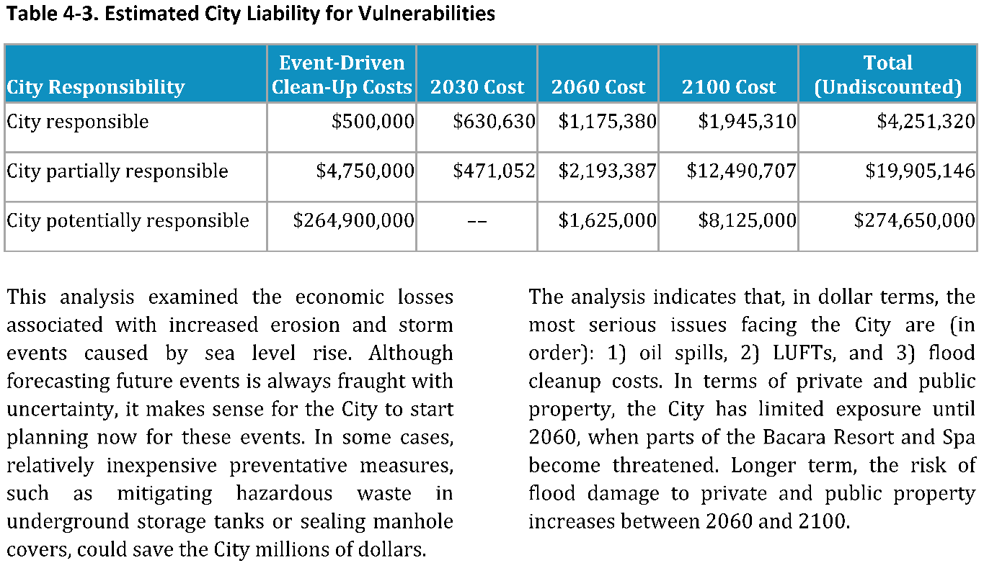
The evaluation provides critical transparency to all community members, and the information from Figure 25 was incorporated into the 2023 City of Goleta LHMP:
7.4.1 Climate Change Induced Mitigation Actions
Over the next five years, the City will also be examining mitigation actions considering the findings and recommendations resulting from predicted climate change conditions identified in the 2015 City of Goleta Coastal Hazards Vulnerability Assessment and Fiscal Impact Report, the findings of which are summarized below:
- Existing creek hazards (FEMA) are the highest hazard in the City. Coastal flooding will be exacerbated by SLR, however future climate impacts on creek flooding are not available.
- Coastal flooding damages to structures in Goleta could increase dramatically by 416% between the time horizons of 2060 and 2100.
- Adaptation costs to elevate and accommodate coastal flooding by 2100 ($175 million) exceed damages ($14 million) and cleanup (approximately $5 million) by an order of magnitude.
- The Storke Ranch neighborhood becomes exposed around 2100 when Goleta and Devereux Sloughs come together.
- Coastal flooding impacts the light manufacturing sector the greatest between 2 and 5 feet of SLR from 2060 to 2100.

Equity Considerations in Funding
The uneven distribution of risk, costs from damages, funding needs, and funding options could result in unequal adaptation responses. An unequal distribution of adaptation could deepen inequity and increase vulnerabilities for low-income communities. An additional concern is an increased financial burden on low-income communities created by potentially regressive adaptation funding mechanisms.
It is important to consider who is paying, who benefits, and how things are paid for. Additionally, smaller jurisdictions, Tribes, and under-resourced communities may face additional barriers in accessing competitive grant funding because of a number of factors that may include limited staffing or technical expertise. Understanding these elements of funding and financing tools is essential to building equitable adaptation.

Diverse, Layered Funding Led by Local Sources
Funding and financing sources can include local general funds, bonds, taxes, assessments, fees, grants, private sector partnerships or investments, non-profit grants and partnerships. Adaptation funding is also an area of ongoing innovation, with communities utilizing funding sources and tools in creative ways.
Ideally, communities will be able to develop a layered and diverse funding portfolio - one that includes a diverse set of public funding mechanisms as well as private and philanthropic funding. In addition, it is not just funding streams earmarked specifically for adaptation that will be utilized, but funding currently used for a wide variety of city and county projects will need to incorporate resilience as a major component of project planning and implementation costs. For instance, new transportation projects in the future floodplain will need to examine raised streets, bridges and transit facilities.
Local initiatives will play the largest role in ensuring climate risk-reduction, as most land use and infrastructure projects are planned, managed, implemented, and maintained by local jurisdictions.
A good place to start is to embed resilience budgeting into the community’s fiscal planning. A local government’s Capital Improvement Plan (CIP) is an annual or biennial plan for financing community projects and is typically what funds community assets or infrastructure, such as bridges, water treatment facilities, street improvements, parks or community centers. Incrementally, resilience projects and initiatives need to be part of the regular budget and decision-making discussions.
Examine all funding sources at hand as possible resilience monies that can open new possibilities to implement projects more quickly. Existing revenues can be slightly reallocated to incorporate adaptation into existing projects and services. Cities can task their transportation, planning, and public works divisions to incorporate adaptation into all projects using existing funds for these sectors. Comb through internal budget sources and consider how to re-purpose existing funds or create new revenue scenarios to leverage what’s already available.
Policy Connection: Local Hazard Mitigation Plans
The Local Mitigation Planning Policy Guide requires plans to describe how existing authorities, policies, programs, funding, and resources support the mitigation strategy, including building codes and land use and development regulations. Plans must also describe each participant’s ability to expand or improve these capabilities or note any limitations. Identifying current capabilities and gaps helps justify mitigation actions and address vulnerabilities identified in the risk assessment.

Case Study: City of La Verne’s LHMP
The City of La Verne LHMP 2026 lists its fiscal capabilities in Figure 26, along with how they can be improved in the future.
Figure 26. Excerpt from La Verne’s LHMP
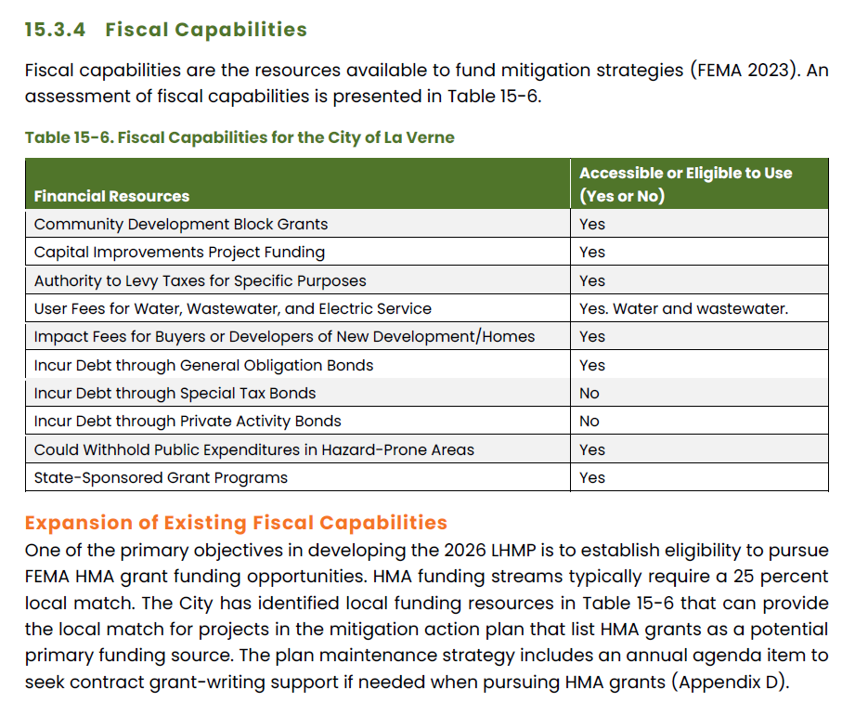

Which Type of Tool is Most Appropriate?
Adaptation and resilience projects may require large upfront expenditures; financing is often necessary since it may be difficult to pay for the construction of a multimillion-dollar project in full. To secure financing, project proponents must be able to identify and commit to securing a dependable revenue source that can repay investors over a longer time.
- Funding: direct revenue or cash to pay for projects, e.g. through taxes, fees and grants
- Financing: project payment over time by borrowing money from institutions; provision of the initial cash for the projects at a return rate, e.g. a loan or a bond
There are many funding tools available for project development in California, and it is common for projects to be supported by a mix of such tools. To help develop an effective funding strategy, it is important to consider each relevant funding tool’s revenue potential, approval requirements, and cost burdens, as well as the administrative complexity of applying for and administering the funds. Additional criteria to evaluate tools may be useful for specific projects and contexts. For example, the 2018 Paying for Climate Adaptation in California: A Primer for Practitioners discusses San Francisco’s seawall funding strategy project leaders considered whether or not the funding tool would divert money from other City needs.
Policy Connection: Key Legislation
California Prop. 13, passed in 1978, limits property tax to no more than 1% of the house’s value in 1975 and limits annual increases to inflation or 2%, whichever is lower. It also requires a two-thirds majority vote of the state legislature to increase non-property taxes and a two-thirds majority vote for local governments for any special taxes.
California Prop. 26, passed in 2010, requires a two-thirds supermajority for new taxes, levies, charges, and fees. This makes any new funding measures very challenging to approve without proper public engagement and education.
Table 20. Funding tools
Funding Tool | Who Pays? | Key Benefits | Key Drawbacks
Grants | Federal, state, local funds / taxpayers | Money raised from broader geographies (e.g. federal level) can be invested locally,  Can be used to attract additional funding | High capacity is needed to apply for and manage and report on funds,  Redirects money that could be used for other purposes
Assessments | Property Owners | Costs linked to benefits,  Flexible geography,  Not considered a tax under Prop. 26 | Extensive documentation of benefits required,  Approval requires support of most affected property owners
Taxes: Ad valorem property tax for voter-approved debt | Property Owners | Potential for significant funding | Requires two-thirds voter approval
Taxes: Parcel tax | Property Owners | Can be regional in scale Flexible use | Requires two-thirds voter approval
Taxes: Tax-increment financing (TIF) or Climate Resilient Districts | Property Owners | Not subject to Proposition 13 limitations | Issuance of TIF bond requires 55% voter approval in district,  Requires redirecting future property tax revenue,  Dependent on anticipated increases in value; limited for highly built-out areas,  Requires district property owners to voluntarily allocate increment to the district
Taxes: Mello-Roos tax | Property Owners | Low approval thresholds for new development,  Boundaries do not need to be contiguous,  Tax could be based on relative risk-reducing benefits | Requires two-thirds approval of district’s registered voters if there are more than 12 registered voters
Taxes: Other taxes (e.g., sales, gas, hotel, utility users, business license) | Residents, Businesses, Visitors | Typically, general taxes, which require only a simple majority for cities and counties to levy (less than two-thirds threshold for special taxes) or two-thirds of legislature for state general taxes,  Flexible use | Can be regressive
Fees: Property-Related Fees: Water, stormwater, and wastewater fees | Users | Majority protest threshold for publicly owned utilities is lower than other voter approval thresholds,  Privately owned water utilities are exempt from Proposition 218 (these deliver water to roughly 20% of the state’s residents),  Not considered a tax under Prop. 26 | Publicly owned utilities subject to Proposition 218,  Funds raised must directly support operations and rates cannot be tiered to address affordability issues,  Private utilities’ rate setting is regulated by the California Public Utilities Commission (CPUC)
Fees: Non-Property-Related Fees: Gas, electric fees | Users | Not subject to Proposition 218,  No voter approval required,  Not considered a tax under Prop. 26 | Funds raised must directly support operations,  Rate setting regulated by CPUC for investor-owned utilities or by elected boards for publicly owned utilities
Fees: Developer impact fees | Developers, Property Owners | Can be used to ensure new development is resilient,  No voter approval required  Not considered a tax under Prop. 26 | Tied to market conditions which are often cyclical and difficult to forecast,  Requires new development/major redevelopment to manifest resilience at a meaningful scale
Fees: Other user fees (e.g., Transit fares, tolls) | Users | Fees charged to those who use and benefit from the services | Participation of disadvantaged and vulnerable communities may be limited without subsidies/affordability programs
Private Involvement: Business Improvement Districts | Businesses, Consumers | Useful for district-wide infrastructure that could benefit from economies of scale (e.g., stormwater infrastructure),  Contributes private revenues to public or shared goods | Limited revenue generation,  Require contiguous boundaries
Private Involvement: Enterprise revenues (e.g., naming rights, concessions) | Businesses | Contributes private revenues to public good,  Effective for funding operations and maintenance expenses | Limited revenue generation,  Commercialization of and less public control over public space
Private Involvement: Incentives (e.g., exemptions, discounts) | Businesses, Developers, Property Owners | Encourages investment that may otherwise not occur | Jurisdictions forfeiting potential revenue sources
Private Involvement: Community benefit agreements | Businesses, Developers, Property Owners | Can involve communities in the planning and development process | Can be time and resource intensive to adequately determine and address community needs, and negotiate between key players
Private Involvement: Regulations (e.g. building codes) | Businesses, Developers, Property Owners | Passes upfront costs to the private sector, placing less burden on public to invest in adaptation needs/ disaster bailouts,  Institutionalizes building standards that account for future risk | Requires regulatory action by appropriate state agency,  Can deter development

Case Study: San Francisco Bay Restoration Authority’s Measure AA
San Francisco Bay Restoration Authority’s Measure AA passed in 2016 and introduced a $12 annual parcel tax for 20 years to fund Bay Area habitat restoration projects. This totals $500 million, or $25 million a year for 20 years before automatically expiring in 2037.

Case Study: Marin Wildfire Prevention Authority
Marin County’s Measure C passed with 70.8% voter support in March 2020 to fund proactive, state-of-the-art wildfire prevention and preparedness efforts. Measure C approved a tax to all parcels of real property in Marin County within the defined boundary of the “Member Taxing Entities,” starting in 2020-21 for a period of ten years.
The parcel tax levies up to 10¢ per building square foot ($75 per multifamily unit) for ten years, providing $19,300,000 annually. A joint powers authority among 17 member agencies covering most of Marin County created the Marin Wildfire Prevention Authority (MWPA) to coordinate fire prevention activities using Measure C funds. Funds will be used for ﬁre protection and prevention services, including but not limited to: Vegetation management (Fuels reduction), Wildfire detection, Evacuation plans & alerts, Grants, Public education and Defensible space and fire-resistant structure evaluations.
Financing tools allow for funds generated over time to be used as a form of repayment. They provide necessary upfront capital for project development before all revenues are collected. To help develop an effective financing strategy, it is important to consider a financing tool’s use in the market, investor appeal, and complexity to structure and deploy. Additional criteria to evaluate tools may be useful for specific projects and contexts; for example, municipalities seeking private financing might compare the interest burden of private versus public finance tools.
Table 21. Financing tools
Financing Tools | Key Issuers/ Involved Parties | Key Benefits | Key Drawbacks
Municipal Bonds (General Obligation Bonds, Revenue Bonds) | Local or state government | Commonly used | Subject to voter approval requirements
Private Activity Bonds | Private Activity Bonds | Encourages private sector participation | Limited application and amount
Pay for Success Financing (Social Impact bonds, Environmental Bonds) | Partnership between public agency, private provider, and third-party verifier | Transfers risk of achieving intended outcomes from public sector to private sector | Limited use to date Significant monitoring and evaluation required
Green Bonds | Local or state government | Social impact investor appeal Publicizes commitment of spending towards environmental purposes | Limited use to date Lack of standardization of what it means to be “green” Administrative complexity
Insurance-Linked Securities (Catastrophe Bonds, Resilience Bonds) | (Re)Insurance companies, public and private organizations | Less or no correlation with markets adds investor appeal
Loans: Federal Loans | Federal issues,  Borrower can be private or public entity | Commonly used Applicable dedicated loans for transportation and water infrastructure | Dependent on authorization from Congress
Loans: Revolving Loan Funds | State issues,  Borrower can be non-profits or public entity | Dedicated state programs focused on water and infrastructure programs | Sustainability of programs dependent on loan repayment
Loans: Program Related Investments (PRIs) | Philanthropies | Flexible application | Requires alignment of philanthropic goals with adaptation and resilience outcomes

State Conservancies as Funding and Implementation Partners
Consider partnering with a state conservancy to fund and implement strategies. California's 11 state conservancies are uniquely positioned to advance locally tailored climate resilience through funding, land conservation, habitat restoration, and regional partnerships. To identify the state conservancy serving your planning area and available grant programs, visit the California Natural Resources Agency's State Conservancy Network.

Case Study: Blue Forest’s Forest Resilience Bond
Blue Forest’s first Forest Resilience Bond (FRB), the Yuba I FRB, launched in 2018 with restoration work completed in 2023. The Yuba I FRB helped to catalyze the formation of the North Yuba Forest Partnership (NYFP) in 2019. The NYFP is a partnership of nine federal, Tribal, state, and local government agencies and nonprofits focused on forest restoration across 275,000 acres of public and private lands in the North Yuba River Watershed.

Best Practices
- Develop clear, consistent project descriptions that can be adapted for different funders.
- Align projects to address multiple goals. By highlighting multiple benefits of resilience projects, more funders are likely to emerge to support implementation.
- Build relationships with representatives of key State and Federal agencies.
- Work with regional agencies and nearby jurisdictions to apply for grants together. Collaboration with regional partners can result in joint planning and resource sharing activities, as well as cooperative purchasing agreements to support implementation.
- Leverage community and private sector alliances. Aligning strategies with local community groups and private sector entities is a good way to ensure ongoing effectiveness. It also is a way to limit cost burden by delegating aspects of implementation to an external entity. This can be formally established with an MOU or a similar formal partnership agreement. The following section describes outreach specifically, a critical part of ensuring that adaptation benefits are shared in all parts of a community and that the actions bolster social equity.
- Build local support. Building and sustaining partner support for resilience action is an essential component of a finance strategy. As a jurisdiction overhauls its internal spending plan to incorporate climate and disaster resilience improvements, develops new revenue sources, or seeks voter approval for tax measures, having solid community backing is a baseline need.

Step 4.1C: Implementation Outreach
When the adaptation planning process is complete and the plan is approved, the transition to implementation can be celebrated with a fun, public event. Such an event is an opportunity to honor partners and their role in the process and can serve as a launch point for the next phase of putting the adaptation plan into action. The event should be planned with those already engaged in the process, but this is also an opportunity to identify partners that have not been involved and could be important voices and partners during implementation. This includes communities most likely impacted by one or more points of vulnerability or affected by the strategies that have been prioritized for implementation. Community members and community-based organizations can continue serving as partners throughout the lifespan of the plan by sharing local knowledge, providing feedback and helping evaluate if strategies are achieving intended outcomes.
During engagement, the planning team can share ongoing progress of adaptation actions and their resulting benefits with:
- Collaborators in education
- Participants and facilitators of tours of adaptation projects as they are implemented
- Recipients of surveys assessing effectiveness and social acceptance
- Receptors or generators of online updates of adaptation progress
- Participants or leaders of pop-up booths at locations illustrating adaptive action or community events
Communities can ensure ongoing support for adaptation by maintaining outreach efforts. Climate adaptation requires ongoing, long-term commitment despite changes in elected leaders. When people are informed about and involved in adaptation strategy development, implementation, and monitoring, they are more likely to call on local leadership to continue support.
Continued engagement requires reducing barriers; making ongoing participation accessible is a key factor for implementation. When engaging with the community, consider meeting times, language access, disability access, childcare, transportation, virtual options, and other factors that can support more community members to participate.
During implementation, it is important to have community members assess whether adaptation actions are reaching the intended population and reducing identified disparities. Celebrating milestones throughout implementation can be a powerful way to recognize the contributions of community members, Tribes, partner organizations, local governments, and other collaborators whose participation supports long-term resilience.
Case Study: City of Lakewood’s Local Hazard Mitigation Plan
The 2026 City of Lakewood LHMP committed to public engagement and outreach during its implementation phase as a way to celebrate their mitigation successes and draw attention to the work it was doing to protect life and property:
Continued Public Involvement
To facilitate ongoing public input, the completed and adopted Hazard Mitigation Plan will be posted on the City’s website and social media outlets to allow the public to remain engaged and provide feedback. Additionally, the City’s social media outlets and weekly email magazine will be used to inform the public on mitigation action implementation, including the progress and completion of projects. These outreach platforms also provide an opportunity to highlight the City’s “wins”, emphasizing how mitigation efforts protect public safety, reduce long-term recovery costs, and demonstrate responsible use of public funds.

Step 4.2: Monitoring and Evaluation
Goal: Monitor changing climate and community conditions and track effectiveness of adaptation strategies to determine if adjustments are needed.
Monitoring progress and evaluating identified strategies are essential tools to ensure effective implementation of adaptation strategies and projects. These practices help ensure projects address local needs, secure sustainable and long-term funding, and maintain strong coordination and collaboration across key partners. For adaptation strategies to be effective, it is imperative to continuously monitor, evaluate, and adjust strategies to be responsive to a changing climate and community conditions. Adaptation strategies should be flexible to effectively respond to climate conditions, advancements in best available science and technology, changes in funding priorities, and community needs.
Effective monitoring of strategies requires clearly defined timelines, designated agencies or teams responsible for tracking progress, and clear intended outcomes. Establishing these components early helps ensure consistent oversight and accountability throughout implementation. Clear monitoring roles and expectations also support coordination across agencies and departments, aligning efforts towards shared goals and milestones. These elements should be incorporated during Phase 3 to strengthen implementation tracking and ensure progress can be measured over time.

Step 4.2A: Metrics and Indicators
All plans should incorporate clear monitoring and evaluation metrics to track implementation progress, assess effectiveness, and determine whether the strategies are achieving equitable outcomes. Metrics and indicators should be clearly defined, measurable, and align with the overall goals of the plan (see examples in Table 22 below). Monitoring data should be regularly evaluated to determine if strategies are still effective and if any adjustments are needed. The monitoring data should be analyzed and evaluated to identify if and how a strategy no longer meets community needs. This evaluation should focus on what the community sees as the goal of the adaptation strategy, so that effectiveness can be assessed based on community need. An evaluation solely based on monitoring metrics could show that a strategy is being successfully implemented even if a community is dissatisfied with the strategy. However, a holistic assessment focused on evaluating community needs and monitoring metrics could reveal pathways forward for adjusting a strategy to meet community needs.

Table 22. Example indicators and metrics
Indicator | Description | Example Metrics
Climate Change Indicators | These indicators are measurable variables that track changes associated with the impacts of climate events. | Mean High Tide (Sea Level Rise), flood frequency and intensity, fire frequency and intensity, greenhouse gas (GHG) concentration, drought severity, global average temperature
Vulnerability Indicators | These indicators track the community’s exposure to climate threats, the sensitivity of the community of these events, and how suited a community is to adapt to climate threats. | # of people living in flood-zone or high fire severity zone, poverty rate, % of households below poverty line, asthma rates
Climate Adaptation Indicators | These metrics track the community’s progress towards planning for and responding to the impacts of climate change. | # of disaster response plans, existence of early warning systems, % of infrastructure resilient to flooding, # of training programs to support disaster response, adoption of climate action plans and policies, or climate budgets
Equity Indicators | These indicators measure how identified strategies and plans are benefiting vulnerable communities and reducing disparities. | % of adaptation strategies that prioritize vulnerable communities, % of resources and outreach materials offered in languages besides English, representation of vulnerable communities in decision-making process

Case Study: Manzanita Band of Kumeyaay Nation Crowdsources Adaptation Project Monitoring
The Manzanita Band of the Kumeyaay Nation has a deep cultural connection to the ‘snyaaw (Coast Live Oak) in southern California. The 2020 Manzanita Band of the Kumeyaay Nation Tribal Resilience Project is working to understand the effects of climate change on the habitat in the area and what the Tribe can do to ensure the tree is available for future Manzanita generations.
Part of that work is monitoring the status of the trees over time to determine where new stands of trees are planted, where they are thriving and where they are not, and capturing data for future uses. The Tribe suggests a crowdsourcing method for this, which puts ownership back in the hands of the people most affected:
Monitoring Plan Recommendation
Consider a virtual design process for citizen science oak monitoring including an interactive Google Earth Pro map, survey, and data repository for the Manzanita Tribe. The tool guiding the design parameters is based on the virtual tools and capabilities of Google Earth Pro. With Google Earth Pro, virtual retroactive monitoring can be conducted to build a strong dataset using the Historical Imagery tool. High-resolution Google Earth Pro imagery for the Manzanita Reservation dates back to 2012, with lower-resolution imagery available through 1994. This can help correlate how trees on the reservation responded during dry years and prolonged drought, including canopy die-back, tree mortality, disease, and insect infestations. Google Earth Pro can also support year-round remote monitoring.

Considerations when Choosing Metrics
When identifying metrics to track, consider baseline data, set short-and long-term targets, and establish timelines for regular data collection and review. The 2019 Regional Resilience Toolkit highlights key considerations when identifying metrics:
- Qualitative or quantitative: Consider adopting a combination of both qualitative and quantitative outputs.
- Simple and clear: Identify a small set of metrics that are clearly defined, meaningful, and generally accepted by decision-makers and partners.
- Availability of resources and data: Spending too many resources or too much time on data collection can create barriers to access implementation. Metrics are only helpful as they increase the ability of the user to create real, on the ground change.
- Types of metrics to use: Communities should be deliberate about selecting metrics systems and not be afraid to adapt systems to meet their needs.
- Up-to-date and relevant: Consider identifying several measurement periods rather than a single absolute end to allow course correction and updates (e.g. quarterly measurements with annual evaluation). Review and evaluate metrics regularly and adjust as needed.

Additional Factors to Monitor
There are additional factors besides indicators and metrics that should be monitored and evaluated to ensure that a strategy and/or plan remains effective. FEMA’s 2024 Climate Adaptation Planning: Guidance for Emergency Managers outlines some of these factors:
- New information on climate science
- New data and tools for vulnerability and risk analysis
- Experience with recent extreme weather events
- Community development patterns
- Population characteristics
- Community values
- Updates to other community plans and strategies
- Addition of new staff and expertise
- New technology innovations that change demand and service patterns
- Laws and regulations
Monitoring changes to these factors is key to evaluating when adjustments may be needed.
Using Loss Avoidance Studies for Monitoring
Case Study: Cal OES Russian River Loss Avoidance Study
California’s Governor’s Office of Emergency Services (Cal OES) Hazard Mitigation Assessment Unit conducted a Loss Avoidance Study (LAS) evaluating 275 residential structures elevated through FEMA’s Hazard Mitigation Grant Program (HMGP), Flood Mitigation Assistance (FMA) program, and Severe Repetitive Loss (SRL) program along the Russian River corridor in Sonoma County. Rather than projecting future benefits, the LAS measured actual avoided losses by analyzing structure performance across seven post-mitigation flood events occurring between January 2002 and February 2019, using HEC-RAS hydraulic modeling and FEMA Flood Depth Grids together with FEMA depth-damage functions to estimate the damages elevated structures would have sustained had mitigation not occurred. The analysis produced a benefit-cost ratio of 3.85, providing Cal OES and Sonoma County with empirical, event-tested evidence that the elevation program continues to perform as intended. This is distinct from a forward-looking benefit-cost analysis (BCA) prepared before implementation.
This work illustrates how a completed LAS can serve dual purposes within Phase 4: as a Step 4.2 monitoring and evaluation tool that verifies whether an implemented mitigation strategy continues to perform under real hazard conditions, and as a Step 4.1B business-case input that strengthens future grant applications and funding requests by replacing assumed savings with documented, event-specific outcomes.
Figure 27. Representative pre- and post-mitigation elevation profile, based on median Ground Elevation, First Floor Elevation, and Base Flood Elevation values across the verified 275-structure inventory.
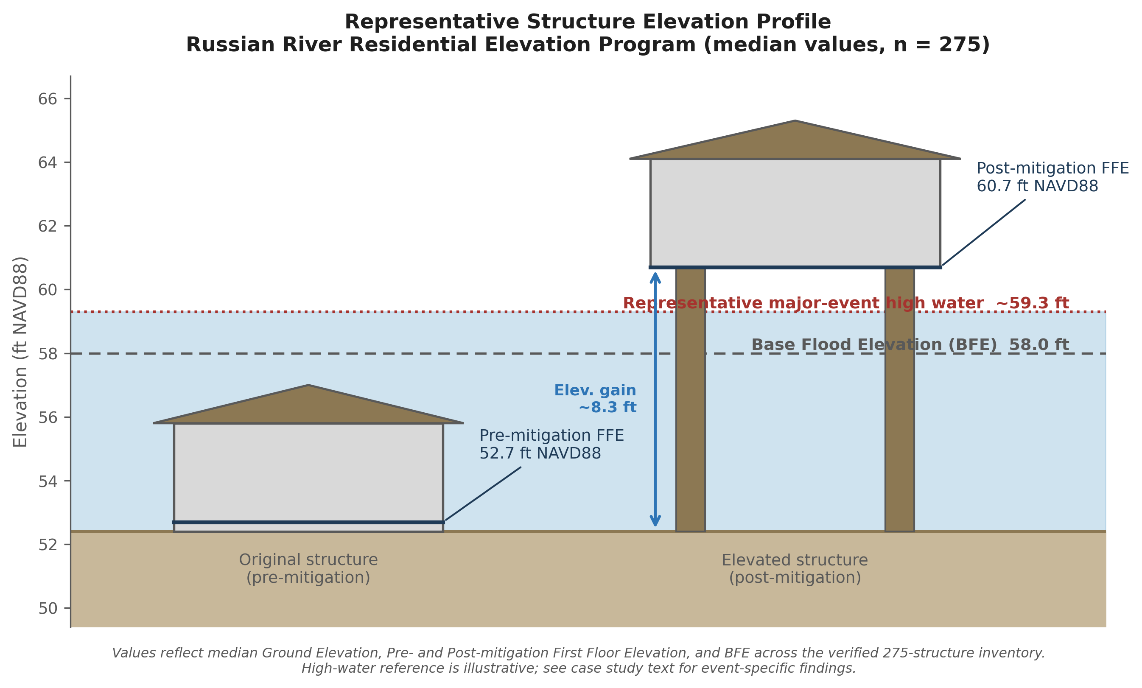
Monitoring Plan Recommendation
Consider structuring loss avoidance studies as a living, repeatable monitoring framework rather than a one-time analysis. The Russian River study’s design illustrates how this can work: a verified structure inventory, including building footprints, foundation type, first-floor elevations, and elevation certificates, maintained as a standing geodatabase, layered with regionally calibrated depth-damage functions. After each significant flood event, the same flood depth grid extraction and loss estimation workflow (HEC-RAS for modeled events, FEMA Flood Depth Grids for major or out-of-range events) can be rerun against the existing inventory to add a new event to the cumulative loss avoidance record, without rebuilding the underlying analysis from scratch. This allows a mitigation program’s benefit-cost performance to compound and strengthen automatically as new flood events occur, providing continuously updated evidence for Step 4.2’s monitoring and evaluation requirements and for future grant and funding applications under Step 4.1B.
Figure 28. Losses avoided by event and loss category, with cumulative program total. Each new flood event extends the monitoring record without re-deriving prior years.
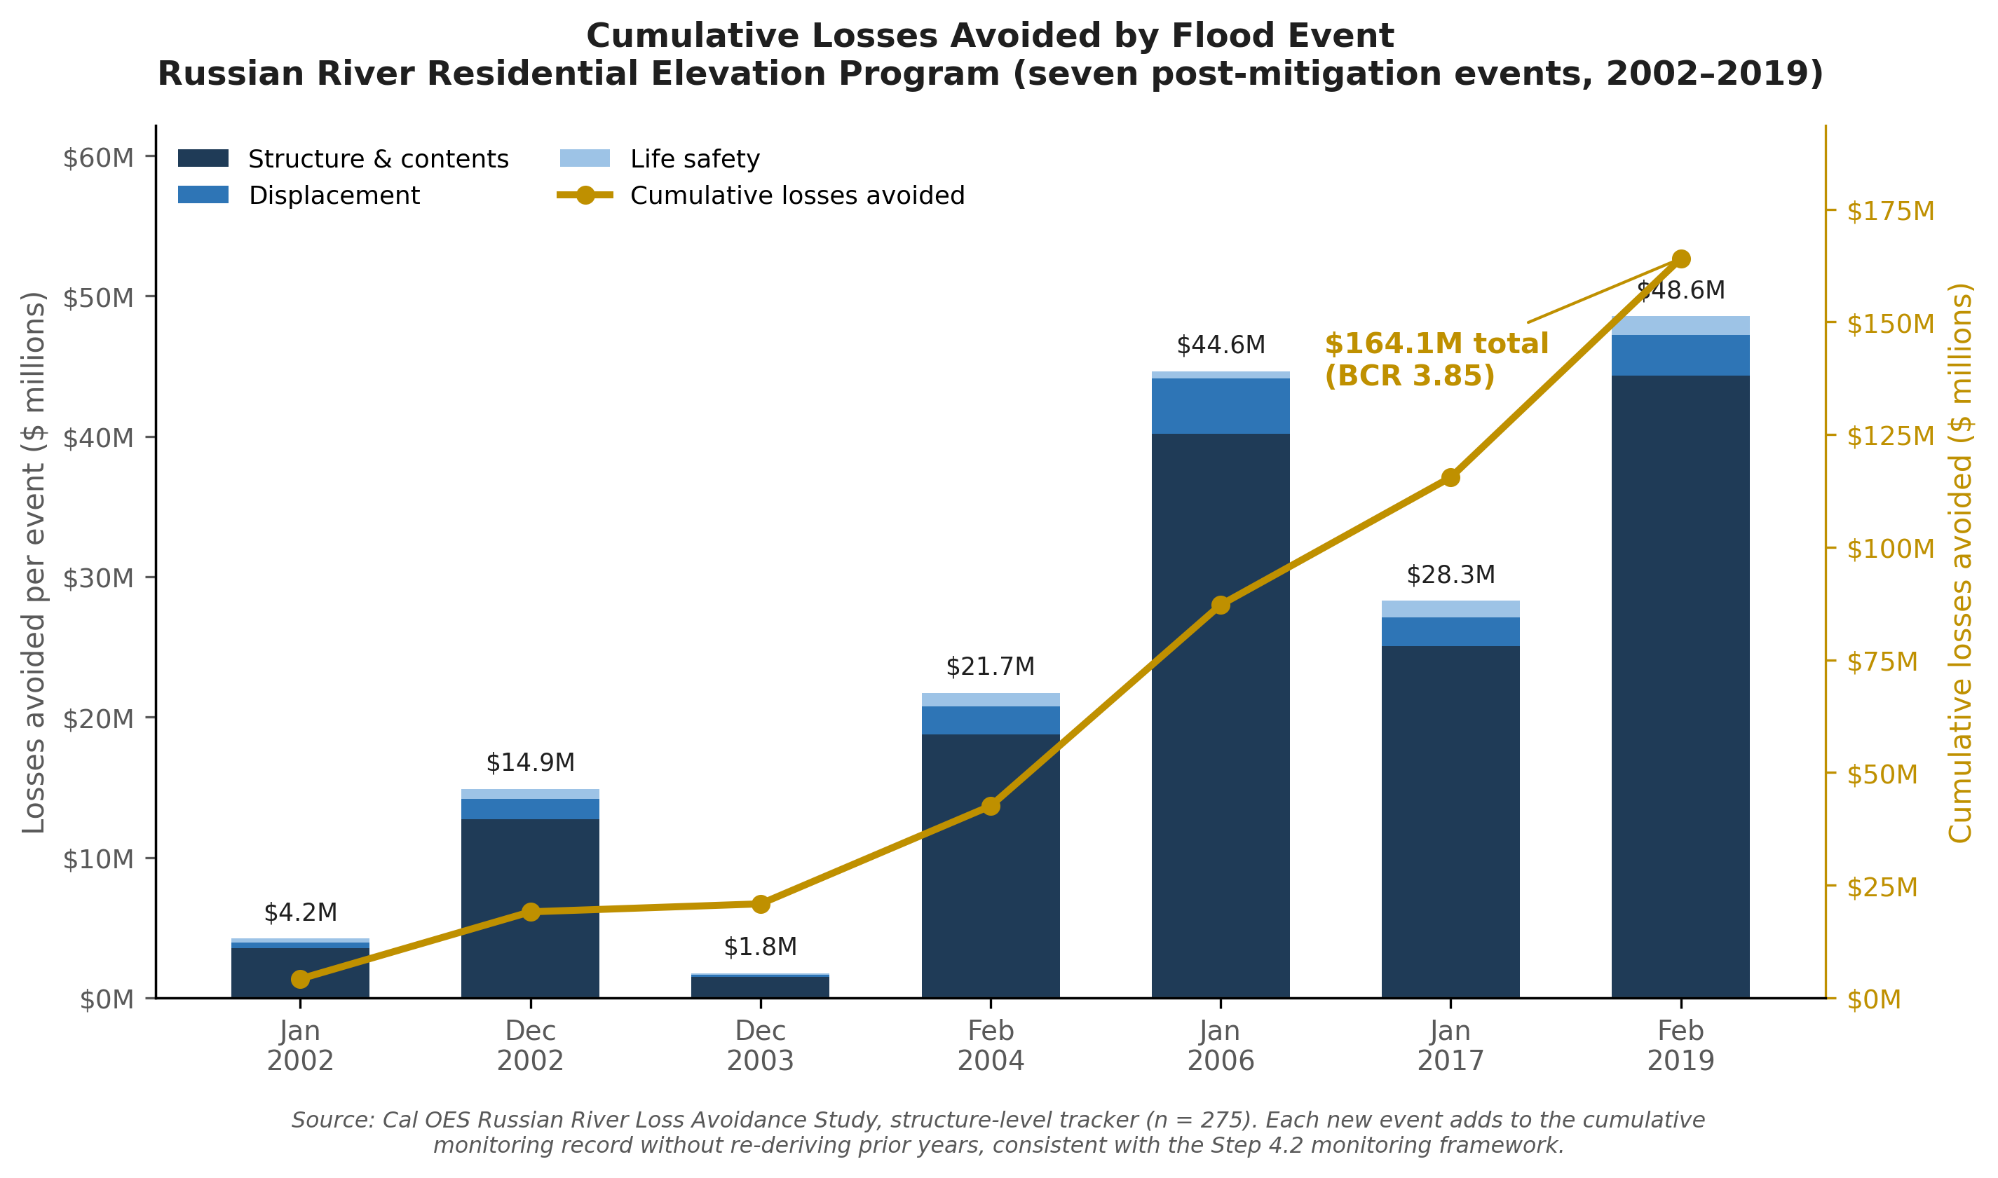

How to Monitor and Evaluate Effectively – Best Practices
- Streamline Information Collection: Streamlining the collection of information is essential for effective climate adaptation monitoring. When possible, standardize measurable indicators across strategies to ensure consistency and avoid duplication of efforts. Centralize and organize all data points in a uniform system to ensure data is accessible to all users.
- Strengthen Internal Cross-Department Collaboration: Effective adaptation and resilience implementation requires strong partnerships and coordination across departments. Identify a department lead for each strategy to help monitor and track implementation progress. In many cases, this also requires designation of a dedicated funding source for monitoring activities. The agency responsible can be a jurisdictional department, regional entity such as a council of governments, or a community group.
- Develop a Public Dashboard to Foster Transparency and Accountability: Consider developing a publicly accessible virtual dashboard to monitor climate adaptation strategies and measure implementation progress. A well-designed dashboard promotes transparency, strengthens accountability, and builds public trust by clearly demonstrating how plans translate into action. Dashboards should be maintained and updated on a routine basis, either quarterly or annually.
Case Study: West Hollywood’s Climate Action Dashboard
The City of West Hollywood (WeHo) developed a WeHo Climate Action Dashboard to track progress and implementation of the City’s 2021 Climate Action and Adaptation Plan. The dashboard is organized around 5 climate action focus areas that include more detailed actionable strategies. The dashboard is frequently updated and includes progress indicators tracking if each strategy is on track, behind schedule, at-risk, or completed.

Step 4.2B: Monitoring and Evaluating Outreach
Community engagement should remain a central component of monitoring and evaluating any adaptation plan or project throughout implementation. Transparency in implementation progress and decision-making processes is essential so that communities can track milestones, understand changes, and provide input on adjustments to identified strategies over time. As discussed above, dashboards are a virtual tool to track ongoing progress of strategies and plans.
Too often, implementation plans are treated as internal documents, created primarily for administrative purposes and not designed for public use. By developing a public-facing implementation plan, local jurisdictions can help promote transparency and accountability while ensuring community input meaningfully shapes decision-making and guides progress.

Best Practices for Monitoring and Evaluating Progress
- Document Lessons Learned: Community engagement during the implementation phase should intentionally build upon lessons learned and key insights during public engagement in Phases 1-3. Reviewing and applying prior feedback helps maintain continuity, strengthen trust, and improve overall effectiveness. Document lessons learned to ensure that engagement efforts are strategic and not repetitive.
- Establish a Community Advisory Committee (CAC): Consider convening a CAC to help track progress, evaluate outcomes, and provide continuous feedback. Community members can help monitor and review implementation milestones, priorities, and performance metrics, communicate with the broader community, and identify and elevate emerging community issues that might require adjustments to strategies over time. A CAC can help serve as a bridge between the adaptation project implementers and the broader community. The committee should include a diverse group of partners, such as residents, community-based organizations, academic institutions and subject-matter experts, Tribal members and Indigenous knowledge holders, non-profits, youth, and local businesses.
- Partner with a Third-Party Evaluator: Consider leveraging partnerships with a third-party evaluator, such as an academic institution to help track implementation progress and outcomes. Partnering with a third-party evaluator can help support lower capacity communities establish performance indicators, develop public dashboards, track milestones and outcomes, as well as coordinate with a community advisory committee to ensure community voices are included throughout all decision-making processes.
- Reporting Back to the Community: Community members should receive regular updates throughout implementation. Sharing successes and challenges helps build trust and demonstrates accountability. When reporting back to the community, use communication methods that are accessible and appropriate for the intended audience.

Step 4.3: Adjust
Goal: Determine what adjustments are needed and how the adjustments will be implemented to improve the effectiveness of adaptation strategies.
Adjustments should respond to the results of monitoring and evaluation findings and changing local conditions. Adjustments should be made if an evaluation of monitoring data reveals an adaptation strategy and/or plan is losing effectiveness. Updates can also occur periodically, due to pre-established plan update cycles or legislative requirements (e.g., General Plan’s Safety Element and LHMP/THMP updates). Adjustments are distinct from and do not need to be tied to plan updates; it is more practical to focus the adjustments to be as narrow as possible.

Step 4.3A: Adjustment Considerations
Adjustments can range from changing the speed of implementation, to altering its location, to revising the implementation mechanism. Findings from the monitoring and evaluation phase should inform the process of identifying how and what adjustments should be made. If monitoring indicates that a strategy is not effective, the strategy should be carefully assessed to determine the extent to which it can be bolstered to address climate change impacts. Opportunities to strengthen existing strategies presented in Step 3.3 are helpful to consider when adjusting strategies. For example, are there opportunities to strengthen equity considerations or improve coordination across departments? When making adjustments, it is also helpful to consider the extent to which the strategy intersects with alternative strategies that may more effectively address the impacts.

Step 4.3B: Adaptation Pathways
An Adaptation Pathways approach can pre-identify a portfolio of alternative adaptation strategies that can be put into effect once specific triggers and thresholds – usually observation of specific physical conditions – are met. When evaluation of monitoring data shows that a specific pre-identified trigger or threshold is met, a strategy can be strengthened or transitioned into an alternative strategy.
In many cases the alternative strategies that are potentially more effective take longer or cost more to implement, making them better suited to be a longer-term strategy that can be implemented after priority strategies are put into effect. Choosing when to shift to the longer-term strategy is more easily managed when specific triggers for the shift are identified ahead of time.
Triggers are measurable indicators that represent a point in time when action must be taken to address hazard-related vulnerabilities before impacts reach a point of emergency. An appropriate trigger provides enough notice and lead time to plan for and implement an adaptation strategy before vulnerabilities become severe. For example, a community might determine that once sea levels rise by 0.2 foot, they will begin expanding wetland vegetation to protect a coastal walkway, and once sea levels rise by 0.5 foot and the walkway will soon become regularly flooded, they will rebuild or reroute the coastal walkway. Lead time should also be considered alongside triggers, since infrastructure changes can take significant time to implement once a trigger is reached. The Adaptation Pathway approach strategically plans for future strategy adjustments, creating opportunities for more dynamic and responsive adaptation strategies that can be strengthened to more effectively address climate impacts.

Case Study: Santa Cruz’s Adaptation Pathways Approach
The City of Santa Cruz has proposed an Adaptation Pathways approach for their coastal adaptation planning that includes triggers to signal when to transition to next step coastal adaptation solutions. Once monitoring and evaluation reveals that a certain physical condition is met that will make an existing strategy no longer effective, they will transition to a pre-identified alternative strategy. For instance, their draft adaptation pathway for Natural Bridges State Beach identifies beach width as a trigger that will initiate the planning and implementing process for a living shoreline strategy, and once triggers are met for several additional monitoring parameters, managed retreat of state parks infrastructure would be pursued.

Loss avoidance studies can also serve as a trigger-verification tool for an Adaptation Pathways approach. Because loss avoidance measures actual structure performance against real, observed flood events, rather than a forward-looking model, it can confirm whether an infrastructure-based strategy’s design threshold still holds or is beginning to erode.
In the Russian River study, the February 2019 flood, the largest event in the seven-event record, showed that a portion of the elevated inventory, 26 of 239 flooded structures, experienced inundation above their post-mitigation first-floor elevations for the first time in the record. A metric of this kind (for example, percent of inventory exceeding post-mitigation elevation at a given event magnitude or gauge stage) is exactly the type of measurable indicator that could be pre-identified as a pathway trigger, prompting a community to plan for a complementary or alternative strategy, such as additional elevation, buyouts, or upstream storage, before vulnerabilities become severe, consistent with the trigger-based logic described in Santa Cruz’s coastal adaptation pathways approach.

Figure 29. Elevated Structures and the 2019 Russian River Flood Extent – Sonoma County
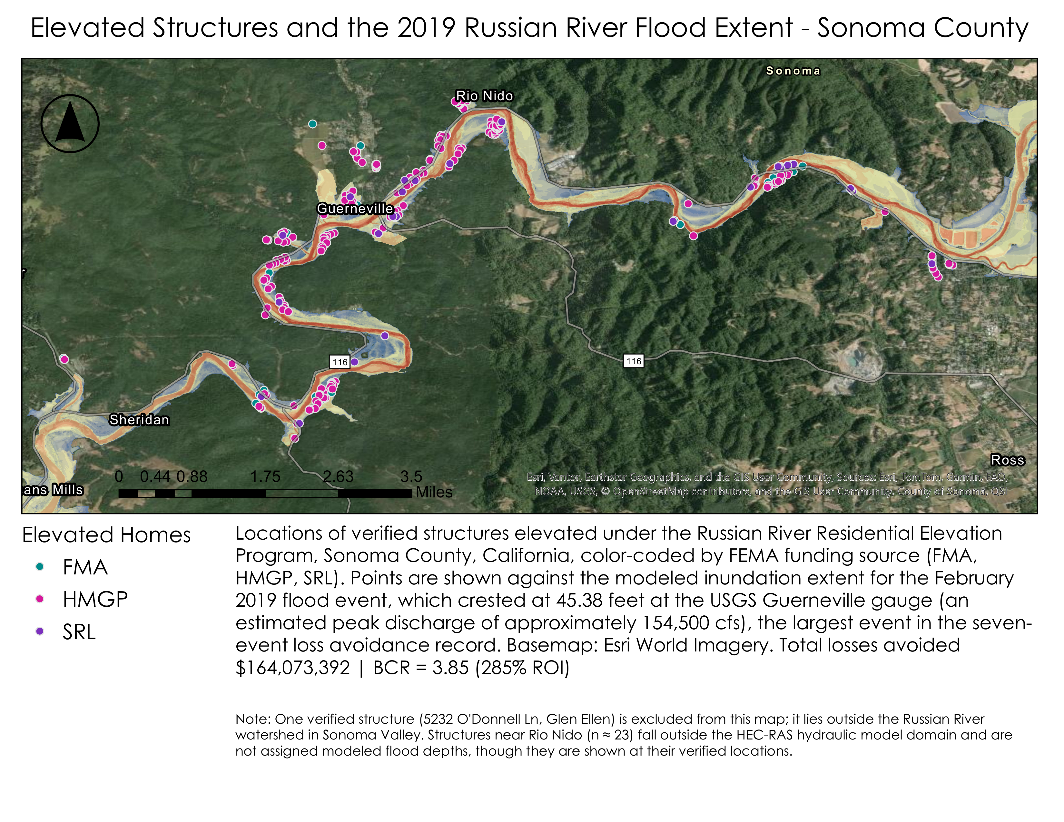
While Adaptation Pathways is one approach for addressing uncertainty in climate adaptation planning, other methods, such as decision-scaling approaches, can help identify vulnerabilities, performance thresholds, and when adjustments based on climate conditions may be needed.
Additional guidance on this approach is provided in the State Water Project Adaptation Strategy.

Step 4.3C: Adjustment and Outreach
Communicating with the community and inviting its collaboration throughout the implementation process, both before and during adjustment, are critical to sustaining ongoing adaptation. A community should not be surprised by changes in strategies, which should be communicated consistently as a normal part of long-term climate adaptation. Without appropriate inclusion of the community throughout the process, changing a strategy could be viewed as abandoning it or as a failure of implementation rather than as a successful outcome of good monitoring and evaluation. Sustained engagement with the community and transparency in monitoring and evaluation can help avoid such misunderstandings, which can lead to community dissatisfaction with adaptation actions. Additionally, community inclusion can supplement the selection process for the new or bolstered strategy.
Some best practices for engaging the public in the update process are:
- Ensure that lessons learned and outcomes from review and monitoring of implementation are publicly available.
- Use data to inform plan updates and/or make course corrections.
- Develop materials allowing for pop-up events to solicit feedback and ideas for strategy adjustment when needed.
- Collaborate with the community to update strategies and program implementation based on lessons learned from monitoring.

Case Study: Beach Cities Health District (BCHD)’s LHMP
BCHD committed to increasing accessibility and public participation by building on the outreach capacity used during the development of its first Beach Cities Health District LHMP in 2025. The District’s process below outlines a few simple but effective methods to keep outreach momentum going:
- Enhance Public Education and Community Engagement
Building on existing outreach capacity, BCHD can:
  - Publish the adopted LHMP on its website and link it through its Health Resource Directory
  - Present plan goals and updates at public events, partner forums, and partner meetings
  - Share mitigation tips and updates via newsletters, social media, and wellness campaigns
- Expand Partnerships with Vulnerable Population Advocates
BCHD already serves many high-risk populations. Future efforts can enhance mitigation equity by deepening engagement with:
  - Senior centers (e.g., Joslyn Center)
  - Behavioral health providers
  - South Bay paratransit and mobility services
  - School-based wellness coordinators
  - Cultural and language-specific community organizations
These partners can help co-design mitigation strategies, distribute risk communication materials, and ensure inclusive planning.
- Use Diverse Communication Tools
To increase accessibility and participation, BCHD will continue using hybrid formats (virtual/in-person) for outreach and meetings. Written materials, video content, and infographics may be translated into Spanish and other prevalent languages. Communications will be distributed through BCHD’s website, newsletters, social media, local news outlets, and direct outreach with trusted community partners.
These strategies help normalize mitigation as part of overall health protection.

Phase 4 Wrap-Up
Implementation is a critical part of any adaptation plan. Once a plan is developed, communities must put strategies into action, monitor progress, evaluate outcomes, and adjust based on feedback and changing conditions. Because climate impacts and community needs can change over time, adaptation planning should be viewed as an ongoing, iterative process.
Successful implementation also requires identifying funding sources, establishing realistic timelines, and assigning key roles and responsibilities to determine who will lead specific actions and how progress will be tracked.
Monitoring and evaluation are key to successful implementation of adaptation strategies. By maintaining a robust and flexible adaptation planning process, communities can position themselves to build capacity to withstand climate change impacts and continue to thrive in a changing environment.

APPENDIX A: OUTREACH & ENGAGEMENT METHODS

How to Use This Appendix
This Appendix provides additional guidance for outreach and engagement throughout all phases of the APG. Unless a specific step is referenced, the guidance is intended to support and be applied across every step of the process.

Racial Equity Framework
The California Racial Equity Commission developed a 2025 Racial Equity Framework that provides a comprehensive set of tools, resources, and best practices to support equitable community outreach and engagement. It helps communities design inclusive processes, center the voices of those most impacted by inequities, and build trust through transparent and culturally responsive engagement. By offering practical guidance on partnership-building, decision-making, and accountability, the framework enables local governments and organizations to develop more effective, community-informed solutions that advance equity.

The Spectrum of Community Engagement to Ownership
The Spectrum of Community Engagement to Ownership is developed by Rosa Gonzalez of Facilitating Power. The spectrum can be used by local governments, community-based organizations, and non-profits to facilitate community participation in solutions development and decision making. It is designed to:
- Acknowledge Marginalization as the status quo practice of current systems that have been historically designed to exclude certain populations
- Assert a Clear Vision for rebuilding local democracies, as key to solving today’s toughest crises, through inclusion, racial justice, and community ownership
- Articulate a Development Process for rebuilding local democracies that require significant investment in the capacity to participate as well as the capacity to break down systemic barriers to community participation
- Assess Community Participation Efforts and Progress toward participation goals
Start on page 6 (PDF pg. 7) for guidance on how to apply the spectrum of community engagement across different communities, as well as how the tool can be used to inform a plan and decision-making.

Best Practices for Conducting Outreach and Engagement Activities
Outreach and engagement activities can vary in format and style depending on a community’s needs, culture, and capacity. Below is a list of best practices to consider when implementing outreach and engagement strategies across all phases of the APG. Activities may include, but are not limited to the following:

Meet People at Existing Events
These are events hosted by other organizations in the community that can be partnered with, presented at, or set up a booth or table at. This is a great opportunity to meet community members in their own spaces. Here are a few examples of these kinds of events:
- A booth at a regular community gathering like a local farmer’s market, high school football game, music festival, block party, or school fair. Some options are to hand out flyers, ask people to take surveys for small prizes, and put up posters with information or questions about climate vulnerabilities in the area that people can react to by placing sticky notes or colored dots for voting.
- Presentation to a neighborhood association, church group meeting, PTA meeting, service club meetings (Rotary Club, Kiwanis Club, social groups like Scouting, little league sports, other community groups), hobby group meetings (garden club, historical society, hiking club). Ask for a few minutes at the beginning or end of the meeting to explain the project and ask for specific feedback. Keep things as clear and concise, and try to connect climate issues back to the mission of the group being presented to, as much as possible.

Meet People at Everyday Spots
These are places people go on a regular basis to run errands. Meeting people in these places ensures inclusion of the perspective of folks who may not have time to go to extra events. Offer opportunities for quick activities or surveys and offer food or gift cards for people’s time. Invite known partners and advertise on social media to attract more attendees as well. Some examples include:
- Pop-up at a local laundromat to talk to people while they wait for their laundry
- Table at a local grocery store
- Set up a booth at a main transit station (bus, train stops)
- Tent at a park or playground
- Offer free coffees for those who take a survey inside a local cafe or coffee shop
- Set up a booth at a local post office, DMV, or other government service building
- Outside a school during drop off and pick up times

Offer Virtual Engagement Opportunities
Ensure that engagement and outreach events are available both in-person and in virtual format to reach broader audiences. Leveraging virtual engagement sessions can help reach individuals who are unable to physically attend or participate in an in-person format. Consider these options:
- Host a virtual meeting: Use a platform like Zoom to present plans and include time for people to ask questions and use polling tools to make it interactive.
- Share online surveys through social media: Keep these short and mobile-friendly and consider offering some kind of incentive for filling it out.
- Mail surveys to constituents’ houses or drop them outside their doors: This is great for reaching older populations and those without reliable internet. Include a pre-paid return envelope.
- Place large posters in high-traffic areas like storefront windows or community boards: Use a QR code that links directly to a 30-second video explaining the project and a quick survey.

Organize an Event
Creating and managing an event is the best way to get in-depth discussions and feedback going, since it can ensure there is more time to introduce the work and space to set up activities. A common strategy for receiving feedback on a climate vulnerability assessment is through a workshop. The workshop generally includes the following:
- An overview of the climate vulnerabilities identified, including past disaster events, major hazards, populations most vulnerable, secondary hazards, and assets at risk.
- A discussion or activity where participants can provide their own knowledge and experience of climate vulnerabilities- like marking areas on a map, discussing in small groups, or writing on posters.
- An overview of existing adaptation strategies planned in the community (by local government, regional government, or state agencies), how effective they are, and what opportunities were identified to increase adaptive capacity.
- A discussion or activity where participants can provide input on how to advocate to improve existing adaptation strategies and ideas for new programs or projects to build resilience.
- Lastly, an overview of what actions the organization is thinking of taking to address these challenges (expansions of existing programs, leveraging assistance programs, new projects) and how it is planning on getting there (partnerships, grants, etc.), with an opportunity for participants to provide feedback and input.
When organizing an event, know that events work best when there is some kind of ‘draw’. Try coupling the discussion of climate issues in the community with something fun or useful for the attendees:
- A pop-up event in a public space with food and drinks, activities, and seating. Instead of just a booth, try to utilize a small zone in a high foot traffic area to attract passersby. Consider getting a food truck or partnering with a nearby local restaurant and use large planters, colorful chairs, and outdoor rugs to define the space. Check out this pop-up toolkit for more ideas.
- Walking tour of the community with stops at local institutions and discussion of climate impacts to the area (this bakery half-marathon walk in LA had over 1,600 people apply for 50 spots).
- Partner with a local medical center or clinic to organize a wellness event with free health screenings (blood pressure, vision, dental, etc.) and talk about the connections between health and climate in the community.
- Leverage Ready California initiatives to bring people together. (Neighborhood Block Party is designed to help neighbors prepare for disasters. To learn more visit: Neighborhood Block Party – Listos California)

Once the strategy is decided, word needs to get out. A few examples of strategies include:
- Outdoor message boards: High schools, city halls, libraries, community centers, and churches may have electronic or changeable marquees or message boards that can be used to announce events. Local public works departments and police or sheriff’s offices often have electronic traffic message boards that can be placed in high-traffic locations to advertise events.
- Street and park banners: Many communities can string banners across roadways on main streets, near parks, or in other public spaces to publicize events.
- Multilingual flyers and posters: Flyers and postcards can be printed with two languages (one on each side). These materials can be:
  - Sent home with school kids
  - Handed out door-to-door
  - Shared on social media (make sure your social media posts are accessible, click here to learn best practices to create a post accessible on social media.)

- Shared at businesses and community centers
- Consider partnering with an academic institution or educational nonprofit organization to perform engagement through participatory research. Work with the researchers to have them popularize technical information about local climate impacts to make it more accessible to the broader community. For example, researchers could co-create fact sheets related to natural hazards or conduct parts of the vulnerability assessments, such as interviewing several local small businesses to assess post-disaster capacity. If funding is available, partnering with CBOs to do a supplemental analysis about vulnerability in lower-income communities and communities of color could be ideal.

Community engagement does not end when an event ends. Participants will want to understand how their input influenced the planning process. It is important to consider sharing summaries of engagement findings and explaining how their feedback was incorporated into decisions. Being consistent with this approach, communities are more likely to participate in future efforts.

Partner Interviews
APG Connection: Step 2.2D
This step focuses on partner interviews to validate assumptions, surface unaccounted impacts, and explore how climate risks may evolve over time.
Partner interviews can be conducted individually or in small groups in one or multiple rounds, depending on staff capacity. Questions should be shared in writing in advance whenever possible, allowing participants time to reflect and prepare. Teams should also adapt and add questions as needed to reflect local conditions, specific hazards, or assets. Sample interview questions include:
- Infrastructure Climate Impacts
These questions are designed to gather partner expertise on historical impacts and how those impacts may change under future climate conditions. They are for technical partners (local government or agency staff, utility staff).
  - What services have been impacted by the climate hazard? Are these services disrupted? How might impacts to services change given projected changes in climate?
  - What facilities have been damaged, destroyed, or otherwise impacted by the climate hazard? How might climate impacts to facilities change given projected changes in climate?
  - Have populations been impacted physically or mentally by the climate hazards? How might climate impacts to populations change given projected changes in climate?
  - Have there been additional downstream disruptions that result from the loss of critical services (e.g., electrical disruptions impacting hospital service)? How might impacts arising from interdependencies change given projected changes in climate?
  - How have impacts varied across the community? Which populations have been most affected? Which populations might be most impacted in the future?
  - Did the climate hazard create economic losses? How might economic losses change given projected changes in climate?
  - Have community ecological or cultural resources been impacted? How might impacts to these resources change given projected changes in climate?
- Infrastructure Management Efforts
These questions are designed to gather partner input on existing and planned efforts to manage climate impacts now and in the future, particularly high priority climate impacts. They are for technical partners (local government or agency staff, utility staff).
  - Are there existing programs and policies that help the community manage climate impacts?
  - How effective are they in managing present-day climate impacts?
  - Based on projected changes in climate, will they be effective in managing future climate impacts?
  - Are there planned programs and policies that will help the community manage climate impacts?
  - How effective will they be in managing present-day climate impacts? Future climate impacts?
  - What are the barriers to managing climate impacts in the community?
- Community Climate Impacts
These questions are designed to get direct community perspective on past and present climate impacts. They are for community partners.
  - What type of weather events (heatwaves, floods, storms) have affected the community in the past few years? Are there specific stories or examples that come to mind?
  - How have essential services (power, water, transport) been disrupted during these events?
  - Which places (community centers, churches/temples, grocery stores, food banks, libraries, etc.) are important to the community? How have they been impacted?
  - Have any groups (elderly, low-income, children, disabled) been disproportionately affected? How?
  - What climate impacts are most worrying regarding the future of the neighborhood?
- Community Management Efforts
These questions are designed to gather community perspective on efforts to manage climate impacts. They are for community partners.
  - How are weather alerts or warnings sent out? Are these alerts easy to understand and act upon? What are the best ways to reach people in the community with urgent information (text, call, social media)?
  - What solutions have worked (or not worked) in the past?
  - What is one thing that can be done to help the community prepare for future climate challenges?

Vulnerability and Resilience Building
APG Connection: Step 2.3C
Here engagement and outreach efforts focus on gathering feedback and insights to integrate into the assessment of climate vulnerability and adaptive capacity assessment developed in Phase 2. The goal of these engagements is to identify local knowledge of climate impacts, neighborhood strengths and assets, as well as community-defined priorities, concerns, and ideas for adaptation.
Decide what kinds of activities the attendees will participate in during engagements to get their feedback. This Appendix provides a few options pulled from the Pacific Institute’s 2013 Climate Change Survivor Workbook with Games:
Climate Jeopardy
- Purpose: To introduce the concepts of climate vulnerability and resilience.
- Group activity (6+)
- 15+ minutes
- This game allows a group of participants to become more familiar with concepts foundational to the assessment to set the stage for more in-depth discussion. To start the activity, review definitions of vulnerability and resilience, then bring out a bowl with strips of paper that have different characteristics that either contribute to vulnerability or resilience. Participants can discuss and add the characteristic to a large poster board.
- More details on hosting climate jeopardy are available in the Climate Survivor Workbook (pg. 16).
Participatory Mapping
- Purpose: To gain insight into the community’s specific experiences with climate change.
- Group activity 4+ (best for 4-8 per map)
- 1+ hour
- Participatory mapping is one of the best activities for a small group setting to get a sense of the location and nature of climate impacts people are experiencing and the major assets in the area that are helpful for the community to cope with those impacts or may be potentially at risk. Participatory mapping involves community members collectively marking on a large map where they have experienced climate impacts from flooding, extreme heat, wildfire, sea level rise, drought, etc. as well as identifying specific vulnerable populations, critical services or places, and local resources that are important during emergencies. This activity allows people to share their lived experience and local knowledge to reveal insights about community vulnerability to climate change beyond what can be understood from the data.
- Participatory mapping can be done in-person using a large poster board with a printed map and stickers or sticky notes for attendees to identify issues. It can also be done online using a GIS platform.
- More information on setting up participatory asset mapping is in the Advancement Project’s Healthy City Participatory Asset Mapping or in the Climate Survivor Workbook (pg. 23).
Community Impacts Timeline
- Purpose: To get people thinking about climate impacts as something that are real and have had a recent impact on their community.
- Group activity (6+)
- 30+ minutes
- Use the information gathered in the historical events section of the assessment to create a timeline of past climate impacts in the community. This can also be supplemented with any insights from partner interviews.
- The timeline should be large with lots of images, try using a big posterboard or print out images and text to arrange on a wall. Review the events that are on the timeline with participants and ask if anyone has any memories of these events and how they responded to the disaster. Jot down people’s responses. Add in other events that people remember occurring in the community or nearby.
- At the end, participants can also be invited to think of possible future events and use this as a springboard to discuss what was found in the climate projections data for the area. This can then segue into a discussion of how to improve resiliency in the community to deal with these impacts before they arrive.
- More details on creating a community impact timeline are available in the Climate Survivor Workbook (pg. 12).
Climate Bean Bag Toss
- Purpose: This activity can help kickstart quick, one-on-one discussions with people about the climate impacts that they might face.
- Individual activity
- 5+ minutes
- It is easy to set up and great to set up on the sidelines of a bigger event or as a focal point of a booth.
- Start by creating a board out of cardboard, scrap wood, or poster paper on a hard surface, and mark it with at least five different colored squares to represent each of the different climate change impacts and climate related disasters. The player tosses their bean bag onto square and then a discussion starts with them about how they might be affected by that climate impact. For example, if their bean bag lands on flood, someone could ask them about where they live and look at whether that is in an area that is flood vulnerable on the VCP’s Vulnerability Map.
- More details on creating a community impact timeline are available in the Climate Survivor Workbook (pg. 21).
Step into the Circle
- Purpose: To get a quick scan of the participants’ climate vulnerabilities and get them thinking as a group of what needs to be addressed to build resilience.
- Group Activity (8+)
- 45+ minutes
- In this activity, participants stand in a circle and take a step forward when the facilitator reads off a statement related to climate vulnerability that applies to them (ex. Step into the circle if they use an inhaler, Step into the circle if they work or play outside, Step into the circle if they have an emergency preparedness kit at home). How many people stepped forward for each statement is recorded and at the end, participants discuss which characteristics were most common for those in the room and what climate change impacts those might be applicable to. Participants then discuss what could be done to make themselves safer from the most problematic climate impacts given the vulnerabilities that people have.
- More details on creating a community impact timeline are available in the Climate Survivor Workbook (pg. 28).

For additional engagement tools, games, and virtual engagement resources, see
- Virtual Engagement Tools and Best Practices - CivicWell
- Listos California also offers preparedness games, including Road to Safety and Route to Resilience, which can support community engagement and discussions around emergency preparedness and resilience.

Outreach to Develop Adaptation Strategies
APG Connection: Steps 3.3D
The Local Government Commission developed a Participation Tools For Better Community Planning Guidebook in 2013. This guidebook provides an overview of public participation tools that can help communities plan for health-promoting land use and transportation, with a focus on lower-income, underserved communities, along with an examination of the value of resident involvement and the key principles for successful community planning. These tools are currently being used successfully in diverse communities throughout California and across the nation. The tools explored in the guidebook can be applied to a range of settings, such as community planning workshops and advisory committees. Tools discussed include:
- Community Design Charrettes
- Participatory Budgeting
- Scenario Planning
- Low-Cost Demonstrations and Transformations
- Virtual Participation
- Health Impacts Assessments
- Participatory Mapping
- Walkability Assessments
- Focus Groups
- Interactive Models and Tactile Tools
- Photo Visioning
- Visual Preference Survey
- Techniques for Effective Meetings and Popular Events
- High-Visibility Outreach

APPENDIX B: CLIMATE DATA TOOLS

How to Use This Appendix
This Appendix provides instructions for using the data and mapping tools to complete the steps in Phase 2: Assess Vulnerability.
For additional and more detailed resources, please look to the Governor’s Office of Land Use and Climate Innovation’s Climate Ready Training.

Vulnerable Communities Platform (VCP)
APG Connection: 2.1C, 2.1D, and 2.2A
The Vulnerable Communities Platform is California’s first tool to identify where climate hazards will be most severe and which communities are the most vulnerable to those hazards. It is the recommended starting point for the vulnerability assessment in Phase 2. The platform combines climate hazard data with social vulnerability indicators to identify where climate vulnerable communities are located.
Table 23. Description of VCP features
VCP Features | What It Shows
Climate Vulnerability Map | Vulnerability scores (Low / Medium / High) for extreme heat, flood, sea level rise, and drought — combining climate hazard exposure with social vulnerability
Social Vulnerability Indicators | Individual data layers for each social vulnerability factor (income, disability, limited English, housing type, outdoor workers, etc.) by hazard type
Infrastructure Map | Critical facilities (schools, hospitals, roads, utilities) overlaid with climate hazard layers
Other Vulnerability Tools Page | Side-by-side comparison of VCP with CalEnviroScreen, Healthy Places Index, and other tools — use this to decide which tool best fits
Help Desk | One-on-one support from LCI staff for communities conducting vulnerability assessments
The Vulnerable Communities Platform evaluates the severity of climate hazards over two timeframes: current and 2050.
The Climate Vulnerability Map uses the intersection of climate hazard and social vulnerability to identify areas of increased risk that should be prioritized for adaptation. It uses a bivariate categorization for each climate hazard: extreme heat, flooding, sea level rise, and drought. The bivariate color scheme is pictured in the image below.
Figure 30. The VCP’s bivariate color scheme, which uses the intersection of climate hazard and social vulnerability
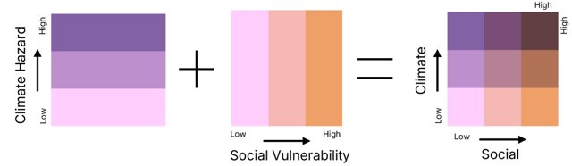
The purple gradient in the first box represents a combination of hazard data for a specific hazard. For example, for extreme heat, this includes climate projection data about the number of days over 100 degrees in the summer and warm overnight temperatures. The orange gradient in the second box represents a combination of social data also relevant to that same hazard. For example, for extreme heat, this would include social data like the percentage of people with asthma or diabetes, outdoor workers, and the frequency of Public Safety Power Shutoff (PSPS) events. The third box represents the combination of climate and social data. This is the color scheme representing climate vulnerability on the map. The dark maroon color in the top right box of this gradient represents the most climate vulnerable communities because these are the places that have both the highest climate hazard and social vulnerability to that hazard.
For example, the maroon areas on the map for extreme heat would represent places that experience high temperatures and the people who live there are low-income. On the other hand, places that are more purple would represent areas that experience high temperatures but the people who live there are not low-income. Conversely, places that are orange might represent areas where temperatures remain mild, but the community is low-income. Out of these three options, the places that experience high temperatures and have low-income community members are the most vulnerable.
The Climate Vulnerability Map only maps vulnerability where it has data on the location of communities (see this user guide for more information). This means that places like parks, stadiums, and forests do not have data on the map. This does not mean that there are no climate risks in these areas, but that there is no record of people living in these areas.
The Climate Vulnerability Map shows climate information for two timeframes. The "Now" timeframe captures estimates for 2015-2044. The "2050" timeframe captures 2045-2074. However, the map uses the same social data for the current and 2050 timescales because it does not have projection data for demographic factors like income and health.
To access the Climate Vulnerability Map, go to the VCP and click on “View Climate Vulnerability Map.” There are eight steps to use the map to assess a hazard:
- Select a specific region from the options: Climate Vulnerability Map - View by Region

Figure 31. The landing page for the VCP’s Climate Vulnerability Map
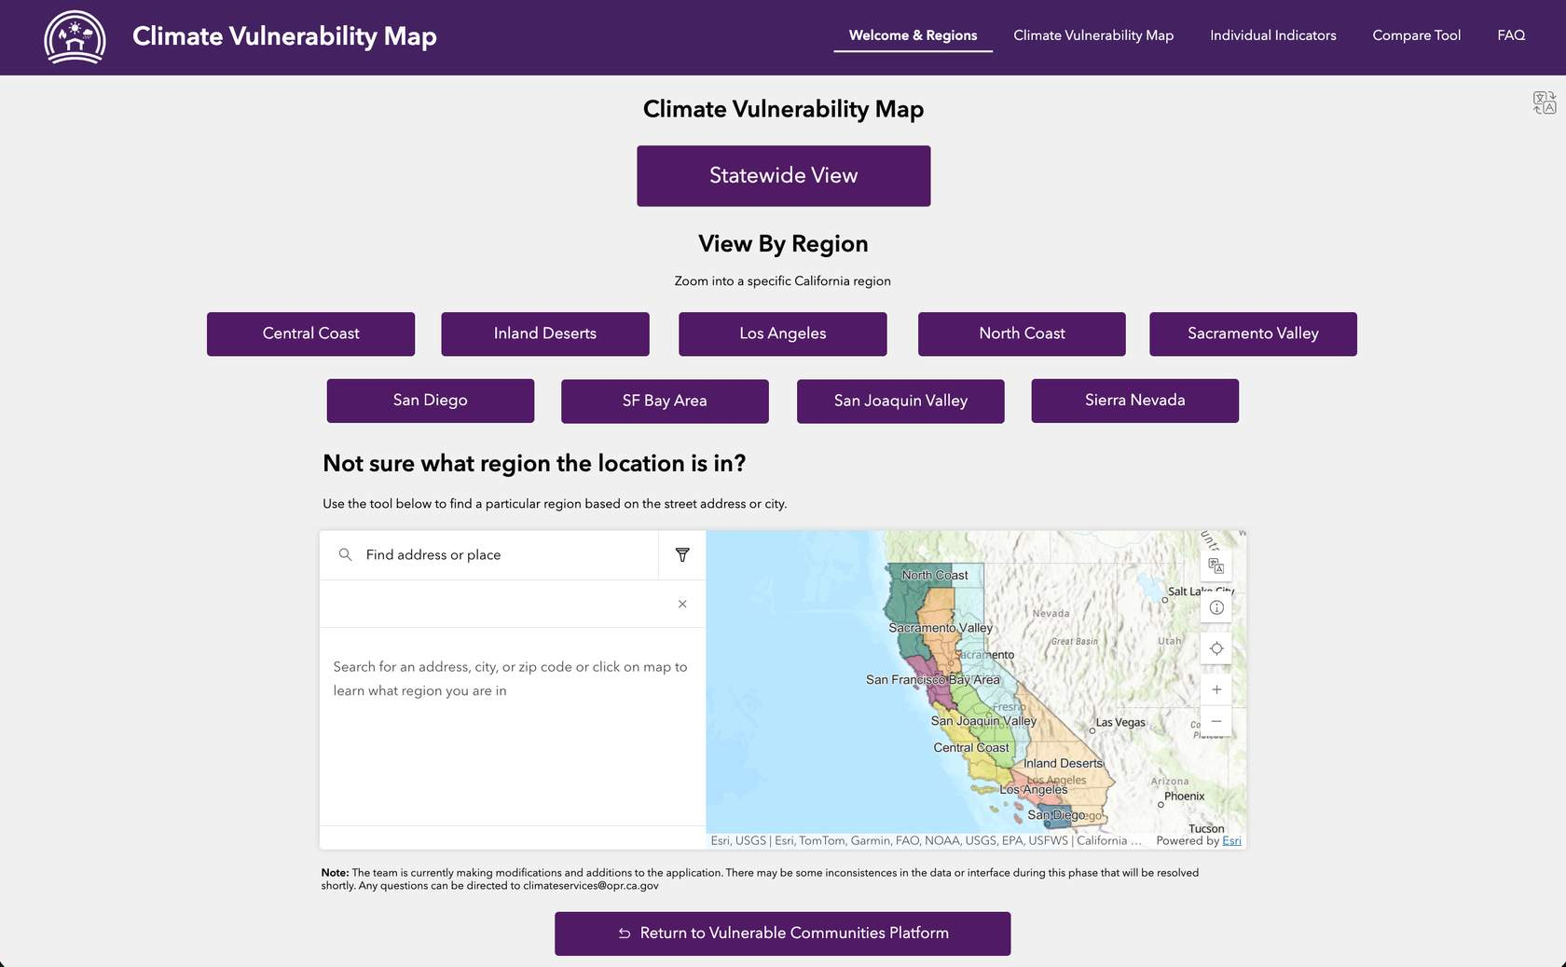

- Navigate to the specific area:
  - Once on the map, use the cursor to navigate to the desired area, or
  - Enter an address in the search bar to zoom in automatically.
Figure 32. The Los Angeles Region of the VCP’s Climate Vulnerability Map
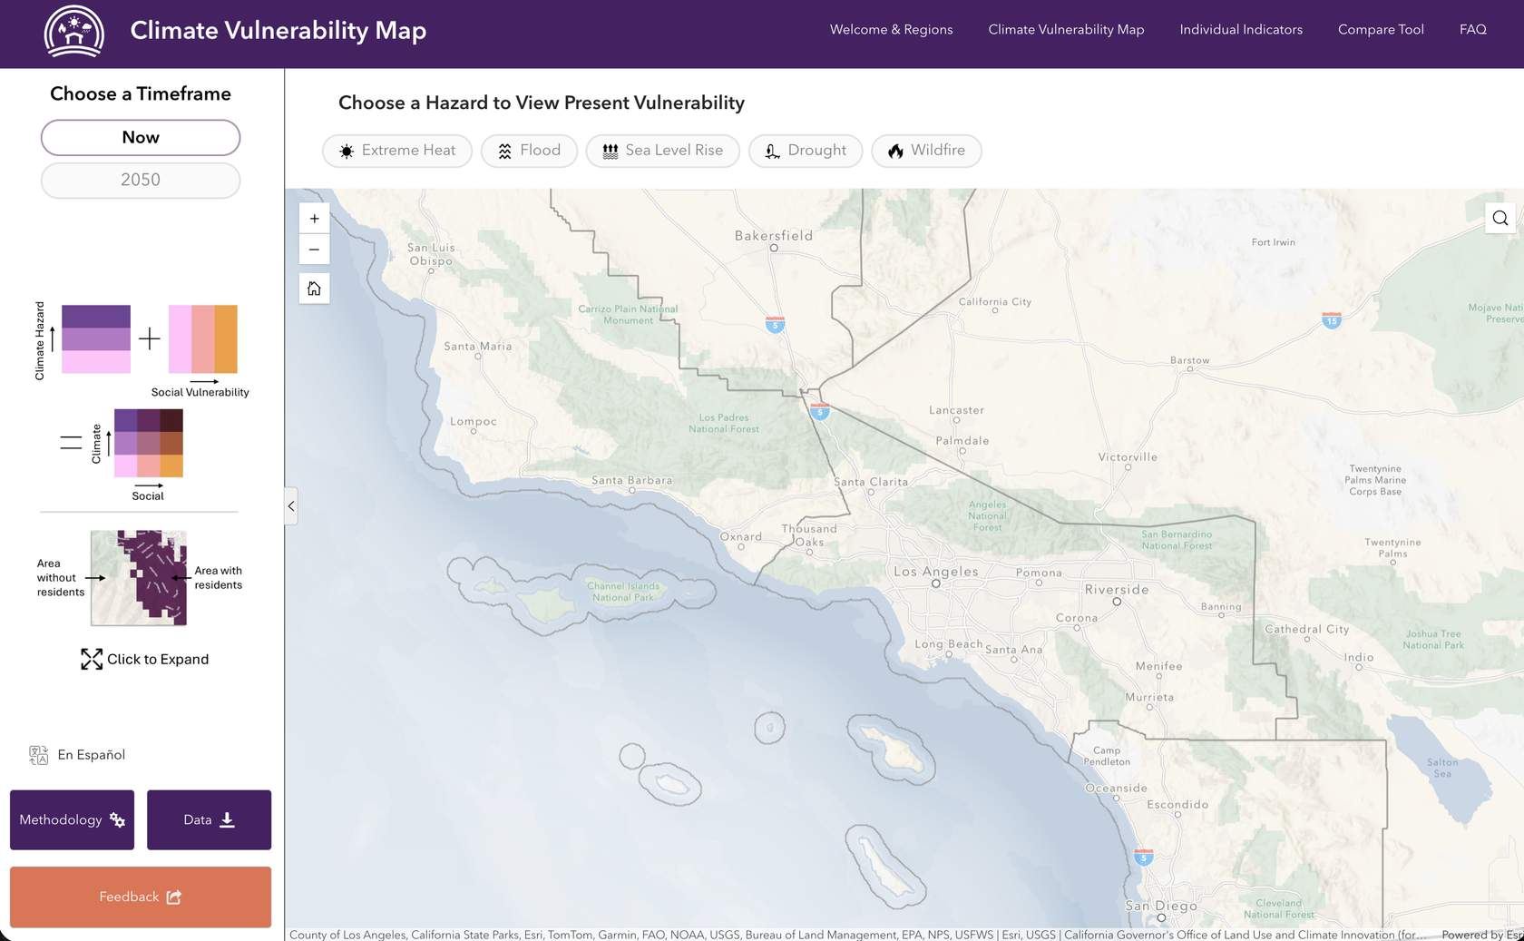
- Choose a timeframe: Choose ‘Now’ for the current timeframe or ‘2050’ for the future.
- Choose a hazard: Choose from Extreme Heat, Flood, Sea Level Rise, Drought, and Wildfire. Note: Wildfire only has data for the Now timeframe
- Additional Layers: The following layers can be overlaid on the vulnerability map for additional context.
  - Estimated Night-time Population (FEMA): This shows population estimates from FEMA to get a sense of the scale of the communities.
  - Tribal Lands: This shows Bureau of Indian Affairs (BIA) Tribal Lands data.
  - Very Low Income: This shows block groups that have a median income of 60% or less of the Area Median Income (AMI).
  - When looking at the Sea Level Rise layer, there is a Coastal Flooding Concern layer and a Groundwater Table Rise Concern layer. These layers are meant to show if the sea level risk represented on the map is due to direct flooding concern or a rising groundwater table that can lead to contamination from toxic sites and surface flooding during heavy rains.
- Look at the Pop-Up:
- Click on a spot on the map to generate a pop-up for the area that gives a detailed summary of all the climate vulnerability data for the block group including: current and future high, medium, and low vulnerability designations for each hazard
Figure 33. Climate vulnerability data pop-up for each block group
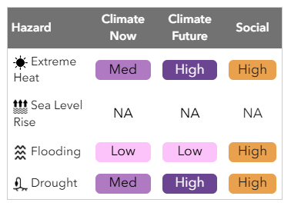
    - Demographic, income, and population values
Figure 34. Demographic breakdown pop-up for each block group
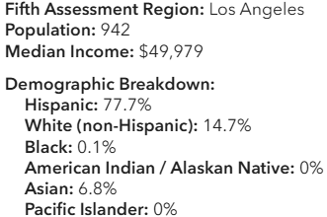

    - Percentage values for each indicator making up the social vulnerability score. The greyscale pill color displays how high the value is for this block group relative to the rest of the state. A darker color means that this indicator has a particularly high value relative to the State.
Figure 35. Social score components pop-up for each block group
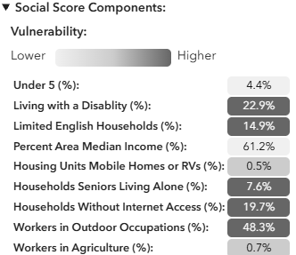
    - Percentage values for each indicator making up the climate vulnerability score.
Figure 36. Climate hazard score components pop-up for each block group
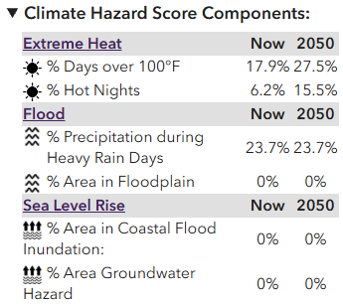
- Individual Indicator tab:
  - Go to the Individual Indicator tab on the top header.
  - This map has every layer in the Climate Vulnerability Map available to view separately. Layers can be seen one at a time or overlaid.
  - The layers are broken down into categories. Select the desired category and specific layer underneath.
Figure 37. Los Angeles Region with the asthma layer displayed in the Individual Indicators Viewer
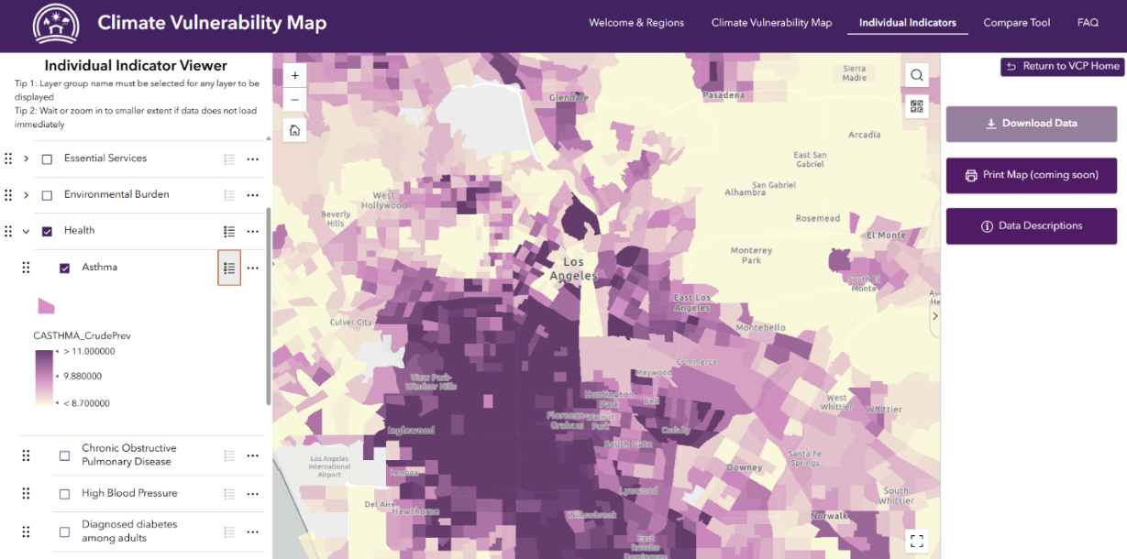
- Compare tab:
- Go to the Compare tool tab on the top header.
- This map shows two views side by side. To view how climate vulnerability changes over time, select a map under ‘Now’ on the left side and under ‘2050’ on the right side.

Figure 38. Los Angeles Region with extreme heat vulnerability for now (left) and 2050 (right) displayed in the Compare Tool Map
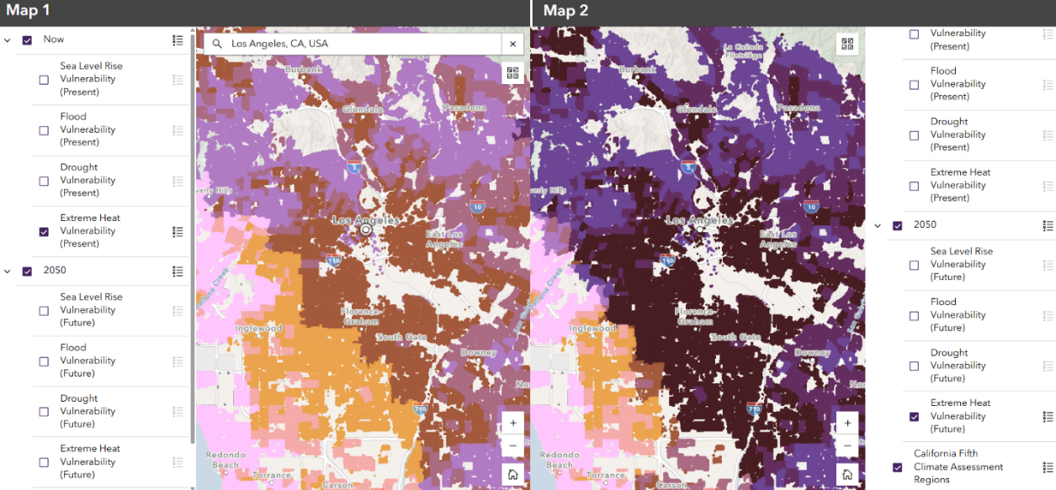
Now
2050
The VCP has created user guides to help teach how to use the Climate Vulnerability Map specifically tailored to community organizations or local governments. Please read through the most relevant user guide.
- Community Organization User Guide – Grant Applicant:
For community organizations or nonprofits who are interested in learning how to use the platform to illustrate their community’s climate challenges for a grant application.
- Local Planner User Guide Part 1 and Part 2
  - SB 379: For city, county, or regional planners who are interested in learning how to use the platform to assess their jurisdiction’s climate vulnerabilities as required by SB 379.
  - Identifying Adaptation Strategies: For planners who are interested in digging a little deeper into the data to inform strategies to build climate resilience.

Extreme Heat

LCI’s Climate Data Viewer
APG Connection: Step 2.1B – 2.1D
The Climate Data Viewer offers four extreme heat metrics for current and future timeframes:
  - Select Extreme Heat from the climate hazard options across the top of the screen.
  - Select either ‘Now’ or the ‘2050’ timeframe from the toggle on the left side of the screen.
  - Select a metric from the choices on the panel on the right side of the screen. Look at the Definitions section on the left side of the screen to see exactly what each metric means.
  - Enter the location into the search box in the top left corner of the map to zoom in to the location. Click on the desired area to get a pop-up with the exact value for the area. Record the value for the area and take a screenshot of the map for the area if needed, including the legend.

Wildfire

US Forest Service (USFS) Wildfire Risk to Communities
APG Connection: Steps 2.1C, 2.2A, 2.2B, 3.3A
Wildfire Risk to Communities has many current wildfire maps that are more detailed than those from CAL FIRE. This includes the annual probability of wildfire, expected wildfire intensity, exposure to communities, and susceptibility of a home or community to be damaged by wildfire.
- Start on the Explore Risk page and enter the desired community into the search bar.
  - The display will show an overview of the wildfire risk in the area (High, Medium, Low) and specific maps for risk to homes, risk reduction zones, wildfire likelihood, and vulnerable populations.
- Wildfire Likelihood
  - This map displays the probability of a wildfire occurring, taking into account: weather, topography, and ignitions.
  - The Low/Med/High designation includes populated areas within 1.5 miles of the boundary of the selected community.
  - Record the Low/Med/High and take a screenshot of the map.
- Risk to Homes
  - This map displays the risk of wildfire to residential structures, which comes from the combination of wildfire likelihood (annual probability of the fire occurring) and intensity (how bad the fire will be).
  - Record the Low/Med/High and take a screenshot of the map.
- Risk Reduction Zones
  - This map shows the homes that have minimal, indirect, and direct exposure to wildfire. Also calculated is the percentage of buildings in each zone.
    - Knowing what kind of exposure a place has is important because it influences the types of adaptation actions to take. Places with indirect exposure should use wildfire resistant building materials to protect from potential embers during a wildfire. Places with direct exposure due to adjacent flammable vegetation should additionally remove dry grass, fallen trees, dense forests, logs, and shrubs regularly.
  - Record the percentage of exposed buildings by zone and take a screenshot of the map.

CAL FIRE Historical Fire Perimeters
APG Connection: Step 2.1B
CAL FIRE’s Historical Fire Perimeters: This map shows outlines of all past major fires in the state since 1878.
- Historical California Wildfires
  - Use the search bar or scroll on the map to desired community.
  - Record the name and acres burned for all the past fires in or near the community and take a screenshot of the map.
- Times Burned
  - This map shows the number of times a certain area has been burned.
  - Take a screenshot of this map for the community.
- Fire Across Time
  - This video shows how the number and size of annual wildfires have changed over time from 1898 to the present.
  - It may be difficult to take a screenshot of this map for the area, but observations can still be noted. Are fires becoming more frequent? Bigger?

Wildfire Smoke Map from Stanford University’s Environmental Hazard Adaptation Atlas
APG Connection: Step 2.1B, 2.2A
Standford Wildfire Smoke Map: This map shows the annual average wildfire smoke PM2.5 concentrations by census tract.
- Ensure that the Geography selected is Census Tract, and use the search bar at the bottom left corner of the screen to zoom into the community area.
- Take a screenshot of the map for Wildfire Smoke Concentration (annual average of wildfire smoke PM2.5), Extreme Smoke Days (number of days above 35 which is the EPA’s 24-hour limit for PM), Smoke Induced Asthma (% increase in emergency department visits for smoke induced asthma), and Smoke Induced Mortality (% increase in annual mortality from wildfire smoke PM2.5).
- Click on a census tract to see the graphs of each metric for an area.
- If the community is small enough to be covered by 1-2 census tracts, take screenshots of these graphs. If not, switch over to the county geography and take screenshots of those graphs instead.

CAL FIRE Fire Hazard Severity Zones (FHSZs)
APG Connection: Step 2.1C
The VCP’s Climate Vulnerability Map displays FHSZs when wildfire is selected, but if desired, visit CAL FIRE’s FHSZ website.

Flooding

California Department of Water Resources (DWR) Best Available Maps (BAMs)
APG Connection: Steps 2.1C, 2.1D
California Department of Water Resources Best Available Maps (BAM): DWR has put together 100-, 200-, and 500-year floodplain maps through its BAM web viewer.
- While the VCP uses 100-year floodplains for the present timeframe and 500-year floodplains for the 2050 timeframe flood vulnerability, the exact boundaries of the planning area’s floodplain can be viewed through the BAM tool. While these maps do not represent future climate projections, they provide important information on areas with existing flood exposure and can serve as a baseline for evaluating future flood vulnerability.
- Start by entering a location into the search bar in the top left-hand corner.
- Select the ‘Layers’ button at the top of the screen and click the drop-down arrow under the desired floodplain (100-, 200-, and 500-year floodplain).
  - Select all layers under the dropdown to be able to view them all together under the map. These are floodplains from different sources, including FEMA regulatory maps, DWR awareness maps, and USACE regional studies.
- Click on ‘Print’ at the top right corner to capture the desired maps with significant risk.

LCI’s Climate Data Viewer
The Climate Data Viewer offers five flood metrics for current and future timeframes:
  - Select Flood from the climate hazard options across the top of the screen and follow the same steps as above in the Extreme Heat section (see pg. Error! Bookmark not defined.).

Sea Level Rise

California Our Coast Our Future (OCOF) Viewer
APG Connection: Steps 2.1C, 2.1D
California Our Coast Our Future (OCOF) Viewer: This web tool shows projections of coastal flooding, erosion, and rising groundwater hazards across different levels of sea level rise, coastal storm frequencies, and other scenarios. The hazard maps come from the U.S. Geological Survey Coastal Storm Modeling System (CoSMoS).
- Go to California’s Sea Level Rise Guidance document to see what levels of sea level rise are most applicable to a community.
  - Go to Appendix 1 (on page 84) and find which tide gauge location is closest.
  - Scroll down to the table for that tide gauge. Select the desired sea level rise to evaluate by choosing a year and a scenario.
    - A detailed explanation of the scenarios is available starting on page 27. Recommendation: use the intermediate scenario for analysis of the 2020 and 2050 timeframes.
  - Record the values.
- Next, go to the OCOF viewer and click on the Hazard Map tab.
  - Zoom to the area using the search bar on the top left corner.
  - . Move the sea level rise scale to the desired value (click on ‘use ft’ to switch the values to feet). The scale starts at 0.8ft, so if the first value is too small (like 0.1ft for 2020), use the value for the next desired timeframe. Smaller values are discussed in the next tool.
  - Start on Flooding (the default scenario topic) and look at what the flood depth map will look like under various storm frequencies for the community.
  - Take screenshots of the map when there is a significant impact. Look at some of the other scenarios and take screenshots whenever there is a significant impact.
  - Consider viewing the “Min/Max Flooding” scenario topic to get a better understanding of the range of potential flood extent for any given SLR/storm scenario.
- In addition to potential flooding resulting from rising seas, the tool shows changing erosion hazards with the Cliff Retreat and Shoreline Position scenario topics, as well as how the Groundwater table may rise and contribute to surface flooding or impact underground assets.
- Click on the “?” icons in the left panel of the Hazard Map for explanations, explore the Science and Modeling page for helpful context and background information, and explore the Case Studies for example applications.
- Hazard maps are available for download as geospatial (GIS) products. See detailed instructions here.

U.S. Geological Survey (USGS) Hazard Exposure Reporting and Analytics (HERA) Web Tool
APG Connection: Steps 2.1C, 2.1D
USGS Hazard Exposure Reporting and Analytics (HERA) web tool: This tool contains the same USGS CoSMoS hazard maps and scenarios as the OCOF viewer, but it provides exposure metrics for a variety of assets, summarized by community and county jurisdictions (Census Designated Place boundaries). For example, it can show how many miles of roads might be flooded under a given SLR/storm scenario.
- Determine what levels of sea level rise are most applicable for the community by following the same steps as #1 for the OCOF viewer.
- From the HERA website, look at flood exposure information by clicking “launch” for the Coastal Flood tool.
- Select the community or county of interest under “Choose Your Place(s)”
- Select a sea level rise and storm scenario, and begin with the “most likely” flood hazard
- Next, select a desired Asset:
  - Residents (Total Residents, Housing Units)
  - Economy (Number of Employees, Parcel Values)
  - Land Type (e.g., forest, wetland, developed)
  - Transportation (Roads, Railroads)
  - Critical Facilities (e.g., hospitals, schools, wastewater treatment facilities)
- An exposure dashboard should pop up in the lower right below the map. The dashboard can be maximized to see it better, and screenshots can be taken of the summary charts.
  - Next to “Scale” is a toggle between “Place” and “County” level summaries
  - The View Summary tab summarizes exposure metrics with various charts
  - If more than one Place was selected, the Compare Places tab will compare their exposure metrics
  - View and download the exposure metrics under the View Data Table tab to personalize charts/tables.
- The Coastal Groundwater and Shoreline Change tools function in much the same way as the Coastal Flooding tool
- See the “Get Started” or “Help” tabs on the main menu above the map for more detailed tutorials and assistance
- See the “About” for links to data sources that were used to develop the exposure metrics for specific geography

National Oceanic and Atmospheric Administration (NOAA) Sea Level Rise (SLR) Viewer
APG Connection: Steps 2.1C, 2.1D
National Oceanic and Atmospheric Administration (NOAA) SLR Viewer: This map is similar to the OCOF viewer, but it covers different scenarios, including marsh migration and high tide flooding.
- Move the sea level rise scale to the desired value. This scale starts at 0.5ft so it can catch some of the smaller values.
- Zoom to the community using the search bar at the top of the screen. Explore scenarios for Mapping Confidence, Marsh Migration, and High Tide flooding.
- Take screenshots of the map and record thoughts wherever there are significant impacts.

Drought

DWR Water Shortage Vulnerability Tool
APG Connection: Steps 2.1C, 2.1D, 2.2A
DWR Water Shortage Vulnerability Tool: This dashboard combines climate impacts, water infrastructure, and reported shortages data to paint a picture of water shortage vulnerability in an area. This type of vulnerability puts communities at especially high risk in the event of drought conditions.
- First, select the county that the community is in using the top left search bar.
- The default layer turned on is the ‘Physical Vulnerability Index’. This is the combination of all the datasets in the dashboard.
- The bottom of the screen shows the number of State Small Water Systems, Domestic Wells, and the average Physical Vulnerability score. Record these numbers.
- State small water systems serve 5-14 connections; these in combination with domestic wells are often the most vulnerable water provider types. Use the specific layers in the layer legend on the right side of the screen to see exactly where these are located. Take a screenshot of these two maps if there is a significant number in the community.
- Look through the other layers and see which ones have interesting results in the area. Click on the list icon at the right side of a layer to see the legend for the layer to understand what the colors mean. Go to the tutorial page on the top left side of the screen for more details about what each layer means. Take a screenshot of the maps that are most important for the area and record observations. All of this information is also included in the Climate and Environmental Data Source page of the VCP.

LCI’s Climate Data Viewer
The Climate Data Viewer offers five drought metrics for current and future timeframes:
  - Select Drought from the climate hazard options across the top of the screen and follow the same steps as above in the Extreme Heat section (see pg. XXX).

APPENDIX C: WORKSHEETS

How to Use This Appendix
This Appendix contains all optional worksheets referenced throughout Phases 1-4. Each worksheet is labeled with a reference to the step.
Print the relevant worksheets when working through each phase, or complete them digitally. They are designed to be filled in directly.

Partner Mapping
Used in Step 1.3A
For each partner organization, record their interest in the plan, intended role, preferred engagement format, and frequency.
Partner Organization | Interest/ Connection to Plan | Role (Informant/ Reviewer/Co-Developer) | Preferred Format | Frequency

Review Existing Documents
Used in Step 2.1A
Use the table below to organize and inventory reports that have information about climate hazards, vulnerable populations, and anticipated risks in the area.
Report Name and Link | Key Findings and Notes

Determine Historical Hazards
Used in Step 2.1B
Record findings about historical hazard events that the community has experienced in the table below.
Event Name and Date | Hazard Type | Neighborhoods or Regions Affected | Human Impacts | Infrastructure Impacts | Environmental Impacts

Identifying and Analyzing Primary Climate Hazards
Used in Steps 2.1C, 2.1D, 2.2A
Use the table below to document and organize an initial assessment of the community’s vulnerabilities. Fill in the observations and insights based on the VCP’s Climate Vulnerability Map. The key below describes where to look to find the information to fill in each row of the table.
#1. Look at the map for each hazard to assess if there is vulnerability present and where it is located.
#2. Look at the Pop-ups for a quick ‘report card’ of the clicked block group that includes its High/Med/Low designation for each hazard.
#3. Use the ‘Compare Tool’ – found in the top right corner of the page – to compare hazards across the Now timeframe and the 2050 timeframe.
#4. Use the ‘Individual Indicators’ tab – found in the top right of the page – to select specific individual indicators of vulnerability from the left side menu.
 | Extreme Heat | Flood | SLR | Drought | Wildfire
A. Is this climate hazard present in the area of interest (Yes/No) now or in 2050? (#1)
B. What specific neighborhoods are affected in the current timeframe? (#1,#2)
C. How are they affected? (HIGH Climate & HIGH Social, MED Climate & HIGH Social, etc.)? (#1,#2)
D. How does vulnerability change between now and 2050? (#3)
E. What specific social indicators are driving vulnerability in this area? (#2, #4)

Secondary and Cascading Hazards
Used in Step 2.1E
Review the reports from Step 2.1A to identify any referenced secondary and cascading hazards and who or where they affect. Record findings about secondary hazards in the table below.
Secondary Hazard | Source | Effect (Where and Who)

Evaluate Community Assets Exposed to Hazards
Used in Step 2.2B
Use this table to document community assets.
Exposed Asset | Potential Hazard | Impact

Partner Interview Findings
Used in Step 2.2D
Use the tables below to document insights gathered from partner interviews.
Impact Area | Key Insights
Services impacted (e.g., utilities)
Facilities or physical assets impacted
Populations impacted (demographic, health, occupations, etc.)
Downstream or cascading disruptions
Economic impacts
Existing community assets, such as partnerships, local knowledge, local resilience strategies
Ecological or cultural resource impacts

Topic | Key Insights
How impacts may change with future climate conditions
Assets or services expected to face increased risk
Populations expected to be more affected in the future
Emerging or previously undocumented risks
Other predicted future climate impacts

Question | Key Insights
How have impacts varied across the community?
Which populations have been most affected to date?
Which populations may be most vulnerable in the future?
Where do partner insights align or conflict with mapped data?
How have impacts varied across the community?
Are there communities you believe are underrepresented?

Reviewing Documents for Adaptive Capacity Insights
Used in Step 2.3A
Use the table below to inventory the documents reviewed for adaptive capacity.
Document Name | Link | Scale (local, regional, state) | Sector (e.g., water, land use, public health) | Reason for inclusion

Adaptive Capacity Strategies
Used in Step 2.3B
Use the table below to evaluate the identified existing adaptive capacity strategies.
Source (e.g., general plan) and Plan Adoption Date | Relevant Policy or Strategy | Climate Impacts Addressed | Timeframe | Status (implemented, in progress) | Opportunities to strengthen strategy | Address social vulnerability?

Prioritize Climate Vulnerability
Used in Step 2.4B
Use the table below to describe vulnerabilities, assign them a Potential Impact Score and Adaptive Capacity Score, and then combine those scores to create an Overall Vulnerability Score.
Vulnerability Description | Potential Impact Score | Adaptive Capacity Score | Overall Vulnerability Score

Draft Adaptation Strategies
Used in Step 3.3B
Use the table below to draft adaptation strategies
Problem Statement: This is the problem statement that the strategy is responding to. This should come out of the risk assessment and reflect community goals.
Strategy Statement
Strategy Result or Objective: A short description of what the strategy is designed to achieve
Hazards Addressed
Lead Agency: Which agency has the authority, capacity, and knowledge to implement.
Partners: Those who have some decision-making authority, political influence, policy or regulation authority, or who can assist with implementation
Implementation Timeframe (e.g., Ongoing, Short-Term, Mid-Term, Long-Term, # of years/months, etc.)
Co-Benefits
Monitoring Metrics
Cost Estimate / Potential Funding Sources

GLOSSARY
Access and Functional Needs (AFN)
Examples include if an individual has developmental or intellectual disabilities, physical disabilities, chronic conditions, injuries, limited English proficiency or are non-English speaking; and/or are an older adult, child, living in an institutionalized setting, low income, experiencing homelessness, or transportation disadvantaged, including, but not limited to, those who are dependent on public transit, or those who are pregnant (Government Code § 8593.3).
Adaptation (Climate Change)
An action or set of actions that reduces physical climate risk (California Climate Adaptation Strategy, 2024).
Adaptive Capacity
The ability of a system to adjust to climate change (including climate variability and extremes) by coping with consequences, moderating potential damage, or taking advantage of opportunities (5th Assessment placeholder).
Asset
Any human-caused or natural feature that has value, including people, buildings, infrastructure, such as bridges, roads, sewers, and water systems, lifelines, such as electricity and communication resources; and environmental, cultural, or recreational features, such as parks, wetlands, and landmarks (2023 California State Hazard Mitigation Plan).
Cascading Impacts
Impacts that occur when an extreme hazard generates a sequence of secondary events in natural and human systems that result in physical, natural, social, or economic disruption, whereby the resulting impact is significantly larger than the initial impact. Cascading impacts are complex and multidimensional, and are associated more with the magnitude of vulnerability than with that of the hazard (IPCC, 2022).
Climate Adaptation Planning
A structured process used to identify threats and hazards that could affect a community under current and future climate conditions. It helps communities understand the risks these hazards pose and take steps to avoid or minimize climate-related impacts (adapted from 2020 APG).
Climate Change Mitigation
Focusing on reducing greenhouse gas emissions to limit the severity of future climate impacts (2020 APG).
Climate Change
Refers to a change in the state of the climate that can be identified by changes in the mean and/or the variability of its properties, and that persists for an extended period, typically decades or longer. Climate change may be due to natural internal processes or external forcings such as modulations of the solar cycles, volcanic eruptions, and persistent anthropogenic changes in the composition of the atmosphere or in land use (IPCC, 2022).
Climate Extreme (Extreme Weather or Climate Event)
An event that is significantly different from the average or usual weather pattern. This may take place over one day or another period of time. For example, flash floods, wildfires, and heatwaves (5th Assessment placeholder).
Climate Justice
Recognizing the disproportionate impacts of climate change on low-income communities and communities of color around the world; and the people and places least responsible for the problem. It seeks solutions that address the root causes of climate change and simultaneously address a broad range of social, racial, and environmental injustices (UC Center for Climate Justice; 5th Assessment placeholder).
Climate Scenarios
A coherent, internally consistent and plausible description of possible climatic conditions. It is not a forecast; rather, each scenario is one alternative image of how the climate can unfold. A projection may serve as the raw material for a scenario, but scenarios often require additional information (e.g., about baseline conditions) (5th Assessment placeholder).
Community Lifelines
The most fundamental services in the community that, when stabilized, enable all other aspects of society to function. The integrated network of assets, services and capabilities that make up community lifelines are used day to day to support recurring needs. Lifelines enable the continuous operation of critical government and business functions and are essential to human health and safety or economic security (FEMA, 2025).
Community-Based Organization
Any organization incorporated for the purpose of providing services or other assistance to economically or socially disadvantaged persons within its designated community (State of California Strategic Growth Council).
Critical Community Infrastructure
Infrastructure necessary to provide vital community and individual functions, including, but not limited to, drinking and wastewater infrastructure, emergency shelters, communication and warning systems, evacuation routes, emergency power and public medical facilities, schools, town halls, hospitals, health clinics, community centers, community nonprofit facilities providing essential services, libraries, homeless shelters, senior and youth centers, childcare facilities, food banks, grocery stores, and parks and recreation sites (California Prop 4).
Disadvantaged Communities
An area identified by the California Environmental Protection Agency pursuant to Section 39711 of the Health and Safety Code, or an area that is low-income and disproportionately affected by environmental pollution and other hazards that can lead to negative health effects, exposure, or environmental degradation (Government Code § 65302.10). California Prop 4 defines severely disadvantaged community as a community with a median household income of less than 60 percent of the area average or less than 60 percent of statewide median household income (California Prop 4).
Disadvantaged Unincorporated Community
A fringe, island, or legacy community in which the median household income is 80 percent or less of the statewide median household income (Government Code § 65302.10).
Distributional Equity
Where vulnerable communities and individuals, when appropriate, are prioritized for adaptation action to make up for past underinvestment (California Climate Adaptation Strategy, 2024).
Environmental Justice
The fair treatment and meaningful involvement of people of all races, cultures, incomes, and national origins, with respect to the development, adoption, implementation, and enforcement of environmental laws, regulations, and policies (Government Code § 65040.12).
Equity
All people are justly and fairly included in society and that everyone is able to participate, prosper, and achieve their full potential (2020 APG).
Equity (Climate)
The central equity challenges for climate change policy involving several core issues: addressing the impacts of climate change, which are felt unequally; identifying who is responsible for causing climate change and for actions to limit its effects; and understanding the ways in which climate policy intersects with other dimensions of human development, both globally and domestically (5th Assessment placeholder).
Exposure
Refers to the presence of people; livelihoods; species or ecosystems; environmental functions, services, and resources; infrastructure; or economic, social, or cultural assets in places and settings that could be adversely affected (Adapted from IPCC, 2022). Planning entities should evaluate climate hazards that are relevant to their planning area based on historical occurrences, current conditions, and future projections. Examining how exposure differs across the planning area helps identify potential impacts.
Greenhouse Gas (GHG)
Any gas that absorbs infrared radiation in the atmosphere. Greenhouse gases include, but are not limited to, water vapor, carbon dioxide (CO₂), methane (CH₄), nitrous oxide (N₂O), hydrochlorofluorocarbons (HCFCs), ozone (O₃), hydrofluorocarbons (HFCs), perfluorocarbons (PFCs), and sulfur hexafluoride (SF₆) (UNFCC).
Hazard Mitigation
Any sustainable action that reduces or eliminates long-term risk to people, property, and the environment from future disasters. Mitigation planning breaks the cycle of disaster damage, reconstruction, and repeated damage. Hazard mitigation can be one component of climate change adaptation (FEMA, 2025).
Impact
The consequences or effects of each hazard on the participant's assets are identified in the vulnerability assessment. For example, impacts could be described by referencing historical disaster damages with an estimate of potential future losses (such as percentage of damage vs. total exposure) (FEMA, 2025).
Maladaptation
Adaptation efforts that worsen a situation, or transfer the challenge from one area, sector, or social group to another (California Adaptation Planning Guide, 2020).
Mitigation Actions
A measure, project, plan or activity proposed to reduce current and future vulnerabilities described in the risk assessment (FEMA, 2025).
Mitigation Planning
A community-driven process to help state, local, Tribal and territorial (SLTT) governments plan for hazard risk. By planning for risk and setting a strategy for action, governments can reduce the negative impacts of future disasters (FEMA, 2025).
Multi-Benefit Strategies
Strategies intentionally designed to achieve multiple outcomes at once. In addition to reducing vulnerability to climate hazards, they can advance equity, public health, ecosystem health, carbon reduction, and overall community well-being (California Climate Adaptation Strategy, 2024).
Natural Hazard
A source of harm or difficulty created by a meteorological, environmental, or geological event. In climate adaptation planning, hazards refer specifically to climate-related physical events or trends (such as heatwaves, floods, droughts, or sea level rise) (FEMA, 2025; IPCC, 2022).
Nature-Based Solutions
Land management practices that increase the health and resilience of natural systems, which supports their ability to buffer climate impacts and serve as a durable carbon sink (lands that absorb more carbon than they release) (California Climate Adaptation Strategy, 2024).
Nonprofit Organization
A nonprofit corporation qualified to do business in California and qualified under Section 501(c)(3) of the Internal Revenue Code (California Prop 4).
Plan Alignment
The process of leveraging connections, information, and resources to build shared language, data foundations, and processes across multiple planning efforts at any scale (ICARP).
Planning Mechanisms
Refers to the governance structures used to manage local land use development and community decision-making, such as budgets, comprehensive plans, capital improvement plans, economic development strategies or other long-range plans (FEMA, 2025).
Plans
Investment strategies developed through a structured planning process. They are used to identify hazards, assess risks and vulnerabilities, and establish strategies (FEMA, 2025).
Probability
The likelihood of hazard events occurring. Probabilities have traditionally been determined from the historic frequency of events. With changing climate and the introduction of non-climate stressors, the probability of hazard events also changes (IPCC, 2022).
Procedural Equity
Where vulnerable communities are empowered to influence planning and investment decisions (California Climate Adaptation Strategy, 2024).
Resilience (Climate)
Describes a state of readiness to face climate risks, while adaptation refers to actions that reduce physical climate risk. Together, these concepts guide local and statewide efforts to prepare for current and future climate impacts (California Climate Adaptation Strategy, 2024).
Resilience (Community)
The ability of communities to withstand, recover, and to learn from past disasters to strengthen future response and recovery efforts. This can include but is not limited to physical and psychological health of the population, social and economic equity and well-being of the community, effective risk communication, integration of organizations (governmental and nongovernmental) in planning, response, recovery, and social connectedness for resource exchange, cohesion, response, and recovery (FEMA, 2025).
Risk
The potential for adverse consequences of a hazard on lives, livelihoods, health and well-being, ecosystems and species, economic, social and cultural assets, services (including ecosystem services), and infrastructure (adapted from IPCC).
Sensitivity
The degree to which a system is affected, either adversely or beneficially, by climate variability or change. The effect may be direct (e.g., a change in crop yield in response to a change in the mean, range or variability of temperature) or indirect (e.g., damages caused by an increase in the frequency of coastal flooding due to sea level rise) (5th Assessment placeholder).
Social Vulnerability
Social vulnerability (also referred to as social sensitivity) refers to the conditions that people or communities experience that can make the impacts of climate change more severe or detrimental for them. This can be measured through the socio-economic conditions that exacerbate climate impacts or influence the ability of people or communities to prepare for, respond to, and recover from climate impacts, like age, language proficiency, transportation access, and income. Also: the susceptibility of social groups to the adverse impacts of natural hazards, including disproportionate death, injury, loss, or disruption of livelihood (ICARP; 2023 California State Hazard Mitigation Plan).
Strategy
A policy, program, project, measure, or action meant to increase resilience. What a strategy or action looks like can vary widely, depending on a community's priorities, values, assets, natural and built environment, and local government context (FEMA, 2025).
Vulnerability (Climate)
Describes the propensity or predisposition to be adversely affected. Vulnerability encompasses a variety of concepts and elements, including sensitivity or susceptibility to harm and a lack of capacity to cope with and adaptive capacity (IPCC, 2022). For example, a home that has been elevated is less vulnerable to flooding than one that has not. Buried utility lines are less vulnerable to wildfire. Natural systems that are protected are less vulnerable to climate impacts than those that have been degraded.
Vulnerability Assessment (Community)
An analysis of how climate change may harm a community and which elements — people, buildings and structures, resources, and other assets — are most vulnerable to its effects based on an assessment of exposure, sensitivity, the potential impact(s), and the community's adaptive capacity (2020 APG).
Vulnerable Communities
Those that experience heightened exposure and increased sensitivity to climate change and have less capacity and fewer resources to cope with, adapt to, or recover from climate impacts. These disproportionate effects are caused by physical (built and environmental), social, political, and/or economic factors, which are exacerbated by climate impacts. These factors include, but are not limited to, race, ethnicity, class, gender, sexual orientation, national origin, income inequality, and disability (ICARP, 2026; California Climate Adaptation Strategy, 2024).

ACRONYMS
Acronym | Definition
AB | Assembly Bill
ABAG | Association of Bay Area Governments
Adapt-CA | Adaptation Capability Advancement Toolkit
AFN | Access and Functional Needs
APG | Adaptation Planning Guide
ASL | American Sign Language
BCDC | San Francisco Bay Conservation and Development Commission
BCM | Basin Characterization Model
BMI | Body Mass Index
CA | California
CAC | Community Advisory Committee
CAL FIRE | California Department of Forestry and Fire Protection
Cal OES | California Governor’s Office of Emergency Services
CAP/CAAP | Climate Action and/or Adaptation Plan
CBO | Community-based organization
CDAA | California Disaster Assistance Act
CEQA | California Environmental Quality Act
CFR | Code of Federal Regulations
CGS | California Geological Survey
CHA | Community Health Assessment
CHAT | California Heat Assessment Tool
CHIP | Community Health Improvement Plan
CIP | Capital Improvement Plan
ClimRR | Climate Risk and Resilience [Portal]
CMRA | Climate Mapping for Resilience and Adaptation
CNRA | California Natural Resources Agency
COG | Council of Governments
COPD | Chronic Obstructive Pulmonary Disease
CPUC | California Public Utilities Commission
CWPP | Community Wildfire Protection Plan
DWR | California Department of Water Resources
EOP | Emergency Operation Plan
FEMA | Federal Emergency Management Agency
FHSZ | Fire Hazard Severity Zone
GCM | Global Climate Model
GHG | Greenhouse gas
GIS | Geographic Information System
HCR | Hazards and Climate Resilience [Plan]
HMP | Hazard Mitigation Plan
IAP2 | International Association for Public Participation
ICARP | Integrated Climate Adaptation and Resiliency Program
IOOS | Integrated Ocean Observing System
IPCC | Intergovernmental Panel on Climate Change
IRWMP | Integrated Regional Water Management Plan
ITEP | Institute for Tribal Environmental Professionals
K-12 | Kindergarten through 12th grade
LCI | California Governor’s Office of Land use and Climate Innovation, previously called the Governor’s Office of Planning and Research (OPR)
LCP | Local Coastal Program
LGBTQIA+ | Lesbian, Gay, Bisexual, Transgender, Queer/Questioning, Intersex, Asexual, and more
LHMP | Local Hazard Mitigation Plan
MJHMP | Multi-Jurisdictional Hazard Mitigation Plan
NBS | Nature-Based Solutions
NCA | National Climate Assessment
NCTCC | Northern California Tribal Climate Collaborative
NFIP | National Flood Insurance Program
NOAA | National Oceanic and Atmospheric Association
OCOF | Our Coast Our Future
OEM/OES | Office of Emergency Management/Services
OPR | California Governor’s Office of Planning and Research, now called the Governor’s Office of Land use and Climate Innovation (LCI)
PA | Public Assistance
PG&E | Pacific Gas & Electric Company
PM | Particulate Matter
PSPS | Public Safety Power Shutoff
RSAP | Regional Shoreline Adaptation Plan
SB | Senate Bill
SCAG | Southern California Association of Governments
SLR | Sea Level Rise
SOE | State of Emergency
SUHI | Surface Urban Heat Island
SSP | Shared Socioeconomic Pathways
SHMP | State Hazard Mitigation Plan
THIRA | Threat and Hazard Identification and Risk Assessment
THMP | Tribal Hazard Mitigation Plan
U.S. | United States
USFS | U.S. Forest Service
USGS | U.S. Geological Survey
VCP | Vulnerable Communities Platform
WUI | Wildland-Urban Interface

This guidance does not address CEQA-qualified plans for reducing greenhouse gas emissions prepared pursuant to CEQA Guidelines Section 15183.5. For guidance on preparing a CEQA-qualified CAP or CAAP, refer to Chapter 8 of the Governor’s Office of Land Use and Climate Innovation’s General Plan Guidelines.
Tribes may participate in a multi-jurisdictional Local Hazard Mitigation Plan (LHMP) alongside local governments. However, federally recognized tribes must independently meet the tribal mitigation planning requirements under 44 CFR § 201.7. When a non-federally recognized tribe participates in an LHMP, it must meet the local mitigation planning requirements specified in 44 CFR § 201.6.

