External Web Process

To obtain access to DLA Web applications (i.e. LESO) as an external user, it is necessary to apply for the following:

- AMPS
  - User ID and Password
  - Role Request – “DLA Disposition Services Prod EX - RTD Customer DDS-413”

DO NOT PROCEED UNTIL YOU HAVE REGISTERED IN AMPS AND RECEIVED EMAIL VERIFICATION OF DLA DISPOSITION SERVICES PROD EX - RTD CUSTOMER DDS-413 ROLE APPROVAL

PROBLEMS THAT MAY OCCUR
- Time to complete AMPS to RTD WEB SYNC
  - The sync could take up to 24 hours to complete. If AMPS does not sync with the RTD web you will get authentication errors
Solution: Do not try to log into the RTD Web until you receive confirmation email that your requested roles have been approved

- Users attempting to log in multiple times into the RTD Web prior to the completion of the AMPS to RTD WEB sync will inadvertently lock the user account.
  - After resetting password in AMPS the user must wait 24 hours prior to attempting to log into the RTD Web to allow AMPS to sync with the RTD WEB application

Solution: 1. Reset your password in AMPS, wait 24 hours and try again, if that does not work then contact the Customer Interaction Center (CIC) at 1.8177.352.2255 option 5 and request your account to be unlocked, please inform them you had already tried a password reset in AMPS and waited 24 hours before you tried it again.

EXTERNAL USER RTD WEB REGISTRATION
DO NOT PROCEED UNTIL YOU HAVE REGISTERED IN AMPS AND RECEIVED EMAIL VERIFICATION OF DLA DISPOSITION SERVICES PROD EX - RTD CUSTOMER DDS-413 ROLE APPROVAL (could take up to 24 hours)

https://business.dla.mil/landing/index.jsp
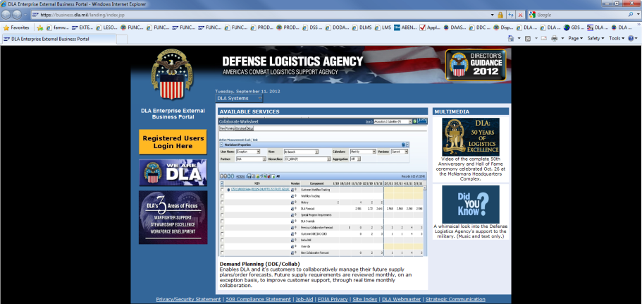
Click [Registered Users Login Here]

YOU MUST HAVE REGISTERED IN AMPS AND RECEIVED EMAIL VERIFICATION OF “DLA DISPOSITION SERVICES PROD EX - RTD CUSTOMER DDS-413” ROLE APPROVAL (could take up to 24 hours)

https://businessportal.dla.mil/consent
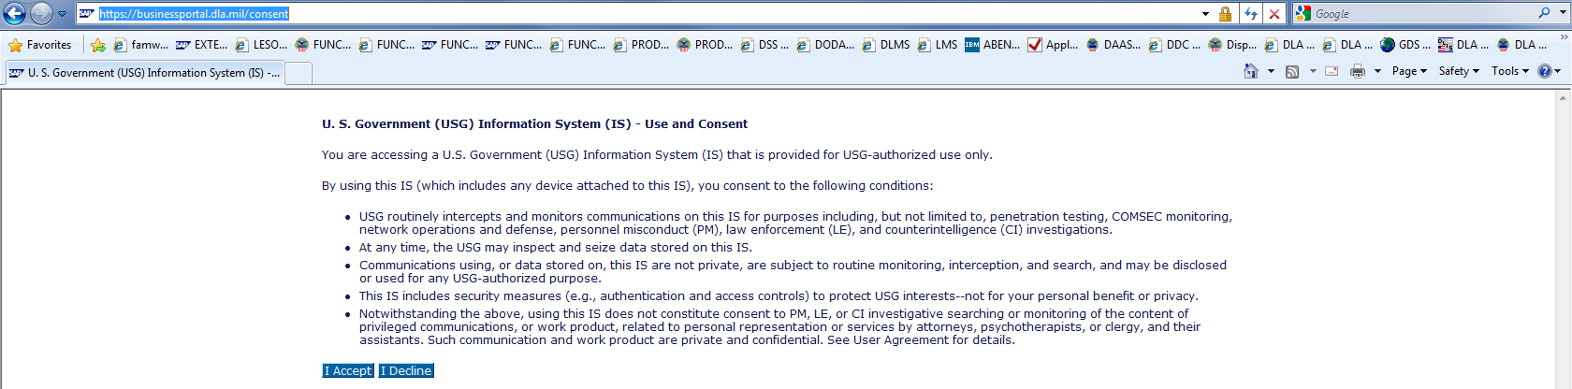
Click [I Accept]

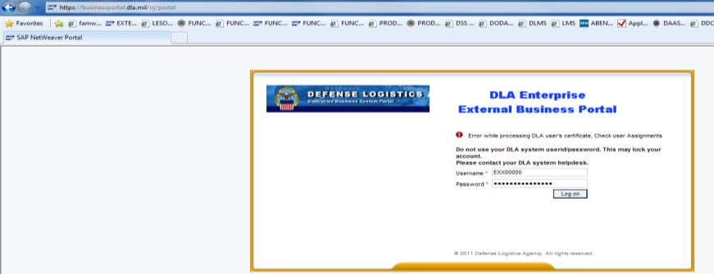
Enter User Name and Password that was established within AMPS during registration
(MAKE SURE YOU DO NOT HAVE ANY SPACES BEFORE OR AFTER YOUR USER NAME OR PASSWORD)

Click [LOG ON]

YOU MUST HAVE REGISTERED IN AMPS AND RECEIVED EMAIL VERIFICATION OF “DLA DISPOSITION SERVICES PROD EX - RTD CUSTOMER DDS-413” ROLE APPROVAL (could take up to 24 hours)

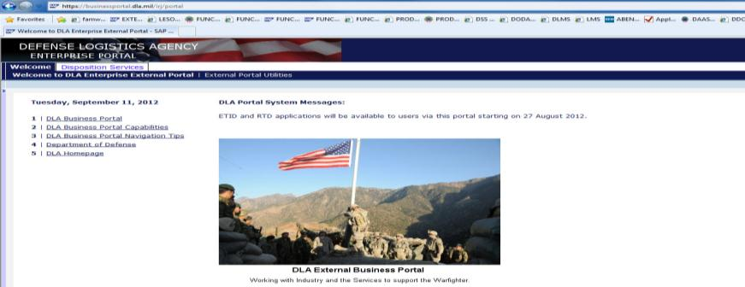
Click the [Disposition Services] tab
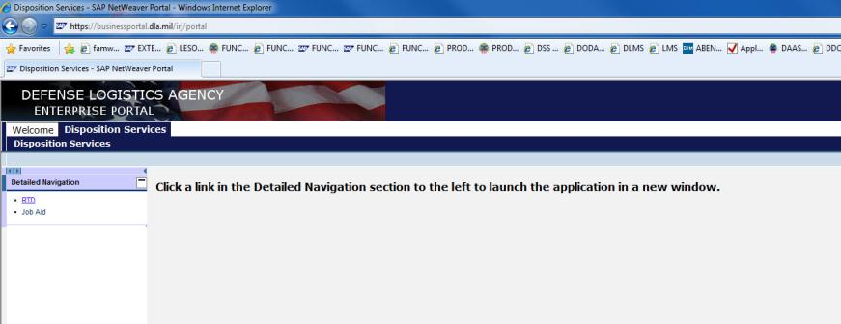
Click the [RTD] tab

This screen will display
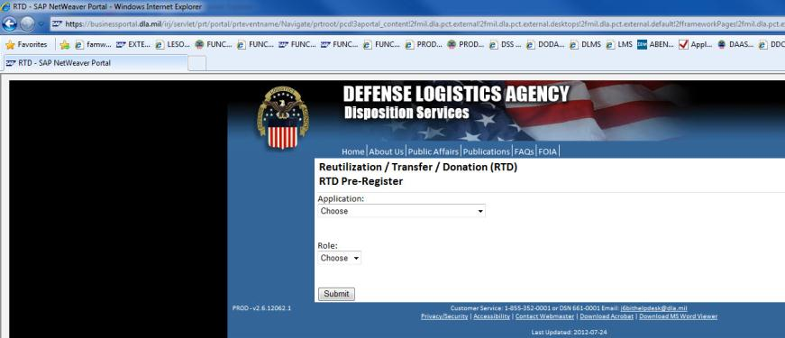
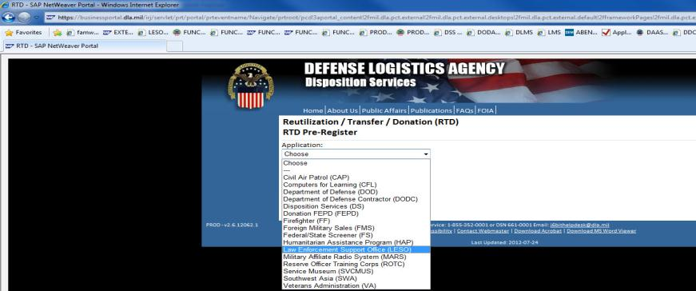
Choose the ‘Law Enforcement Support Office (LESO) from the drop down menu
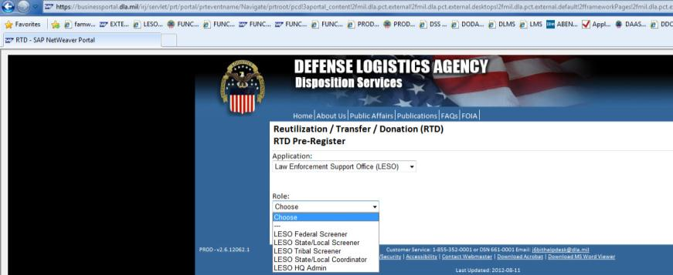
Choose the role that best represents your need for access from the drop down menu

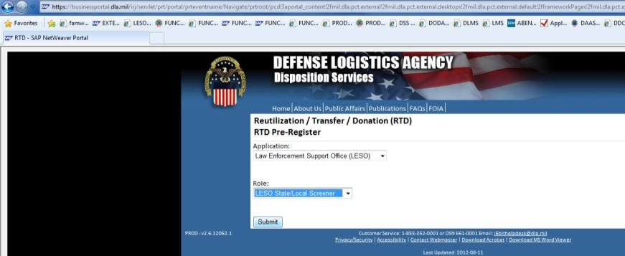
Click [SUBMIT]

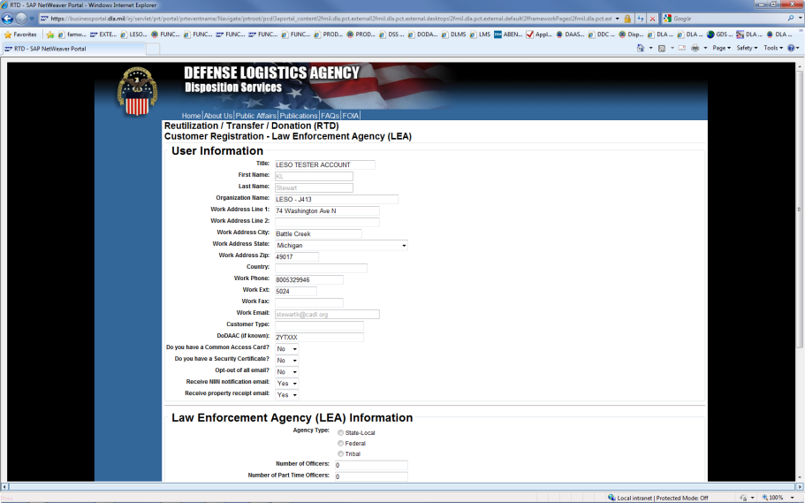
USER INFORMATION is displayed:

Verify that the pre-populated data is correct – If not update as required

Enter: Title, Agency Name, Country, Work Fax

Customer Type = Role Requested
DoDAAC = your new 2YT DoDAAC

Answer the YES/NO Questions as applicable

NOTE: phone numbers must only contain numbers
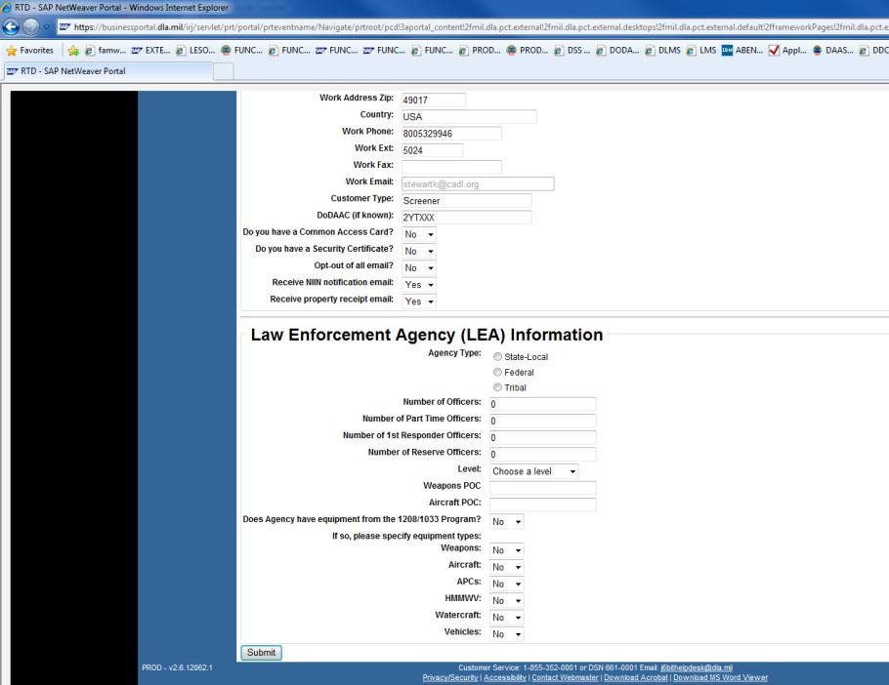
LEA INFORMATION:

Select the Agency type, fill in number of officers in each category.

Enter your Weapons and Aircraft POC names – or NA if not known

Level:

Answer the YES/NO Questions as applicable

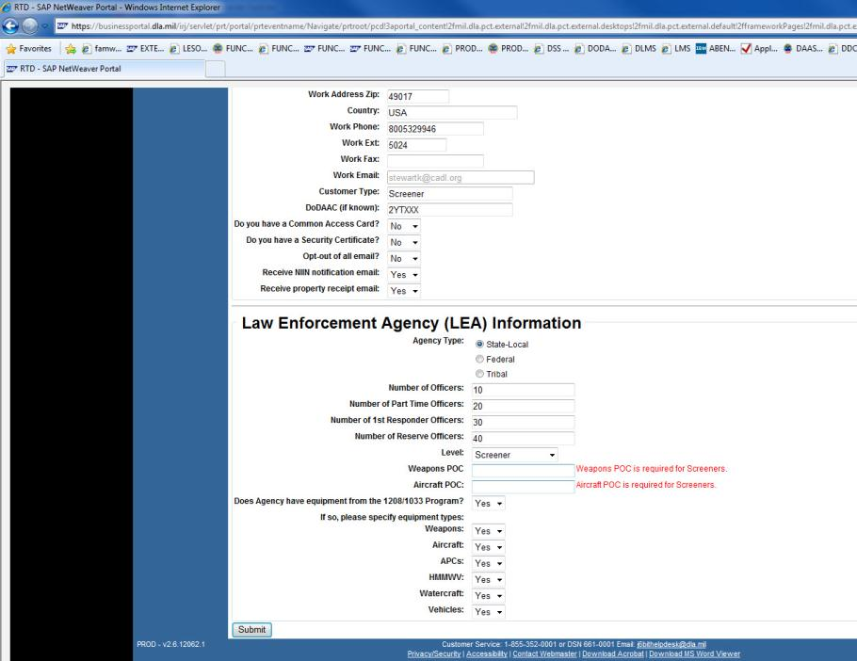
Click [SUBMIT]
NOTE:

Weapons and Aircraft POC are required fields; enter NA if unknown or if you do not have one

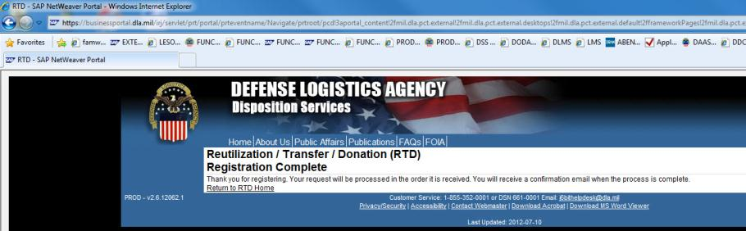
CLICK [Return to RTD HOME]

