Hazard Mitigation Assistance

**Notice of Interest (NOI)**

**Salesforce Portal Quick Start Guide**



**Table of Contents**

Preferred Browser 2

Registration/Sign-Up 2

Password Email 4

Homepage 4

Prepare to Submit an NOI & View Existing NOIs 5

NOI – Submission Detail Page 6

NOI Help 7

Common NOI questions: 7

Appendix A: NOI Questions 9

Appendix B: Subapplication and Project Types by Program 14

## Preferred Browser

Please ensure you are not using Internet Explorer. The CalOES Portal does not support internet explorer.

The preferred browser is Chrome. If you do not have access to Chrome, Microsoft Edge will work as well.

## Registration/Sign-Up

To submit a Notice of Interest (NOI) you must register for an account. Select “Sign Up” on the [Sign Up Page](https://caloes.force.com/s/login/) https://caloes.force.com/s/login/.

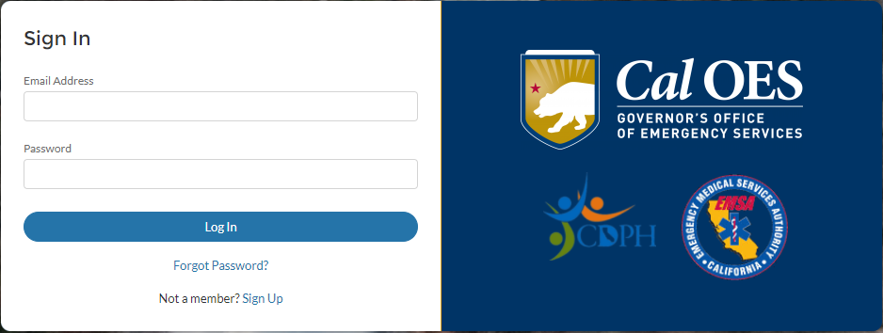

**Entity Type**

Enter your First Name, Last Name, Email, Phone and select your Entity Type. The entity types are County, State Agency, Non-governmental Entity, City, Tribal, and Special District. For Non-governmental entities you must also enter your Non-Governmental Entity name and Federal Tax ID #.

**Entity Name**

Once you select the Entity Type a drop down with a list of entity names will appear. Individuals working for departments within Cities or Counties will select the City or County name. For example, City of Sacramento Fire Department would register as Sacramento, City of. If your entity name is not specifically listed in the drop down list you will need to contact [Salesforce.Support@caloes.ca.gov](mailto:Salesforce.Support@caloes.ca.gov) and submit a request to have your entity name added.

When making your request to add an unlisted entity name, provide the following information:

Your Name:

Your Phone number:

Your email Address:

Entity Name:

Entity Federal Tax ID #:

Entity Street Address:

Entity City:

Entity County:

Entity State:

Entity Zip:

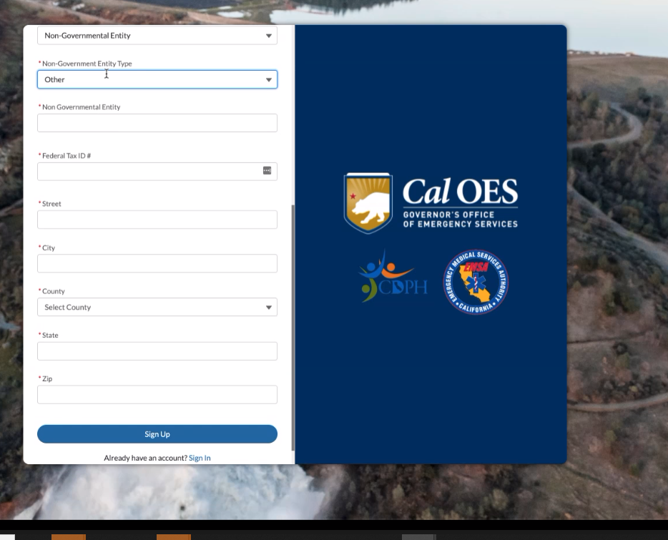

## Password Email

Once you sign up, you will receive an email to verify your registration. This is a system generated email so please check your spam folder. Click the link within to set your password. Once your password is set you will be able to log in to the portal and land on the home page.

## Homepage

Once logged in you will see the following screen:



## Prepare to Submit an NOI & View Existing NOIs

Refer to Appendix A for a list of questions on the NOI form and Appendix B for a list of subapplication and project types.

When you first log in, you will not have any existing NOI Submissions. This screen will be blank until you submit an NOI.

Click ‘New’ button in the top right of this screen to begin entering your NOI.

After submission, this will be where you can view your submitted NOIs and the view the status of our review process.

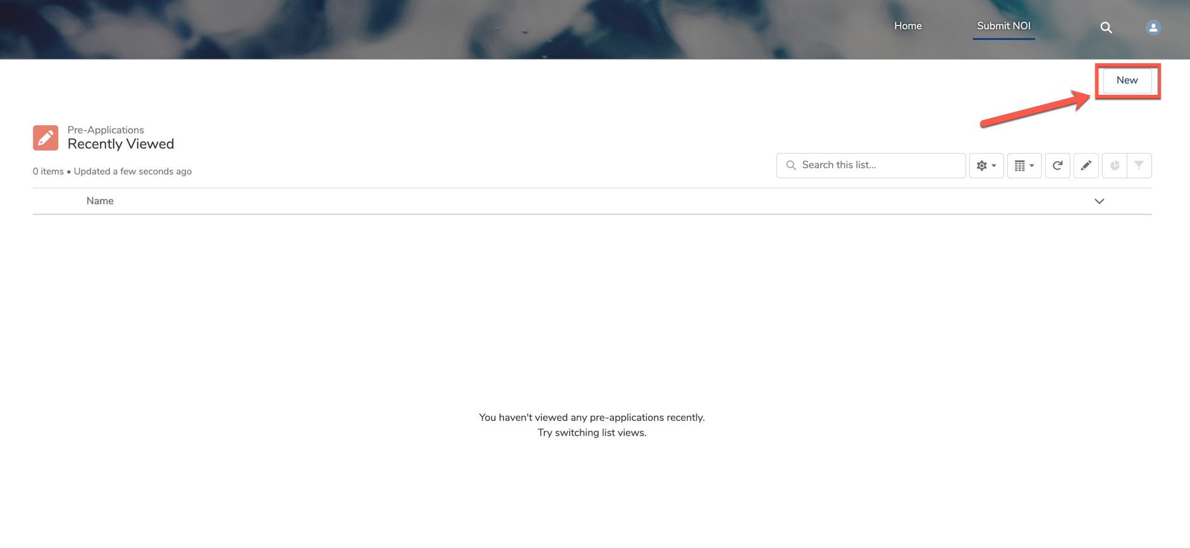

You must select the Hazard Mitigation Assistance program to submit the NOI under.

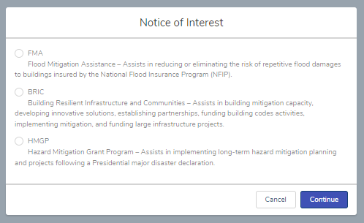

| Program | Description |
| --- | --- |
| FMA – Flood Mitigation Assistance | Assists in reducing or eliminating the risk of repetitive flood damages to building insured by the National Flood Insurance Program (NFIP) |
| BRIC – Building Resilient Infrastructure and Communities | Assists in building mitigation capacity, developing innovative solutions, establishing partnerships, funding building code activities, implementing mitigation, and funding large infrastructure projects. |
| HMGP – Hazard Mitigation Assistance Program | Assists implementing long-term hazard mitigation planning and projects following a Presidential major disaster declaration. |

There NOI is 5 pages. You do not have to complete the entire form in one session. **To save a page of the form, you must complete all fields on the page. If you select “Previous” page, prior to saving a page, you will lose your work.**

After the form is completed you will be able to review the form before submitting. To officially submit the Notice of Interest to Cal OE, click “Submit”.

## **NOI – Submission Detail Page**

Once you submit your request, you will be brought to the detail page. You will be able to edit this submission via the ‘Edit Request’ button in the top right, up to the point where the Status = Analyst Review. Once it has been assigned to ‘Analyst Review’ by the HMA team you will no longer be able to edit.

This image is a screenshot of the "Pending Review" page.  Fields on this page include: Name (of pre-application), Last name of person completing NOI, Disaster (disaster ID number), Applicant Type, First name of person completing NOI, DUNS (#),


## NOI Help

For assistance filling out your NOI request or for Salesforce support, please reach out to the [Hazard Mitigation Branch](mailto:HMA@Caloes.ca.gov) at HMA@caloes.ca.gov. We will review your inquiry and respond within 1-3 business days.

Common NOI questions:

Q: What is my FIPS/ DUNS number?

A: Contact us at HMA@caloes.ca.gov

Q: When will the next NOI period be open?

A: Funding opportunities vary by grant program. Hazard Mitigation Grant Program (HMGP) NOIs are accepted on a rolling basis. NOIs are accepted annually for Building Resilient Infrastructure and Communities (BRIC) and Flood Mitigation Assistance (FMA). Refer to the [Hazard Mitigation web page](https://www.caloes.ca.gov/cal-oes-divisions/hazard-mitigation) for current funding opportunities https://www.caloes.ca.gov/cal-oes-divisions/hazard-mitigation.

Q: I have a local hazard mitigation plan (LHMP) that is outdated, will I still be eligible to receive funding?

A: LHMP requirements vary by grant program. For HMGP, the LHMP must be adopted locally by the time of obligation. For BRIC and FMA the LHMP must be current at the time of subapplication submission and obligation.

Q: Can I enter more than one contact?

A: Yes, you are required to enter a minimum of two contacts.

Q: Can I make edits to a submitted NOI?

A: If the Application Status is in “Pending Review” you can make edits to a submitted NOI.

## Appendix A: NOI Questions

The following is a list of questions that are included on the Notice of Interest form.

**General Information**

* First Name of Person Completing NOI
* Last Name of Person Completing NOI
* Subapplicant Name (Entity)
* Subapplicant Type - *\*\*Subapplicant type should be based upon how the entity is identified in the Hazard Mitigation Plan, this excludes private non-profit.\*\**
* Street Address
* City
* Zip
* County - *\*\*Only use multi-county if the project is located in more than one county\*\**
* Region
* State
* Federal Information Processing Number (FIPS #) - *\*\*If you do not know your FIPS #, you can request it by emailing* [*HMA@caloes.ca.gov*](mailto:HMA@caloes.ca.gov)*. \*\**
* Data Universal Numbering System (DUNS #) - *\*\*If you do not know your DUNS #, call Dun & Bradstreet (D&B) at 1-866-705-5711 for more information.\*\**
* Employer Identification Number (For Private Non- Profits) - *\*\*The Employer Identification Number (EIN) is a federal nine-digit tax number that IRS assigns to non-profits, charities, organizations, and businesses in the following format: XX-XXXXXXX.\*\**
* Is the subapplicant a small, impoverished community? (BRIC Only)

**Project / Plan Information**

* Project / Plan Title - *\*\*The project/plan title must include the subapplicant name and subapplication type or project type. Do not use abbreviations in the title. For example, Marin County Marin Center Exhbit Hall – Seismic Retrofit Project, City of Los Angeles Stormwater Analysis – Element Plan Update, City of Dunsmuir Hazard Mitigation Plan – New Plan.\*\**
* Brief Summary - *\*\*Complete the response in the format provided: Example: This flood mitigation project will reduce or prevent localized flooding of 25 houses in a North Sacramento subdivision resulting from rain events characterized by an average of 2 inches of rain per day for three or more days by increasing the size of the culvert under Del Paso Road from the current 2-foot diameter to a 6 foot diameter. For planning or planning-related subapplications, provide a brief summary of the activities you plan to do.\*\**
* Activity Location Latitude - *\*\*Provide latitude for at least one point at the activity location\*\**
* Activity Location Longitude - *\*\*Provide longitude for at least one point at the activity location\*\**
* Project / Plan Duration (in Months) - *\*\*Indicate the number of months it will take for this mitigation action to be implemented. Cannot exceed 36 months (33 months implementation plus 3 months for closeout). Community flood mitigation projects under Flood Mitigation Assistance (FMA) may be implemented in 48 months for (45 months implementation plus 3 months for closeout).\*\**
* Has a full subapplication for this project/ plan been submitted to OES previously? - *\*\*Indicate if a full subapplication for the project/plan has been submitted to OES under another disaster for HMGP, HMGP Post Fire, BRIC, PDM, or FMA.\*\**
  + If yes, provide the program and project number
* Does another Federal entity have primary funding authority for this project? - *\*\*FEMA will not provide assistance for activities for which it determines the more specific authority lies with another federal agency or program. Other programs and authorities should be examined before applying for HMA funding. For example, is this activity eligible for funding from another federal program such as the NRCS Emergency Watershed Protection Act, FEMA Public Assistance Program, and the US Department of Agriculture/Department of the Interior Healthy Forest Restoration Act of 2002.\*\**
  + If yes, identify the program
* Has physical project work already started? - *\*\*For example, ground-breaking, demolition, construction, ad/or geotechnical work that involves ground disturbance including soil boring\*\**
  + If yes, please explain in detail what work has been started/completed?
* Is the subapplicant responsible for the operations and maintenance of this infrastructure? - *\*\*For example, does the subapplicant have full authority and ownership of the infrastructure to perform the proposed project.\*\**
  + If no, name the entity responsible for operation and maintenance of this infrastructure)
* Is this an independent mitigation activity? - *\*\*Is this project dependent on another project or funding source (other than match) to be effectively implemented?\*\**
  + If, no, what activity is this mitigation dependent on?
* Do you have planning studies or feasibility reports?
  + If yes, what is available?
* Do you have design documents for this project?
  + If yes, what is available?
* Is the project related to repair, replacement, rehabilitation, or maintenance of an asset? - *\*\*HMA funds are not to be used for the sole purpose of repair, replacement, or maintenance of an asset. The funds must increase the level of protection.\*\**
  + If yes, does this project increase the level of protection for that asset?
* *Is the project in conformance with the latest published building codes? (BRIC only)
* Is the project located in a Special Flood Hazard Area? (BRIC Only) - *\*\*A Special Flood Hazard Area (SFHA) is an area having special flood, mudflow or flood-related erosion hazards and shown on a Flood Hazard Boundary Map (FHBM) or a Flood Insurance Rate Map (FIRM)\*\**
* Is the project located in a jurisdiction that is in good standing with the National Flood Insurance Program (NFIP)? (BRIC [If in SFHA] & FMA Only)
* Provide the National Flood Insurance Program (NFIP) community number (BRIC [If in SFHA] & FMA Only)
* Are all the structures to be included in the subapplication insured under the National Flood Insurance Program (NFIP)? (BRIC [If in SFHA] & FMA Only)
* Does the project mitigate Severe Repetitive Loss or Repetitive Loss properties? (FMA Only)

**Problem Statement**

* Describe the problem to be mitigated. - *\*\*Provide a detailed description of the problem or the risk to be addressed. Include the cause of the problem, how long the problem has existed, the types of damages that occur (including dates and approx.. costs), and any studies that have been performed.\*\**

**Solution Description**

* What is the mitigation action? - *\*\*Describe in detail the proposed mitigation action and how it will mitigate the problem. The description should include the proposed approach and expected mitigation outcome(s)\*\**
* How will this action provide protection from future natural hazards? - *\*\*Describe how the proposed action will reduce or eliminate damage or risk to life and property, include information on the level of protection the project will provide if designed to a specific standard (For example, 6.0 earthquake, 100-year flood, etc.)\*\**
* What is the implementation plan for this mitigation effort? - *\*\*Indicate the person (by title) managing the project and identify title of in-house personnel whom will be supporting the project and tasks they will be assigned. If applicable, specify any tasks which will be completed by 3rd party contractors.\*\**
* Have all specific sites where project work will be conducted been identified?
* What is the percentage level of design?
* Is this project phased? - *\*\*If you do not know the location of all project sites, or if your design level is below 60%, this project will need to be phased.\*\**

**Benefit Cost Analysis**

* Does the proposed project area have a documented history of significant damages, loss of service/function, or other loss/disruption? - *\*\*Significant damages are those which have caused damage physical or financial damage to a structure, facility or infrastructure. For example, may include physical damages, loss of function/service, and displacement.\*\**
  + If yes, what is available?
* Do you have data and/or studies documenting the extent, severity, and/or current risk of the hazard? - *\*\*Resources such as FEMA flood maps, tsunami maps, landslide maps or similar documents can be used to document the extent and severity of the hazard. Reports may include seismic structural elevations, geotechnical reports, hydrologic and Hydraulic studies or similar reports that further analyse the current risk. Additionally, prevented disaster costs and/or loss of function may be used to quantify current risk of hazard. Loss of function is the direct economic impact that occurs when physical damage is severe enough to interrupt the function or normal use of a building and/or infrastructure.\*\**
  + If yes, what is available?

**Activity Costs**

* Total Activity Cost ($) - *\*\*Enter the total cost to implement the project. Inclusive of both Federal share and local match.\*\**
* Non-Federal Cost Share ($) - *\*\*Financial responsibility of the subapplicant.\*\**
* Federal Share Request ($) - *\*\*Financial responsibility of Federal Government.\*\**
* Percentage of Non-Federal Cost Share
* Percentage of Federal Request Share
* Source of Non-Federal Cost Share - *\*\*Contributions of cash and donated resources, or any combination thereof, can be used for the subapplicant match. For example, cash and in-kind contributions of services and labor, volunteer labor, and Community Development Block Grant Discover Recovery (CDBG-DR) funds.\*\**

**Local Hazard Mitigation Plan Information**

* Does your entity have an active LHMP? - *\*\*To be eligible for funding a community must have participated in the Local Hazard Mitigation Planning (LHMP) process and formally adopted a LHMP through formal resolution. For BRIC and FMA, the LHMP must be approved and adopted at time of application and award. For HMGP the LHMP must be in approved and adopted at time of award. If you are not sure of your LHMP status please contact your County Emergency Manager or* [*hma@caloes.ca.gov*](mailto:hma@caloes.ca.gov)*. \*\**
* LHMP Approval Date - *\*\*Private Non-Profits are not required to populate this field.\*\**
* LHMP Status - *\*\*Provide the status of the LHMP\*\**
* Is this activity addressed in your Local Hazard Mitigation Plan? - *\*\*The project does not have to be specifically referenced in your plan.\*\**

**Contact Information**

* First Name
* Last Name
* Entity
* Entity ID
* Email
* Phone
* Alternate Phone
* Role
* Type

## Appendix B: Subapplication and Project Types by Program

### Hazard Mitigation Grant Program (HMGP)

#### Subapplication Types

| Subapplication Type | Examples |
| --- | --- |
| Planning | Activities include developing a new hazard mitigation plan or updating a current mitigation plan. |
| Planning Related | Activities include: Updating or enhancing sections of the current FEMA-approved mitigation plan, integrating information from mitigation plans with other planning efforts, building capacity through delivery of technical assistance and training, evaluating adoption and/or implementation of ordinances that reduce risk or increase resilience. |
| Project | Activities involve construction and/or physical work. Examples: acquisition demolition/relocation, debris basin, structural elevation, structural seismic retrofit, hazardous fuels reduction, defensible space, generator(s) (If benefit cost analysis (BCA) feasible). |
| Advance Assistance | Activities can be used to develop mitigation strategies and obtain data to prioritize, select, and develop mitigation projects and complete applications. Examples: evaluation of facilities or areas to determine mitigation actions, collect data for BCA and environmental historical preservation compliance, conduct engineering designs and feasibility studies, conduct hydrologic and hydraulic studies and cost estimation. |
| 5% Initiative | Activities are defined as mitigation actions that meet all HMGP requirements but may be difficult to evaluate against traditional program cost-effectiveness criteria. Examples such as, early warning systems, post-disaster building code enforcement, public awareness and education for mitigation campaigns, hazard identification or mapping, new techniques/methods of mitigation and generator(s) (if protecting a critical facility and if there is insufficient data to evaluate a generator project using a standard HMA-approved Benefit-Cost Analysis (BCA) method). |

#### Project Types

| Project Type | Activities |
| --- | --- |
| Acquisition Demo-Relocation | Purchase of properties on a voluntary basis in order to remove structure(s) from natural hazards (flood/landslide/avalanche). Structures must be demolished or relocated outside hazard area.  *\*\*As referenced in the Hazard Mitigation Assistance Guidance: Property Acquisition and Structure Demolition Projects, Property Acquisition and Structure Relocation Projects* |
| Drainage / Flood Control | Stormwater management projects, including the construction, installation, or improvement of culverts, drainpipes, pumping stations, floodgates, and detention or retention basins.  Flood protection measures for water and sanitary sewer systems or other utility systems. Slope stabilization or grading to direct flood waters away from homes, schools, businesses, utilities, or governmental facilities.  Flood protection and stabilization measures for roads and bridges construction, demolition, or rehabilitation of: Dams, Dikes, Levees, Floodwalls, Seawalls, Groins, Jetties, Breakwaters, Stabilized sand dunes, Large-scale channelization of a waterway  Vegetation management for shoreline stabilization (coastal, riverine, riparian, and other littoral zones) Soil stabilization and erosion control activities.  Drought mitigation activities.  *\*\*As referenced in the Hazard Mitigation Assistance Guidance: Localized Flood Risk Reduction Projects, Non-Localized Flood Risk Reduction Projects, Soil Stabilization, Infrastructure Retrofit, Green Infrastructure* |
| Elevation-Floodproofing | Elevation: Construction to elevate structures above the base flood elevation.  Dry Floodproofing: Implementation of techniques to seal the structure from floodwaters.  *\*\*As referenced in the Hazard Mitigation Assistance Guidance: Elevation (Structure Elevation); Dry Floodproofing (Dry Floodproofing of Historical Residential Structures, Dry Floodproofing of Non-Residential Structures)* |
| Seismic | Retrofitting homes or buildings structurally or non-structurally to reduce damages from earthquakes.  *\*\*As referenced in the Hazard Mitigation Assistance Guidance: Structural Retrofitting of Existing Buildings, Non-Structural Retrofitting of Existing Buildings and Facilities* |
| Wildfire & Vegetation Management | Creation of defensible space around homes, structures, and critical facilities by reduction of flammable vegetation. Hazardous fuel reduction which is the removal of vegetative fuels proximate to at-risk structures. Implementation of ignition-resistant construction techniques utilizing non-combustible materials on new and existing structures.  *\*\*As referenced in the Hazard Mitigation Assistance Guidance: Wildfire Mitigation* |
| Mitigation Reconstruction | Construction of an improved, elevated building on the same site where an existing building and/or foundation has been partially or completely demolished or destroyed.  *\*\*As referenced in the Hazard Mitigation Assistance Guidance: Mitigation Reconstruction* |
| Generator(s) | Installation of generator(s) which provides a secondary source of power to a critical facility. Examples: police and fire station, hospitals, water and sewer treatment plant.  *\*\*As referenced in the Hazard Mitigation Assistance Guidance: Generators* |
| Tsunami Vertical Evacuation | Construction of an evacuation tower which is utilized during a tsunami event to escape the tsunami and debris wave. |
| Safe Room | Construction of safe rooms to provide protection for people in public and private structures from tornado and severe wind events. This type of project includes retrofits of existing facilities or new safe room construction projects.  *\*\*As referenced in the Hazard Mitigation Assistance Guidance: Safe Room Construction* |

#### 5% Initiative Types

| 5% Initiative | Examples |
| --- | --- |
| Generator(s) | Installation of generator(s) which provides a secondary source of power to a critical facility. Examples: police and fire station, hospitals, water and sewer treatment plant). |
| Post-Disaster Code Enforcement | Extraordinary post-disaster code enforcement projects to ensure disaster-resistant codes are implemented during disaster reconstruction after the normal costs of the building department are deducted. Example: Hiring staff to help process building permits to confirm post-disaster code is implemented, perform home construction plan review and field inspection of homes being built after a fire to ensure codes are followed. |
| Public Awareness and Education | Public awareness or education campaigns about mitigation. Example: Development of materials related to the various hazards that can impact a community and deliver trainings in the community. |
| Early Warning Systems | Equipment and systems for the purpose of warning citizens of impending hazards. Example: Installation of a camera system to detect and notify residents of fire risk. |
| Hazard Identification or Mapping | Hazard identification or mapping and related equipment for the implementation of mitigation activities. Example: Development of maps and data to will assist in the identification of necessary erosion control measures, slope stabilization, structural protection, and flood and debris flow hazard and risk analyses. |
| GIS for Mitigation | Acquisition of GIS software, hardware, and data whose primary aim is mitigation. |
| New Techniques Methods | The use, evaluation, and application of new, unproven mitigation techniques, technologies, methods, procedures, or products |

### Building Resilient Infrastructure and Communities (BRIC)

#### Subapplication Types

| Subapplication Type | Examples: |
| --- | --- |
| Capability and Capacity Building (C&CB) | Activities which enhance the knowledge, skills, expertise, etc., of the current workforce to expand or improve the administration of mitigation assistance. C&CB activities must result in a resource, strategy, or tangible mitigation product that will reduce or eliminate risk and damage from future natural hazards, increase resiliency, and promote a culture of preparedness. This includes activities in the following sub-categories: building codes activities, partnerships, project scoping, mitigation planning and planning-related activities, and other activities. |
| Project | Cost-effective, risk reduction projects designed to increase resilience and public safety; reduce injuries and loss of life; and reduce damage and destruction to property, critical services, facilities, and infrastructure; Activities involve construction and/or physical work. Examples: nature-based solutions/green infrastructure, acquisition demolition/relocation, debris basin, structural elevation, structural seismic retrofit, hazardous fuels reduction, defensible space, generator(s). |

#### Project Types

| Project Type | Activities: |
| --- | --- |
| Acquisition Demo-Relocation | Purchase of properties on a voluntary basis in order to remove structure(s) from natural hazards (flood/landslide/avalanche). Structures must be demolished or relocated outside hazard area.  *\*\*As referenced in the Hazard Mitigation Assistance Guidance: Property Acquisition and Structure Demolition Projects, Property Acquisition and Structure Relocation Projects* |
| Drainage / Flood Control | Construction of debris basins, levees, dikes, dams, and culverts. Soil stabilization and erosion control activities. Drought mitigation activities.  *\*\*As referenced in the Hazard Mitigation Assistance Guidance: Localized Flood Risk Reduction Projects, Non-Localized Flood Risk Reduction Projects, Soil Stabilization, Infrastructure Retrofit* |
| Elevation-Floodproofing | Elevation: Construction to elevate structures above the base flood elevation.  Dry Floodproofing: Implementation of techniques to seal the structure from floodwaters.  *\*\*As referenced in the Hazard Mitigation Assistance Guidance: Elevation (Structure Elevation); Dry Floodproofing (Dry Floodproofing of Historical Residential Structures, Dry Floodproofing of Non-Residential Structures)* |
| Seismic | Retrofitting homes or buildings structurally or non-structurally to reduce damages from earthquakes.  *\*\*As referenced in the Hazard Mitigation Assistance Guidance: Structural Retrofitting of Existing Buildings, Non-Structural Retrofitting of Existing Buildings and Facilities* |
| Wildfire & Vegetation Management | Creation of defensible space around homes, structures, and critical facilities by reduction of flammable vegetation. Hazardous fuel reduction which is the removal of vegetative fuels proximate to at-risk structures. Implementation of ignition-resistant construction techniques utilizing non-combustible materials on new and existing structures.  *\*\*As referenced in the Hazard Mitigation Assistance Guidance: Wildfire Mitigation* |
| Mitigation Reconstruction | Construction of an improved, elevated building on the same site where an existing building and/or foundation has been partially or completely demolished or destroyed.  *\*\*As referenced in the Hazard Mitigation Assistance Guidance: Mitigation Reconstruction* |
| Generator(s) | Installation of generator(s) which provides a secondary source of power to a critical facility. Examples: police and fire station, hospitals, water and sewer treatment plant.  *\*\*As referenced in the Hazard Mitigation Assistance Guidance: Generators* |
| Tsunami Vertical Evacuation | Construction of an evacuation tower which is utilized during a tsunami event to escape the tsunami and debris wave. |
| Safe Room | Construction of safe rooms to provide protection for people in public and private structures from tornado and severe wind events. This type of project includes retrofits of existing facilities or new safe room construction projects.  *\*\*As referenced in the Hazard Mitigation Assistance Guidance: Safe Room Construction* |
| Nature-Based Solutions/Green Infrastructure | Land conservation, greenways, wetland restoration, stormwater parks, floodplain restoration, rain gardens, vegetated swales, green roofs, rainwater harvesting, permeable pavement, tree canopy, tree trenches, green streets, coastal wetlands, oyster reefs, dunes, waterfront parks, and living shorelines. |

#### Capability and Capacity Building (C&CB) Types

| Capability and Capacity Building (C&CB) | Examples: |
| --- | --- |
| Planning | Activities include developing a new hazard mitigation plan or updating a current mitigation plan. |
| Planning-Related | Activities include updating or enhancing sections of the current FEMA-approved mitigation plan, integrating information from mitigation plans with other planning efforts, building capacity through delivery of technical assistance and training, evaluating adoption and/or implementation of ordinances that reduce risk or increase resilience. |
| Project Scoping | Activities include engineering design and feasibility studies for larger or complex projects, Hydrologic and Hydraulic (H&H) studies, obtain staff or resources to develop cost-share strategy and identify potential match funding, evaluate facilities or areas to determine appropriate mitigation actions, incorporate environmental considerations early into program decisions, collect data for benefit cost analyses, environmental compliance and other program requirements, evaluation of potential solutions (i.e., alternative analysis), and project scoping across a wide variety of programs to incorporate sustainability, resilience and renewable building concepts. |
| Partnerships | Activities can include public and private stakeholders working together to identify funding sources, project goals, and to further identify risks/hazards for mitigation. |
| Building Code | Activities can include evaluation/adoption and/or implementation of codes that reduce risk, enhance existing adopted codes to incorporate more current requirements or higher standards, and develop professional workforce capabilities through technical assistance and training. |

### Flood Mitigation Assistance (FMA)

#### Subapplication Types

| Subapplication Type | Examples: |
| --- | --- |
| Flood Hazard Mitigation Planning | Planning subapplications for the flood hazard component of State, Local, Territory, and Tribal (SLTT) Hazard Mitigation Plans and plan updates. |
| Project Scoping | Activities include developing community flood mitigation projects and/or individual flood mitigation projects that will subsequently reduce flood claims against the National Flood Insurance Program (NFIP). Eligible activities must benefit NFIP insured properties. Examples include, but are not limited to: conducting meetings, outreach and coordination with subapplicants and community residents, developing or conducting engineering, environmental feasibility and/or benefit cost analyses, undertaking activities that lead to development of project applications, evaluating facilities to identify mitigation actions, and using staff or resources to develop cost share strategies. |
| Community Flood Mitigation Project | Projects that address community flood risk for the purpose of reducing NFIP flood claim payments. Eligible activities must benefit NFIP insured properties. Examples include, but are not limited to: localized flood control, floodwater storage and diversion, floodplain and stream restoration, stormwater management, and wetland restoration/creation. |
| Individual Flood Mitigation Project | Projects that mitigate the risk of flooding to individual NFIP insured structures. Projects must directly benefit and include SRL and RL properties. |

#### Community Flood Mitigation Project Types

| Project Type | Activities: |
| --- | --- |
| Drainage / Flood Control | Construction of debris basins, levees, dikes, dams, and culverts. Soil stabilization and erosion control activities. Drought mitigation activities.  Drought mitigation activities.  *\*\*As referenced in the Hazard Mitigation Assistance Guidance: Localized Flood Risk Reduction Projects, Soil Stabilization, Infrastructure Retrofit* |
| Nature-Based Solutions/Green Infrastructure | Land conservation, greenways, wetland restoration, stormwater parks, floodplain restoration, rain gardens, vegetated swales, green roofs, rainwater harvesting, permeable pavement, tree canopy, tree trenches, green streets, coastal wetlands, oyster reefs, dunes, waterfront parks, and living shorelines |

#### Individual Flood Mitigation Project Types

| Project Type | Activities: |
| --- | --- |
| Acquisition Demo-Relocation | Purchase of properties on a voluntary basis in order to remove structure(s) from natural hazards (flood/landslide/avalanche). Structures must be demolished or relocated outside hazard area.  *\*\*As referenced in the Hazard Mitigation Assistance Guidance: Property Acquisition and Structure Demolition Projects, Property Acquisition and Structure Relocation Projects* |
| Drainage / Flood Control | Construction of debris basins, levees, dikes, dams, and culverts. Soil stabilization and erosion control activities. Drought mitigation activities.  Drought mitigation activities.  *\*\*As referenced in the Hazard Mitigation Assistance Guidance: Localized Flood Risk Reduction Projects, Soil Stabilization, Infrastructure Retrofit* |
| Elevation-Floodproofing | Elevation: Construction to elevate structures above the base flood elevation. Dry Floodproofing: Implementation of techniques to seal the structure from floodwaters.  *\*\*As referenced in the Hazard Mitigation Assistance Guidance: Elevation (Structure Elevation); Dry Floodproofing (Dry Floodproofing of Historical Residential Structures, Dry Floodproofing of Non-Residential Structures)* |
| Mitigation Reconstruction | Construction of an improved, elevated building on the same site where an existing building and/or foundation has been partially or completely demolished or destroyed.  *\*\*As referenced in the Hazard Mitigation Assistance Guidance: Mitigation Reconstruction* |
| Nature-Based Solutions/Green Infrastructure | Land conservation, greenways, wetland restoration, stormwater parks, floodplain restoration, rain gardens, vegetated swales, green roofs, rainwater harvesting, permeable pavement, tree canopy, tree trenches, green streets, coastal wetlands, oyster reefs, dunes, waterfront parks, and living shorelines |