Gun Violence Restraining Order
Social Media Toolkit

Goals …………………………………………………………………………………………..2
How to use the Toolkit………………………………………………………………………2
About California’s Gun Violence Restraining Order Campaign…………………...2
Partner Social Media Handles.....................................................................................3
Hashtags ........................................................................................................................3
Sample Social Media Copy………………………………………………………………...3
Graphics..........................................................................................................................7

Goals

- Inform Californians about Gun Violence Restraining Orders as a tool to intervene and temporarily prevent someone in crisis from accessing or possessing firearms, giving them the opportunity to seek help.
- Direct Californians to credible information about Gun Violence Restraining Orders at the GunSafety.CA.gov website.

How to use the Toolkit

This toolkit contains graphics and sample copy for use on social media channels such as Facebook, Instagram and Twitter to share credible information and help engage your audiences in the discussion.

- Use any of the suggested social media copy options for your posts. Adjust these as needed or write your own. Graphic sizes are adapted for various social media platforms available.

- When you share this content on social media, add several of the hashtags shared below to the end of your post. Hashtags help extend your post's reach, amplify all your great content, and help us determine success.

- When mentioning Governor Gavin Newsom or the California Governor’s Office of Emergency Services (Cal OES), tag the social media channel appropriate handles in your post (the public username with the @ symbol before it) in your post.

- Use alt-text, the written copy that describes an image, to make your posts more accessible by describing the images you share so people who use screen readers can fully understand your posts. Suggested alt-text copy is included with the images in this toolkit.

About California’s Gun Violence Restraining Order Campaign

As gun violence surges nationwide, Governor Gavin Newsom has made historic investments to reduce gun violence in California and keep communities safe.
One crucial tool is a gun violence restraining order (GVRO), which empowers Californians to intervene and prevent someone in crisis from possessing firearms while the order is in place.
So far, California has invested $11 million in a community-focused outreach and education campaign to increase awareness of the state’s gun violence restraining order law among communities and populations most at risk. The initiative includes recognized leaders in California’s gun violence prevention movement.
Partner Social Media Handles

California Governor’s Office of Emergency Services
- Facebook: @CaliforniaOES
- Instagram: @Cal_OES
- Twitter: @Cal_OES

Governor Gavin Newsom
- Facebook: @CAGovernor
- Instagram: @CAGovernor
- Twitter: @CAGovernor

Hashtags

#GVRO
#EndGunViolence
#GunSafety
#StopGunViolence
#PreventGunViolence

Hashtags (Spanish)
#GVRO
#SeguridadDeArmas
#PrevenciónDeViolenciaArmada
#AltoALaViolenciaArmada

Sample Social Media Copy
Facebook and Instagram
English

1 of 2:

Gun violence, from mass shootings to firearm suicide, is preventable. That is why California has implemented the nation’s strongest gun safety measures to keep our communities and families safe.

Among the suite of tools to help reduce gun violence is the Gun Violence Restraining Order, which temporarily prevents someone in crisis from purchasing or possessing firearms or ammunition. Learn more: GunSafety.CA.gov #EndGunViolence #GunSafety #PreventGunViolence #GVRO

2 of 2:

No Californian should have to live in fear of the threat of gun violence.

Those closest to an individual are often the first ones to see the warning signs when a person in crisis is at risk of harming themself or others. In California, family members, coworkers and teachers are eligible to file a request for a temporary Gun Violence Restraining Order. Learn more: GunSafety.CA.gov #GunSafety #PreventGunViolence #GVRO

Spanish

1 of 2:

La violencia armada, desde tiroteos masivos hasta suicidios, se puede prevenir. Es por eso que California sigue dedicada a implementar las medidas de seguridad de armas más fuertes de la nación para mantener seguras a nuestras comunidades y hogares.
Entre el paquete de herramientas para ayudar a reducir la violencia armada se encuentra la #GunViolenceRestrainingOrder una herramienta efectiva que evita temporalmente que alguien en crisis compre o posea armas de fuego o municiones. Infórmese: GunSafety.CA.gov #SeguridadDeArmas #PrevenciónDeViolenciaArmada #AltoALaViolenciaArmada
2 of 2:
Ningún californiano debería tener que vivir con miedo a la amenaza de la violencia armada.
Las personas más cercanas a una persona suelen ser las primeras en ver señales de advertencia cuando una persona en crisis corre el riesgo de hacerse daño a sí misma o a los demás. En California, los miembros de familia, compañeros de trabajo y maestros son elegibles para solicitar una #GunViolenceRestrainingOrder temporal para evitar que posean armas y municiones. Infórmese en: GunSafety.CA.gov #SeguridadDeArmas #PrevenciónDeViolenciaArmada #AltoALaViolenciaArmada
Twitter

English

1 of 4:
One tool available to help #PreventGunViolence in California is the Gun Violence Restraining Order, or #GVRO, which temporarily prevents individuals in crisis from accessing/purchasing firearms. Learn more: GunSafety.CA.gov

2 of 4:
Public safety tools are available in California to help those experiencing a crisis, including a Gun Violence Restraining Order, or #GVRO, which allows family members, teachers, coworkers & others to intervene to keep loved ones safe. Learn more: GunSafety.CA.gov

3 of 4:
California families, roommates, coworkers & teachers can help ensure a loved one can press pause during times of crisis by temporarily preventing access to firearms while they seek help. Learn how to file a Gun Violence Restraining Order, or #GVRO: GunSafety.CA.gov

4 of 4:
Gun Violence Restraining Orders are a powerful tool to prevent firearm suicides, which on average, account for more than half of California’s gun deaths. Californians have resources that might help prevent gun violence and self-harm. Learn more: GunSafety.CA.gov

Spanish

1 of 4:

Una herramienta disponible para ayudar a prevenir la violencia en
California es la #GunViolenceRestrainingOrder temporal, que impide
que las personas en crisis accedan o compren armas de fuego. Infórmese
: GunSafety.CA.gov

2 of 4:

Existen herramientas en California para ayudar a quienes experimentan una crisis, como la Gun Violence Restraining Order, que permite a miembros de familia, maestros y compañeros de trabajo a intervenir para mantener seguros a sus seres queridos. Infórmese: GunSafety.CA.gov

3 of 4:

En CA, familias, compañeros de cuarto y/o de trabajo & maestros pueden ayudar a que un ser querido pueda hacer una pausa en tiempos de crisis impidiendo el acceso a armas de fuego mientras buscan ayuda. Aprenda a presentar una #GVRO: GunSafety.CA.gov

4 of 4:

Las Órdenes de Restricción de Violencia Armada son una herramienta para prevenir suicidios con armas de fuego, que en promedio representan más de la mitad de las muertes por armas de fuego en California. Los californianos tienen recursos que podrían ayudar: GunSafety.CA.gov

Graphics

Graphics are below and attached in a separate zip file.

Facebook & Instagram:
English

1 of 3:

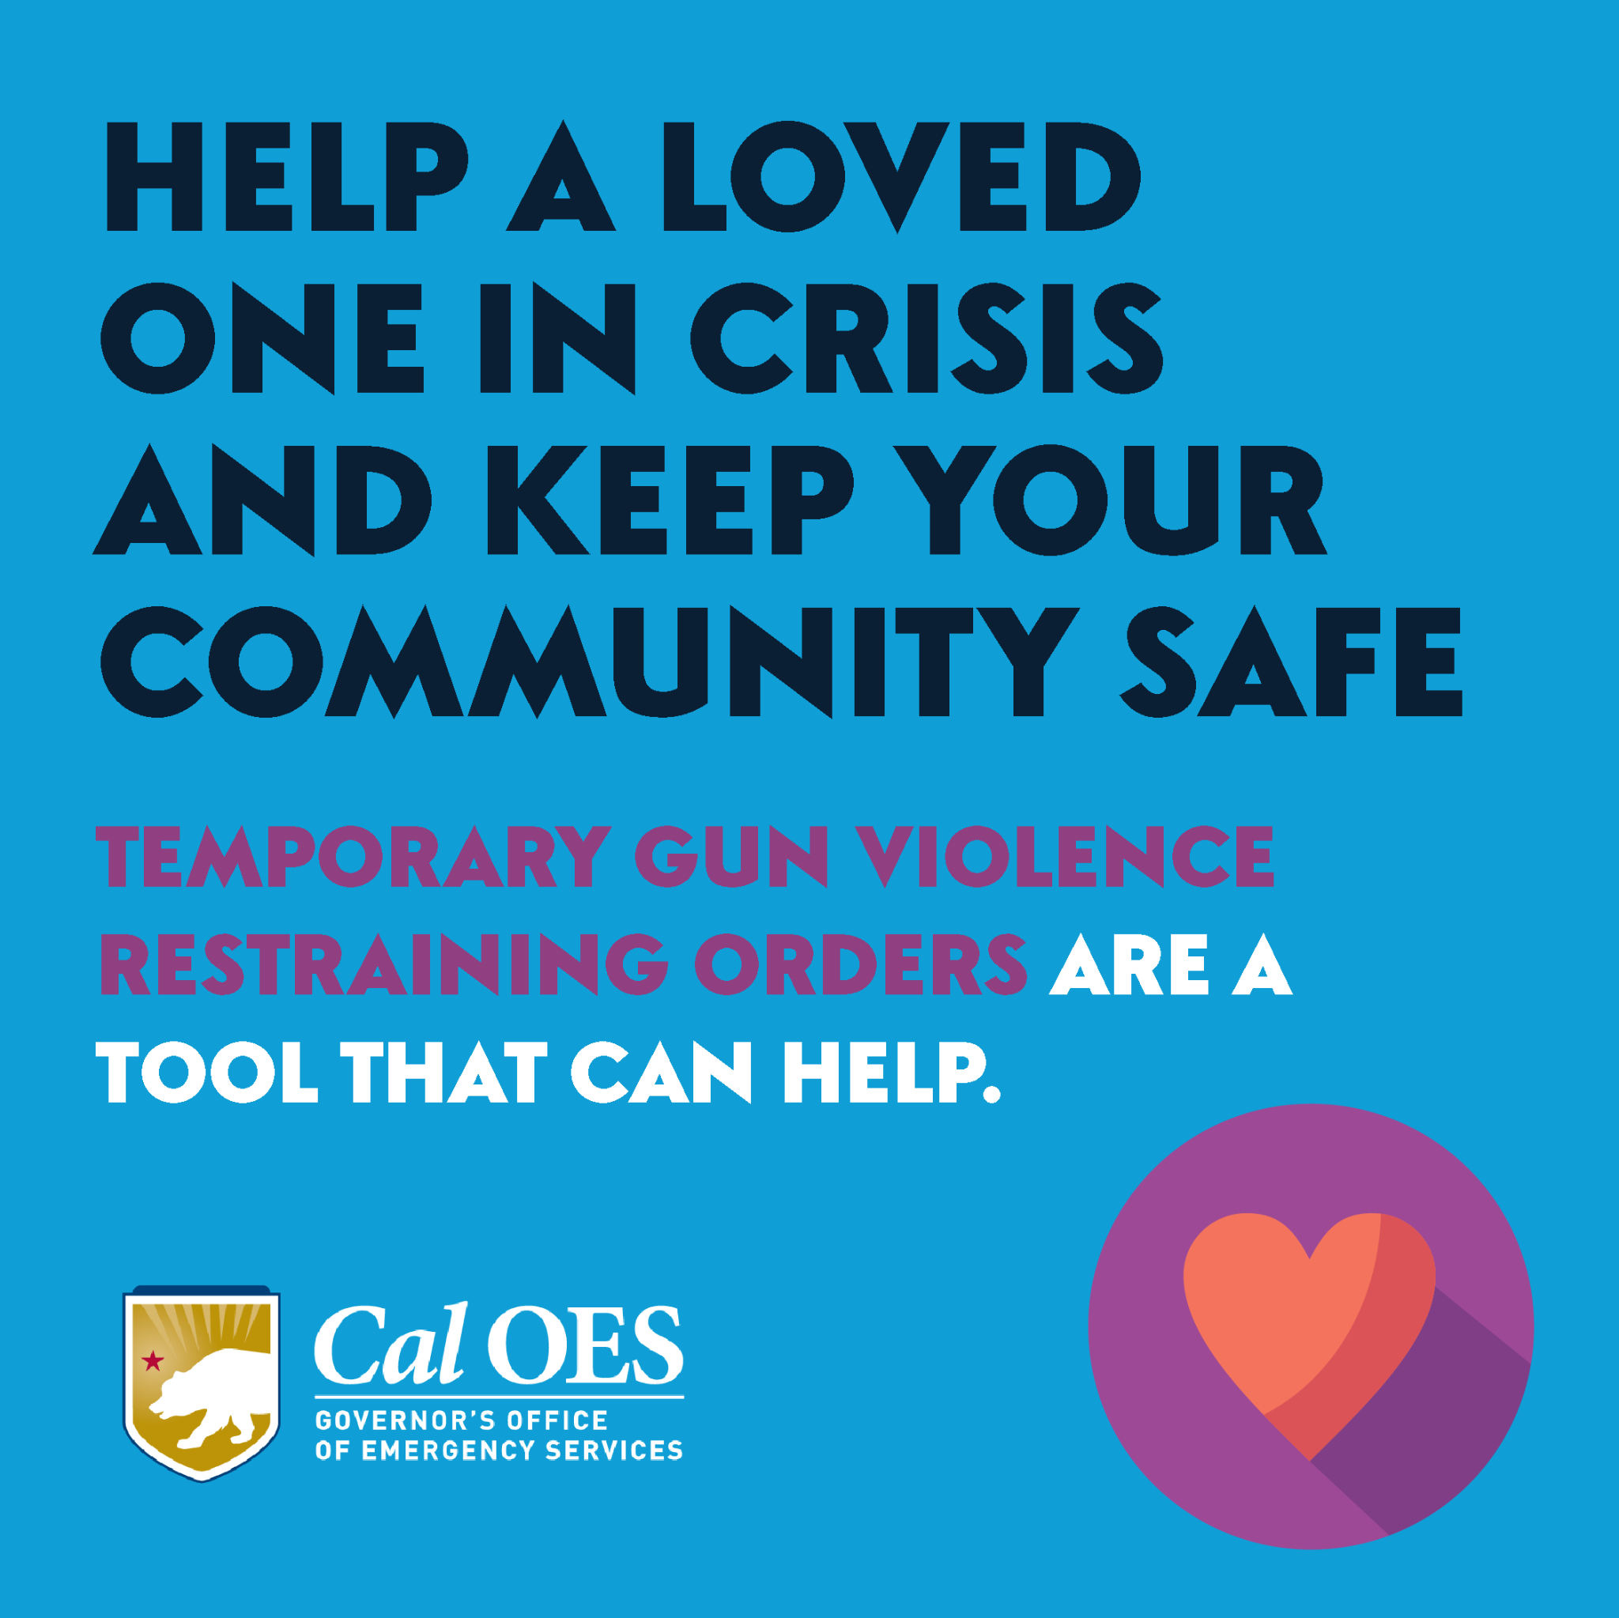

2 of 3:

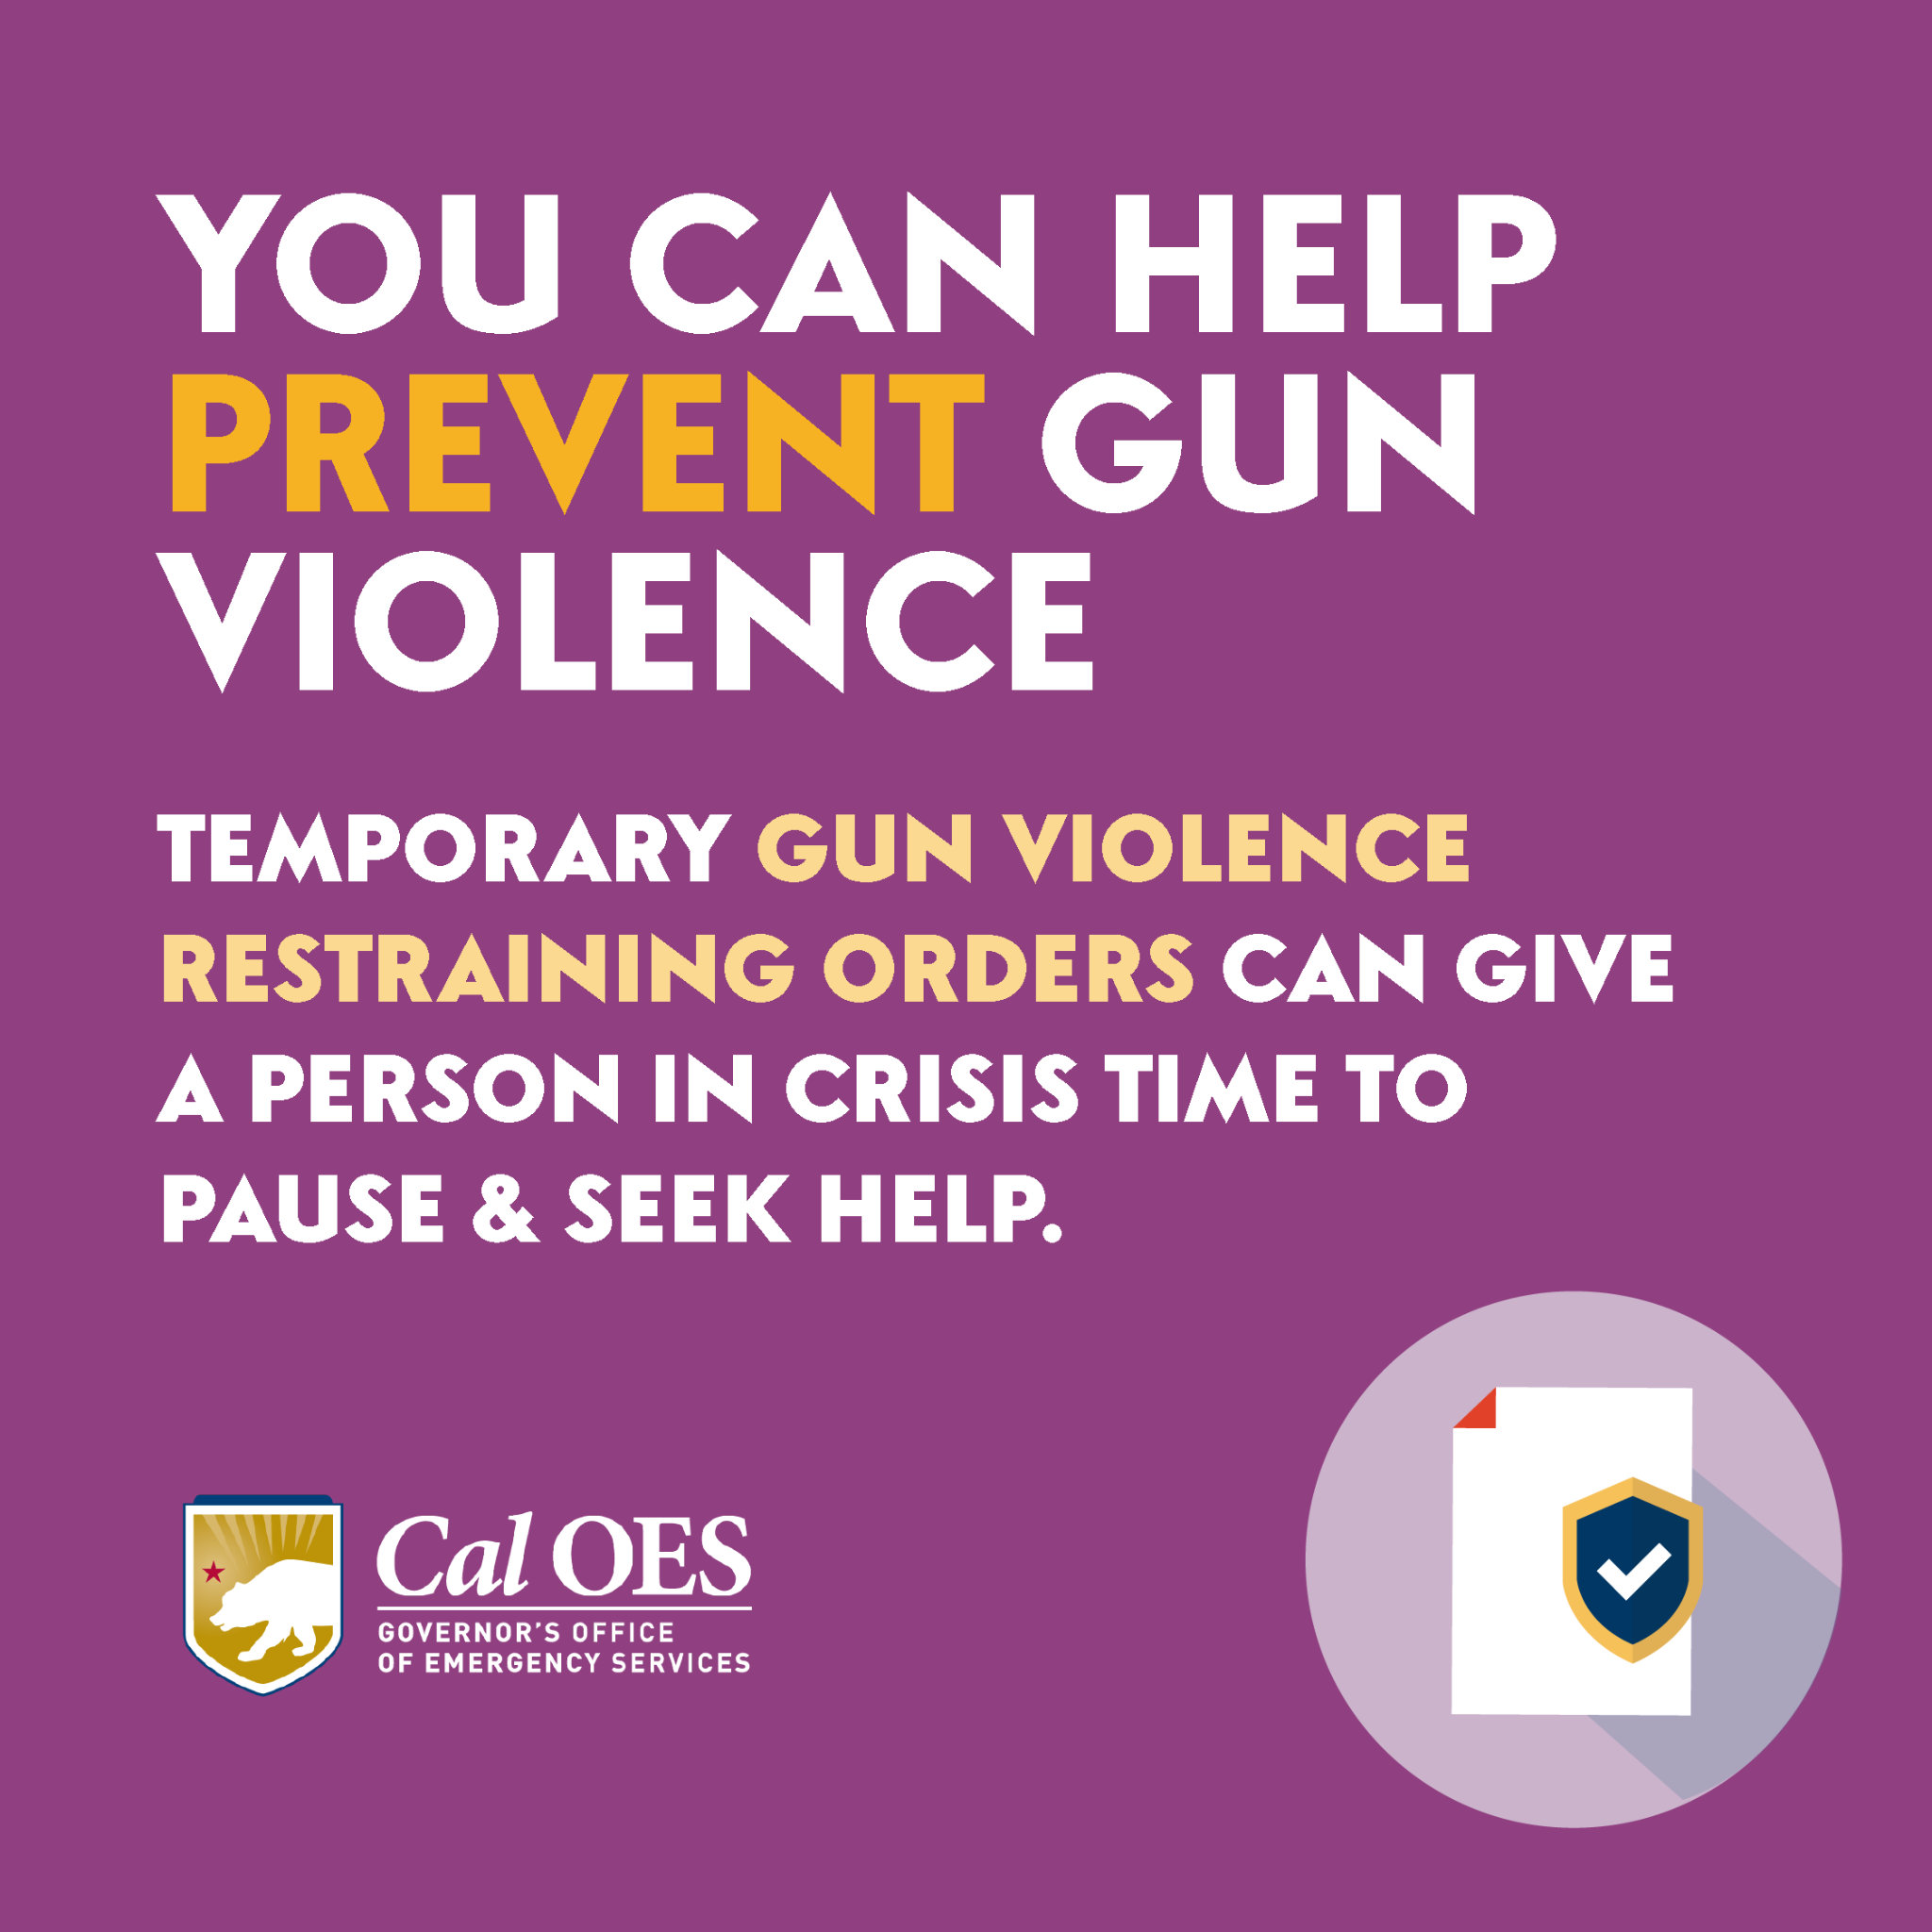

3 of 3:
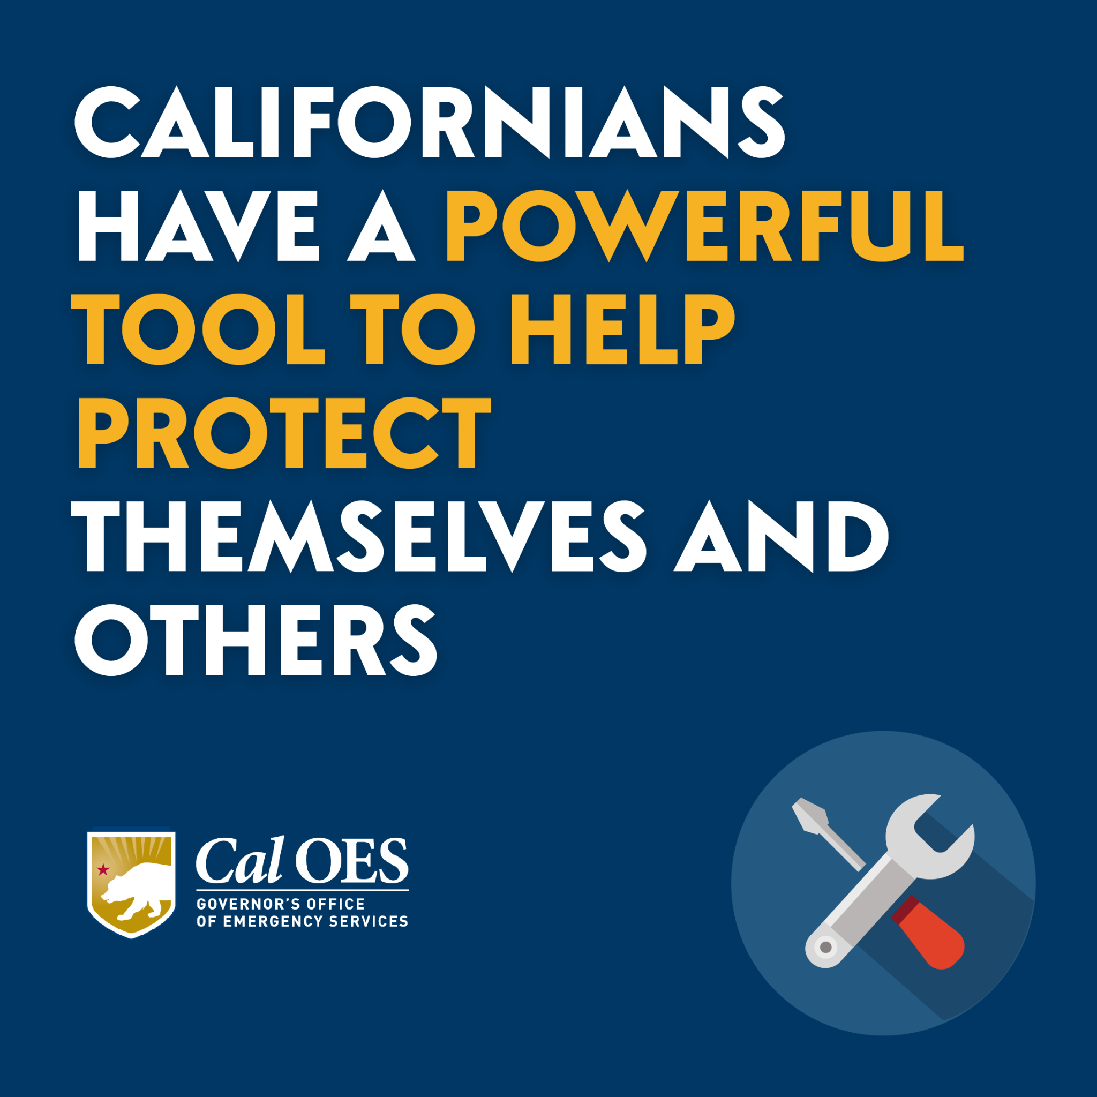

Facebook and Instagram:
Spanish

1 of 3:

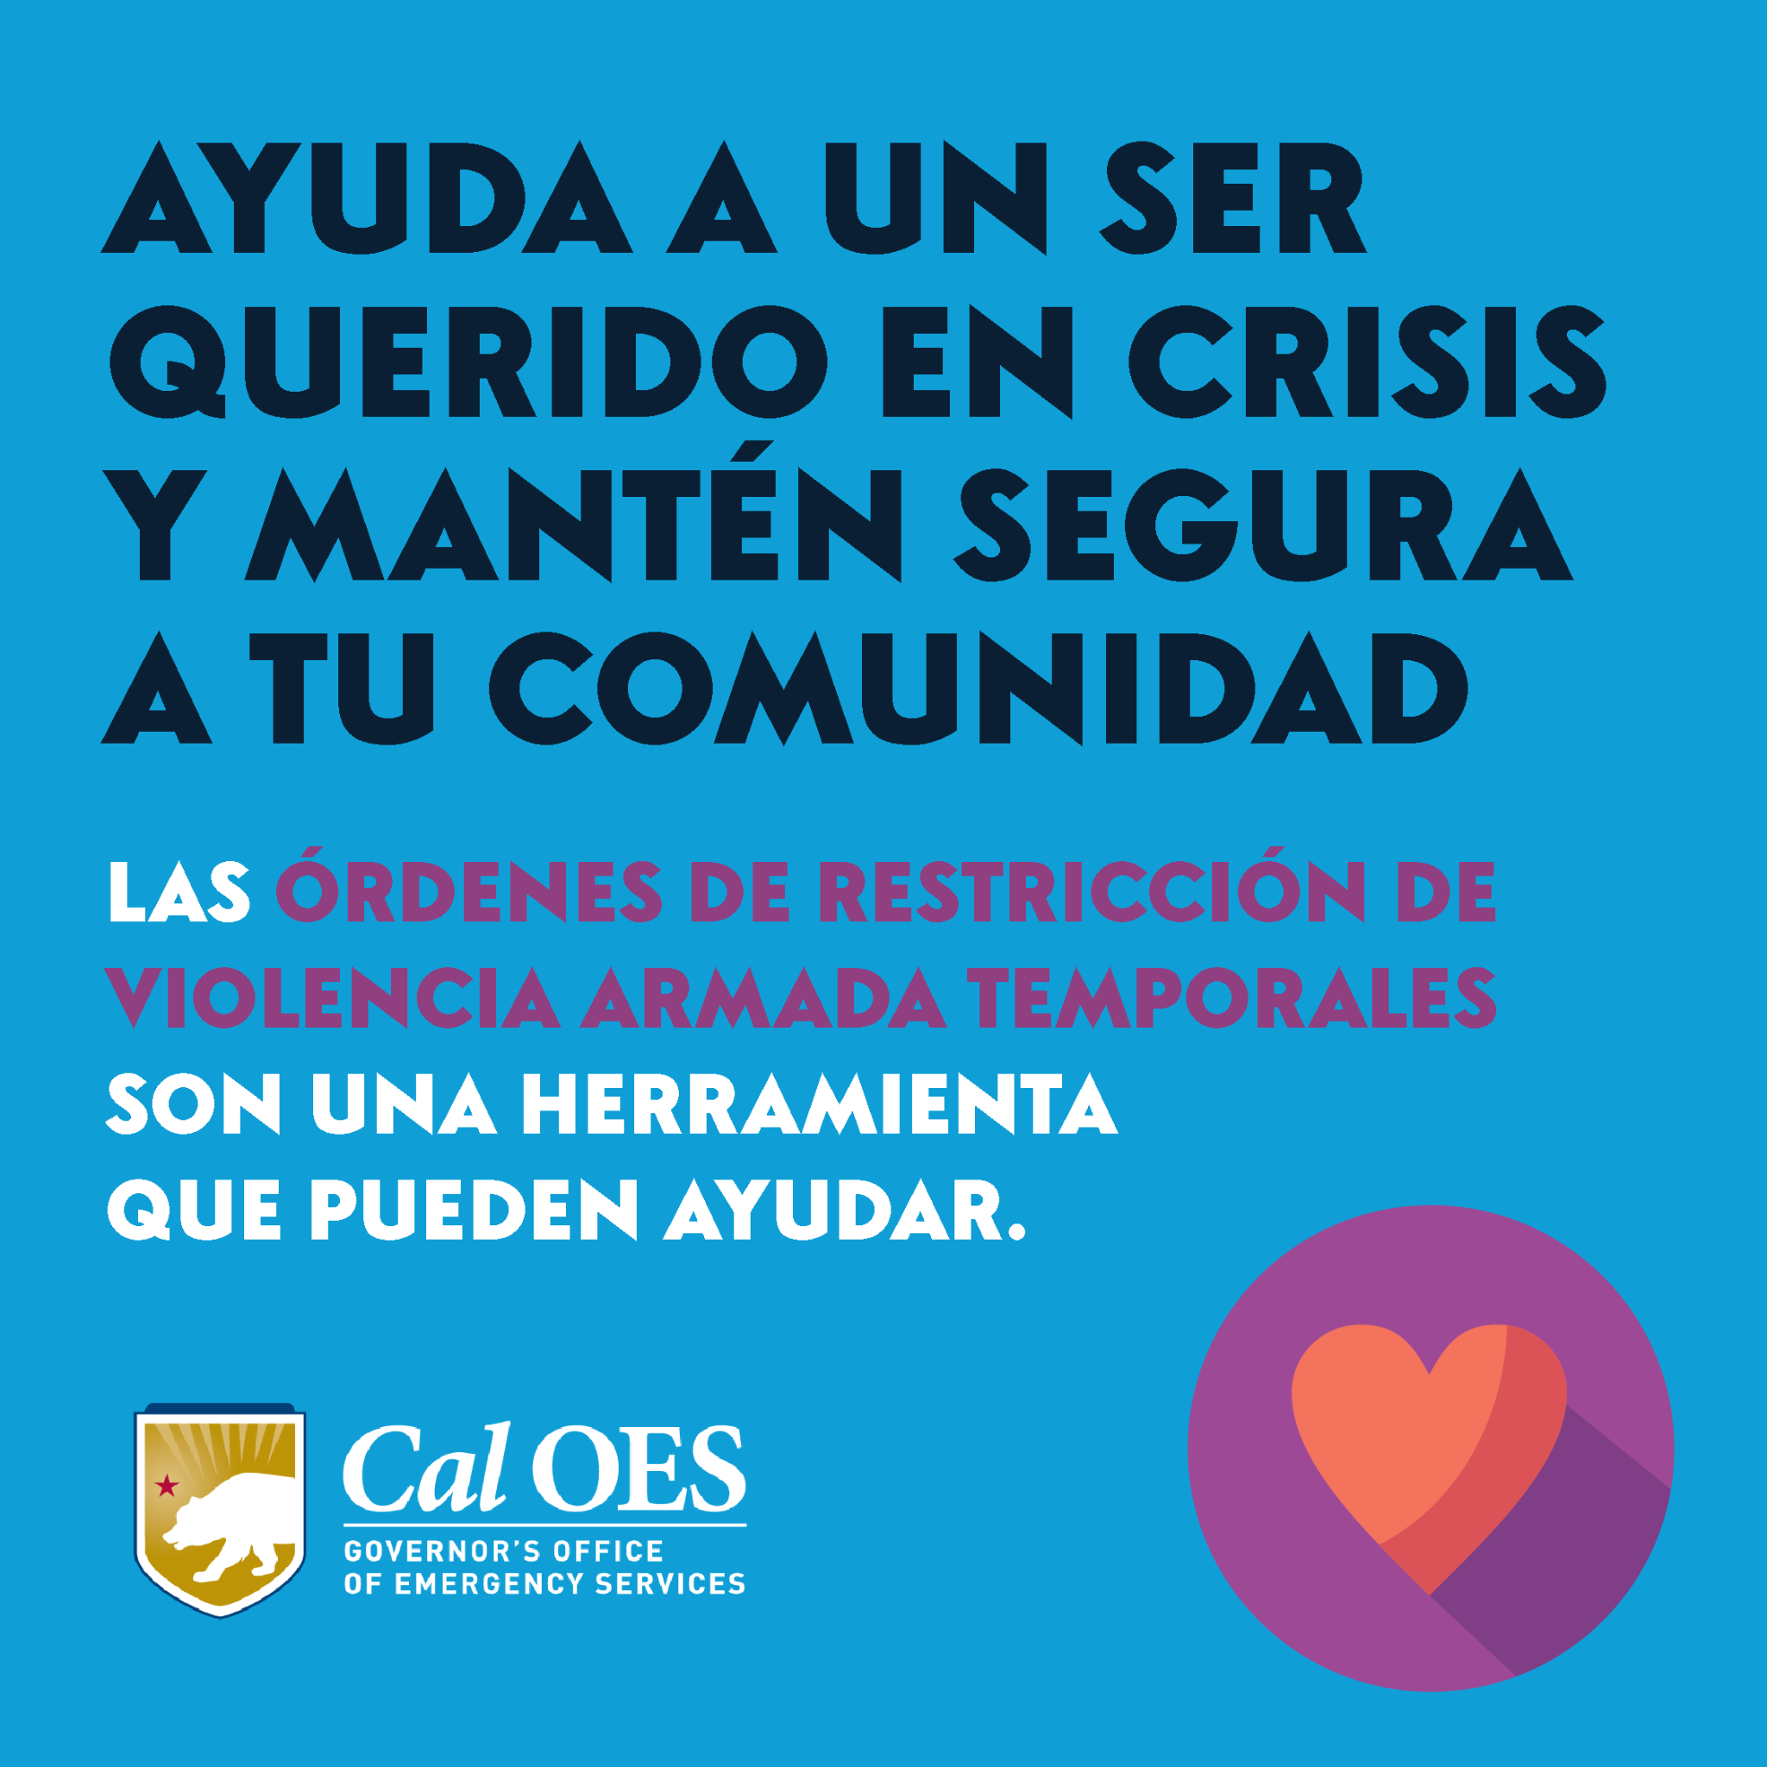

2 of 3:

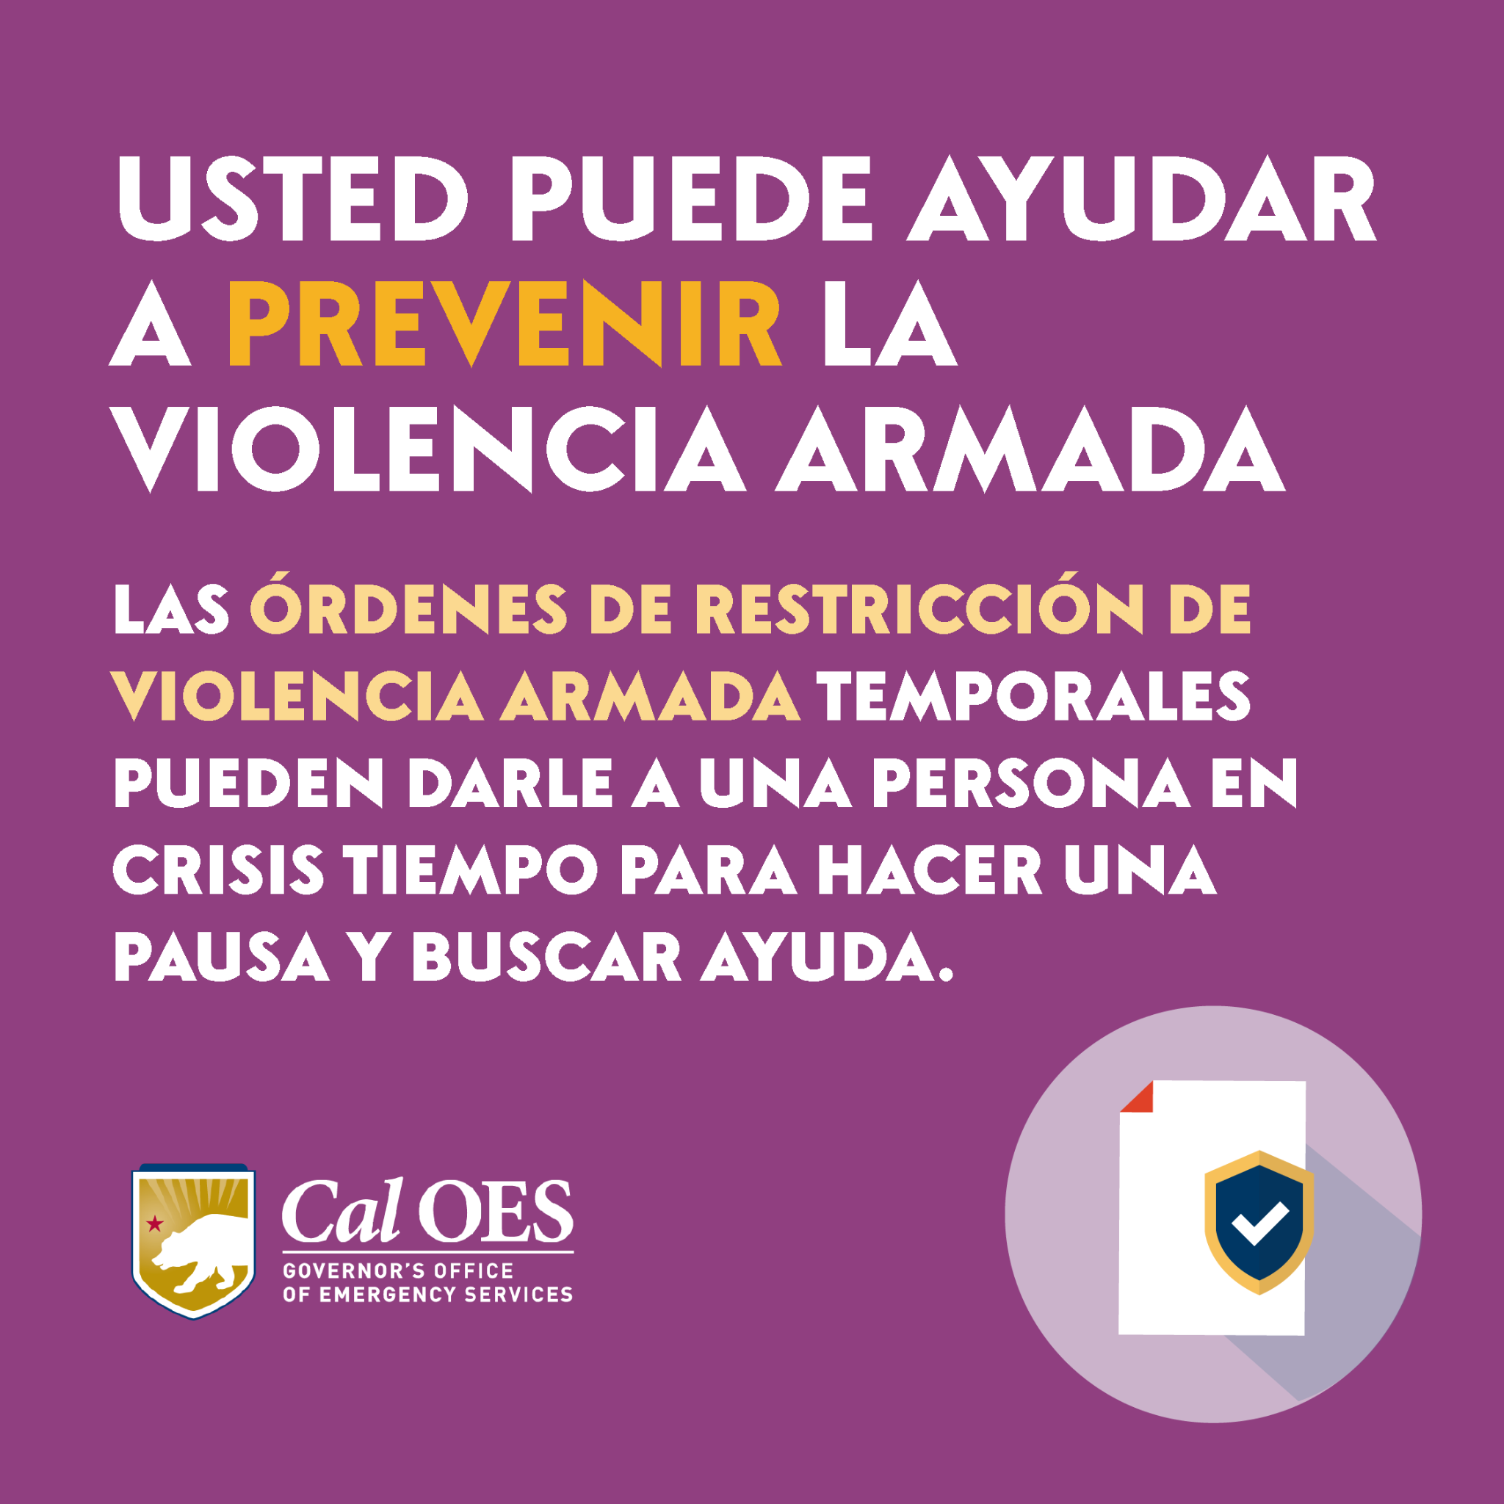

3 of 3:

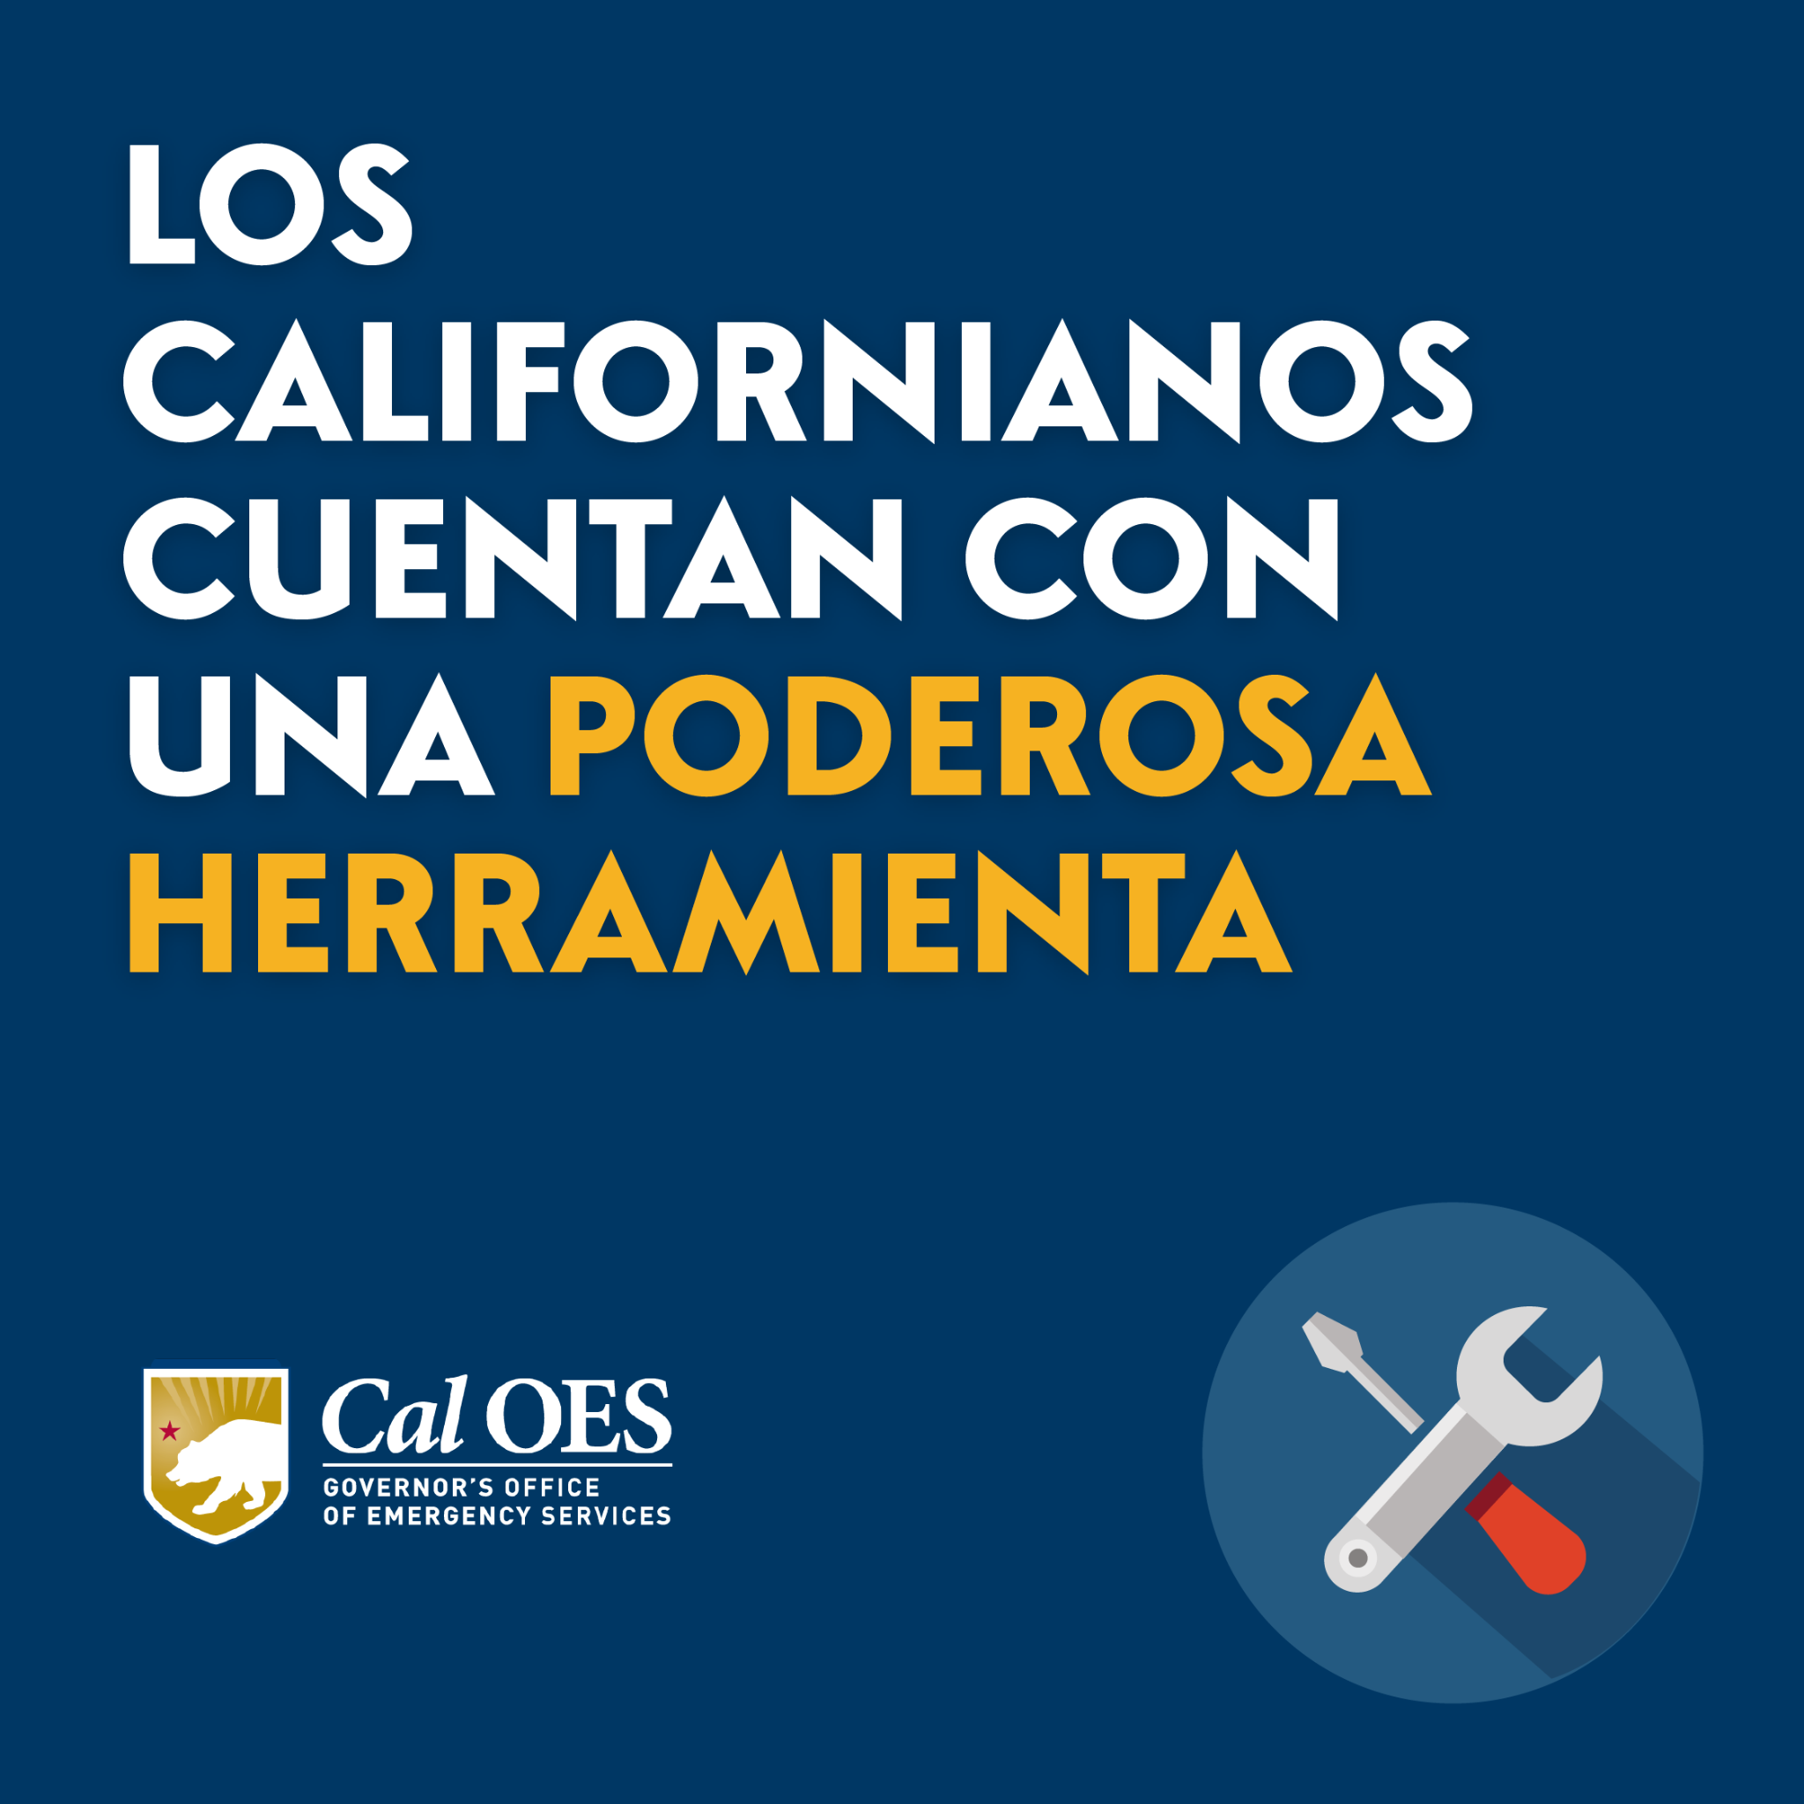

Twitter:
English

1 of 3:

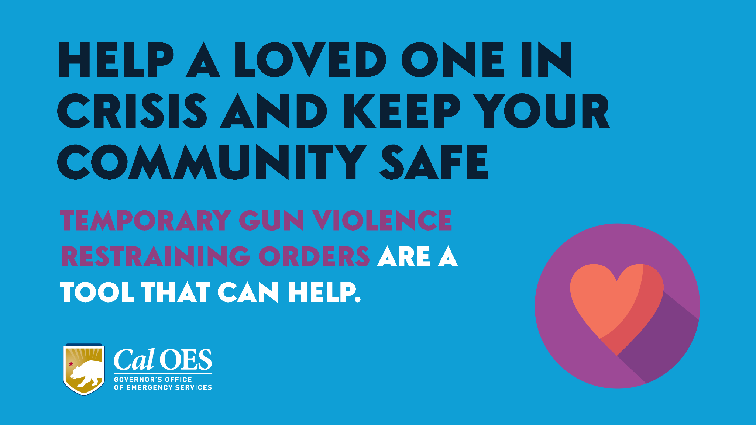

2 of 3:

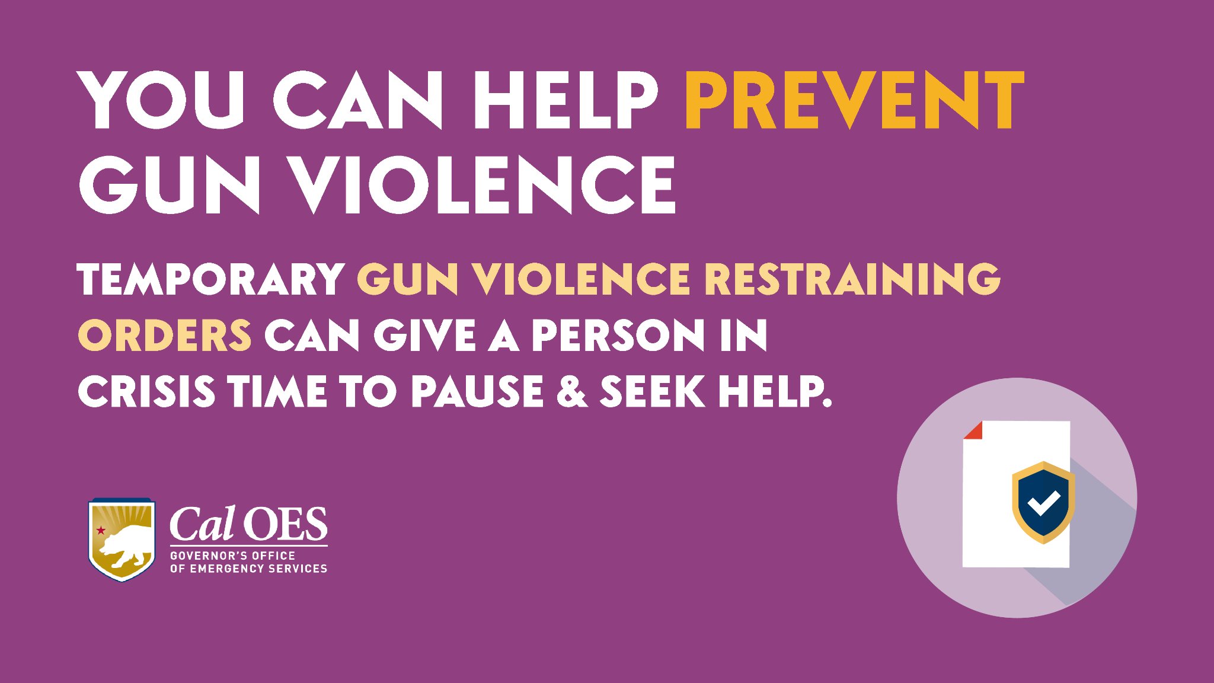

3 of 3:

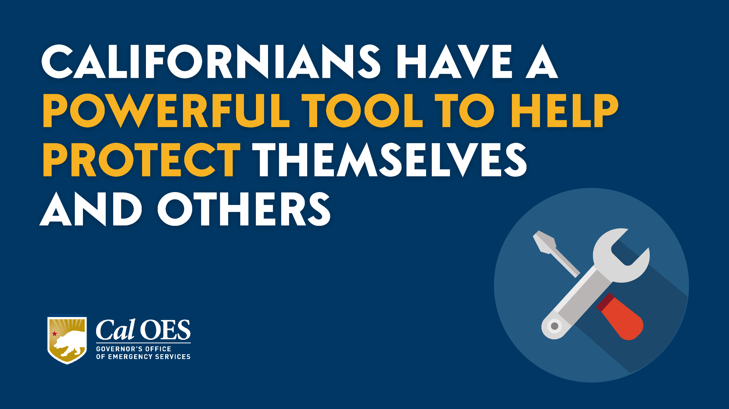

Twitter:
Spanish

1 of 3:

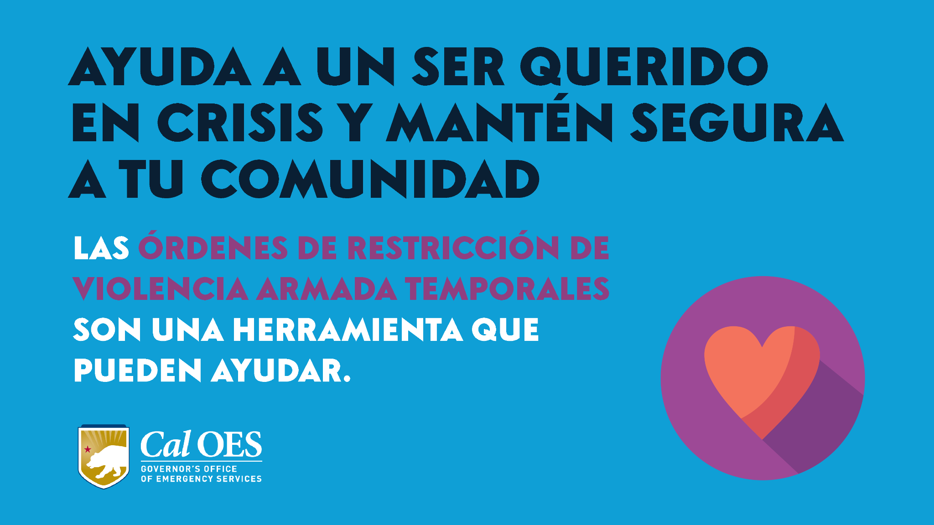

2 of 3:

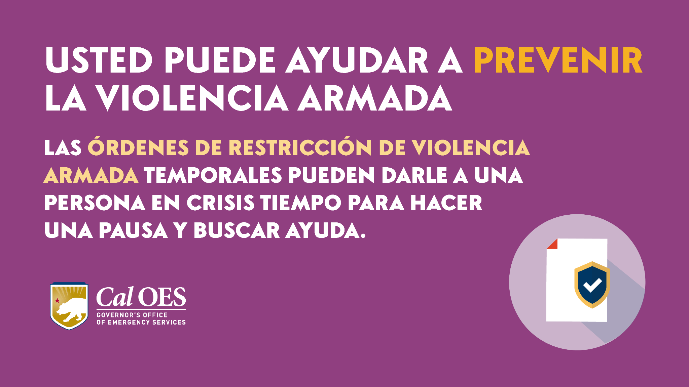

3 of 3:

