On April 11, 2025, Cal OES issued a Grant Management Memorandum (GMM) which stated that Federal grant funding was paused while the Department of Homeland Security (DHS)/ Federal Emergency Management Agency (FEMA) conducted a “manual review” of grant programs. This manual review also included information concerning whether a subrecipient was a sanctuary jurisdiction and applied to pending disbursement requests such as those submitted by subrecipients, which
Cal OES has processed but DHS/FEMA has not yet paid out.
On April 14, 2025, the Rhode Island district court issued an order reinstating its April 4, 2025, enforcement order which provided that FEMA end its “manual review” process and comply with the court’s prior order that FEMA not pause or impede the disbursement of federal grant funds. We still have not received disbursements for any pending requests related to Homeland Security Grant Program (HSGP), Emergency Management Performance Grant (EMPG), Emergency Operations Center Grant Program (EOCGP), Nonprofit Security Grant Program (NSGP), or State and Local Cybersecurity Grant Program (SLCGP), and thus have not been able to provide reimbursements to subrecipients. Cal OES will continue to provide updates on any significant developments on the release of funding and other pertinent information as it becomes available.
UPDATE: On April 21, 2025, FEMA announced the end of their manual review process. FEMA and DHS will resume processing grant payment requests and obligations using the same processes and procedures it was using prior to the implementation of the manual review process. At this time, FEMA will not require additional reviews on grant payments and obligations
HSGP, EMPG, NSGP, and SLCGP subrecipients should continue sending questions to: grantsmanagement@caloes.ca.gov as Cal OES is committed to maintaining communication and answering questions:
Q: | Where is my reimbursement request that I submitted in February/March?
A: | Cal OES has processed all reimbursement requests submitted in February/March.  However, as of mid-April, no disbursements for any pending requests related to HSGP, EMPG, EOCGP, NSGP, or SLCGP have been received, and thus Cal OES has not been able to provide reimbursements to subrecipients.  UPDATE: Effective immediately and pursuant to the Court’s Orders most recently, April 14TH order, DHS/FEMA will resume processing grant payment requests and obligations. Cal OES is now seeing some movement in the federal payment systems with our reimbursement requests. However, due to the enormous backlog in these systems, it may take another four or so weeks before you, the subrecipient, receive payment(s). By May 30, if you have not received payment for reimbursement requests submitted in February/March, please let your assigned Grants Analyst know.  In the meantime, please continue to submit reimbursement requests so that we may complete our internal processing and submit to DHS/FEMA for payment. This will prevent further payment delays.
Q: | What fiscal years (FYs) does this “federal pause” affect?
A: | This pause affects all open FYs, including 2021, 2022, 2023, and 2024.
Q: | Should I continue to submit reimbursement requests to Cal OES?
A: | Cal OES continues to process reimbursement requests, and we strongly encourage you to continue submitting these requests so that we may complete our internal processing for submission to DHS/FEMA.
Q: | What about the recent memo from DHS regarding sanctuary jurisdictions?
A: | On April 14, 2025, the Rhode Island district court issued an order reinstating its April 4, 2025, enforcement order which provided that FEMA end its “manual review” process – which also included information concerning whether a subrecipient was a sanctuary jurisdiction – and comply with the court’s prior order that FEMA not pause or impede the disbursement of federal funds.  We are hopeful all pending reimbursement requests will soon be released and will not include any additional restrictions impeding the disbursement of federal grant funds including restriction of funds to sanctuary jurisdictions.
Q: | What impact will the recently issued Sanctuary Jurisdiction list have on our application?
A: | The United States Department of Justice published its updated Sanctuary Jurisdiction list on August 5, 2025. (Office of the Attorney General | U.S. Sanctuary Jurisdiction List Following Executive Order 14287: Protecting American Communities From Criminal Aliens)  During their August 6, 2025, webinar discussing the 2025 NOFOs, FEMA stated that if a jurisdiction is on the list, it should still submit its application.
Q. | Should we continue implementing our FEMA-approved projects at this time?
A: | Cal OES understands the uncertainty of this situation and the frustration it has caused. The decision to continue implementing your FEMA-approved projects must be made by your entity as you know what is best for your community and situation.
Q: | DHS has recently released Terms and Conditions for FFY 2025 that include significant changes compared to prior years. What does this mean for HSGP, EMPG, NSGP, and SLCGP?
A: | UPDATE: On May 19, 2025, California joined 19 other states (Plaintiff States) in filing a lawsuit against FEMA, DHS, the U.S. Coast Guard and their Administrator/Secretary/Commandant (Defendants) challenging the immigration conditions contained in the revised 2025 DHS Standard Terms and Conditions that apply to any grant awards made on or after March 27, 2025. The Plaintiff States are seeking to have the Court permanently enjoin defendants from implementing or enforcing the Civil Immigration Conditions and the Civil Immigration National Priority Area (NPA) contained in the HSGP NOFO. The matter will be fully briefed by  August 11, 2025, with a decision to follow.  After the filing of the lawsuit, DHS updated its website to reflect that “Not all of DHS’s Standard Terms and Conditions apply to every DHS grant programs. DHS directs individuals to review the program’s NOFO and/or FEMA-State Agreement to determine which Terms and Conditions apply to a particular grant.” FY 2025 DHS Standard Terms and Conditions.  FEMA also determined that the immigration conditions do not apply to SLCGP and NSGP. As to HSGP, EMPG, and RCGCP, Section 9, O (1) of the HSGP and EMPG NOFOs provides that “An immigration term and condition, including those in the DHS Standard Terms and Conditions, may be material to the Department of Homeland Security’s decision to make this grant award, and the Department of Homeland Security may take any remedy for noncompliance, including termination, if the state or territorial recipient or any local government subrecipient fails to comply with this term and condition. No final agency determination has been made as of the date of this publication.”  Cal OES will be submitting a Reservation of Rights letter along with the  FY 2025 HSGP application, noting that there is ongoing litigation concerning the immigration conditions contained in the DHS Standard Terms and Conditions in State of Illinois et al. v. Federal Emergency Management Agency, et al. (D. R.I., No. 1:25-cv-206-WES-PAS). The reservation of rights letter will indicate that submission of the FY 25 HSGP application should not be construed as agreement to the disputed conditions, certification of compliance with the disputed conditions or as a waiver of any rights by Cal OES or the State of California, or any of its political subdivisions.  Cal OES will continue to provide updates as information becomes available.
Q. | How do we address the HSGP NOFO NPA concerning “Supporting Border Crisis Response and Enforcement” in our application? Is this also being challenged in the ongoing litigation?
A. | Yes, the Plaintiff States have also requested that the court enjoin Defendants from implementing or enforcing this NPA.  During their August 6, 2025, webinar discussing the 2025 NOFOs, FEMA stated that a jurisdiction is not required to have a Section 287(g) agreement to receive such funding and also noted that the NOFO provides examples of the potential types of projects, including supportive activities such as technology and information sharing and community engagement.  FEMA also stated that jurisdictions should consult with their respective law enforcement agencies to determine how to address this NPA in their applications in light of applicable state law. The California Office of the Attorney General updated its bulletin regarding SB 54 earlier this year and can be located at the following link: 2025-DLE-03 Updated Responsibilities of Law Enforcement Agencies Under the California Values Act, California TRUST Act, and the California TRUTH Act.
Q. | How do we address the HSGP NOFO NPA concerning “Election Security” in our application?
A. | Page 17 of the FY 25 HSGP NOFO states that jurisdictions must comply with three election-related conditions (“Election Security NPA Conditions”) relating to use of the Voluntary Voting System Guidelines 2.0, testing through a Voting System Test Laboratory accredited by the Election Assistance Commission, and use of the SAVE system to verify the citizenship of poll workers.  Cal OES will be submitting a Reservation of Rights letter along with the  FY 2025 HSGP application, noting that there is ongoing litigation concerning Executive Order No. 14248 which this NPA incorporates, as well as various court orders enjoining the Executive Order’s enforcement. In addition, the letter will address additional concerns, including that the Election Security NPA Conditions are vague, fail to provide meaningful guidance on what specific conduct is required, and are inconsistent with election administration practices and obligations. Cal OES will also explain that submission of the FY 25 HSGP application should not be construed as a certification of compliance with the Election Security NPA Conditions or as a waiver of any rights by Cal OES or the State of California, or any of its political subdivisions.

On April 4, 2025, DHS/FEMA announced the cancellation of its Building Resilient Infrastructure and Communities (BRIC) grant program. Cal OES is working with FEMA to understand the specific California projects that are affected by this decision and next steps.

BRIC subrecipients should continue sending questions to: HMA@caloes.ca.gov as
Cal OES is committed to maintaining communication and answering questions:

Q: | Can I submit time extensions, scope modifications and/or budget modifications for my Building Resilience and Building Resilient Infrastructure and Communities (BRIC) award?
A: | Cal OES received guidance that FEMA will not grant any period of performance extensions on any BRIC projects without prior approval by the Senior Official Performing the Duties of the FEMA Administrator  (SOPD F1). It is also very unlikely that scope modifications or budget modifications will be approved.  This applies to already submitted time extension/scope modification/budget modifications as well.  Cal OES recommends that you complete the scope of work for non-construction deliverables as approved by the end of your period of performance.
Q: | Will there be a review of partially or fully approved BRIC grants? What will that review include? Should we continue to work on our grant deliverables or wait until the review is completed?
A: | It is unclear when the reviews will take place or be completed. The initial guidance received indicated that funds would be disbursed in support of approved deliverables for non-construction activities.  Cal OES understands the uncertainty of this situation and the frustration it has caused. The decision to continue implementing your FEMA-approved BRIC projects must be made by your entity as you know what is best for your community and situation.

Q: | Should our community stop work or continue incurring costs toward completing our deliverables approved under this BRIC?
A: | Cal OES understands the uncertainty of this situation and the frustration it has caused. The decision to continue implementing your FEMA-approved BRIC projects must be made by your entity as you know what is best for your community and situation.
Q: | What about the Hazard Mitigation Grant Program? Will it be canceled as well?
A: | The April 4, 2025, FEMA Advisory cancelling the BRIC program only applies to BRIC. No changes have been announced to other Hazard Mitigation Assistance Programs, including the Hazard Mitigation Grant Program (HMGP), HMGP-Post Fire, Flood Mitigation Assistance (FMA), High Hazard Potential Dam (HHPD), Pre-Disaster Mitigation (PDM) Program, or the Congressionally Directed Spending Pre-Disaster Mitigation / Mitigation Earmark (CDS PDM) grants.
Q: | I am interested in switching my project over from BRIC to the open NOFO for the Hazard Mitigation Grant Program (HMGP). Can I do that?
A: | Please send an email to the Cal OES Technical Assistance Division via email: ResilientCA@caloes.ca.gov and copy the Grants Analyst assigned to your community. Ask to set up a Scoping Call to submit a Notice of Interest for DR-4856 HMGP, and a member of our Technical Assistance team will reach out to discuss next steps.  We ask that you do so as soon as you're ready, as "Notices of Interest" are due to Cal OES in our Engage system by 5/29/2025.
Q: | Who can I contact to discuss the NOFO or questions about HMGP?
A: | Please contact ResilientCA@caloes.ca.gov for more information and a member of our team will discuss next steps.
Q: | Is there a funding cap or maximum for submissions to HMGP?
A: | There is no funding cap or maximum. However, because of the cancellation of the BRIC program, we expect there to be more interest in the HMGP than we have funding available. It is not a guarantee that your community will be selected at this time.
Q: | Do I need to submit a new Notice of Interest or Subapplication for HMGP?
A: | See page 4 in the HMGP-DR-4856 Notice of Funding Opportunity posted on the Cal OES Hazard Mitigation Assistance "Grant Opportunities" page at: https://www.caloes.ca.gov/office-of-the-director/operations/recovery-directorate/hazard-mitigation/hm-grant-opportunities/
Q: | How do I submit a Notice of Interest for HMGP?
A: | Please go to the Cal OES Hazard Mitigation Assistance "Grant Opportunities" page at: https://www.caloes.ca.gov/office-of-the-director/operations/recovery-directorate/hazard-mitigation/hm-grant-opportunities/ Click the link for "HMGP-DR-4856" to read more about submitting a Notice of Interest in the Engage system via the NOFO document.  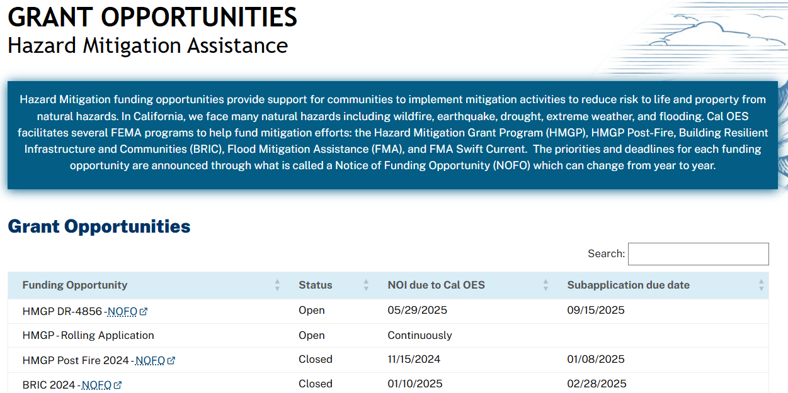
Q: | We submitted our Local Hazard Mitigation Plan and it is with FEMA for review. What is the status of my Local Hazard Mitigation Plan?
A: | On 4/16/2025, FEMA released updated Local Hazard Mitigation Planning Guidance, in response to a waiver to certain planning elements. Cal OES will be posting an updated crosswalk and all materials on the "Local Mitigation Planning" website: https://www.caloes.ca.gov/office-of-the-director/operations/recovery-directorate/hazard-mitigation/local-mitigation-planning/  Region 9 has begun approving LHMPs under this amended guidance as of 4/14/2025 and working through a backlog of plan reviews/approvals. Please contact our team at MitigationPlanning@caloes.ca.gov for more information.

