The Just-In-Time EOC Training Videos prepared by the Bay Area UASI may be viewed via the following methods.
- Go to YouTube.com and search for Bay Area UASI or use this link: https://www.youtube.com/channel/UCrgBrhx0uiI1JXPMQGt3t3Q.
All videos are available for viewing via the Bay Area UASI channel on YouTube.
- Use this Dropbox Link to download the videos to your local hard drive: https://www.dropbox.com/sh/91epc885khxt049/AAATB_mas7xtodTdMdpoSMaKa?dl=0
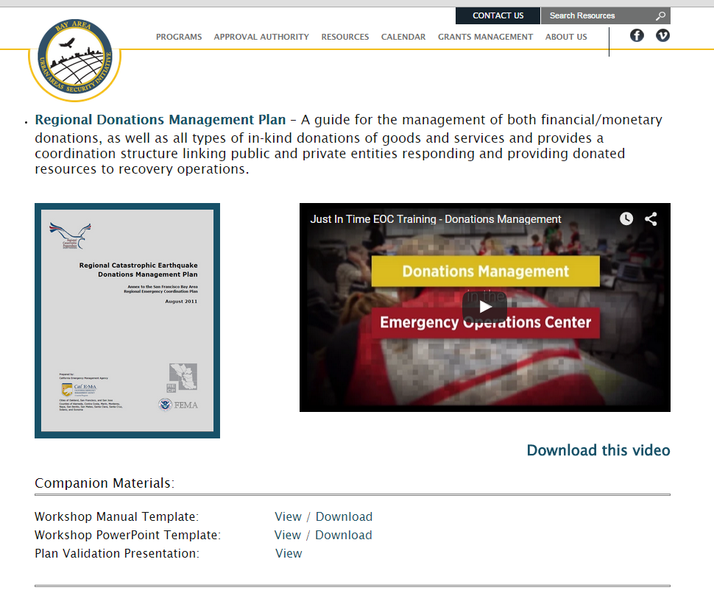
- Go to http://www.bayareauasi.org/catastrophicplans. Click on a plan. You may view the video through this site, or use the presented link to download the video.
With questions or for assistance accessing the Just-In-Time EOC Training Videos, please contact:
Corinne Bartshire, AICP, CFM
Resilience and Recovery Regional Project Manager
Bay Area Urban Areas Security Initiative (UASI)
711 Van Ness Avenue #420
San Francisco, CA 94102
Corinne.Bartshire@sfgov.org
415-353-5234 (desk)
415-861-9005 (cell)

