11B-603 Toilet and bathing rooms
11B-603.1 General. Toilet and bathing rooms shall comply with Section 11B-603.
11B-603.2 Clearances. Clearances shall comply with Section 11B-603.2.
11B-603.2.1 Turning space. Turning space complying with Section 11B-304 shall be provided within the room.
11B-603.2.2 Overlap. Required clear floor spaces, clearance at fixtures, and turning space shall be permitted to overlap.
11B-603.2.3 Door swing. Doors shall not swing into the clear floor space or clearance required for any fixture. Other than the door to the accessible water closet compartment, a door, in any position, may encroach into the turning space by 12 inches (305 mm) maximum.
Exceptions:
1. Reserved.
2. Where the toilet room or bathing room is for individual use and a clear floor space complying with Section 11B-305.3 is provided within the room beyond the arc of the door swing, doors shall be permitted to swing into the clear floor space or clearance required for any fixture.
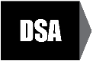
Advisory 11B-603.2.3 Door swing. The door to the accessible water closet compartment may swing over the turning space without limitation. Other doors may swing over the turning space up to 12 inches. 
11B-603.3 Mirrors. Mirrors located above lavatories or countertops shall be installed with the bottom edge of the reflecting surface 40 inches (1016 mm) maximum above the finish floor or ground. Mirrors not located above lavatories or countertops shall be installed with the bottom edge of the reflecting surface 35 inches (889 mm) maximum above the finish floor or ground.

Advisory 11B-603.3 Mirrors. A single full-length mirror can accommodate a greater number of people, including children. In order for mirrors to be usable by people who are ambulatory and people who use wheelchairs, the top edge of mirrors should be 74 inches (1880 mm) minimum from the floor or ground.
11B-603.4 Coat hooks, shelves and medicine cabinets. Coat hooks shall be located within one of the reach ranges specified in Section 11B-308. Shelves shall be located 40 inches (1016 mm) minimum and 48 inches (1219 mm) maximum above the finish floor. Medicine cabinets shall be located with a usable shelf no higher than 44 inches (1118 mm) maximum above the finish floor.
11B-603.5 Accessories. Where towel or sanitary napkin dispensers, waste receptacles, or other accessories are provided in toilet facilities, at least one of each type shall be located on an accessible route. All operable parts, including coin slots, shall be 40 inches (1016 mm) maximum above the finish floor.

Exception: Baby changing tables are not required to comply with Section 11B-603.5
11B-603.6 Guest room toilet and bathing rooms. Toilet and bathing rooms within guest rooms that are not required to provide mobility features complying with Section 11B-806.2 shall provide all toilet and bathing fixtures in a location that allows a person using a wheelchair measuring 30 inches by 48 inches (762 mm by 1219 mm) to touch the wheelchair to any lavatory, urinal, water closet, tub, sauna, shower stall and any other similar sanitary installation, if provided.

11B-606 Lavatories and sinks
11B-606.1 General. Lavatories and sinks shall comply with Section 11B-606.
Advisory 11B-606.1 General. If soap and towel dispensers are provided, they must be located within the reach ranges specified in Section 11B-308, except for those in toilet and bathing rooms which must comply with Section 11B-603.5. Locate soap and towel dispensers so that they are conveniently usable by a person at the accessible lavatory.
11B-606.2 Clear floor space. A clear floor space complying with Section 11B-305, positioned for a forward approach, and knee and toe clearance complying with Section 11B-306 shall be provided.
Exceptions:
1. A parallel approach complying with Section 11B-305 shall be permitted to a kitchen sink in a space where a cook top or conventional range is not provided and to wet bars.
2. Reserved.
3. In residential dwelling units, cabinetry shall be permitted under lavatories and kitchen sinks provided that all of the following conditions are met:
(a) the cabinetry can be removed without removal or replacement of the fixture;
(b) the finish floor extends under the cabinetry; and
(c) the walls behind and surrounding the cabinetry are finished.
4. A knee clearance of 24 inches (610 mm) minimum above the finish floor or ground shall be permitted at lavatories and sinks used primarily by children 6 through 12 years where the rim or counter surface is 31 inches (787 mm) maximum above the finish floor or ground.
5. A parallel approach complying with Section 11B-305 shall be permitted to lavatories and sinks used primarily by children 5 years and younger.
6. The dip of the overflow shall not be considered in determining knee and toe clearances.
7. No more than one bowl of a multi-bowl sink shall be required to provide knee and toe clearance complying with Section 11B-306.
11B-606.3 Height. Lavatories and sinks shall be installed with the front of the higher of the rim or counter surface 34 inches (864 mm) maximum above the finish floor or ground.
Exceptions:
1. Reserved.
2. In residential dwelling unit kitchens, sinks that are adjustable to variable heights, 29 inches (737 mm) minimum and 36 inches (914 mm) maximum, shall be permitted where rough-in plumbing permits connections of supply and drain pipes for sinks mounted at the height of 29 inches (737 mm).
11B-606.4 Faucets. Controls for faucets shall comply with Section 11B-309. Hand-operated metering faucets shall remain open for 10 seconds minimum.
11B-606.5 Exposed pipes and surfaces. Water supply and drain pipes under lavatories and sinks shall be insulated or otherwise configured to protect against contact. There shall be no sharp or abrasive surfaces under lavatories and sinks.
11B-606.6 Adjacent side wall or partition. Lavatories, when located adjacent to a side wall or partition, shall be a minimum of 18 inches (457 mm) to the centerline of the fixture.
11B-606.7 Sink depth. Where a forward approach is required at a sink, knee and toe clearance shall be provided in compliance with Section 11B-306.

11B-608 Shower compartments
11B-608.1 General. Shower compartments shall comply with Section 11B-608.
Advisory 11B-608.1 General. Shower stalls that are 60 inches (1525 mm) wide and have no curb may increase the usability of a bathroom because the shower area provides additional maneuvering space.
11B-608.2 Size and clearances for shower compartments. Shower compartments shall have sizes and clearances complying with Section 11B-608.2.
11B-608.2.1 Reserved.
11B-608.2.2 Standard roll-in type shower compartments. Standard roll-in type shower compartments shall be 30 inches (762 mm) wide minimum by 60 inches (1524 mm) deep minimum clear inside dimensions measured at center points of opposing sides with a full opening width on the long side.
11B-608.2.2.1 Clearance. A 36 inch (914 mm) wide minimum by 60 inch (1524 mm) long minimum clearance shall be provided adjacent to the open face of the shower compartment.
Exception: Reserved.
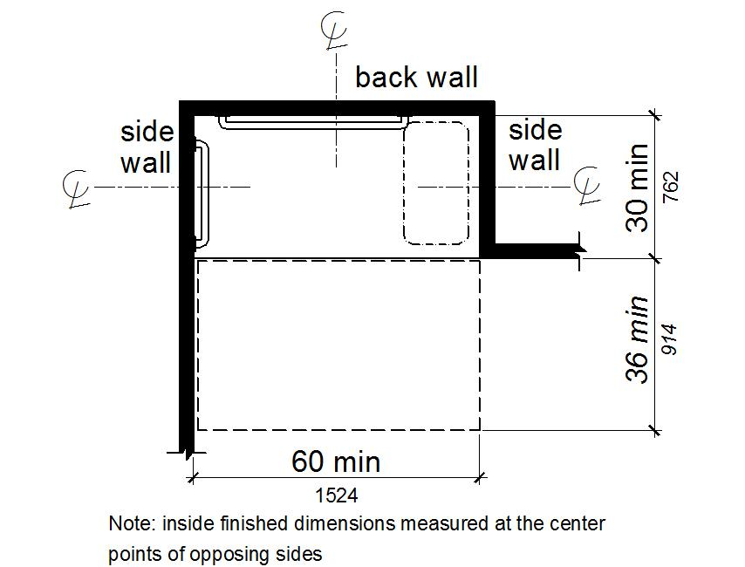
Figure 11B-608.2.2
Standard Roll-In Type Shower Compartment Size and Clearance
11B-608.2.3 Alternate roll-in type shower compartments. Alternate roll-in type shower compartments shall be 36 inches (914 mm) wide and 60 inches (1524 mm) deep minimum clear inside dimensions measured at center points of opposing sides. A 36 inch (914 mm) wide minimum entry shall be provided at one end of the long side of the compartment.
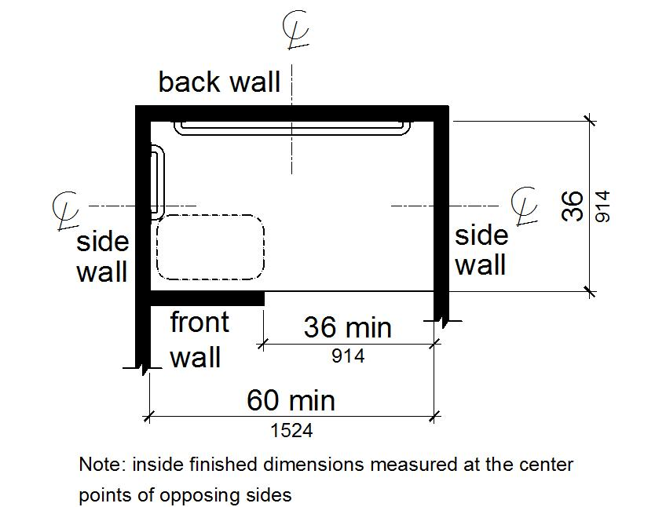
Figure 11B-608.2.3
Alternate Roll-In Type Shower Compartment Size and Clearance
11B-608.3 Grab bars. Grab bars shall comply with Section 11B-609 and shall be provided in accordance with Section 11B-608.3. Where multiple grab bars are used, required horizontal grab bars shall be installed at the same height above the finish floor. Where separate grab bars are required on adjacent walls at a common mounting height, an L-shaped or U-shaped grab bar meeting the dimensional requirements of Section 11B-608.3.2 or 11B-608.3.3 shall be permitted
Exceptions:
1. Reserved.
2. In residential dwelling units, grab bars shall not be required to be installed in showers located in bathing facilities provided that reinforcement has been installed in walls and located so as to permit the installation of grab bars complying with Section 11B-608.3.
11B-608.3.1 Reserved.
11B-608.3.2 Standard roll-in type shower compartments. Grab bars shall be provided on the back wall and the side wall opposite the seat. Grab bars shall not be provided above the seat. Grab bars shall be installed 6 inches (152 mm) maximum from adjacent walls.
Figure 11B-608.3.2
Grab Bars for Standard Roll-In Type Shower
11B-608.3.3 Alternate roll-in type shower compartments. In alternate roll-in type shower compartments, grab bars shall be provided on the back wall and the side wall farthest from the compartment entry. Grab bars shall not be provided above the seat. Grab bars shall be installed 6 inches (152 mm) maximum from adjacent walls.
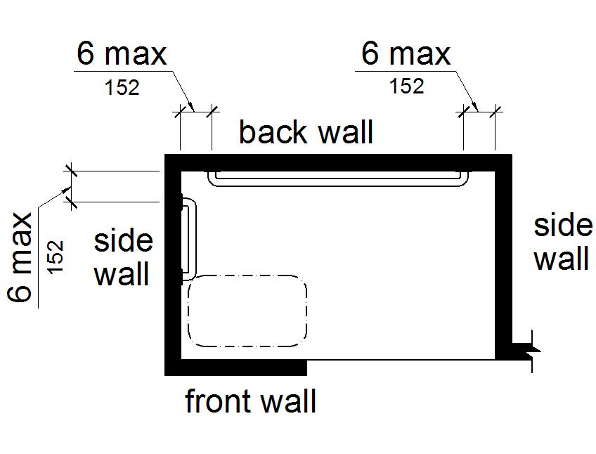
Figure 11B-608.3.3
Grab Bars for Alternate Roll-In Type Showers
11B-608.4 Seats. A folding seat shall be provided in roll-in type showers. Seats shall comply with Section 11B-610.
Exception: In residential dwelling units, seats shall not be required in shower compartments provided that reinforcement has been installed in walls so as to permit the installation of seats complying with Section 11B-608.4.
11B-608.5 Controls. Controls, faucets, and shower spray units shall comply with Section 11B-309.4. Controls and faucets shall be of a single-lever design.
11B-608.5.1 Reserved.
11B-608.5.2 Standard roll-in type shower compartments. In standard roll-in type shower compartments, operable parts of controls and faucets shall be installed on the back wall of the compartment adjacent to the seat wall 19 inches (483 mm) minimum and 27 inches (686 mm) maximum from the seat wall; and shall be located above the grab bar, but no higher than 48 inches (1219 mm) above the shower floor, with their centerline at 39 inches (991 mm) to 41 inches (1041 mm) above the shower floor.
Operable parts of the shower spray unit, including the handle, shall be installed on the back wall adjacent to the seat wall 19 inches (483 mm) minimum and 27 inches (686 mm) maximum from the seat wall; and shall be located above the grab bar, but no higher than 48 inches (1219 mm) above the shower floor.
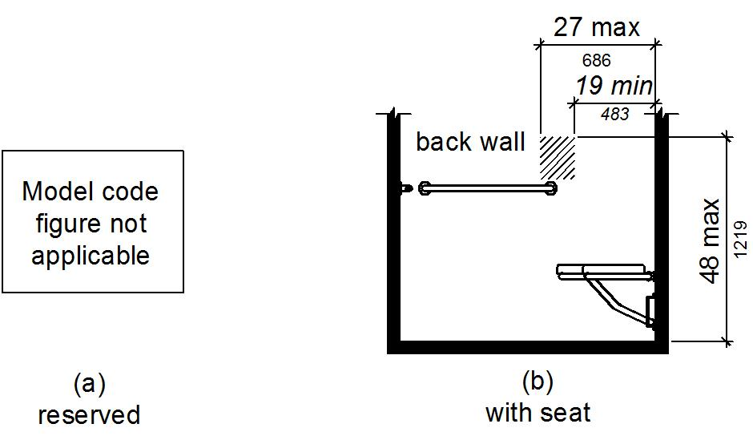
Figure 11B-608.5.2
Standard Roll-In Type Shower Compartment Control Location
11B-608.5.3 Alternate roll-in type shower compartments. In alternate roll-in type shower compartments, operable parts of controls and faucets shall be installed on the side wall of the compartment adjacent to the seat wall 19 inches (483 mm) minimum and 27 inches (686 mm) maximum from the seat wall; and shall be located above the grab bar, but no higher than 48 inches (1219 mm) above the shower floor, with their centerline at 39 inches (991 mm) to 41 inches (1041 mm) above the shower floor.
Operable parts of the shower spray unit, including the handle, shall be installed on the side wall of the compartment adjacent to the seat wall 17 inches (432 mm) minimum and 19 inches (483 mm) maximum from the seat wall or on the back wall opposite the seat 15 inches (381 mm) maximum, left or right, of the centerline of the seat; and shall be located above the grab bar, but no higher than 48 inches (1219 mm) above the shower floor.
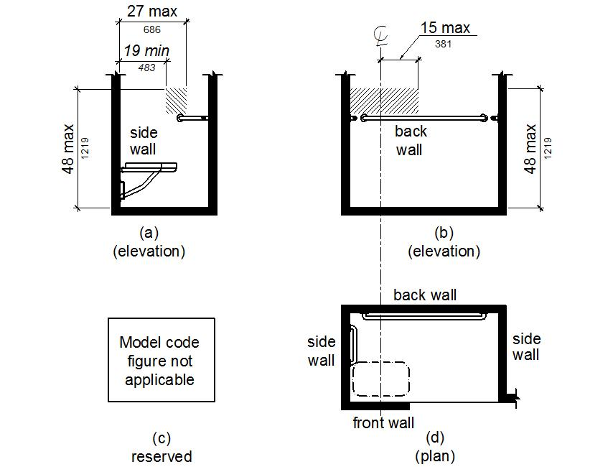
Figure 11B-608.5.3
Alternate Roll-In Type Shower Compartment Control Location
11B-608.6 Shower spray unit and water. A shower spray unit with a hose 59 inches (1499 mm) long minimum that can be used both as a fixed-position shower head and as a hand-held shower shall be provided. The shower spray unit shall have an on/off control with a non-positive shut-off. If an adjustable-height shower head on a vertical bar is used, the bar shall be installed so as not to obstruct the use of grab bars. Shower spray units shall deliver water that is 120°F (49°C) maximum.
Exception: Where subject to excessive vandalism, two fixed shower heads shall be installed instead of a hand-held spray unit in facilities that are not transient lodging guest rooms. Each shower head shall be installed so it can be operated independently of the other and shall have swivel angle adjustments, both vertically and horizontally.
Advisory 11B-608.6 Shower spray unit and water. Ensure that hand-held shower spray units are capable of delivering water pressure substantially equivalent to fixed shower heads.
11B-608.7 Thresholds. Thresholds in roll-in type shower compartments shall be ½ inch (12.7 mm) high maximum in accordance with Section 11B-303.
Exception: Reserved.
11B-608.8 Shower enclosures. Enclosures for shower compartments shall not obstruct controls, faucets, and shower spray units or obstruct transfer from wheelchairs onto shower seats.
11B-608.9 Shower floor or ground surface. Floor or ground surfaces of showers shall comply with Section 11B-302.1 and shall be sloped 1:48 maximum in any direction. Where drains are provided, grate openings shall be ¼ inch (6.4 mm) maximum and flush with the floor surface.
11B-608.10 Soap dish. Where a soap dish is provided, it shall be located on the control wall at 40 inches (1016 mm) maximum above the shower floor, and within the reach limits from the seat.

