Tsunami Hazard Zone Signs
California Governor’s Office of Emergency Services

The California Governor’s Office of Emergency Services (Cal OES) and the California Geologic Survey (CGS) provide the official tsunami hazard zone maps for California. Cal OES also provides guidance and support to local jurisdictions who are responsible for developing tsunami emergency response plans and defining tsunami evacuation routes. Tsunami evacuation routes developed by local jurisdictions can include portions of the State Highway System.

Tsunami Sign Placement Guidance

The ENTERING TSUNAMI HAZARD ZONE (EM-1Ce) sign and the LEAVING TSUNAMI HAZARD ZONE (EM-1CI) sign should be installed on State Highways and other roads to delineate the tsunami hazard zone boundaries as defined by Cal OES and CGS.

The TSUNAMI HAZARD ZONE (EM-1E) sign should be installed on road segments within tsunami hazard zones that are not officially defined as tsunami evacuation routes but inform road users that they are continuing to travel within a tsunami hazard zone.

The EM-1a TSUNAMI EVACUATION ROUTE sign should be used instead of the EM-1E sign on road segments officially defined as tsunami evacuation routes. The EM-1E sign should also be placed at public places within the tsunami hazard zones such as: beaches, parks, parking lots, harbors, ports, vista points, trails, and other places deemed necessary.

The Tsunami Hazard Zone signs shall not be placed where they will conflict with other signs. Where conflict in placement would occur between the Tsunami Hazard Zone sign and a standard regulatory sign, the regulatory sign shall take precedence.

Tsunami Sign Sizes by Roadway Type

California Tsunami Sign Sizes by Roadway Type
Sign or Plaque | Single Lane Conventional Highway * | Multi Lane Conventional Highways | Expressway | Freeway
Entering Tsunami Hazard Zone  (EM-1Ce) | 24 x 30 | 36X42 | 42 x 48 | 42 x 48
Leaving Tsunami Hazard Zone  (EM-1Cl) | 24 x 30 | 36X42 | 42x 48 | 42x 48
Tsunami  Hazard Zone  (EM-1E) | 24 x 24 | 36X36 | 42X42 | 42X42
* A minimum sign size of 18 X 18 may be used on low-volume roadways or roadways with speeds of 25 mph or less.
Note: Dimensions in inches are shown as width x height

Sign Specifications

New Sign Retro-Reflectivity

Tsunami hazard zones signs EM-1Ce, EM-1Cl, and EM-1E have blue text and symbols on a white background. Caltrans sign retro-reflectivity standards for these types of signs require the use of micro-prismatic, high performance Type VIII retro-reflectivity sign sheeting. The Caltrans sign retro-reflectivity standards are required for signs placed on the State Highway System but are optional for signs placed outside of the State Highway System.

Sign Dimensions

Dimensional sign specifications are provided below. Vector based sign specification files for use by sign manufactures are available for download at: (Cal OES hyperlink to files here).

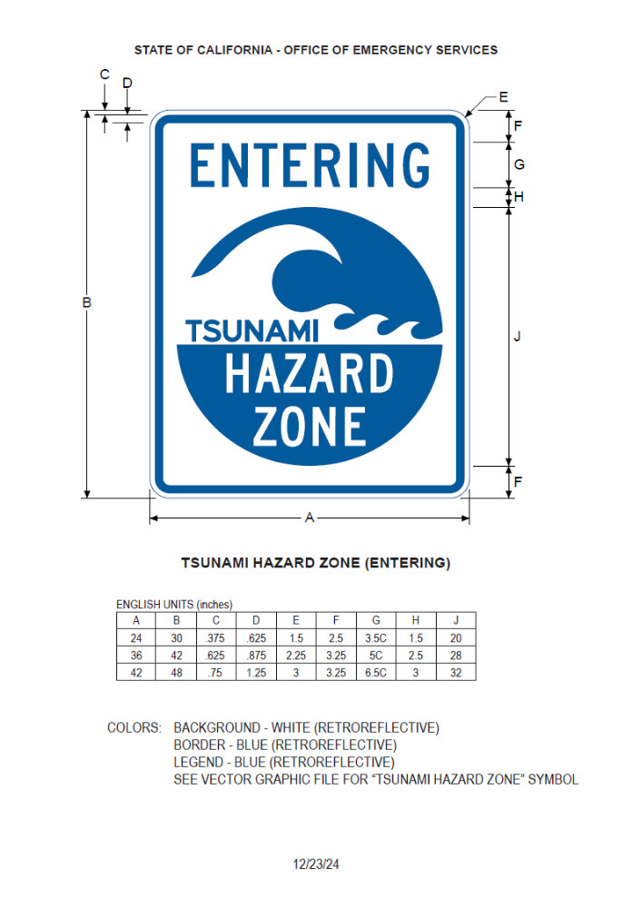
Figure 1: Entering Tsunami Zone Sign (EM-1Ce) Specifications

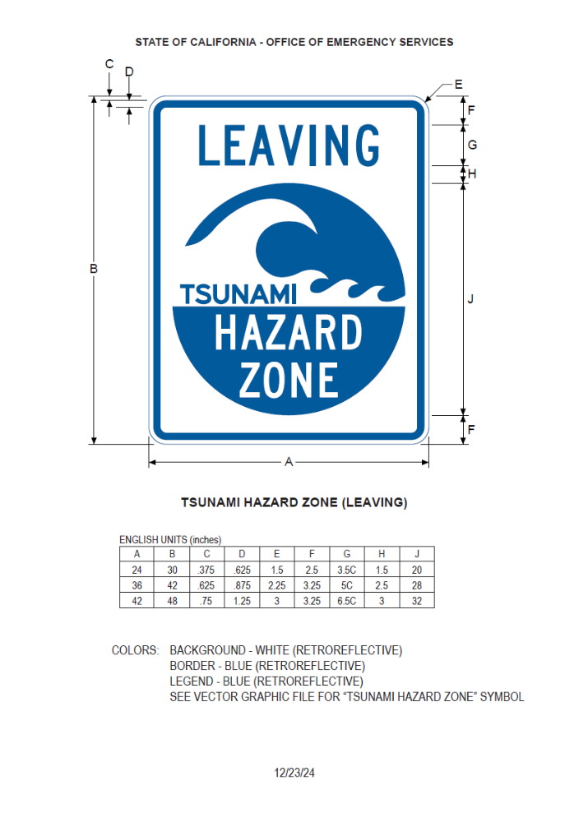
Figure 2: Leaving Tsunami Zone Sign (EM-1Cl) Specifications

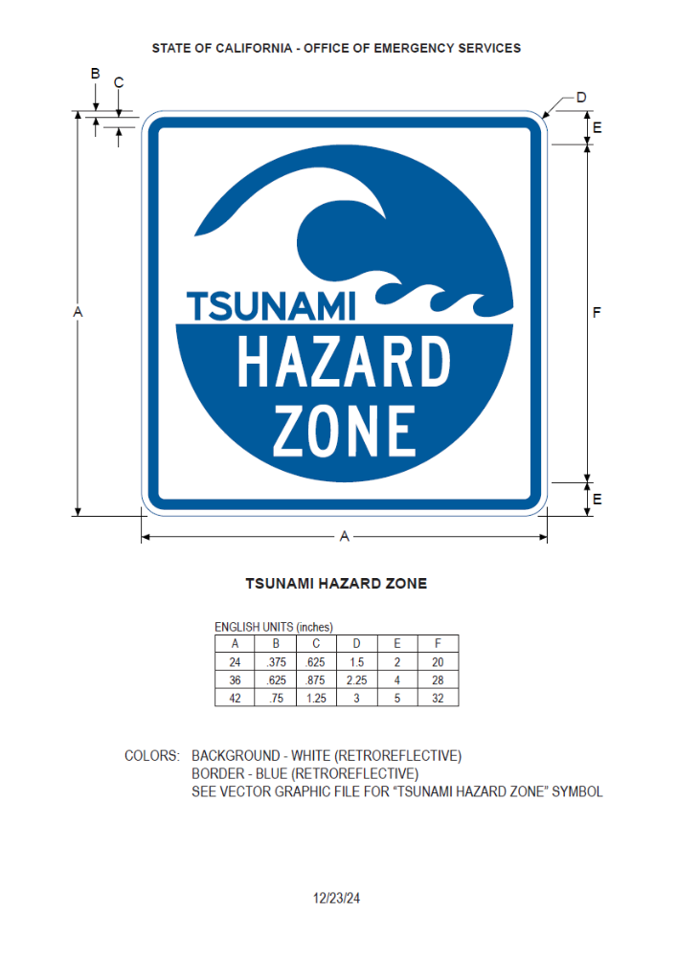
Figure 3: Tsunami Hazard Zone Sign (EM-1E) Specifications

